**Source Code:**

**Question 10 Code and Output:**

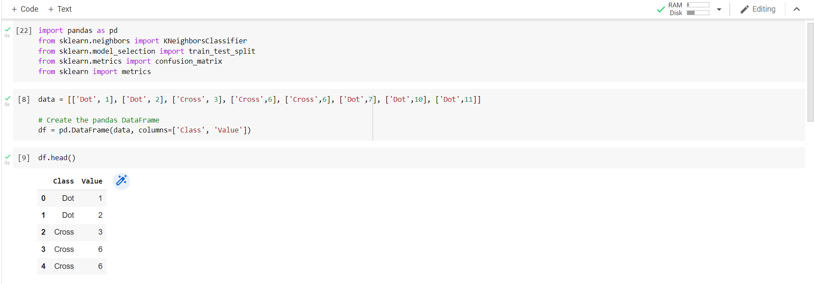

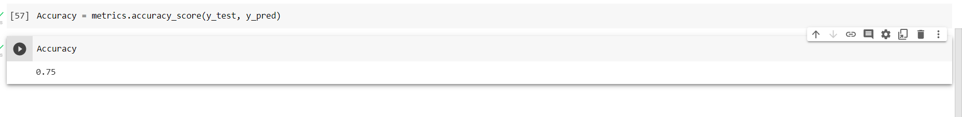

**Question 1 to 9 Output:**

Video link:

https://ucmo0-my.sharepoint.com/:v:/g/personal/rxg63570_ucmo_edu/EWbZJ7tYkyVOooPlPWiXrc8Balwot9fIQuQ63NJeYYjDqg