Kernel Space vs User Space :

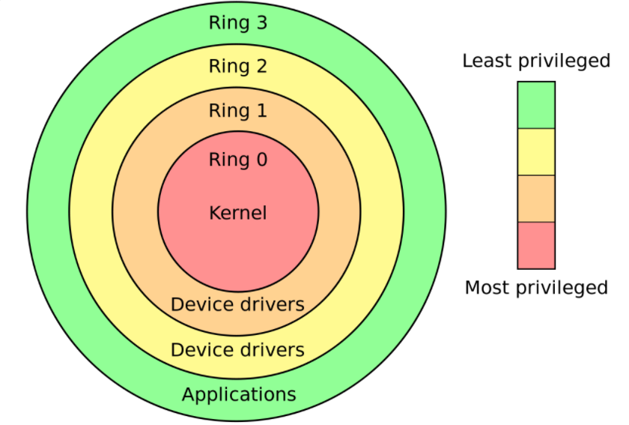

In Layman’s terms…

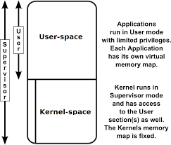

**Kernel space** is where the kernel (i.e., the core of the operating system) runs and provides its *services.* Its something that the user is not allowed to interfere with.

***User space***is that portion of system memory in which *user processes* run. The irony is that even those processes are managed by the ***kernel***. ;)

**Analogy**:

Think about the computer system as a house for a family where kernel space is the list of chores that the parents take responsibility for and user being any of the children that the parents have.

So, the children don’t interfere with what the parents do like paying the electricity bill etc but they do know that the parents will keep them in the best possible condition and they need not worry about a thing.

What the children does, like their homeworks from school comes under user space that the children themselves had to do but the parents(kernel) supervises upon and parents also put up the curfew times like the kernel makes constraints for the available resources that a user can use to perform its job.

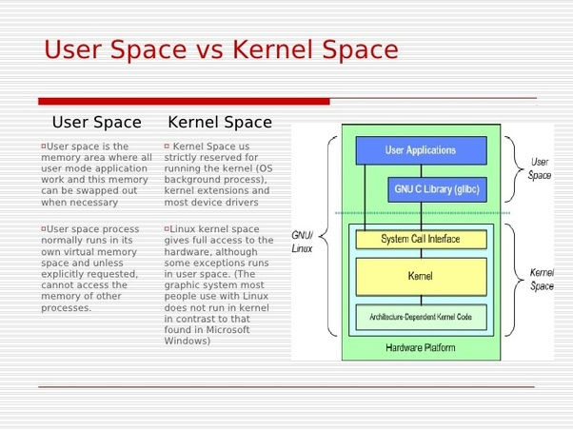

In Linux :

The Linux Kernel refers to everything that runs in Kernel mode and is made up of several distinct layers. At the lowest layer, the Kernel interacts with the hardware via the HAL. At the middle level, the UNIX Kernel is divided into 4 distinct areas. The first of the four areas handles character devices, raw and cooked TTY and terminal handling. The second area handles network device drivers, routing protocols and sockets. The third area handles disk device drivers, page and buffer caches, file system, virtual memory, file naming and mapping. The fourth and last area handles process dispatching, scheduling, creation and termination as well as signal handling. Above all this we have the top layer of the Kernel which includes system calls, interrupts and traps. This level serves as the interface to each of the lower level functions. A programmer uses the various system calls and interrupts to interact with the features of the operating system.