**I 526/B659 Programming Assignment 1**

Shweta Bhartia – [sbhartia@umail.iu.edu](mailto:sbhartia@umail.iu.edu)

Pramod Sripada – [ksripada@umail.iu.edu](mailto:ksripada@umail.iu.edu)

1. Start from depth = 1 and go to diﬀerent depths (2,4,6,8...,16). For each depth, compute the error (the number of misclassiﬁcations) on the test set. Plot a learning curve with the depth of the tree on the x-axis and the accuracy on the y-axis.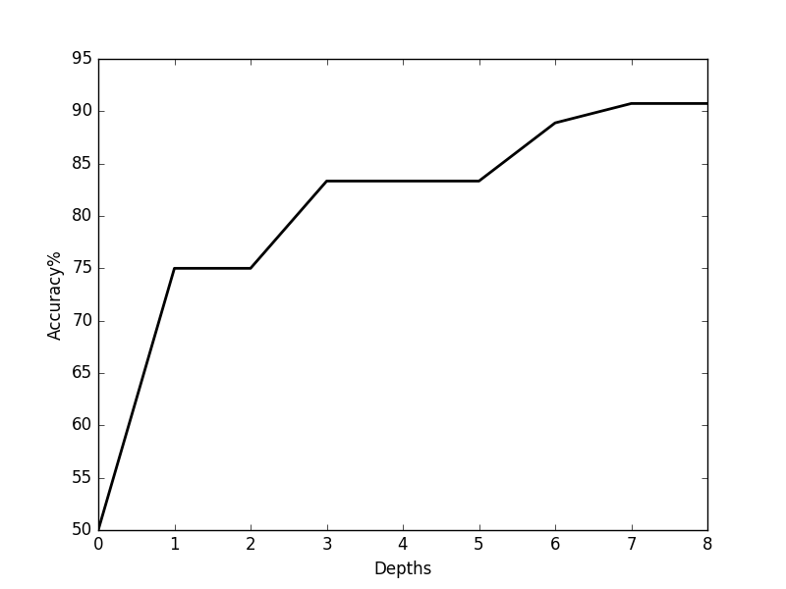

Accuracy graph for testing on monks-1.test on different depths. The file is available in the attachment as monks-1-accuracy.png

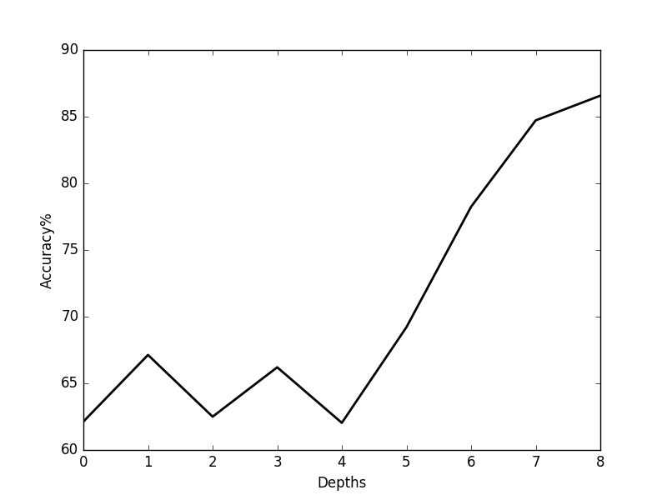

Accuracy graph for testing on monks-2.test on different depths. The file is available in the attachment as monks-2-accuracy.png

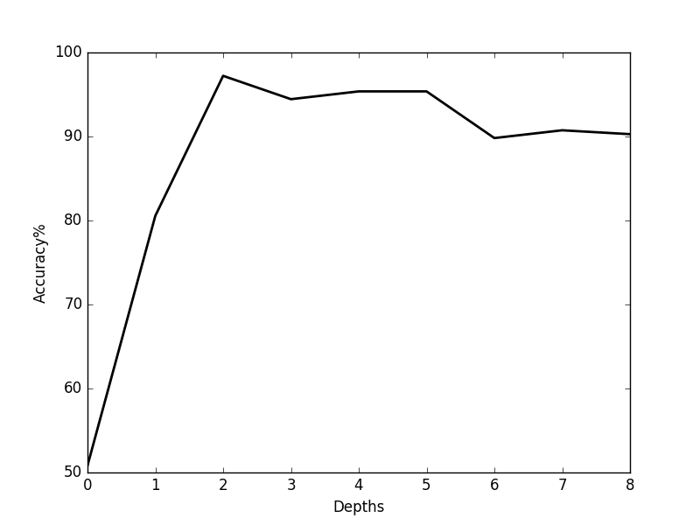

Accuracy graph for testing on monks-3.test on different depths. The file is available in the attachment as monks-3-accuracy.png

2. Report the learned decision tree (depth 1 and depth 2) and report the confusion matrix for these two depths ( A confusion matrix has the true label as rows and predicted labels in the columns. Each entry of the matrix is the number of examples. In a binary case, the top left corner is the number of negative examples correctly classiﬁed and the bottom right is the number of positives correctly classiﬁed)

At depth 1, for monks-1.train the learnt tree is

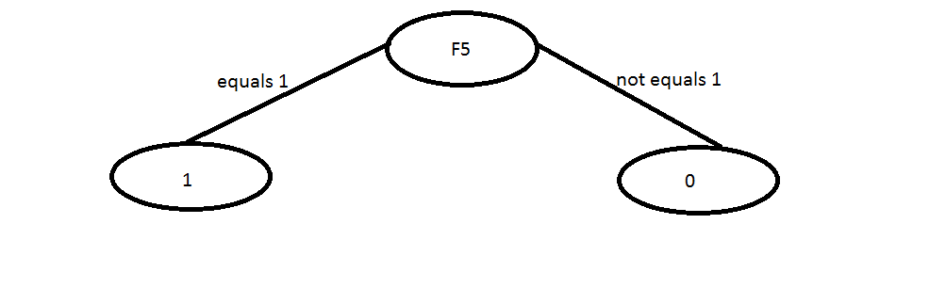

The confusion matrix is

|  |  |  |
| --- | --- | --- |
|  | Predicted: 0 | Predicted 1 |
| Actual 0 | 216 | 0 |
| Actual 1 | 108 | 108 |

At depth 2, for monks-2.train the learnt tree is

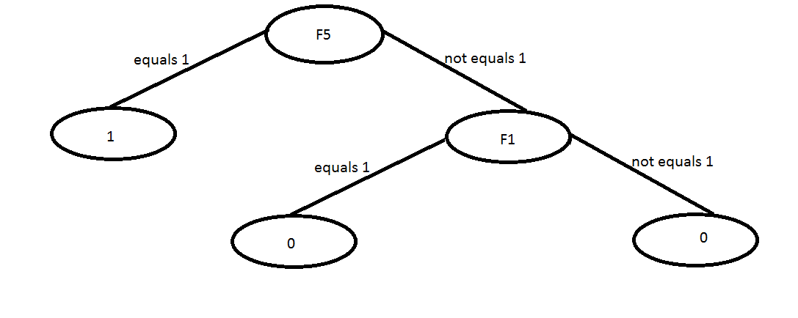

The confusion matrix is

|  |  |  |
| --- | --- | --- |
|  | Predicted: 0 | Predicted 1 |
| Actual 0 | 216 | 0 |
| Actual 1 | 108 | 108 |

At depth 1 for monks -2.train the learnt tree is

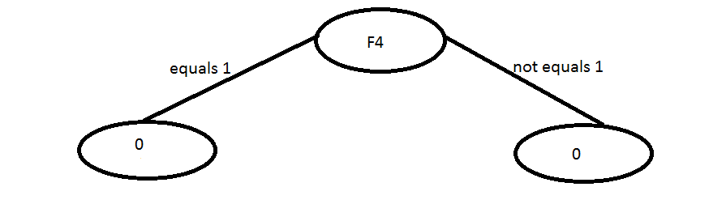

The confusion matrix is

|  |  |  |
| --- | --- | --- |
|  | Predicted: 0 | Predicted 1 |
| Actual 0 | 290 | 0 |
| Actual 1 | 142 | 0 |

At depth 2 for monks-2.train the learnt tree is

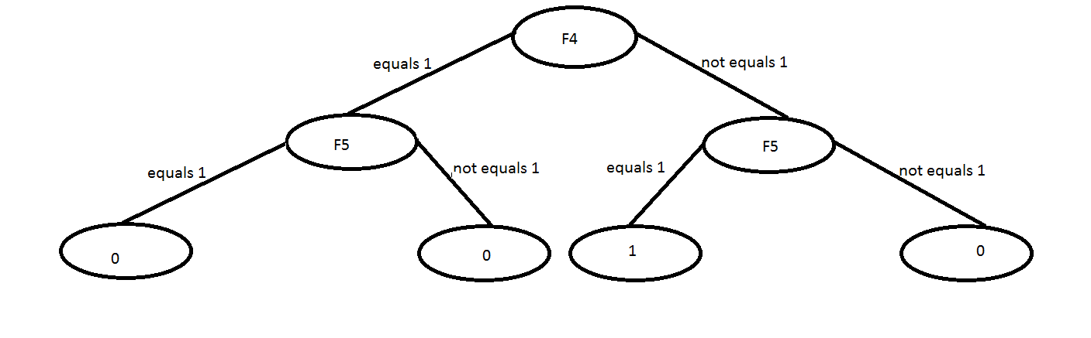

The confusion matrix is

|  |  |  |
| --- | --- | --- |
|  | Predicted: 0 | Predicted 1 |
| Actual 0 | 244 | 46 |
| Actual 1 | 116 | 26 |

At depth 1 for monks-3.train the learn tree is

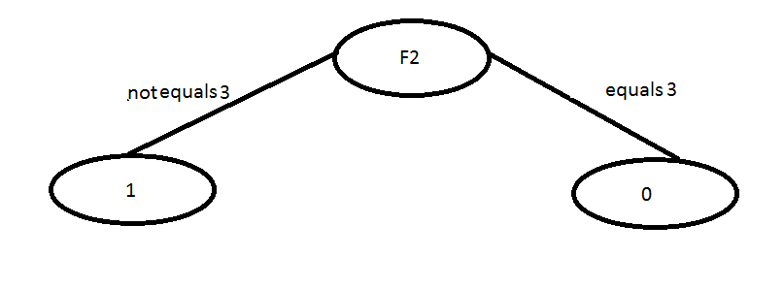

The confusion matrix is

|  |  |  |
| --- | --- | --- |
|  | Predicted: 0 | Predicted 1 |
| Actual 0 | 132 | 72 |
| Actual 1 | 12 | 216 |

At depth 2 for monks-3.train the decision tree is

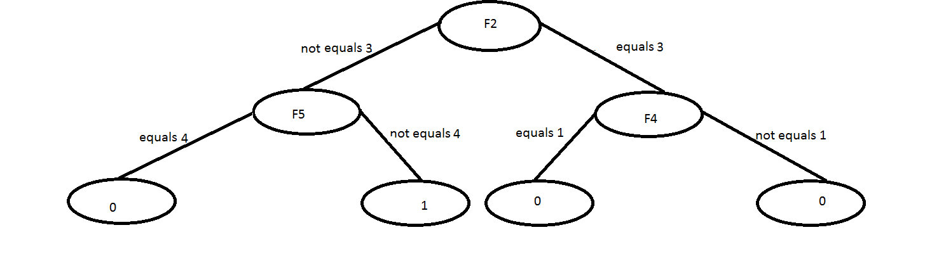

|  |  |  |
| --- | --- | --- |
|  | Predicted: 0 | Predicted 1 |
| Actual 0 | 204 | 0 |
| Actual 1 | 12 | 216 |

4. Repeat steps 2 and 3 with your “own” data set and report the confusion matrices.

The accuracy graph

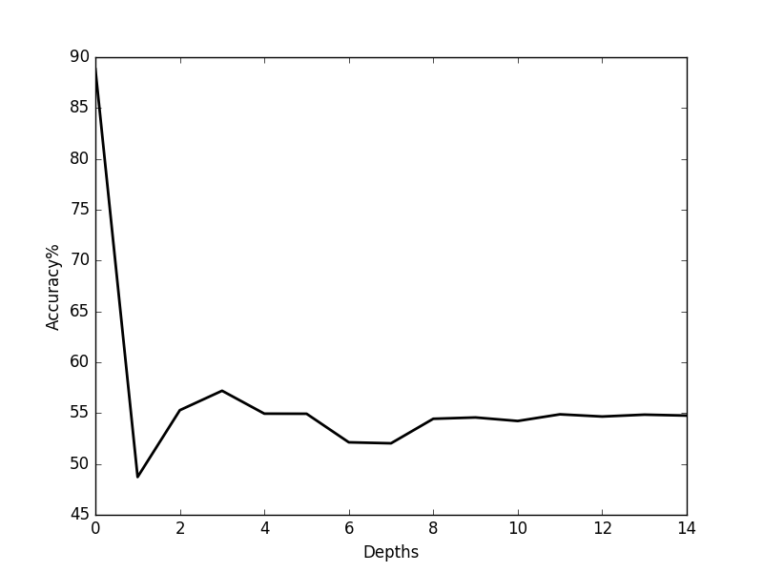

The decision tree at depth 1 looks like

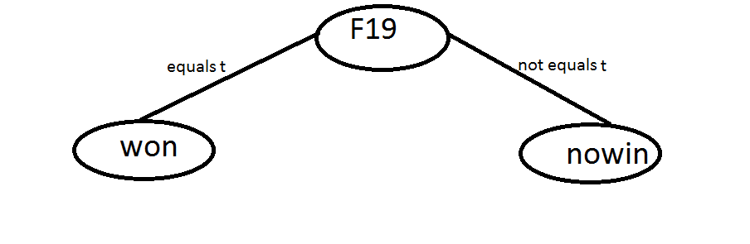

Confusion matrix at depth 1 for the decision tree

|  |  |  |
| --- | --- | --- |
|  | Predicted: nowin | Predicted won |
| Actual nowin | 113 | 26 |
| Actual won | 148 | 33 |

The decision tree at depth 2 for the decision tree

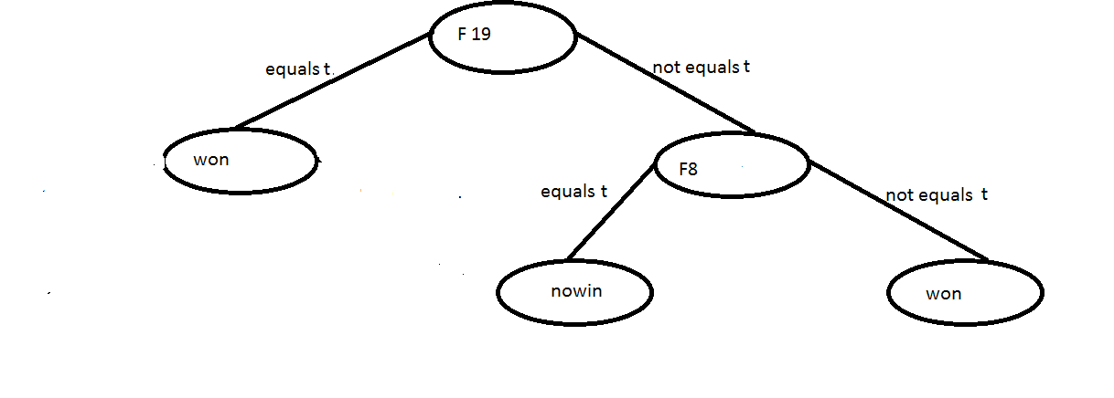

Confusion matrix at depth 2 for the decision tree

|  |  |  |
| --- | --- | --- |
|  | Predicted: nowin | Predicted won |
| Actual nowin | 62 | 96 |
| Actual won | 44 | 118 |