Physician App
An FHIR Client System

This document is a property of Mindfire Solutions and contains some confidential information and hence no part of this document should be distributed or copied elsewhere without permission of PL/TL/AL. This document is for internal purpose only.

Change Log
# | Description | Author | Date
1 | Document Created | Pramod Gupta | 09/14/20
2
3
4

Table of Contents

1. Overview 4
2. F1 – <<Patient Dashboard >> 5

1. Overview
This web application is representation of FHIR client. We are having integration of AZURE FHIR Server . In launching of application we will give ability user to load list of patient and its details after integration with FHIR server. Right now we have implement integration with Azure. Here user has ability to display patient list.

2. F1 – Patient Dashboard Screen
Feature Description:
This screen will display list of patients.

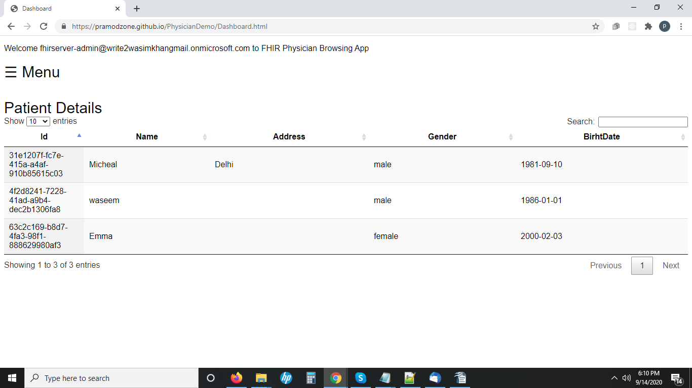

Date: Aug 13, 2020

