Physician App
Developer Documentation

This document is a property of Mindfire Solutions and contains some confidential information and hence no part of this document should be distributed or copied else where without permission of PL/TL/AL. This document is for internal purpose only.

Change Log
# | Description | Author | Date
1 | Document created | Pramod Gupta | 09/14/20
2
3
4

Table of Contents

1. Overview 4
2. Project Description 5
3. Project Details 6
4. System Components 7
5. Architecture Diagram 8
6. Build Steps 9

1. Overview

This web application is representation of FHIR client. We are having integration of AZURE FHIR Server . In launching of application we will give ability user to load list of patient and its details after integration with FHIR server. Right now we have implement integration with Azure. Here user has ability to display patient list.

2. Project Description
It is an Web application connected to Azure FHIR Server which performs different functions related to patient information. The Projected is developed using
- HTML + Js
- Azure User Account Authentication for Login
- The data is stored in Azure Server

3. Project Details
Following are some general and technical details of the project:
GENERAL
Client Name : PhysicianApp
Project Start Date : 09/01/2020
No. of Resources : 1 Dev
Project Type : HL 7 V4 Format

TECHNICAL
Technology : Web App
Platform : Web Application
FHIR SERVER : Azure
IDE : Visual Studio
Development Env. : Azure Envi
FHIR Version : FHIR v4.0.0
Hosting Environment : GITUB
Browser Support : All

REPOSITORY
Type : Internal
URL :
Credentials :

4. System Components
Physician has one major components

- Patient Dashboard – This screen will display list of patients.

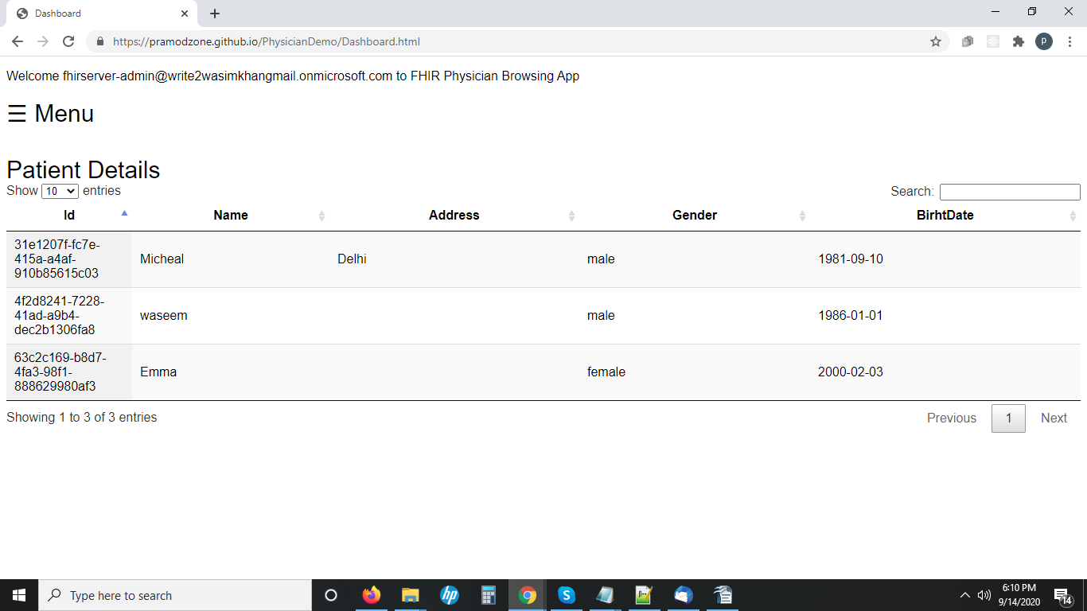

5. Architecture Diagram
A high-level visual depiction of the system architecture. All system components that the application interacts with are included in the diagram. A detailed explanation of the
different components is included in the section System Components above.

