Which Machine Learning Algorithm will produce the best accuracy for predicting NFL play type success
based on Field Position

Philemon Ramontal
St. Thomas University
Miami, FL USA
Pramontal@stu.edu

Abstract
This analysis will endeavor to determine which Machine Learning algorithm will lead to the best accuracies of successful play type based on given parameters. The National Football League is by far the most popular league with the most revenue in the United States. In recent years data analytics has become a large part of every teams strategic planning. Data analyst have endeavored to predict game outcomes, player performance and most recently have used machine learning to predict the next play type.
Unfortunately, predicting the success of an optimal play type based on location on this field is an area that has not yet been analyzed. Consequently, this study will determine to which play type will be most likely to be successful based on field position. Furthermore, historically on 4th down team’s punt or kick a field goal based on field position. However, this analysis will predict weather of not teams should execute a play on 4th down when the yard to gain to reach a 1st down is less than 3.

Introduction

The NFL is a billion dollar industry and any possible advantage to teams would go a long way in enabling them to have success on the field. Solving this problem is important to NFL teams as well as individuals who bet on games. NFL teams would gain an advantage if they knew they possibly had a significant level of success on any given play call against defenses. All 4 downs are important to team’s offensive success however, the location on the field changes the decision making process for coaches. Giving a coach a specific a statistical level of certainty would help in the decision making process as well as creating a team advantage.
5 Machine Learning algorithms will be used to analyze NFL play by play data between 2009-2018 to provide some level of accuracy to the hypothesis. They include Support Vector machine (SVM), Neural Network, Random Forest, Linear Regression and Logistic Regression. Providing a level of certainty for the best possible play given any scenario would greatly benefit NFL teams. The way the game is played on the defensive side of the ball will have to be altered based on any significant discoveries during this analysis. It is critically important to find a solution to this problem to enable NFL teams to have all possible advantages. If this isn’t solved, then teams will be relegated to trusting the gut instinct of coaches without any statistical backing.

Literature Review

Since the early 1950’s statisticians and other have tried to figure out ways of determining winners in athletic events. Since then many researchers have tiered to find various was of creating highly accurate ways of predicting winners. Therefore, this is why sports gambling is such a large part of American society. There has been a boom in sports analytics over the last 10 years. Consequently, NFL teams have invested heavily in analytics departments to provide them with an edge over their competition. Various approaches have been taken to figure out play prediction, next play call prediction, winner of the game prediction and many other factors that affect the outcome of ta given game. The NFL is a multibillion dollar industry and the gambling industry is equally as large. Being able to predict the offensive outcome would be an incredible advantage for the offense.
In 2015, interest in applying machine learning towards football analytics began to blossom as William Burton and Michael Dickey addressed this question of predicting offensive plays [1]. Burton and Dickey reported a prediction accuracy of 75 % with a single-game high of 90%. This level of accuracy is excellent. Burton and Dickey’s work lead to many researchers using ML to predict play type in NFL games. Having this level of accuracy would put offensive coaches in a position to exploit defenses. Predicting the outcome of a play for an offensive team will return the advantage to the offences thus putting them back in control of the game. Lee, Chen and Lakshman undertook to predict offensive play types using various Machine Learning Algorithms they were able to predict play types with a mixed accuracy of about 75% using different ML models. This play type prediction would be a huge advantage for the defensive coach. Critchfield and Stilling had an interesting approach to Risk tolerance study [2] Interestingly, one of their prediction suggested that play calls are affected by games score. They suggest that the play selection is based on weather a team is winning or losing at the time of their offensive possession of the ball. Furthermore, teams play selection is very skewed to the pass in end of half and end of games situations. According to Fernandes the three variables with that had the greatest impact on play prediction were the current down yards to go for first down and point differential [3] These variables are a few of the most important during an NFL game. His model had 65.3% accuracy; though not the highest compared to peer analysis, his variables are integral to a team’s success in each game. This is not the highest accuracy seen in the various papers however, the variables used are integral in team success in each game. In 2014, Nate Silver introduced an ELO-ranking system to rank all 32 NFL teams. The system took into account basic knowledge, such as win and losses, strength of schedule or point differential [4] Silver has used this method to rank teams for the last 6 NFL seasons. He has also used historical stats to predict final scores for weekly NFL games.
Artificial Neural Networks (ANNs) are perhaps the most commonly applied approach among ML mechanisms to the sport related prediction problem. In sports predictions, large numbers of features can be collected including historical performance of the teams, results of matches [5]. Logistic Regression is also used as a binary choice between a win and loss for NFL games. Draws in the NFL are not common so a win and loss would be the options to test. The logistic model will return a probability between 0 or 1. This creates the need for a threshold of what will be considered a win or loss [6] having a return greater than .5 would be considered a win and below .5 would be a loss.
These aforementioned studies are all interesting and have value to solving a problem similar with this analysis. However, they do not take into account location on the field and the down a team is facing. Some of the Machine Learning techniques used in the analysis in the above studies will also be used in this analysis. Artificial Neural Networks, Regressions Models and random Forest models will be used in this analysis. These ML models have produced positive results in previous NFL prediction studies. Using them will provide the opportunity to have robust models with great statistically backed accuracies.

Methedology

This analysis will examine which play type is the best based on location on the field and the down of the play. An NFL football field is made up of 100 yards. At each end is the goal line for the 2 teams competing. When the goal line is crossed a touchdown is scored resulting in 6 point being given to the scoring team. Half of the field belongs to one team and the other half belongs to the other team. The goal is to drive the ball down the field and score by getting the ball past the opposing team’s goal line.

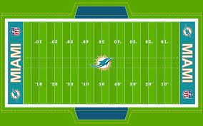

Figure 1. NFL Field

Each team has 4 downs (4 plays) when in possession of the ball. They can execute a variety of plays when in possession of the ball. On downs 1, 2, three the team can execute a play of either run or pass however, on 4th down the team can punt (Kicking the ball back to the opposite team) based on the location of the field. If they are on their own side of the field the probability is, they will punt. However, if they are on the opposing team’s side, they may decide to kick a field goal to gain 3 points or try to execute a play on 4th down. This play comes with a certain level of risk. If they make the yards to gain and get a 1st down, then their drive continues but then again if they do not make the yards to gain, they risk giving the opposing team the ball back with a shortened field. 4th down is an interesting down because most teams punt on 4th down if they are outside of field goal range. This analysis will perform a linear model to determine if teams should execute a run of pass play when the yardage to gain is less than 3 yards. The parameter for location on the field will be from the offensive teams own 40 to the goal line.

Data

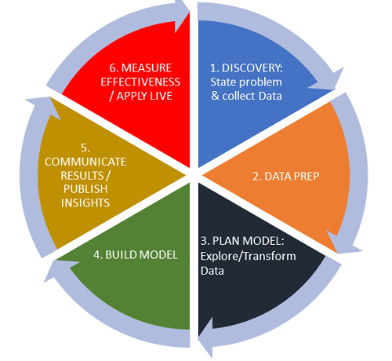

Figure 2. Data Life Cycle

The data being used is a play by play dataset from 2009-2018. The original dataset contains 255 columns and over 400K rows. Each column is an attribute pertaining to the game being played. For this analysis only the first 35 columns will be kept. After importing the data, the rows containing N/A attributes will be removed consequently, the number of rows will also be reduced to about 318K.
Some of the pertinent variables include

- Yards to go (This represents the number of yards to gain for a first down)
- Possession team (This represents the team in possession of the ball)
- Yard Line (This represents Yard line on the 100 yard field where the ball is located)
- Down (1-4 opportunities for the team in possession of the ball)
- Yards (It represents yards gained or lost on any given play)
- Yards net (Net number of yards gained or lost on a play)

These are just a few of the important variables needed to perform this analysis.

Data Source

https://www.kaggle.com/maxhorowitz/nflplaybyplay2009to2016

Materials

For this analysis only a computer is needed. Being that this dataset is very large a machine with at least 16 GB and i5 core processor will be necessary. Rstudio (version 3.6.3) will be needed as well as various packages which include but are not limited to, Tidyverse, GGlopt, NeuralNet, caTools, dplyr, randomForest, and e1071.

C. Procedure

The data will be uploaded from Kaggle.com and transformed into a csv file. The data tidying process will commence by removing all unnecessary columns after which all rows with N/A’s will also be removed. There will be a downsizing of the dataset which was originally 400k rows. Various subsets will be necessary to isolate plays from down 1,2,3,4 and to separate the 100 yard field into two 50 yard blocks.
After data transformation, the data set will be randomly split into a training and testing set. Training set will be 70% testing set will be 30%. A logistic regression model, Neural Network model, SVM (support vector machine) model, classification and regression tree model Random Forest and a linear model will be used to determine the best accuracy for predicting the most successful play outcome.

Logistic Regression

The response variable in logistic regression has only two possible outcomes. In this analysis the variable is the play type being executed. The play type in the dataset are pass and run. To get an accurate model pass will be designated as “1” and run as “0”. This model will be used to predict play type on 3rd down and long which is considered to be 5 yards of more. The data is split into the training and testing sets. The model is than executed after which the predict function is used to determine which play would be best in the given scenario.

Linear Regression

A linear Regression model will be used to predict possible yards gained on a 4th and short play. The parameter for 4th and will be defines as 3 yards of less to gain to reach a 1st down. A subset of the data with all 4th down play type, less than 3 yards to go and, all plays from the 40 yard line of the team in possession of the ball to the goal line.

Random Forest

Random forests are an ensemble learning method for classification and regression that constructs a number of randomized decision trees during the training phase and predicts by averaging the results [8].
Random forest will be much better and more beneficial technique for this analysis because it is better to use than a single tree. Random Forest includes many decision trees to provide for better accuracy and to limit overfitting consequently, providing more accurate results.

Neural Networks

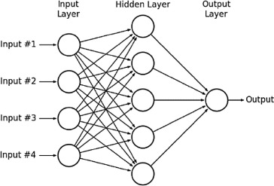

Figure 3: NN Example

Neural Networks are one of the most common algorithms used in sports analytics. Ideally live data would be best unfortunately, that option was not available. The data we used was split into training and testing set. The model will be trained on the training data subsequently, the testing data will be used to test and predict best play type.

Results & Discussion

NN, Support Vector Machine and Random Forest models were used to analyze play types run or pass. The data subset was based on the down of the play.

Model for 1st Down Yard Line 100-50
SVM | 0.72
Neural Network | 0.5
Random Forest | 0.73
Table 1: Model Results Yard Line 100-50 Play Type Accuracy

The results display that the Random Forest model was provided the highest accuracy between the 3 models. Two of the above models predict that the pass play will be the predominant play of choice. The NN model had it split down the middle

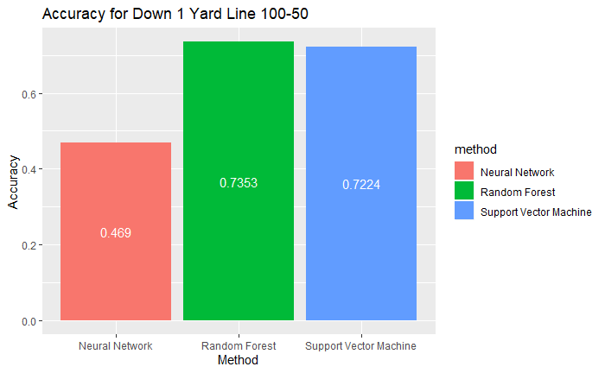
Figure 4: Bar plot of Accuracies Yard Line 100-50 Down 1

An Anova test was performed to determine if there were any statistically significant differences between the model. It was determined that there was not any were significant difference. The P-value is well below the threshold of 0.05.

Model for 1st Down Yard Line 50-0
SVM | 0.70
Neural Network | 0.5
Random Forest | 0.74
Table 2: Model Results Yard Line 50-0 Play Type Accuracy

These accuracies are based on the parameter of yard line 50 to 0 which is the goal line. The results of play selection in the SVM and Random Forest model predicted that the run play would be the predominate play selection inside the 50 yard line. Again, the Random forest model proved to be the most accurate.

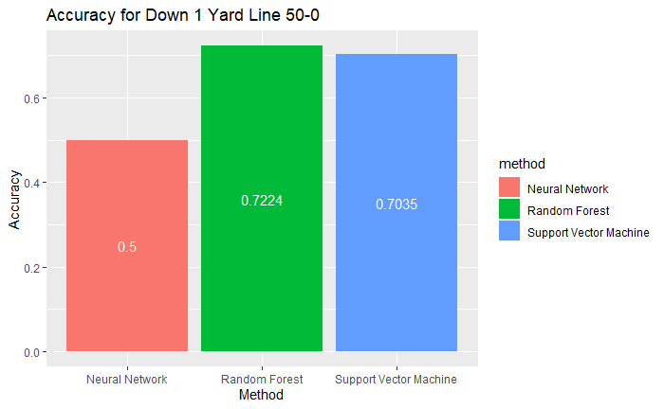
Figure 5: Bar plot of Accuracies Yard Line 50-0 Down 1

Model for 2nd Down Yard Line 100-50

SVM | 0.72
Neural Network | 0.5
Random Forest | 0.74
Table 3: Model Results Yard Line 100-50 Play Type Accuracy

On 2nd down the Random Forest model again performed best with an accuracy of 0.74. The play choice for second down is largely skewed to the pass. There are significant more pass plays call on 2nd down than on 1st down. An assumption can be made here that teams that do not gain positive yardage on 1st down will be forced to throw that ball in order to accumulate more yardage quickly.

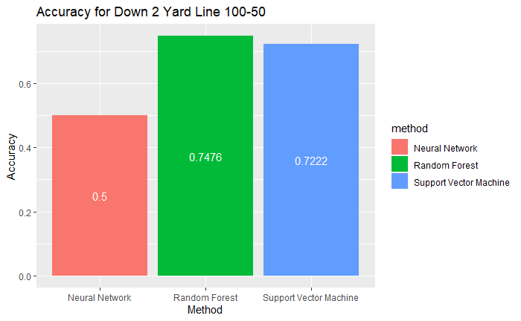
Figure 6: Bar plot of Accuracies Yard Line 100-50 Down 2

Model for 2nd Down Yard Line 50-0

SVM | 0.72
Neural Network | 0.5
Random Forest | 0.70
Table 4: Model Results Yard Line 100-50 Play Type Accuracy

Again, we can see that the Random Forest model has the best accuracy of the 3 models. However, on 2nd down when a team is between the 50 and the goal line the pass play is predicted to be significantly chosen more often than the run play. This can possibly be attributed to the lack of execution on down 1.

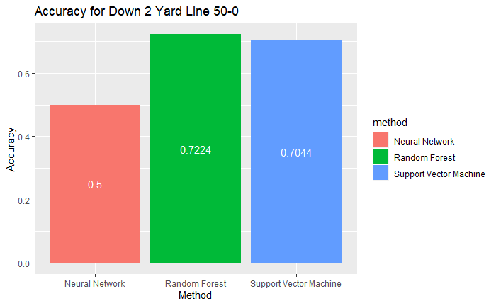
Figure 7: Bar plot of Accuracies Yard Line 100-50 Down 2

Model for 3rd Down Yard Line 100-50

SVM | 0.841
Neural Network | 0.5
Random Forest | 0.849
Table 5: Model Results Yard Line 100-50 Play Type Accuracy

On 3rd down from the goal line to the 50 yard line the play most often selected is the pass play. This is consistent with past result on different downs. However, the best accuracy jumped from the mid 70’s to 0.849. These results are consistent with a normal NFL game. For the most part on 3rd down teams usually execute a pass play. This of course is dependent on the yards to gain.

Model for 3rd Down Yard Line 50-0

SVM | 0.79
Neural Network | 0.5
Random Forest | 0.82
Table 6: Model Results Yard Line 100-50 Play Type Accuracy

On 3rd down between the 50 yard line and the goal line the play type is heavily skewed towards the run. 3rd down is an interesting down because teams tend to not execute a run or pass play on 4th down. Defenses tend to try to stop the run play on 3rd down so teams take the option of the pass play. A Logistic Model was done to determine what play type is call when its 3rd down and less than 4 yards to gain to reach a 1st down. The results were similar to the previous above model. The pass play was still the overwhelming option teams choose.

Being that teams have this hesitation to execute a play on 4th down I decided to include a Linear model to determine how if a team would make a 1st down if they executed a play. The model predicted that teams would on average gain 4.8 yards if they executed a play on 4th and short. Meaning 4th and less than 3 yards.

Future Work

In the future a more detailed break down of the field may lead to more insight on play type prediction in NFL games. Live data would also be a benefit to have a more robust and accurate model.

References

[1]W. Burton and M. Dickey. “NFL play predictions”. In: JSM Proceedings, Statistical Computing Section, 2015.

[2]Critchfield, T. S., & Stilling, S. T. (2015). A matching law analysis of risk tolerance and gain–loss framing in football play selection. Behavior Analysis: Research and Practice, 15(2), 112-121. http://dx.doi.org/10.1037/bar0000011

[3]C. Fernandes, “Predicting plays in the National Football League.” [Online]. Available: https://content.iospress.com/download/journal-of-sports-analytics/jsa190348?id=journal-of-sports-analytics/jsa190348. [Accessed: 23-Mar-2020].

[4]P. Bosch, “Predicting the winner of NFL-games using Machine and Deep Learning. .” [Online]. Available: https://www.math.vu.nl/~sbhulai/papers/paper-bosch.pdf. [Accessed: 23-Mar-2020].

[5]. R. Bunker, “A machine learning framework for sport result prediction,” 01-Jan-2019. [Online]. Available: https://www.sciencedirect.com/science/article/pii/S2210832717301485#b0220. [Accessed: 23-Mar-2020].

[6]S. Bouzianis, “Predicting the Outcome of NFL Games Using Logistic Regression,” 05-May-2019. [Online]. Available: https://scholars.unh.edu/cgi/viewcontent.cgi?article=1472&context=honors. [Accessed: 23-Mar-2020].

[7]K. Ota, “Football Play Type Prediction and Tendency Analysis,” 01-Jun-2016. [Online]. Available: https://dspace.mit.edu/bitstream/handle/1721.1/113120/1016455954-MIT.pdf?sequence=1&isAllowed=y. [Accessed: 23-Mar-2020].

[8]Scornet, E., Biau, G., & Vert, J. (2015). CONSISTENCY OF RANDOM FORESTS. The Annals of Statistics, 43(4), 1716-1741.
Retrieved April 28, 2020,
from www.jstor.org/stable/43556658

