# Simple 3

third text block before image

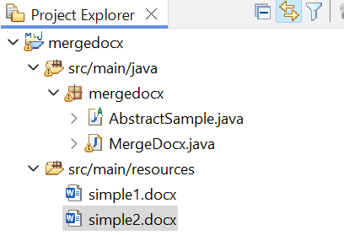

Third text block after image.