**FEWD Experiment-2**

**Navbar using only HTML**

<!DOCTYPE html>

<html lang="en">

<head>

<meta charset="UTF-8">

<meta name="viewport" content="width=device-width, initial-scale=1.0">

<title>Simple Navigation Bar</title>

</head>

<body>

<nav>

<a href="index.html">Home</a> |

<a href="signup.html">Signup</a> |

<a href="login.html">Login</a> |

<form action="search.html" method="GET" style="display: inline;">

<input type="text" name="query" placeholder="Search...">

<input type="submit" value="Search">

</form>

</nav>

<h2>Welcome to Simple Webpage</h2>

<p>This navigation bar uses only HTML.</p>

</body>

</html>

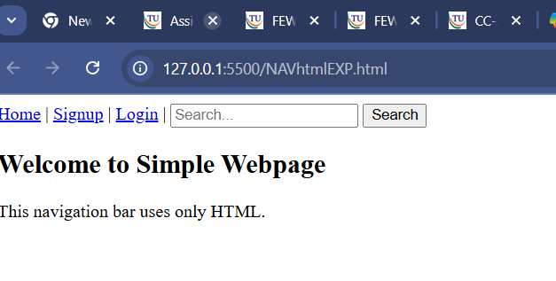

<https://github.com/pranRV/FEWDlab>

Link to github repo