Analysis and Design Report



# Team FOUR-TIFIED

**Bohao Su - 29392179**

**Chenyang Qiu - 29791359**

**Pranav Sharma - 29004772**

**Sandeep Sanjeev - 29908841**

**20/04/2020**

**Version 1**

# INTRODUCTION

# PROJECT OVERVIEW

## Lean Canvas:

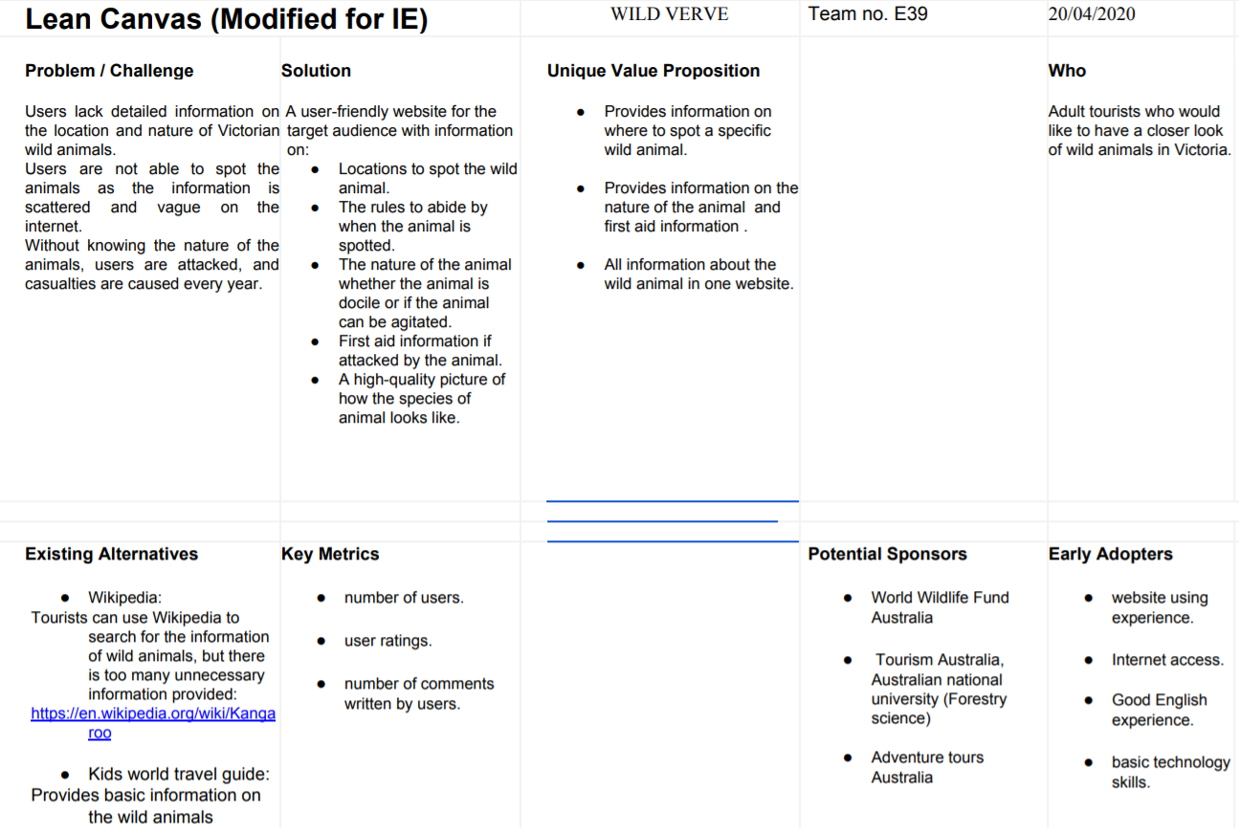

* Specific security aspects for this product (updated as necessary)

## Risks:

* The animal information provided could be incorrect in case of any natural calamity like the wild fires, that could affect the animal habitat.
* The change in government laws on the animals could also lead to a risk of misinformation to the users.

## Personas:

|  |  |  |  |  |
| --- | --- | --- | --- | --- |
|  |  |  |  |  |
| NAME | Adam | John | Ria | Mark |
| AGE | 22 | 45 | 31 | 38 |
| RESIDENCE | France | Hong Kong | Australia | South Africa |
| OCCUPATION | Graduate student | Project Manager | School Science Teacher | WildLife Photographer |
| GOALS | He is coming to Australia for gap travel. He is a road trip lover and he wants to travel around Australia by car. | He and his wife decide to take their son to Australia for holidays. | She wants to know more information on wild animals in Australia to teach her students. | He is visiting Australia to take pictures of exotic wild animals. |
| REQUIREMENT | He wants to know what kind of wild animals he will meet when he drives.  He wants to know the list of animal sanctuaries and zoos that he can visit. |  |  |  |

# Current Iteration

The following functions are being delivered in this Iteration:

**1. website (**[**https://wildverve.ga/**](https://wildverve.ga/)**)**

A website application is designed to meet the requirements for the audience of the project. The domain name is created from freenom.com, the website uses the web hosting from ifastnet.com for accessing at any time. SSL is activated in the website, and the URL is rewritten to https for safer access.

By typing the domain name on the website browser, the home page of the website can be shown on the screen, which shows the work has been done. Different devices and browsers have been tested by typing the domain name, the website can be accessed by all of them.

**2. Home Page**

Home page includes the introduction of the website and simple guides for users. Links and buttons on the home page can direct users to the other pages. The page has made responsive settings to adjust the layout on different devices. The page is user friendly, people with a few website experiences can use the website well.

All the buttons and links are being tested by clicking them on the page, and the user can be directed to the correct page as described on the buttons. Texts on the website are clear and readable.

**3. Explore Map Function**

The function appears in the Explore Map page, a map with one mark is shown on this page to let users know where this place is. Further function can be accessed by clicking the Multi Marker Test button, a map of Victoria with 3 markers shown in the new page, markers indicating the spotting place of wild animals. The location data is collected and wrangled from open data source, latitude and longitude are selected from the data and imported into the map. For this iteration, only three markers are imported for testing, in further iterations, the project tries to include more markers in different maps by species and facilities to fulfill users’ requirements.

The acceptance criteria in this section is to show the map and markers clearly on the web page. Maps can be seen clearly in different devices.

**4. Animal Catalog**

Information about koalas is covered in the Animal Catalog page, including habitats, diet and image. Each information is hidden by a toggle button to minimize the information showing to the user. Another function in this page is a sample table with the following wild animal information: Scientific name, vernacular name, class, order, family, genus, species. This function is for an audience who wants to know more about wild animals, data in this part is collected and wrangled from open data.

Two functions only deliver parts of the data, this iteration is mainly for the visibility testing. Tested tables and texts are correctly appeared on the screen for user interaction.

**5. About Us Page**

About Us page includes project background, solution and a brief introduction of the project team, the page decorated with animation and picture, to let the audience know the project better.

The web page is being tested by accessing with different devices, all the contents in this page shown properly.

# 

# 

# Data Source(s)

|  |  |  |  |  |  |
| --- | --- | --- | --- | --- | --- |
| **NAMES** | **Physical**  **Access** | **Frequency of source updates** | **Frequency of iteration system updates** | **Granularity** | **Copyright / licensing details** |
| Animal Information | CSV | 2 years | 2 years | Animal information and location | <http://www.environment.gov.au/about-us/environmental-information-data/open-data>  License link:  <http://www.gnu.org/licenses/old-licenses/gpl-2.0.en.html> |
| Animal Images | JPEG | 2 years | 2 years | High quality animal images | <https://www.kaggle.com/alessiocorrado99/animals10>  License link: <http://www.gnu.org/licenses/old-licenses/gpl-2.0.en.html> |

DATA PLAN:

* The animal information data set based on Victoria and Datasets on animal Images are used.
* The Data Wrangling for the data sets is done on python using pandas library.
* Missing value rows which contain crucial information and other unwanted columns are removed.
* The source data set is updated every two years.
* The data on the website will also be updated every two years.

# Testing

# Appendix

# *User stories Leankit

*Studio 1: This is for ONE person in your team to do.

You will be asked your **project name,** a ONE sentence description of your **PROBLEM STATEMENT / OPPORTUNITY** you have found, your **target audience** and a ONE SENTENCE description about your **proposed solutions**.