“TIFINIFY”
A
PROJECT SYNOPSIS REPORT



Submitted to
partial fulfilment of the requirement for the award of the degree of
MASTER OF COMPUTER APPLICATION
SESSION: 2025–27

DEPARTMENT OF COMPUTER APPLICATION
JABALPUR ENGINEERING COLLEGE, JABALPUR (M.P.)
(Established in 1947 as Government Engineering College, Jabalpur)
(Declared Autonomous by Government of Madhya Pradesh and RGPV, Bhopal)

Submitted by  Shreya Jhariya  (0201CA251062)  Ayushi Kukrele  (0201CA251014)  III SEM. MCA | Submitted to  Dr. SAMAR UPADHYAY  Head of Department (HOD)  Under the Guidance of  Professor Roshni Vinodia  Professor Anjali Sahu  Professor Megha Malik  Professor Swapnilta Kashyap  Professor Shikha Singh Narela

INDEX
S. No. | Topic | Page No.
1. | Preface | 3
2. | Introduction | 4
 | 2.1 Background | 4
 | 2.2 Problem Statement | 4
 | 2.3 Significance of the Project | 4
3. | Scope and Objectives of the System | 5
4. | Feasibility Study | 6
 | 4.1 Technical Feasibility | 6
 | 4.2 Economic Feasibility | 6
 | 4.3 Operational Feasibility | 6
 | 4.4 Schedule Feasibility | 6
 | 4.5 Ethical and Privacy Feasibility | 6
5. | System Requirements | 7
 | 5.1 Hardware Requirements | 7
 | 5.2 Software Requirements | 7
6. | Technologies Used | 8
7. | Goals | 9
8. | Proposed System | 9
 | 8.1 Multi-Criteria Review Trust Evaluation Model | 9
 | 8.2 Real Business Search Intelligence Pipeline | 9
 | 8.3 AI and Grounded Fallback Flow | 9
9. | Modules | 10
10. | Implementation of DFD (Data Flow Diagram) | 12
 | 10.1 System Overview DFD | 12
 | 10.2 Level 0 DFD (Context Level) | 13
 | 10.3 Level 1 DFD (Detailed Data Flow) | 14
 | 10.4 DFD Interpretation | 15
11. | ER Diagram – Database | 15
 | 11.1 Entity Description | 17
12. | Functional Requirements | 17
13. | Non-Functional Requirements | 17
14. | Methodology | 18
15. | Database Details and Data Integrity | 18
 | 15.1 Data Integrity and Security | 18
16. | Expected Outcomes | 19
17. | Advantages | 19
18. | Limitations | 20
19. | Future Scope | 20
20. | Conclusion | 21
21. | References | 22

1. PREFACE
The rapid migration of students, interns, and young working professionals toward educational, engineering, and industrial hubs has transformed how daily nutritional needs are met. Unlike occasional restaurant dining or on-demand fast-food delivery, subscribing to a daily mess or tiffin service represents an essential, recurring health and financial commitment. A customer does not merely evaluate a single dish; they rely on the provider for consistent hygiene, food freshness, prompt delivery, and affordability twice a day for months.
Consequently, consumers rely heavily on digital reviews to choose a service. However, contemporary consumer directories and search platforms suffer from a critical vulnerability: aggregate star ratings can be manipulated through incentivized campaigns, duplicate promotional spam, coordinated review bursts, and promotional bot submissions. Conversely, genuine customer complaints are frequently drowned out by inflated ratings.
Tifinify has therefore been conceived as an integrated academic software engineering project to solve this dilemma. Rather than functioning as a standard directory, Tifinify unites spatial web discovery, natural language processing, machine learning heuristics, grounded generative AI, interactive geospatial mapping, database persistence, authentication, and responsive user-interface design into a unified decision-support platform.
The core engineering principle of Tifinify is Explainable Review Intelligence & Trust Auditing. The system decouples raw star ratings from an authentic Review Trust Score (0–100) computed via a 4-pillar Multi-Criteria Decision Analysis (MCDA) framework. By combining text normalization, TF-IDF n-gram vectorization, pairwise Cosine Similarity, sentiment-rating inconsistency checks, temporal burst heuristics, and Google Gemini AI contextual synthesis with real web grounding, Tifinify equips consumers with transparent guidance.
Furthermore, the system demonstrates high architectural resilience. While Google Gemini provides contextual summaries and real-world search grounding, the system incorporates deterministic local NLP heuristics and web search intelligence as an operational fallback. This supports uninterrupted discovery even when an external AI service is unavailable.
This synopsis report provides a comprehensive architectural specification of Tifinify, including its problem definition, objectives, feasibility, technological foundations, system modules, Data Flow Diagrams, Entity-Relationship database design, requirements, methodology, expected outcomes, limitations, and future scope.

2. INTRODUCTION
Finding a trustworthy daily meal provider in an unfamiliar city is one of the most stressful challenges facing students and migrant workers. Unhygienic meal services can affect health, nutrition, and academic or professional routines. While commercial delivery apps focus on on-demand restaurant orders, local tiffin centers and student messes operate in a comparatively unorganized sector.
Tifinify transforms this fragmented process into an organized, transparent, and intelligent web application. Users are not restricted to blind star ratings; they receive an explainable, multi-dimensional audit of every provider. The platform highlights authentic strengths while proactively alerting users to signals such as duplicate review text, temporal rating bursts, or severe rating-sentiment conflict.
From an engineering perspective, Tifinify illustrates the integration of modern full-stack web technologies with AI. The system manages spatial calculations, geolocation fallbacks, SQLite ORM relational storage, RESTful JSON APIs, Leaflet.js map rendering, dark-mode filtering, and multi-parameter filtering without coupling itself exclusively to proprietary paid services.

2.1 Background
Traditional consumer directories display aggregate star ratings calculated through a simple arithmetic average. This model does not directly consider the authenticity or behavioral patterns behind reviews. A provider with manufactured or highly repetitive ratings may therefore appear stronger than a provider with fewer but more realistic reviews.
Tifinify addresses this deficiency through a hybrid AI pipeline. It combines statistical NLP, linguistic heuristics, and Google Gemini AI search grounding. This enables users to search a locality and discover meal providers while receiving additional signals about the trustworthiness of review content.

2.2 Problem Statement
Consumers in student and working hubs lack an objective, reliable mechanism to evaluate daily tiffin and mess providers. Existing directory models may fail to detect deceptive review inflation, lack multi-criteria aspect extraction, and can show outdated or synthetic business listings.

2.3 Significance of the Project
The significance of Tifinify lies in bridging practical full-stack web engineering with responsible, explainable Artificial Intelligence. Rather than treating AI as an opaque black box, Tifinify combines contextual AI summaries with mathematical and heuristic evidence so that users can understand the basis of the system's findings.

3. SCOPE AND OBJECTIVES OF THE SYSTEM
The immediate scope of Tifinify is a location-aware web application for consumers such as students, bachelors, and working professionals seeking daily or monthly tiffin and mess subscriptions. The system evaluates provider listings and reviews, extracting actionable insights to assist user decisions. Tifinify does not manage kitchen operations or financial food preparation; its scope is focused on discovery, review auditing, trust evaluation, spatial mapping, and decision support.
The architectural scope encompasses:
- Geolocation resolution via browser GPS, forward geocoding, and IP-based fallback.
- Real establishment discovery via live web search and OpenStreetMap Overpass queries.
- Gemini AI contextual analysis with Google Search grounding.
- Multi-pillar review trust evaluation, aspect categorization, and duplicate text detection.
- Interactive OpenMaps integration with custom map pins, popups, and dark tiles.
- Side-by-side multi-provider comparison tooling.
- User management, secure credential storage, bookmarked favorites, and administrator telemetry dashboards.

Objectives
- Multi-Radius Spatial Search: Allow users to query tiffin providers within 1 km, 3 km, 5 km, and 10 km radial zones using Haversine distance calculations.
- Zero-Billing Place Intelligence: Implement web search and Overpass API adapters to discover actual, operating establishments without requiring paid Google Maps API keys.
- AI-Powered Review Intelligence: Integrate Google Gemini AI to synthesize grounded, objective summaries of customer sentiment.
- Deterministic NLP Trust Auditing: Develop a 4-pillar MCDA engine using TF-IDF cosine similarity, sentiment-rating consistency, and temporal burst heuristics.
- Aspect-Based Sentiment Extraction: Categorize review sentences into operational dimensions such as Taste, Hygiene, Quality, Delivery, and Value for Money.
- Clear Rating Separation: Visually distinguish external star ratings from Tifinify's AI Review Trust Score.
- Interactive Geospatial Visualization: Plot providers on responsive Leaflet maps with food-category markers.
- Accessible & Adaptive UI: Deliver a modern responsive interface with persistent Dark/Light theme support.
- Objective Provider Comparison: Provide side-by-side comparison of pricing, distance, aspect scores, and trust metrics.
- Robust Security & Data Integrity: Protect authentication using salted password hashing and relational SQLite storage.

4. FEASIBILITY STUDY
The feasibility study examines whether Tifinify can be engineered, tested, deployed, and sustained within the academic timeline, resource envelope, and technical competencies of an MCA project.

4.1 Technical Feasibility
Tifinify is built on Python and Flask, with Leaflet.js and OpenStreetMap for mapping, scikit-learn and NumPy for NLP and analytical processing, and SQLite with SQLAlchemy ORM for relational storage. Google Gemini is integrated through the official SDK. The modular architecture supports testing and future migration to a larger database platform.

4.2 Economic Feasibility
The software stack primarily uses open-source technologies such as Python, Flask, Bootstrap, Leaflet.js, and SQLite. Free or publicly accessible mapping and search resources reduce the need for commercial mapping charges. Gemini usage depends on the configured API access and applicable service limits.

4.3 Operational Feasibility
The application interface is designed to be clean, intuitive, and mobile-friendly. Users can discover nearby food by using current location or typing a locality. Trust findings are presented using understandable scores and warning signals rather than raw algorithmic output.

4.4 Schedule Feasibility
The project can be developed through sequential phases covering requirements, database design, spatial search, review analysis, AI integration, frontend development, testing, and deployment configuration. This staged approach reduces integration risk.

4.5 Ethical and Privacy Feasibility
Location detection is opt-in through browser geolocation, with an IP-based fallback where supported. Passwords are not stored in plaintext. Review analysis uses publicly available listing information, and system scores are presented as analytical guidance rather than absolute truth.

5. SYSTEM REQUIREMENTS

5.1 Hardware Requirements
Component | Minimum Requirement | Recommended Requirement
Processor | Dual-Core 64-bit Processor (Intel Core i3 / AMD Ryzen 3) | Quad-Core 64-bit Processor or higher
RAM | 4 GB RAM | 8 GB RAM or higher
Hard Disk | 500 MB free space | 2 GB free SSD space
Display | 1280 × 720 resolution | 1920 × 1080 Full HD
Network | Active internet connection | Broadband / High-speed Wi-Fi

5.2 Software Requirements
Software / Technology | Specification / Version | Purpose
Operating System | Windows 10/11, Ubuntu Linux, or macOS | Development and Host Environment
Programming Language | Python 3.11+ | Core Application Backend Logic
Web Framework | Flask 3.x | Web Routing and Controllers
Database Engine | SQLite 3 via SQLAlchemy 2.0 | Relational Storage
AI & NLP | google-genai, scikit-learn, numpy | AI analysis and similarity processing
Frontend | Bootstrap 5.3.3 | Responsive UI and Theming
Mapping | Leaflet.js 1.9.4 & OpenStreetMap | Geospatial Visualization
Data Visualization | Chart.js 4.x | Sentiment and aspect charts
Testing | pytest | Unit and Integration Testing
Browser | Chrome, Firefox, Edge | Client Application Access

6. TECHNOLOGIES USED
The technological architecture of Tifinify is engineered for modularity, maintainability, and reduced proprietary lock-in. Each major technology has a defined responsibility in the overall architecture.

6.1 Python
Python acts as the primary programming language, executing routing, geospatial calculations, machine-learning pipelines, and database transactions.

6.2 Flask Web Framework
Flask serves as the lightweight WSGI framework. Application Factory and Blueprint-based organization support separation between presentation, business logic, authentication, and APIs.

6.3 Google Gemini AI & Grounded Search
Google Gemini acts as the high-level semantic reasoning engine. When supplied with customer reviews, Gemini generates contextual summaries. Search grounding can also assist real-world establishment discovery.

6.4 NLP & Scikit-Learn Heuristic Engine
The review trust pipeline uses scikit-learn to transform review texts into TF-IDF vectors and compute Cosine Similarity. Heuristics detect repetitive content, rating-sentiment contradictions, and suspicious temporal bursts.

6.5 SQLite & SQLAlchemy ORM
SQLite provides zero-configuration relational storage. SQLAlchemy manages declarative models, relational integrity, database queries, and persistence.

6.6 OpenMaps (Leaflet.js & OpenStreetMap Overpass)
Leaflet.js renders interactive maps while OpenStreetMap and Overpass queries provide geospatial establishment data.

6.7 Supporting Technologies
Bootstrap 5.3.3 supports responsive UI and theme switching; Chart.js supports visualizations; Werkzeug supports password hashing; Open-Meteo supports forward geocoding; IP geolocation services can provide fallback location resolution.

7. GOALS
- Eradicate Review Deception: Build an algorithmic trust engine that identifies duplicate, suspicious, or inconsistent review patterns.
- Democratize Food Discovery: Provide an accessible search engine for student messes and tiffin centers with spatial radius filtering.
- Zero-Cost Operation: Maximize use of open and free-tier resources for place discovery, mapping, and AI analysis.
- Transparent Decision Support: Present users with clear signals across important food-service aspects.
- High Architectural Resilience: Provide deterministic local fallback processing when external services are unavailable.
- Universal Device Accessibility: Offer a mobile-responsive interface with persistent dark/light mode.

8. PROPOSED SYSTEM
Tifinify is designed as an end-to-end web application following an MVC and service-layer architecture. A user initiates discovery by entering an area name or using location detection. The system resolves coordinates, filters local providers using Haversine distance calculations, and triggers live place discovery when required.
Every provider profile displays two distinct metrics: an aggregated external star rating and a Tifinify AI Review Trust Score. Users can inspect sentiment visualizations, an AI-generated grounded summary, individual aspect indicators, map location, and side-by-side provider comparisons.
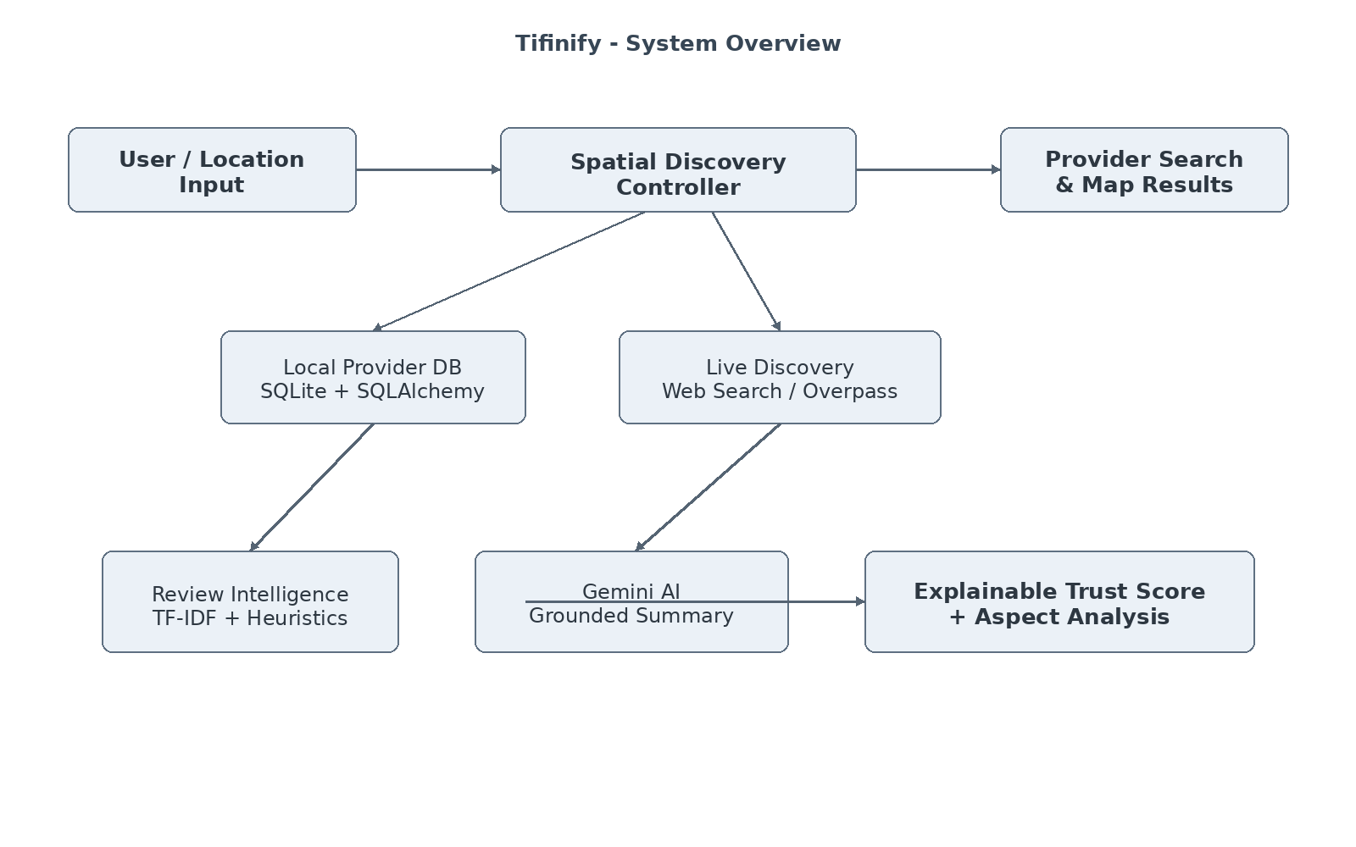

8. PROPOSED SYSTEM - ANALYTICAL MODEL

8.1 Multi-Criteria Review Trust Evaluation Model
Tifinify's scoring engine computes a composite Trust Score based on four weighted pillars:
- Review Text Diversity & Uniqueness (35%): Penalizes identical or near-duplicate phrasing detected through TF-IDF cosine similarity.
- Rating-Sentiment Consistency (25%): Detects cases where numerical ratings conflict strongly with review sentiment.
- Temporal Distribution & Burst Analysis (20%): Flags suspicious clusters of reviews published within an unusually short timeframe.
- Reviewer Volume & Profile Credibility (20%): Considers sample size and distribution balance.

8.2 Real Business Search Intelligence Pipeline
- Queries search engine indices for active local tiffin listings using targeted keywords.
- Queries OpenStreetMap Overpass for registered food-related amenities.
- Sanitizes extracted business titles and removes directory-portal noise.
- Persists discovered businesses into SQLite and triggers review analysis.

8.3 AI and Grounded Fallback Flow
Primary AI Flow: Gemini AI generates contextual review summaries and can assist discovery through grounded search.
Fallback Flow: If Gemini API access is unavailable or quota is exhausted, deterministic local NLP heuristics and web-search processing continue supported functions.

9. MODULES

9.1 Authentication & User Preferences Module
Manages registration, login, session persistence, role assignment, dietary preferences, and search-radius defaults.

9.2 Spatial Discovery & Multi-Radius Search Module
Performs Haversine calculations and supports 1 km, 3 km, 5 km, and 10 km filters along with dietary type, category, rating, and price filters.

9.3 Real-World Web & Overpass Search Intelligence Module
Discovers local providers from public web information and OpenStreetMap Overpass without requiring paid mapping billing.

9.4 Gemini AI Contextual Review Intelligence Module
Uses Google Gemini to synthesize concise, objective summaries of customer experiences.

9.5 TF-IDF Similarity & Duplicate Detection Engine
Transforms review texts into TF-IDF feature matrices and computes pairwise Cosine Similarity. The source specification marks pairs above 0.85 similarity as suspicious.

9.6 Behavioral Heuristics & Sentiment Inconsistency Module
Scans review text for contradictions between numerical ratings and complaint or praise language.

9.7 Aspect-Based Extraction & Scoring Module
Analyzes review sentences across food-service dimensions such as Taste, Hygiene, Quality, Delivery, and Value for Money.

9.8 Explainable Trust Badge & Rating Separation Module
Assigns normalized Trust Scores from 0–100 and presents understandable trust badges.

9.9 Side-by-Side Provider Comparison Module
Allows users to compare selected providers by distance, pricing, aspect satisfaction, and review trust.

9.10 Interactive OpenMaps / Leaflet Mapping Module
Renders OpenStreetMap tiles, provider markers, radius boundaries, and information popups.

9.11 Dark/Light Theme & UI State Engine
Provides persistent theme switching and avoids white-flash during page reload.

9.12 Admin Governance & Telemetry Audit Module
Provides administrative telemetry such as registered users, providers, analyzed reviews, flagged duplicates, and audit logs.

9.13 Automated Testing & Quality Assurance Module
Contains automated tests covering review sanitization, similarity detection, aspect extraction, API routes, and search adapters.

10. IMPLEMENTATION OF DFD (DATA FLOW DIAGRAM)
Data Flow Diagrams illustrate how information moves through Tifinify. The diagrams represent the user, location and provider discovery, review ingestion, AI and local analysis, persistence, and result presentation. The DFD representation focuses on information movement rather than source-code classes or individual screen layouts.

10.1 System Overview DFD
At the highest level, the user supplies search or location information. The system communicates with discovery services, AI services, and the local database before returning provider information, trust metrics, maps, and comparison results.

10.2 Level 0 DFD (Context Level)
The Level 0 DFD presents Tifinify as a single logical system interacting with the User, place-discovery sources, the Gemini AI engine, and the SQLite database. It captures the major external inputs and outputs without decomposing internal modules.
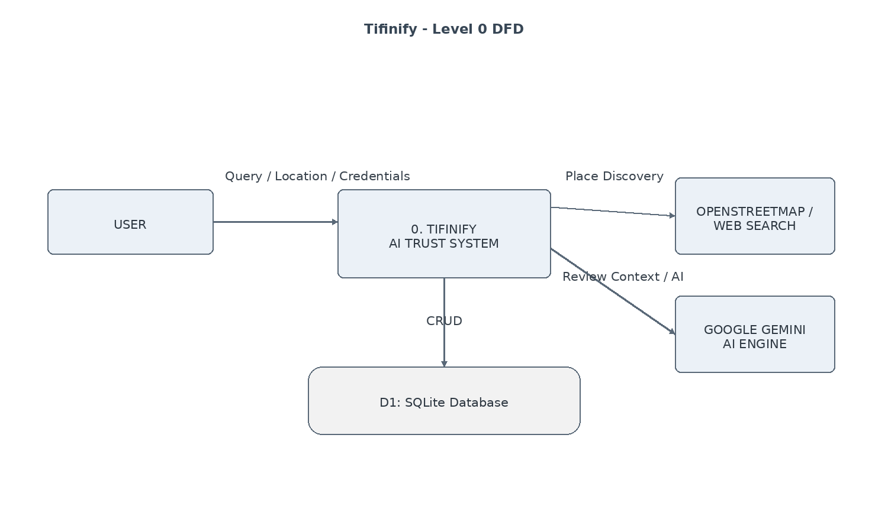
Input flows include query parameters, location information, credentials, review context, and CRUD operations. Output flows include discovered providers, trust findings, map information, and comparison-oriented results.

10.3 Level 1 DFD (Detailed Data Flow)
The Level 1 DFD decomposes the system into authentication, spatial search, real place discovery, review ingestion, NLP and trust scoring, and result presentation processes.
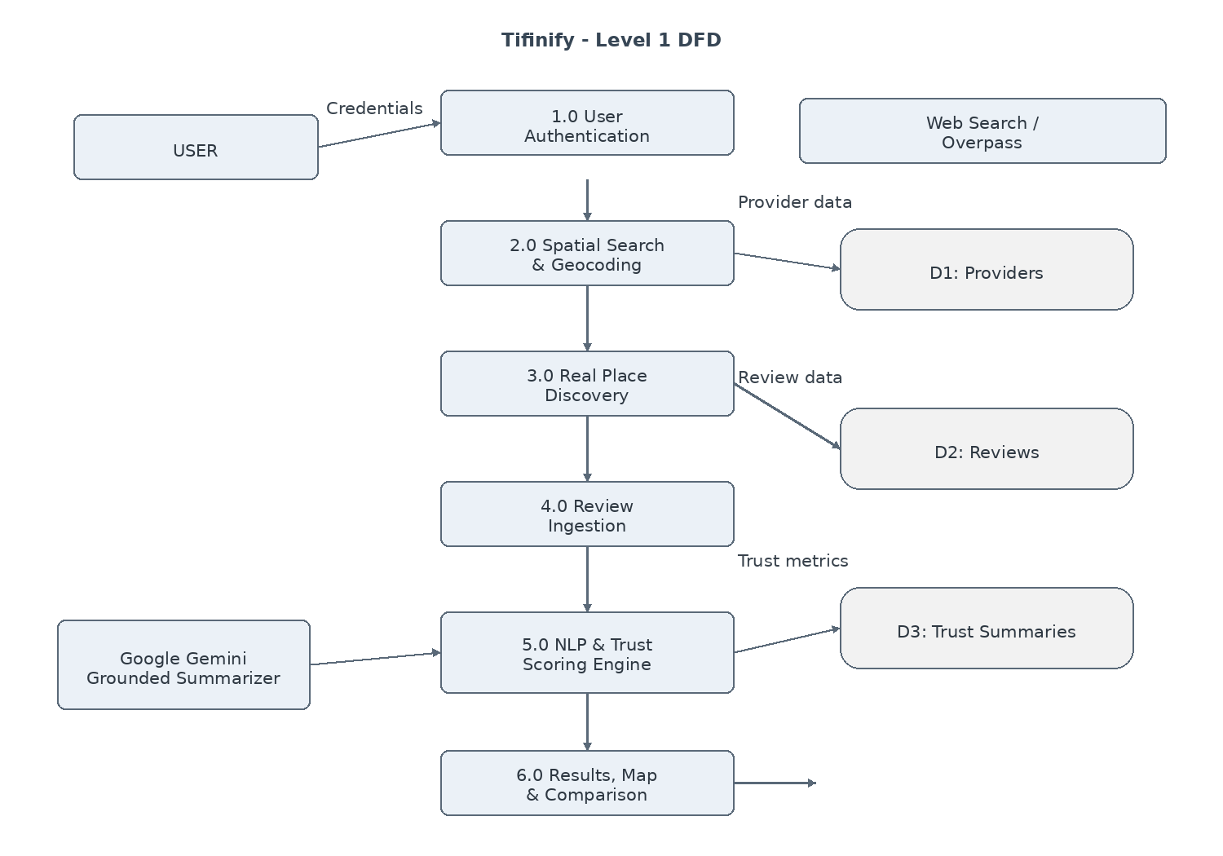

10.4 DFD Interpretation
- Data Flow 1.0: Credentials flow from the user into the authentication controller and are verified against the users datastore.
- Data Flow 2.0 & 3.0: Location parameters are converted into coordinates; the system queries the local providers datastore and may invoke live discovery when required.
- Data Flow 4.0 & 5.0: Review texts flow into the TF-IDF vectorizer and heuristic pipeline, generating trust scores, aspect distributions, and Gemini AI summaries.
- Data Flow 6.0: Computed scores, maps, and comparisons are rendered to the client interface.

11. ER DIAGRAM – DATABASE
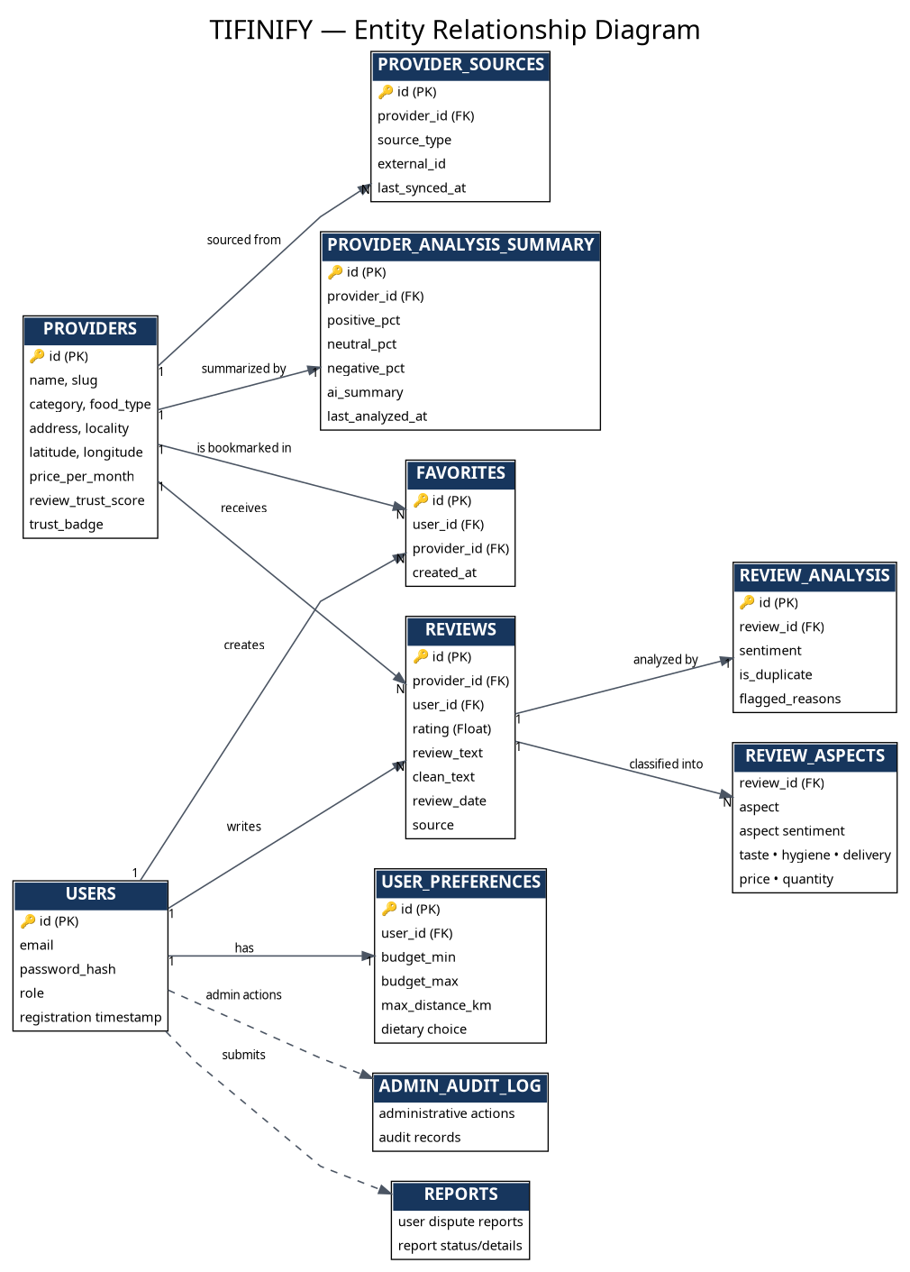
Figure 11.1: TIFINIFY Entity Relationship Diagram

11. ER DIAGRAM – DATABASE (ENTITY DESCRIPTION)

1. Users
Stores account credentials, email, password hash, role, and registration timestamps.

2. UserPreferences
Stores personalized filters such as budget range, dietary choices, and default search radius.

3. Providers
Core entity representing tiffin and mess centers, including business details, coordinates, price, Trust Score, and badge.

4. ProviderSources
Tracks upstream data lineage such as web search, Gemini discovery, manual user input, and OSM Overpass.

5. Reviews
Contains customer feedback, numeric ratings, raw or cleaned review text, source, and timestamps.

6. ReviewAnalysis
Stores NLP audit results including sentiment labels, duplicate flags, and suspicion reasoning.

7. ReviewAspects
Stores normalized aspect sentiment tags such as taste, hygiene, delivery, price, and quantity.

8. ProviderAnalysisSummary
Aggregates provider-level positive, neutral, and negative percentages, AI summary, and audit timestamps.

9. Favorites
Links users to bookmarked providers.

10. Reports & AdminAuditLog
Records user dispute reports and administrative actions.

12. FUNCTIONAL REQUIREMENTS
ID | Requirement | Description
FR-1 | User Authentication | Secure registration, login, logout, and password hashing.
FR-2 | Location Geolocation | GPS detection, IP-based fallback, and text forward-geocoding.
FR-3 | Multi-Radius Search | Filtering across 1 km, 3 km, 5 km, and 10 km boundaries.
FR-4 | Real Place Ingestion | Live querying of actual tiffin establishments through Web Search and OpenStreetMap Overpass.
FR-5 | Review Trust Scoring | 0–100 Trust Score based on duplicate detection, rating-sentiment agreement, and burst analysis.
FR-6 | Aspect Breakdown | Sentence-level extraction and scoring of hygiene, taste, quality, delivery, and value for money.
FR-7 | Grounded AI Summarization | Concise customer-experience summaries using Google Gemini AI.
FR-8 | Side-by-Side Comparison | Structured comparison of selected providers.
FR-9 | Geospatial Map Plotting | Interactive Leaflet.js map with category pins and information popups.
FR-10 | Dark Mode Toggling | Persistent client-side dark/light mode.
FR-11 | User Bookmarking | Logged-in users can save favorite providers.
FR-12 | Administrative Telemetry | Dashboard for platform health, flagged reviews, and provider audits.

13. NON-FUNCTIONAL REQUIREMENTS
- NFR-1: Usability - Modern, responsive interface with clear typography and touch-friendly controls.
- NFR-2: Performance - Spatial queries and local NLP similarity computations are intended to complete rapidly under normal workloads.
- NFR-3: Resilience & Fault Tolerance - External service failures should trigger fallback processing without crashing the application.
- NFR-4: Security - Protection against SQL Injection through parameterized queries, XSS, and CSRF controls.
- NFR-5: Privacy - User location should be processed with privacy-conscious handling and should not be unnecessarily retained.
- NFR-6: Maintainability - Modular Flask Blueprints and independent service classes.
- NFR-7: Testability - Automated pytest tests for important modules and integrations.

14. METHODOLOGY
- Phase 1: Domain Analysis & Problem Formulation - Study student meal challenges and common review-manipulation patterns.
- Phase 2: Mathematical Modeling & Trust Architecture - Formalize the 4-pillar MCDA Trust Score, TF-IDF thresholds, and aspect dictionaries.
- Phase 3: Database & Core Service Layer - Construct the SQLite schema, SQLAlchemy models, and Haversine geospatial modules.
- Phase 4: Real-World Place Intelligence - Develop web-search and OpenStreetMap Overpass adapters.
- Phase 5: Generative AI & Grounding Pipeline - Integrate the google-genai SDK for grounded review synthesis and AI-assisted discovery.
- Phase 6: Frontend Development & Geospatial Mapping - Implement Bootstrap templates, Leaflet interactions, and theme handling.
- Phase 7: Automated Testing & Verification - Validate NLP algorithms, database operations, and API endpoints through pytest.
- Phase 8: Cloud Deployment Packaging - Prepare Procfile and render.yaml configuration for cloud deployment.

15. DATABASE DETAILS AND DATA INTEGRITY
Tifinify utilizes SQLite 3 managed through SQLAlchemy 2.0 ORM. SQLite provides lightweight serverless storage while maintaining a clear relational model suitable for an academic web application.

15.1 Data Integrity and Security
- Relational Integrity: Foreign key constraints and cascading behavior prevent orphaned dependent records.
- Entity Uniqueness: Unique provider slugs and user email constraints reduce duplicate records.
- Input Sanitization: SQLAlchemy parameterized queries reduce SQL Injection risk.
- Password Hashing: Credentials use modern salted one-way password hashing.
- Data Lineage Tracking: Provider and review records retain source information to trace digital origin.

16. EXPECTED OUTCOMES
- A fully functional, responsive web application for discovering tiffin and mess services.
- An operational AI Review Trust Engine for identifying suspicious review patterns.
- Dynamic business discovery across multiple localities without depending exclusively on paid Google billing.
- Clear separation between raw star ratings and explainable review trust scores.
- Interactive map visualization with custom category pins and dark-theme support.
- A side-by-side comparison tool for consumer decision support.
- Automated test coverage for important application functions.
- Deployment-ready project configuration.

17. ADVANTAGES
- Objective Review Verification: Reduces reliance on easily manipulated star averages by adding mathematical trust signals.
- Zero Commercial API Costs: Uses open mapping/search resources and configurable AI access to minimize cost.
- Transparent Explainability: Users can inspect positive and warning signals behind a trust assessment.
- Actionable Aspect Breakdowns: Separates important food-service dimensions rather than presenting one opaque number.
- High Fault Tolerance: Fallback architecture helps prevent external API outages from crashing the platform.
- Student & Bachelor Focused: Designed around recurring food subscriptions rather than one-time restaurant dining.

18. LIMITATIONS
- Web Search Heuristics: Discovery accuracy depends on public web listings and OpenStreetMap coverage.
- Client-Side Geolocation Accuracy: Precision varies according to device and available location signals.
- Gemini Free-Tier Rate Limits: Heavy usage may encounter temporary service limits depending on the configured API access.
- English Language Focus: Current NLP keyword extractors are optimized for English and transliterated Hindi/Hinglish food terminology.

19. FUTURE SCOPE
- Direct Online Subscriptions: Introduce digital payment gateway integration for monthly meal subscriptions.
- Daily Menu Publishing: Provide vendor portals for publishing lunch and dinner menus.
- Multilingual NLP: Extend review trust and aspect extraction to Hindi and other Indian languages.
- Mobile Native Applications: Package the responsive web system into Android and iOS applications.
- IoT Smart Kitchen Hygiene Badging: Explore integration of verified kitchen hygiene certificates and sensor-based evidence.

20. CONCLUSION
Tifinify demonstrates how modern computer science methodologies spanning full-stack web architecture, natural language processing, machine learning heuristics, spatial computing, and generative artificial intelligence can be synthesized into an impactful, consumer-centric software product.
The defining achievement of the project is its Explainable Review Intelligence Architecture. By separating raw star ratings from mathematical Review Trust Scores, Tifinify provides additional transparency for students, bachelors, and working professionals evaluating recurring food services.
Furthermore, the project's open-resource discovery design, fallback architecture, responsive dark/light interface, and automated testing approach establish Tifinify as a complete software engineering project suitable for the Master of Computer Application degree.
TIFINIFY
AI-Powered Tiffin & Mess Service Discovery and Review Trust Analysis System

21. REFERENCES
1. Flask Documentation: Pallets Projects - Flask Web Development Documentation (v3.0.x).
2. Google Gemini API Documentation: Google AI for Developers - Gemini API Reference and Python SDK (google-genai).
3. Scikit-Learn Documentation: Machine Learning in Python, including TF-IDF and Cosine Similarity.
4. SQLAlchemy Documentation: SQLAlchemy 2.0 Unified Documentation.
5. Leaflet.js Documentation: Leaflet - Open-Source JavaScript Library for Mobile-Friendly Interactive Maps.
6. OpenStreetMap & Overpass API: OpenStreetMap Foundation - Overpass API Documentation and Query Guide.
7. Bootstrap Documentation: Bootstrap v5.3 Framework and Color Modes Guide.
8. Jindal, N., & Liu, B. (2008). Opinion Spam and Analysis. Proceedings of the 2008 International Conference on Web Search and Data Mining (WSDM '08), ACM.
9. Manning, C. D., Raghavan, P., & Schütze, H. (2008). Introduction to Information Retrieval. Cambridge University Press.
10. Python Software Foundation: Python 3.11/3.12/3.14 Standard Library and Language Reference.

