Lesson 01 Demo 01
Installing and Setting Up VS Code

Objective: To install and set up VS Code for Python development

Tools required: None

Prerequisites: None

Steps to be followed:
- Install VS Code
- Set up VS Code

Step 1: Install VS Code

- Download the required version of VS Code from the official website:
https://code.visualstudio.com/download

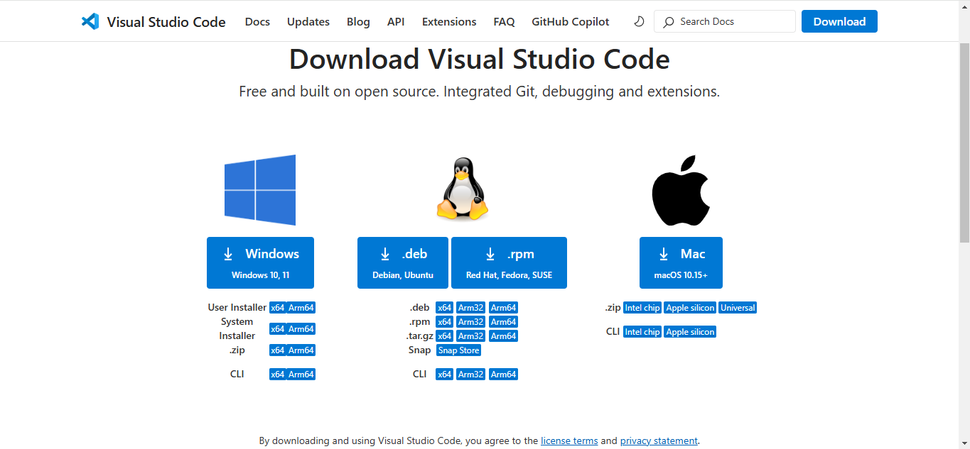

Note: Choose the appropriate download option based on your device's operating system. For this demo, we will use the Windows version. After the download is complete, navigate to the Downloads folder on your device, locate the file, and double-click it to begin the installation process.

Step 2: Set up VS Code

  - When the installer opens, accept the License Agreement and click Next to continue

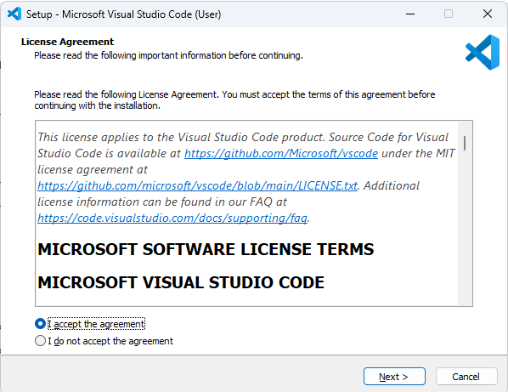

  - Keep the default installation location and click Next to proceed

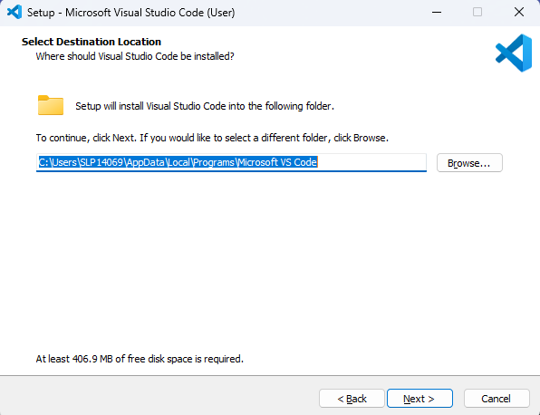

  - Keep the default Start Menu Folder name and click Next

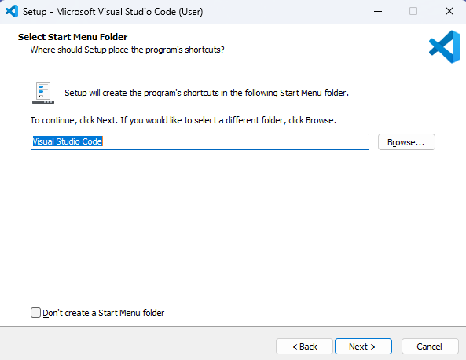

  - Optionally, you can select the boxes highlighted below. Then, click Next to proceed.

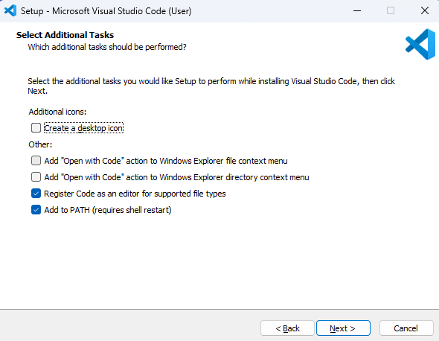

2.5 Check the installation options and then click Install

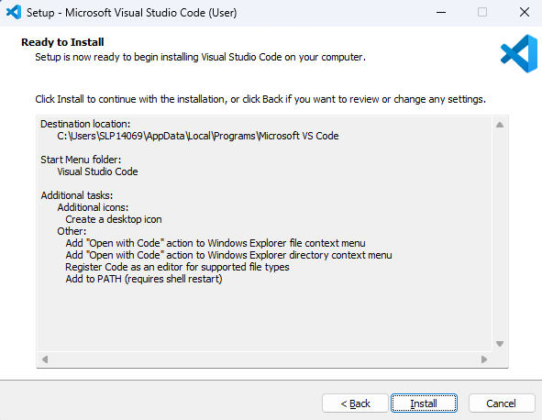

  - Once the installation is complete, click Finish to exit Setup and launch Visual Studio Code

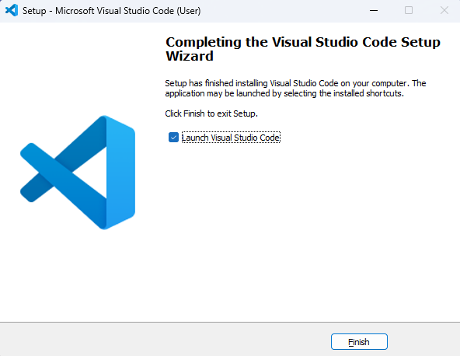

By following these steps, you have successfully installed and configured VS Code for Python programming.

