Lesson 01 Demo 02
Installing Jupyter Notebook Using Anaconda

Objective: To install Jupyter Notebook through the Anaconda distribution for Python development

Tools required: None

Prerequisites: None

Steps to be followed:
- Install Jupyter Notebook

Step 1: Install Jupyter Notebook

- The latest or required version of Jupyter Notebook can be installed using Anaconda Distribution: https://www.anaconda.com/products/distribution


Note: Click on Skip registration below the Submit button to proceed

- Click on the Download button for Windows



Note: For Mac and Linux, scroll down and select the required operating system

- Locate the downloaded .exe file and double-click on it. A pop-up window for installation will appear. Click Next to proceed.

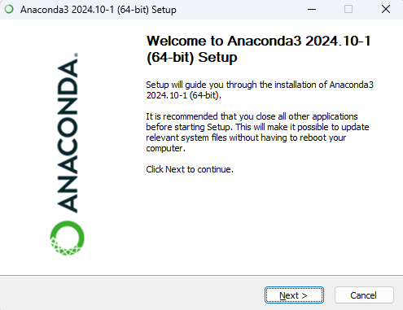

- Review the License Agreement and click I Agree to proceed with the installation

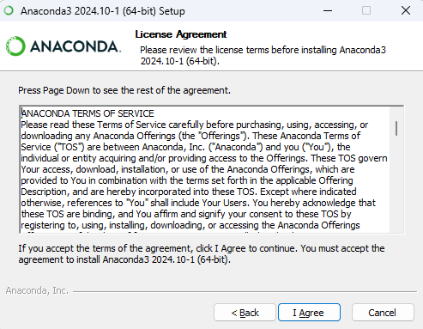

- Choose the Just Me (recommended) option and click Next to continue

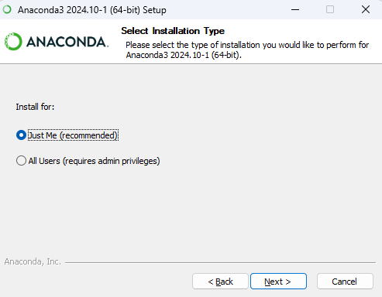

- Choose the folder you want to install Anaconda in and then click Next to continue

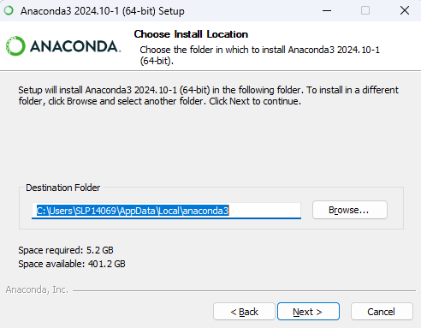

- Choose the selected options as shown below and then click Install to start the installation process:

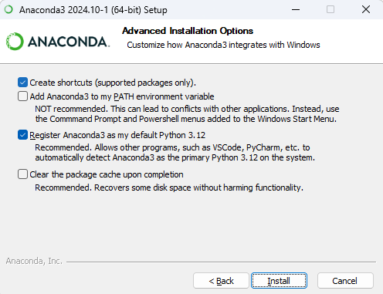

- Select the Launch Anaconda Navigator option and click Finish

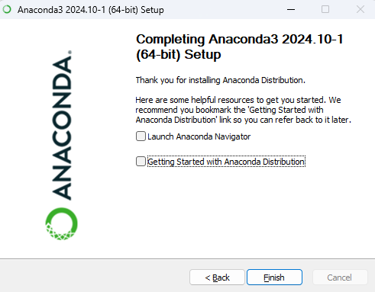

- When the Anaconda Navigator application opens, click Launch under Jupyter Notebook to open it

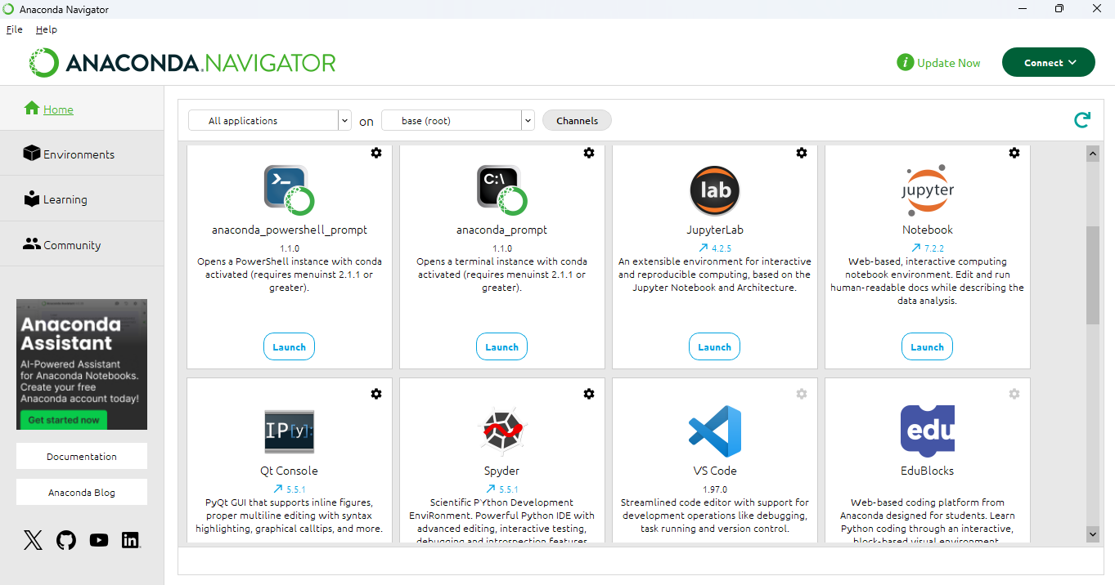

By following these steps, you have successfully installed Jupyter Notebook via Anaconda, setting up an interactive and user-friendly environment for writing and executing Python code.

