Lesson 01 Demo 03
Setting Up Google Colab Notebook

Objective: To set up a Google Colab notebook for writing and executing Python code in a cloud-based environment

Tools required: None

Prerequisites: None

Steps to be followed:
- Sign in to Google Colab and set up a notebook

Step 1: Google Colab sign-in and setup

- Open the following link and click on Sign in: https://colab.research.google.com/
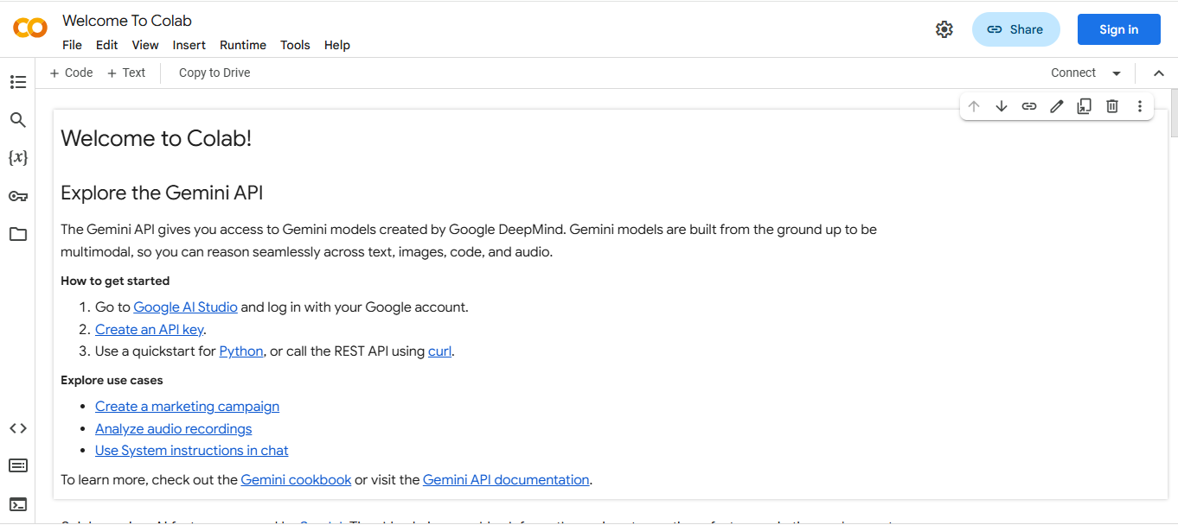
Note: Google Colab requires no installation as it is an online code editor notebook.

- Enter your Google login credentials and click Next

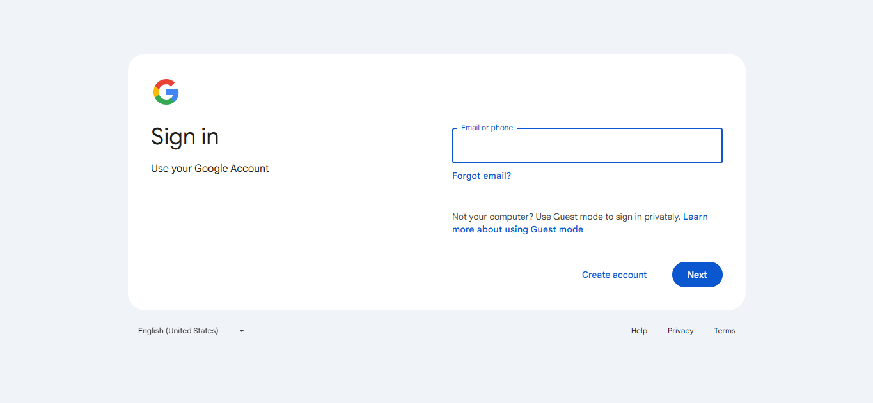

- Click on + New notebook

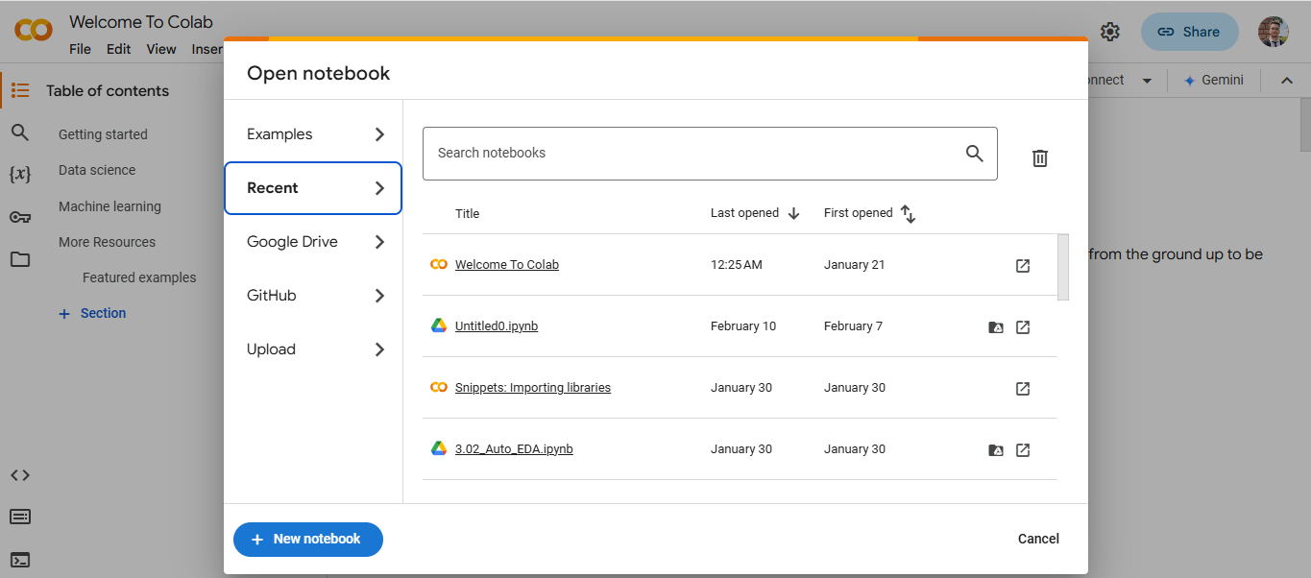

- A notebook named Untitled1.ipynb will open. Within the cell, you can write your Python scripts.

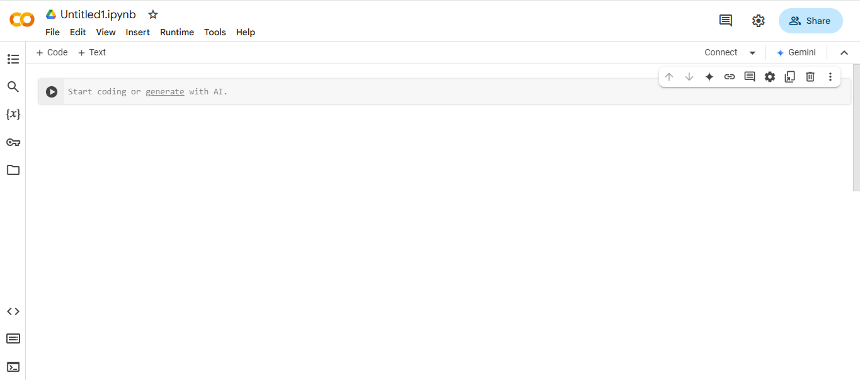
Note: Whenever you open a notebook, remember to click on Connect to establish a connection between the notebook and the server.

By following these steps, you have successfully set up a Google Colab notebook to write and execute Python code seamlessly in the cloud.

