Lesson 01 Demo 04
Writing and Running a Python Program

Objective: To demonstrate Python’s basic syntax while introducing user input and the print function, establishing a foundational understanding of how Python executes code

Tools required: Google Colab

Prerequisites: None

Steps to be followed:
- Open Google Colab and create a new notebook
- Write and execute Python code

Step 1: Open Google Colab and create a new notebook

- Open Google Colab: https://colab.research.google.com/

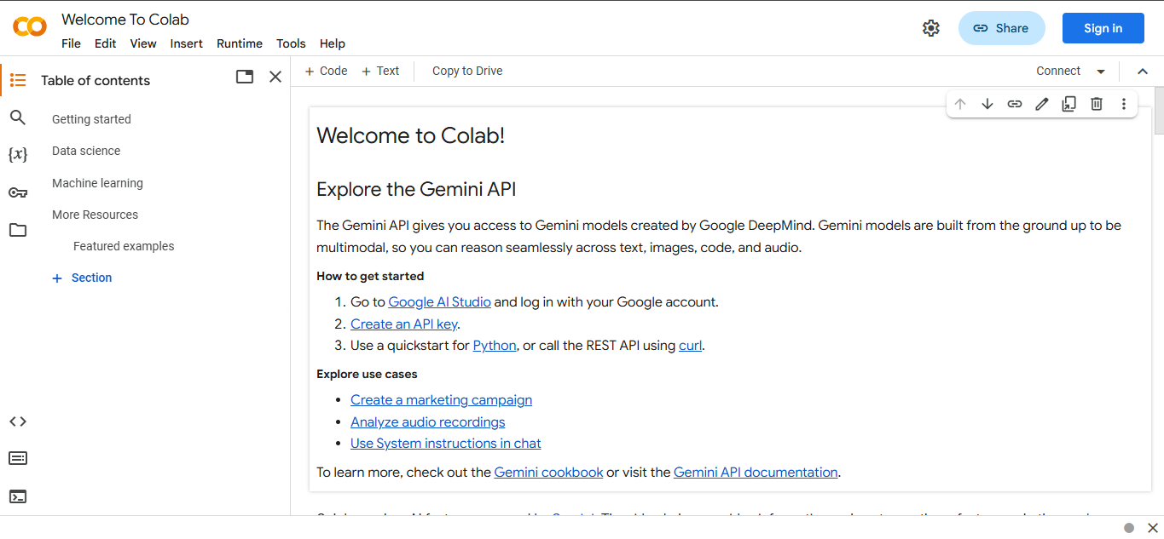

- Click on New notebook

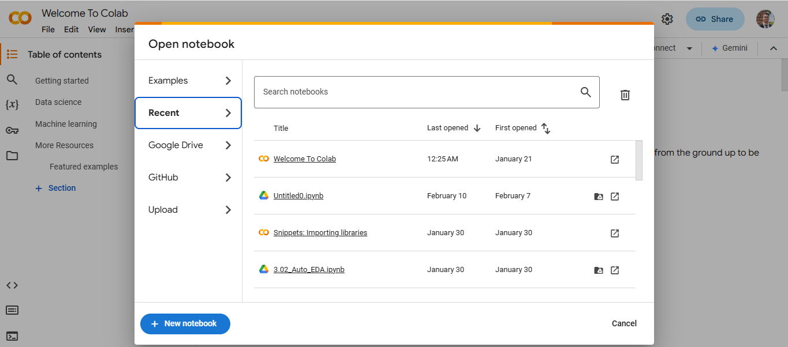

- In the top left corner, rename the notebook as My_first_python_program

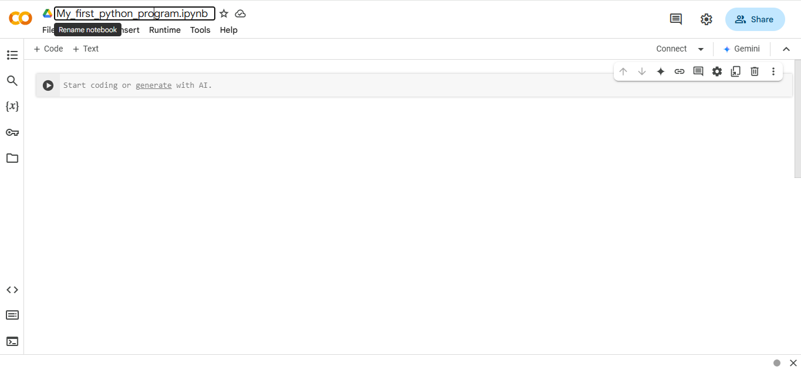

Step 2: Write and execute Python code

  - Write the following code to print a simple output:
print(“Hello, World! Welcome to Python.”)

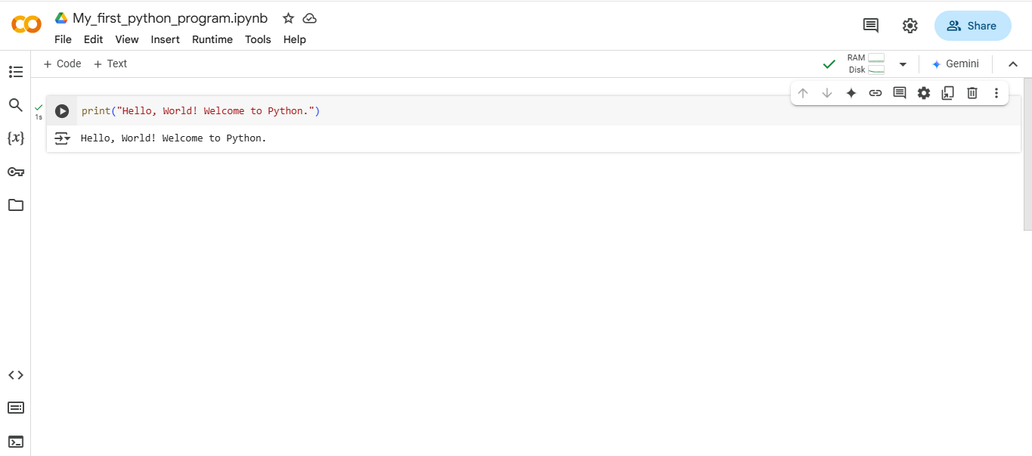

  - Hover the cursor over the old cell and click on + Code to add a new cell in the notebook

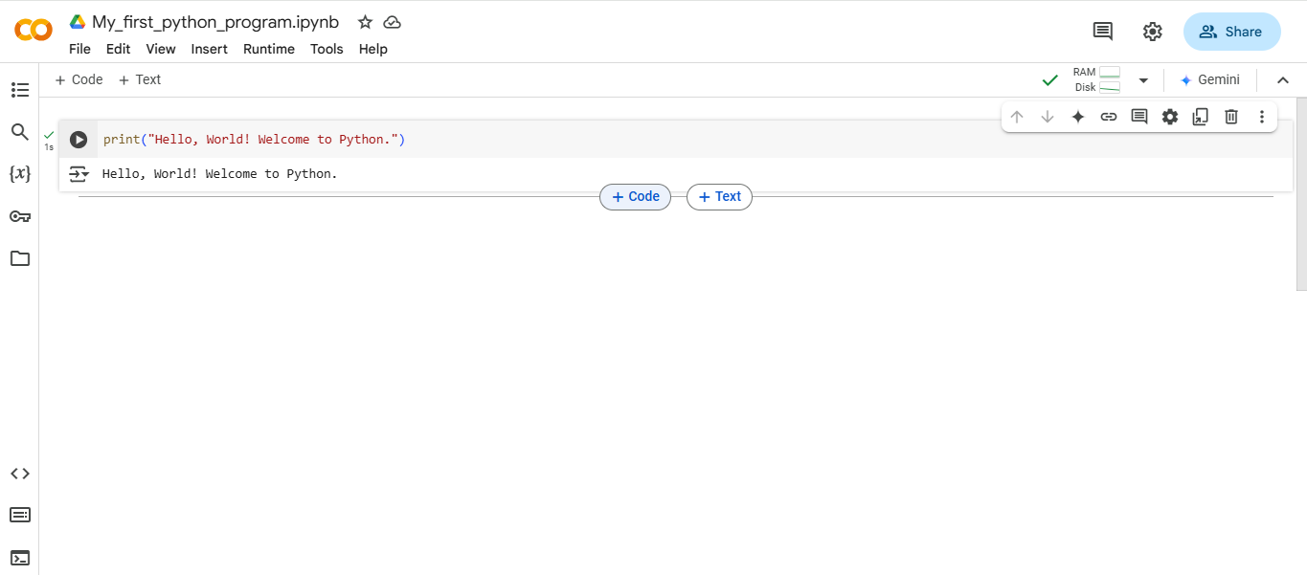

  - In the new cell, write the following code to see how comments work:

# This is a single-line comment
print("Single-line comments are useful for explanations.")

'''
This is a multi-line comment.
It can be used for documentation.
'''
print("Multi-line comments allow for longer explanations.")

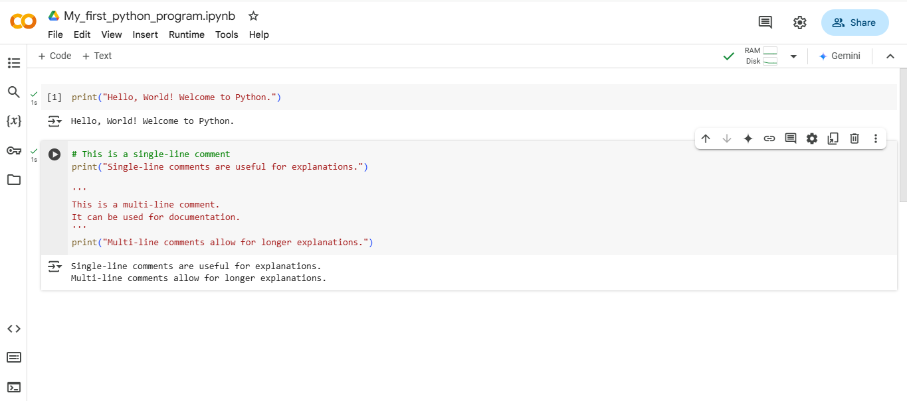

  - Add another new cell, write the following code for user input, and run the cell:

name = input("Enter your name: ") # Taking input from the user
print("Hello, " + name + "! Welcome to Python programming.")

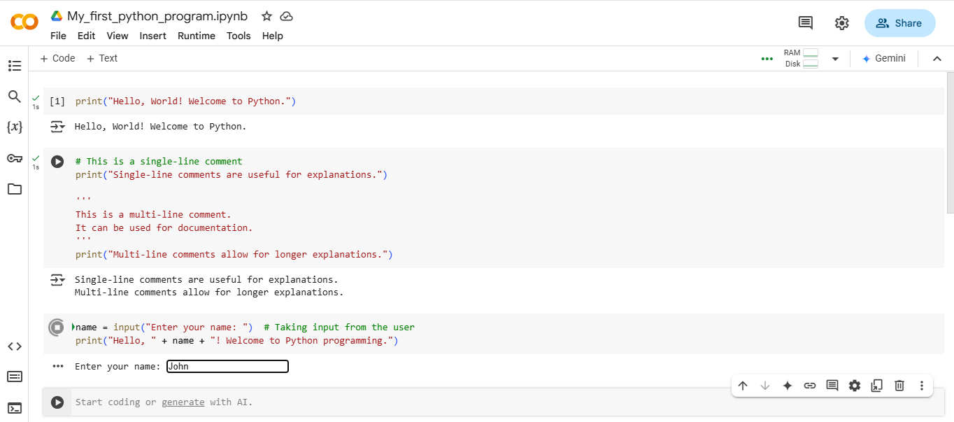

Type your name inside the box when prompted.
  - Press enter, and you will see the following output based on your input:

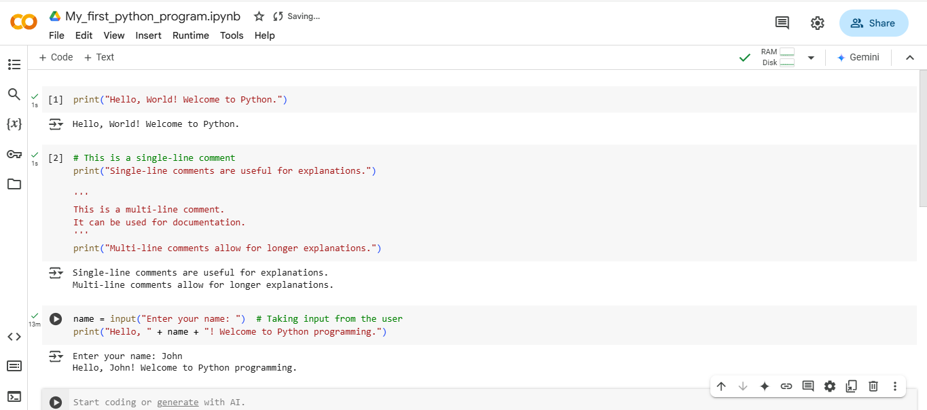

By following these steps, you have successfully written and executed Python code in Google Colab to print output, add comments, and take user input.

