Lesson 01 Demo 05
Storing User Information Using Different Data Types

Objective: To demonstrate how Python handles different data types, focusing on storing and displaying user input to build a strong foundation for data processing

Tools required: Anaconda Navigator (Jupyter Notebook)

Prerequisites: Basic understanding of Python syntax

Steps to be followed:
- Set up Jupyter Notebook and create a Python file
- Write and run the code

Step 1: Set up Jupyter Notebook and create a Python file

- Open Anaconda Navigator and click on Launch below Jupyter Notebook

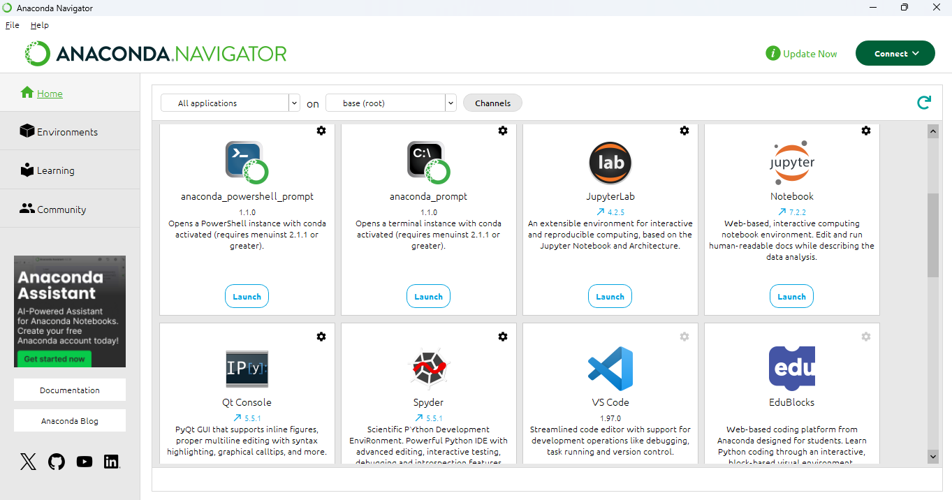

- Once the interface opens, click on New and then on Python 3 (ipykernel) to create a new notebook

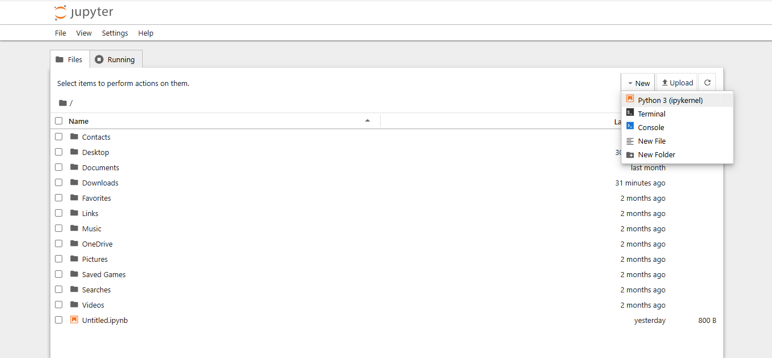

- Click on the title (Untitled1) and rename the notebook to User_Data_Types.ipynb

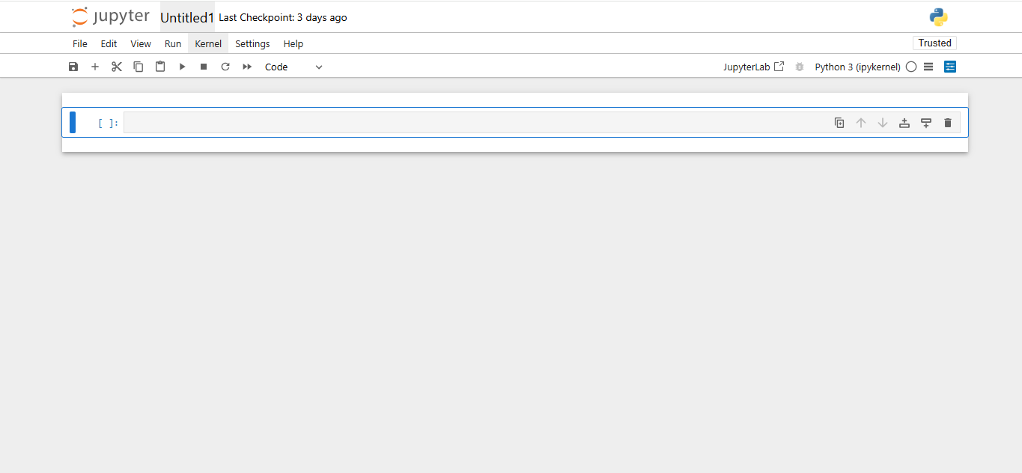

Step 2: Write and run the code

  - In the first code cell of the notebook, write the following script:

# Taking user inputs of different data types
name = input("Enter your name: ") # String input
age = int(input("Enter your age: ")) # Integer input
height = float(input("Enter your height in meters: ")) # Float input
active = input("Are you active? (yes/no): ").lower() == "yes" # Boolean input

# Displaying the stored information
print("\nUser Information:")
print(f"Name: {name} (Type: {type(name)})")
print(f"Age: {age} (Type: {type(age)})")
print(f"Height: {height} meters (Type: {type(height)})")
print(f"Active Status: {active} (Type: {type(active)})")

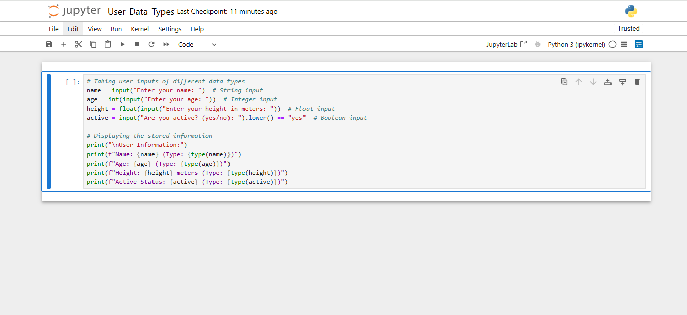

  - Click the Play (▶) button (or press Shift and Enter on your keyboard) to execute the script. Enter the required details when prompted.

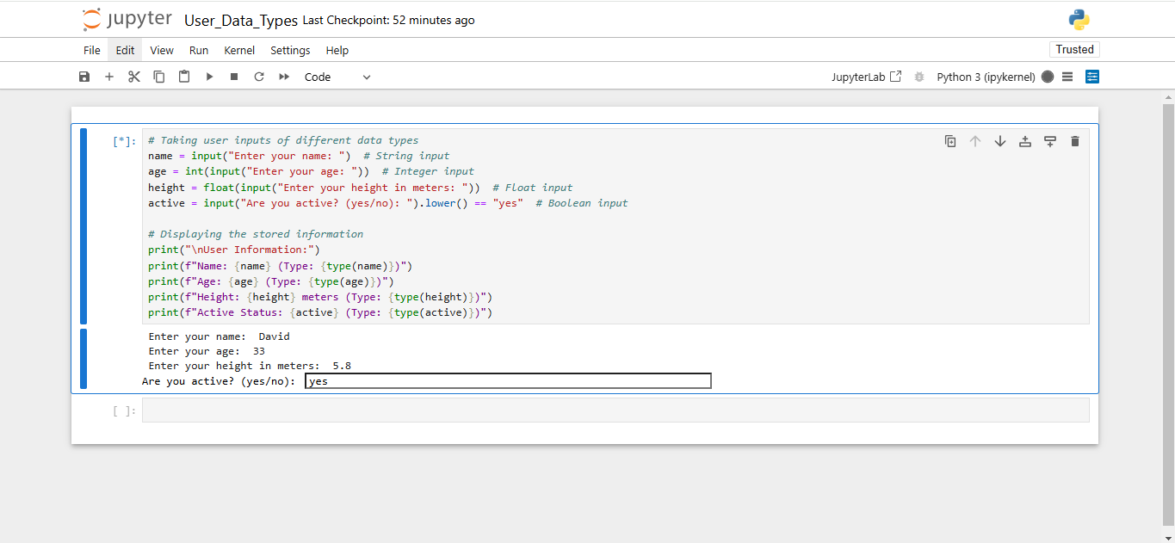

  - Observe the output displaying the values and their respective data types

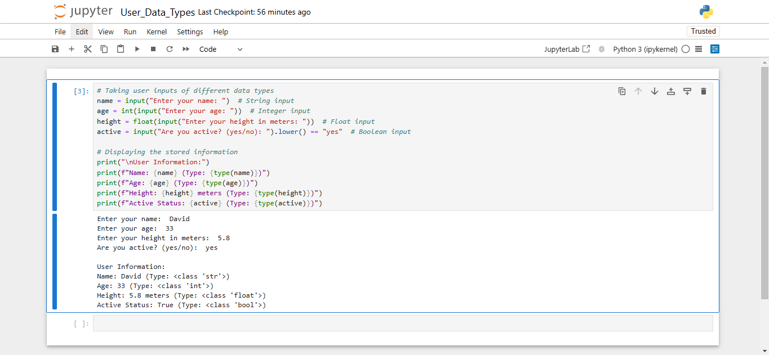

By following these steps, you have successfully explored how Python handles different data types using user input in Jupyter Notebook and how it processes and stores strings, integers, floats, and boolean values.

