Lesson 01 Demo 06
Comparing Numbers Using Python Operators

Objective: To understand how Python's comparison operators work through number comparisons for better decision making in programming

Tools required: Visual Studio Code (VS Code)

Prerequisites: None

Steps to be followed:
- Install the Python extension in VS Code
- Create a Python file in VS Code
- Write and run the code

Step 1: Install the Python extension in VS Code

- Launch the VS Code application on your system
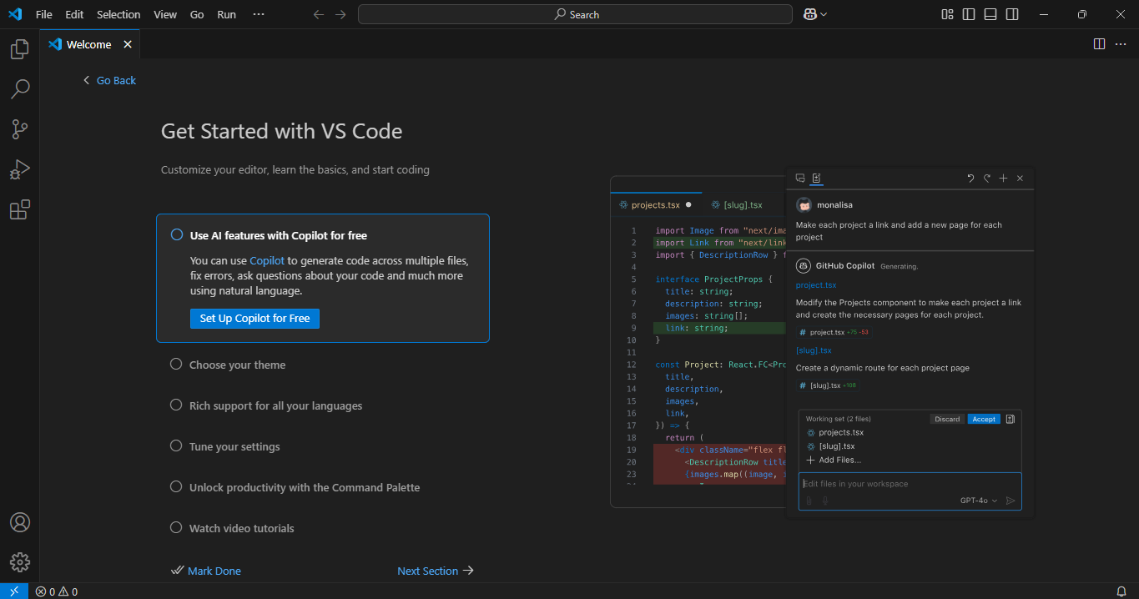

Note: If you don’t have VS Code installed, download it from https://code.visualstudio.com/

- Click on the Extensions icon (or press Ctrl + Shift + X on your keyboard), type Python in the search bar, and select the Python extension by Microsoft

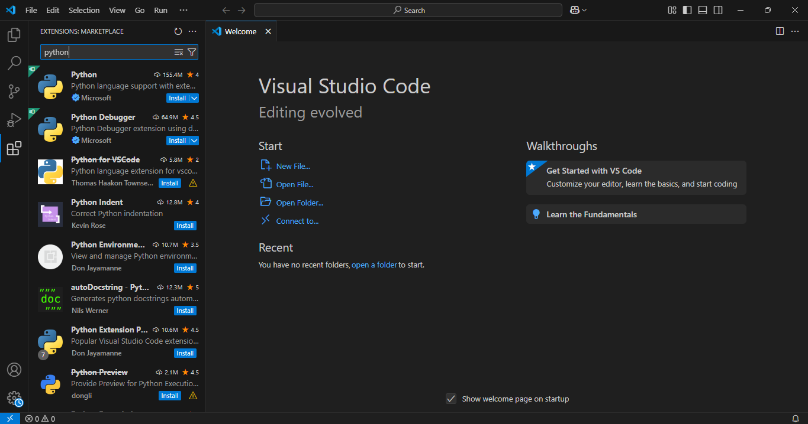

- Click on Install to enable Python support inside VS Code
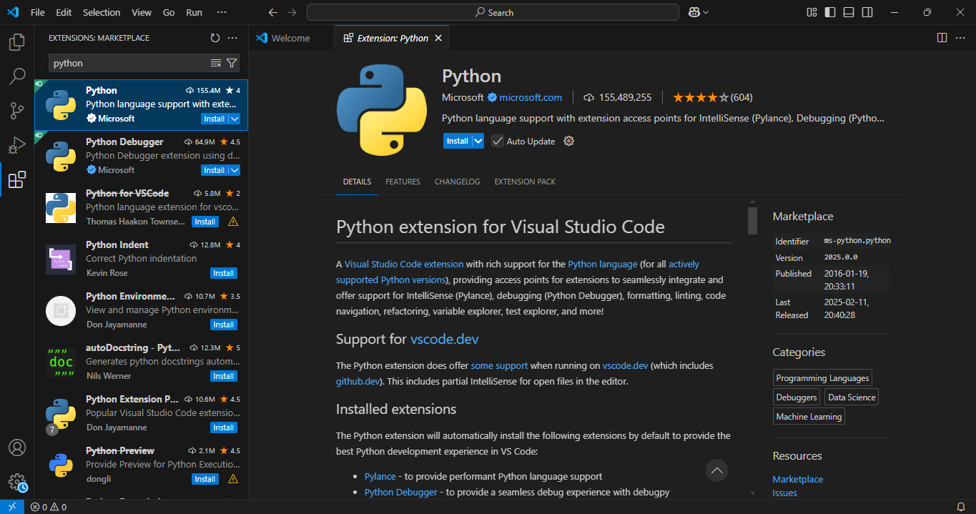

Step 2: Create a Python file in VS Code

  - Click on File and then on New File…

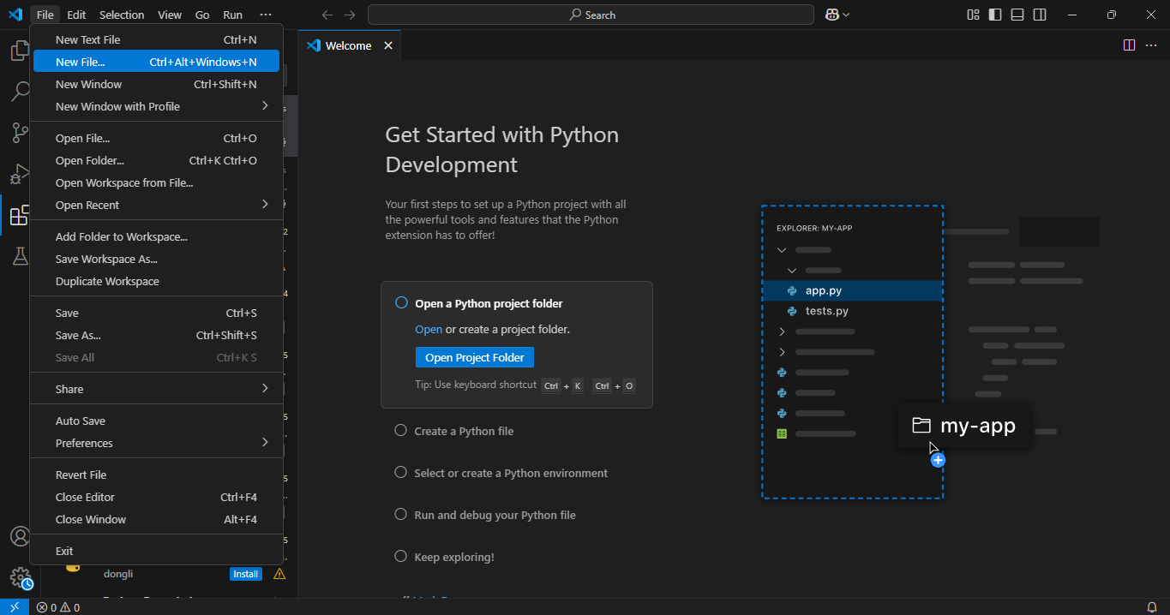

  - Select the Python File option on top, and a new Python file named Untitled-1 will open

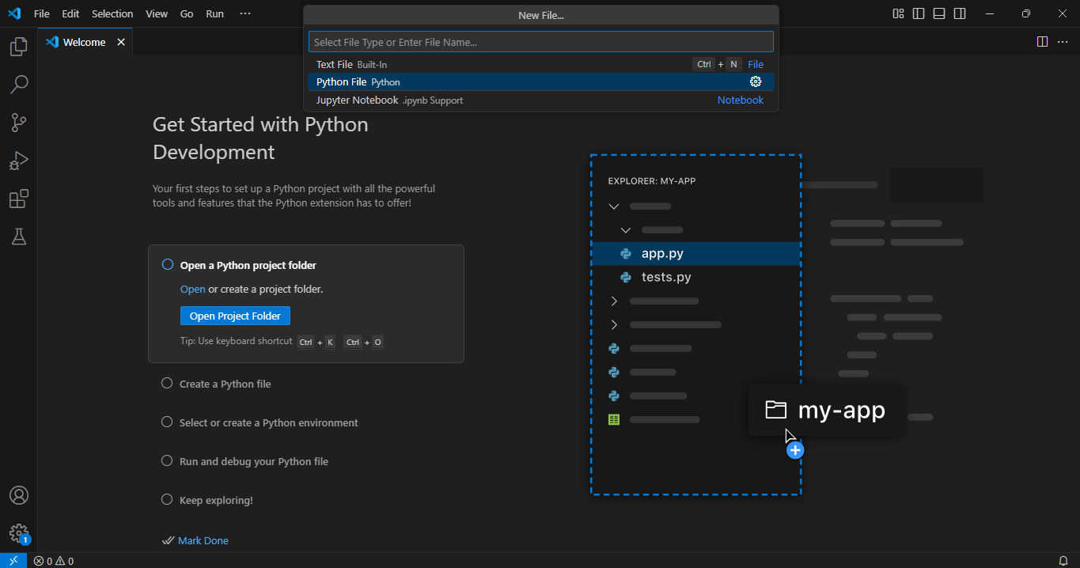

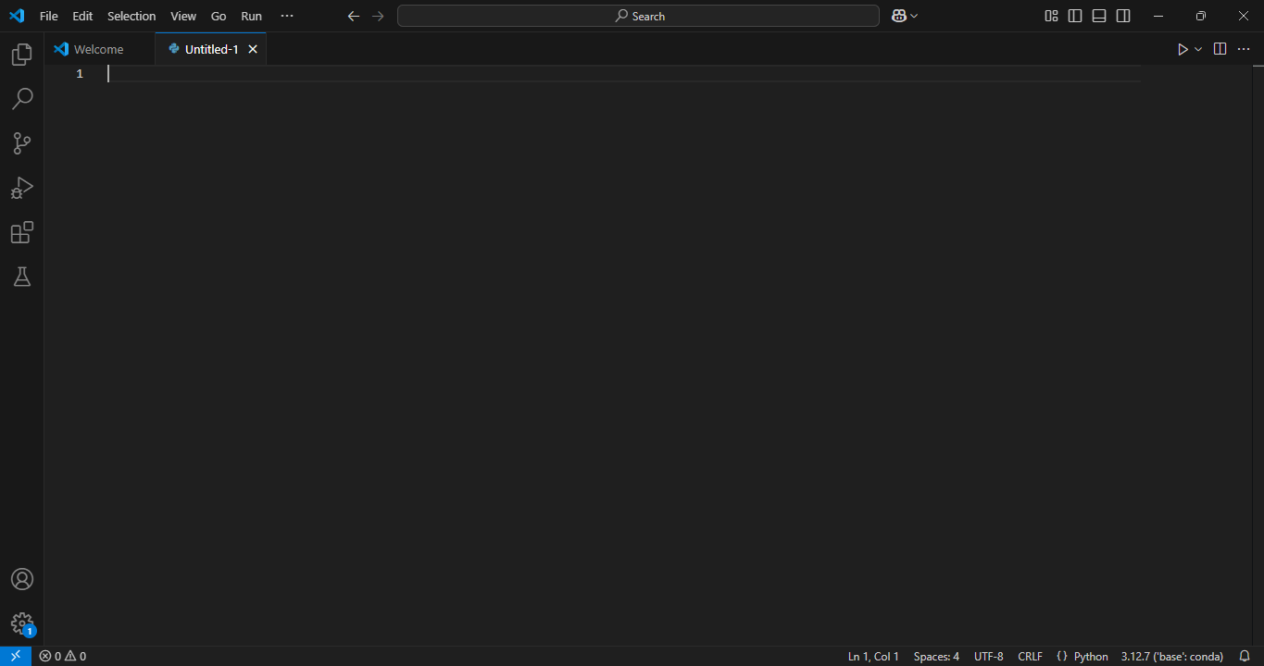

Step 3: Write and run the code

- Write the following Python script in the Untitled-1.py file:

# Taking two numbers as input from the user
a = int(input("Enter first number: "))
b = int(input("Enter second number: "))

# Applying comparison operators and displaying results
print(f"{a} > {b} :", a > b)
print(f"{a} < {b} :", a < b)
print(f"{a} >= {b} :", a >= b)
print(f"{a} <= {b} :", a <= b)
print(f"{a} == {b} :", a == b)
print(f"{a} != {b} :", a != b)

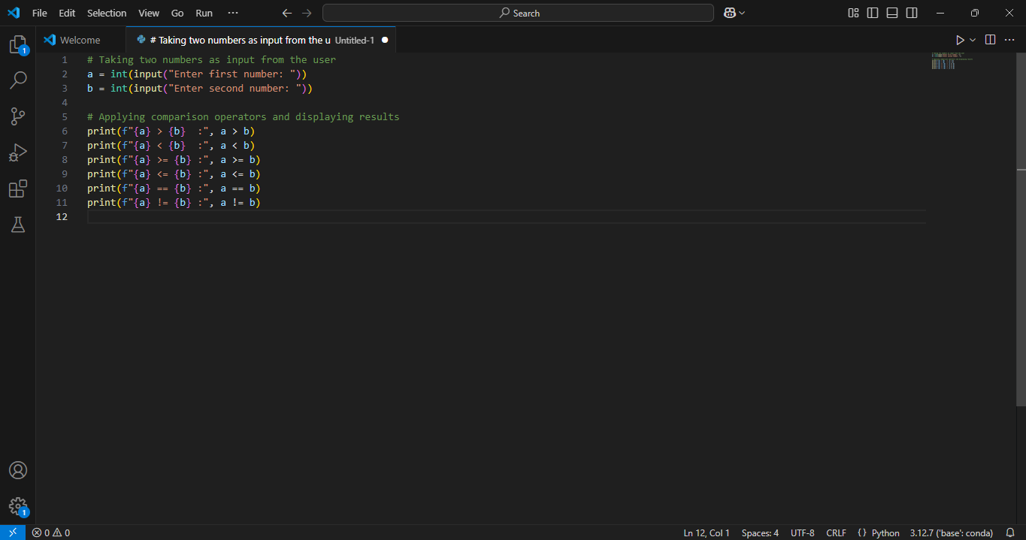

- Click File and then Save As. Name the file as comparison_operators and click on Save.

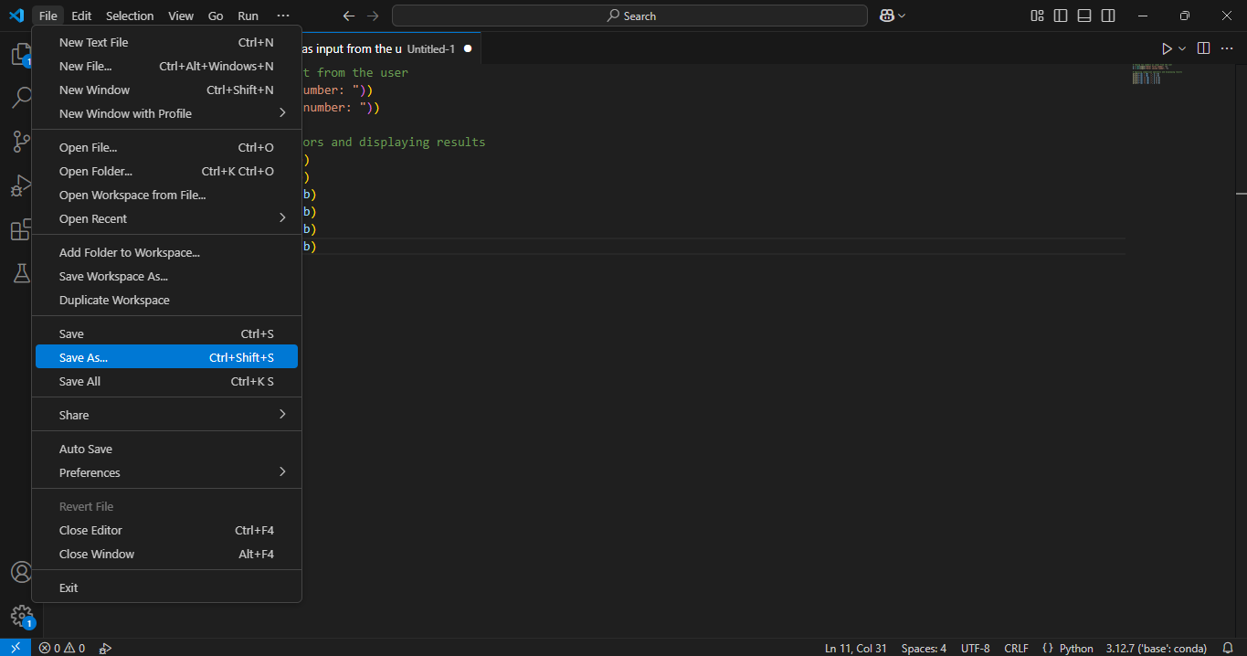
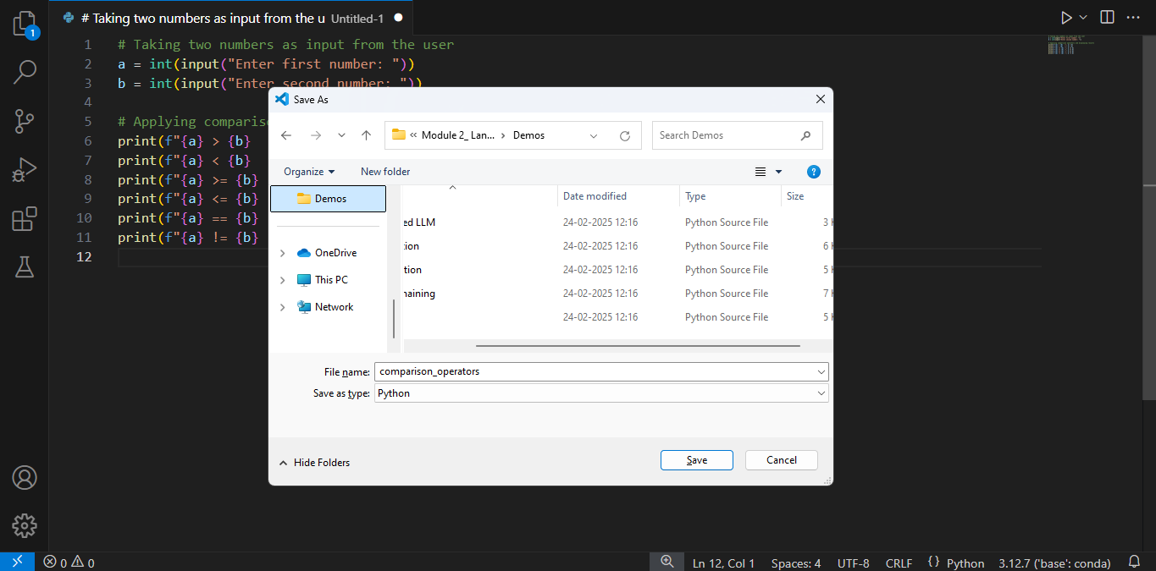

- After saving the file, click the Play (▶) button at the top-right corner to run the script

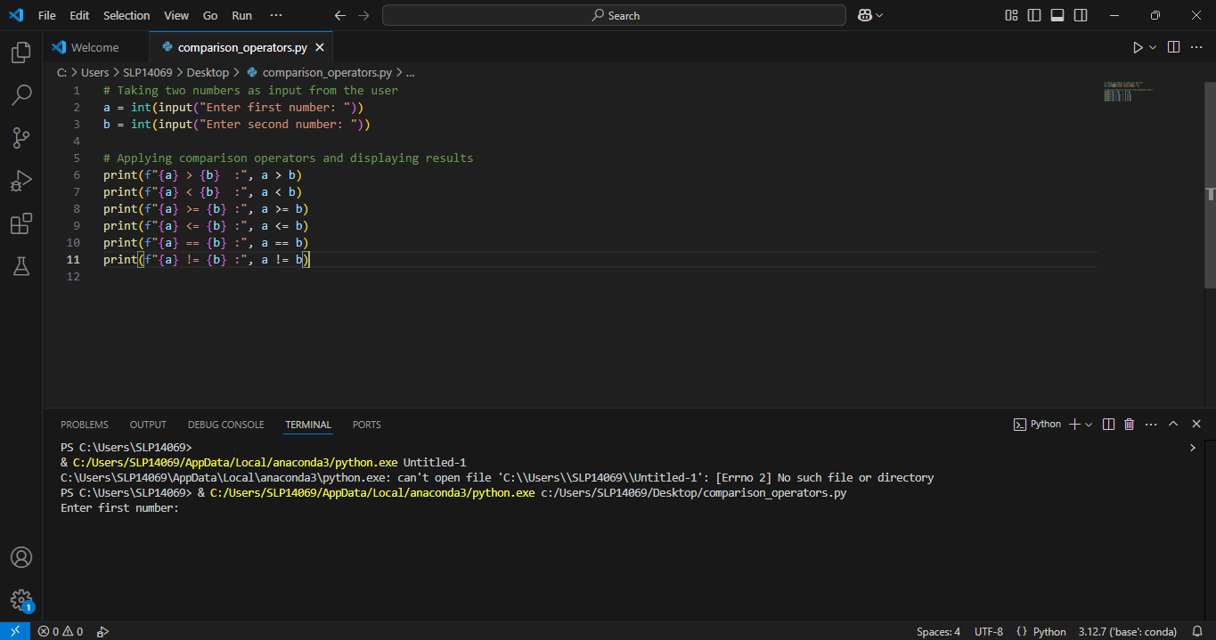

Note: Upon running the script, the integrated terminal in VS Code will open and display the script's output. If there are any syntax or runtime errors, they will also appear in the terminal, helping you quickly identify and debug issues in your code.

- When prompted in the terminal, enter two numbers and press enter to see the results

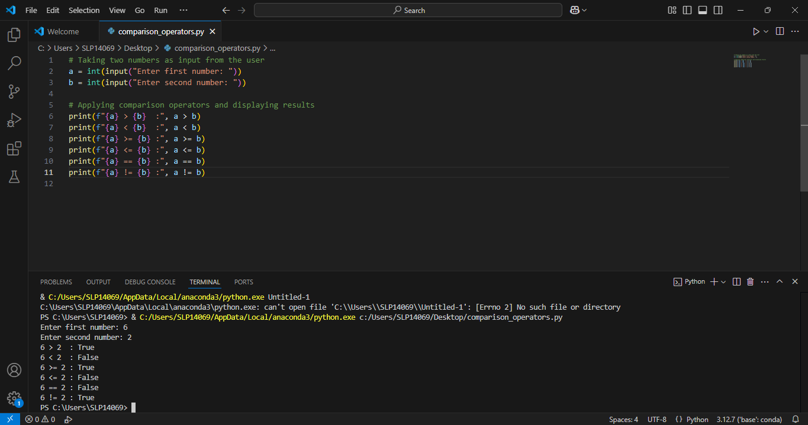

By following these steps, you have successfully explored how Python’s comparison operators work in real time, highlighting its ability to efficiently handle logical comparisons for effective decision-making in programming.

