Dalvi Pranali Bharat.

*Software Engineer.

Contact

Address: Near Jagdamba temple, Sonewadi (Chas).

Tal: Nagar,

Dist:Ahemdnagar

**Phone:**

9529221141

**Email:**

[pranalidalvi8123@gmail.com](mailto:pranalidalvi8123@gmail.com)

Languages

Marathi,English,Hindi

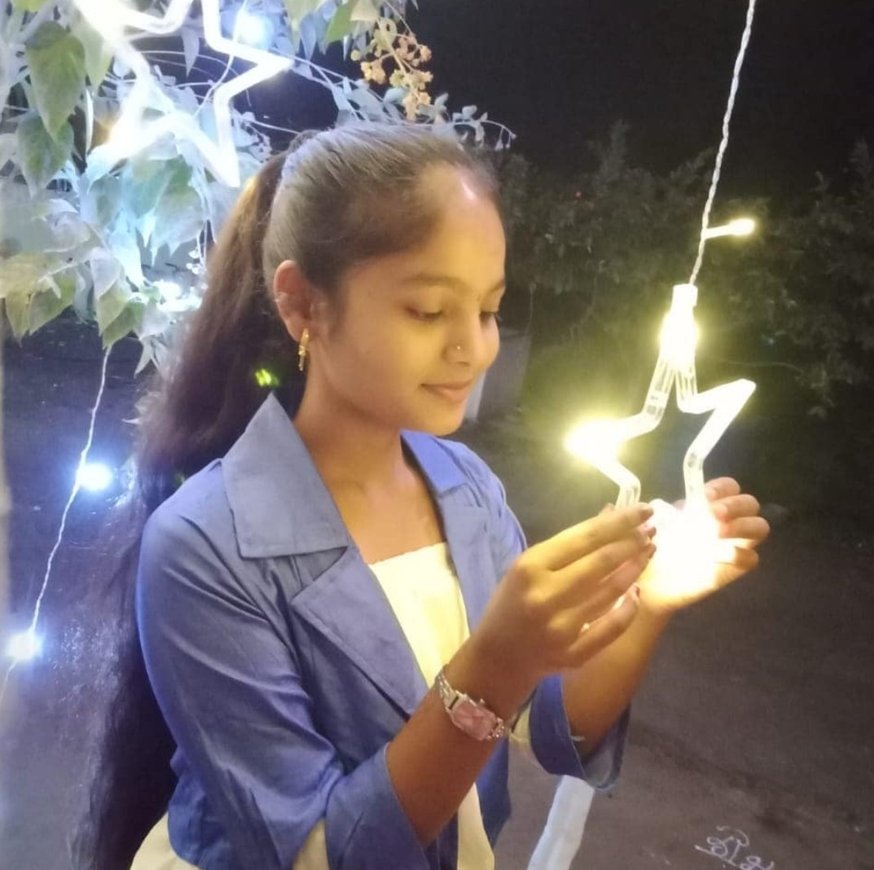

ACADEMIC QUALIFICATION

**Diploma In computer science:**

Government Polytechnic Ahmednagar. Aggregate of percentage till fifth semester: 86.1% (Pursuing)

**10th Grade:** (2018-2019) University of Pune, Maharani Tarabai Kanya Vidyalaya Kedgaon. Percentage:87.20%

**MS-CIT:** (2019)

Balaji Computers Kedgaon in April to May. Percentage:94%.

COMPUTER SKILL

|  |  |
| --- | --- |
| * Project management * Strong decision maker * Complex problem solver | * Completed Maharashtra state certificate in information technology(MSCIT). * Microsoft word, Microsoft power point & Microsoft excel |

SOFTWARE SKILL

**HTML,C,C++,JAVA,PYTHON,CSS,PHP,JS**

Certifications

**C** (certificate):Excel Computers

**C++**(certificate): Excel Computers

**Java**(certificate): Excel Computers

Project

1. Online Food ordering System (css,Html,js)
2. Traffic Signal Control (VB.Net)
3. Bank Account Management System (PHP)
4. Aggrofarm Management System (Css ,Html, Js)
5. Draw a Moving Car (CGR)
6. Hospital Billing System (Java)