BUDDY REFERRAL

Content

1. Introduction
2. Definition
3. Case Study
4. Advantages
5. Disadvantages
6. Conclusion
7. Learning Outcome

Introduction

Employee referral is an internal recruitment method employed by organizations to identify potential candidates from their existing employees. An employee referral scheme encourages a company’s existing employees to select and recruit the suitable candidates from their social networks.

As a reward, the employer typically pays the referring employee a referral bonus. Recruiting candidates using employee referral is widely acknowledged as being the most cost effective and efficient recruitment method to recruit candidates and as such, employers of all sizes, across all industries are trying to increase the volume of recruits through this channel.

Referral recruitment is the development of a recruitment strategy that is dependent on referrals by existing employees. This approach is usually favored when the costs of recruiting needs to be reduced. In recessions the amount of time and money invested in referral schemes often increases due to the perceived frivolousness of other methods of recruiting.

Employee referrals provide better than average candidates because employees know your company culture and have an idea about what employees work successfully in your organization. Employee referrals also reflect on the referring employee who wants to be positively regarded in your organization.

Employee referral scheme’s allows existing employees to screen, select and refer the best candidates to the recruitment process.

**Objective of referral program**

This policy aims to bring candidates with requisite qualification and skills to the organization through employees which help in successful placement of the candidate, where the employee will be awarded on the basis of placement.

**Why employee referral program**?

* In a recent survey, the results on employee referrals are outstanding. The results speak for themselves on why having an employee referral program is vital for every company.
* 40% of all hires are generated by employee referrals. 40% is a large number for one source of hire and it could be even larger with a good employee referral program in place.46% are still working at that company a year later. Thesis good news from companies, as the talent from referrals is top notch.
* The above numbers should be enough to convince you to have an employee referral program in place, but it’s also the most efficient of all other hiring sources. It takes roughly 29 days to fill a position through a referral – 55% faster than any other recruiting source. Not only are employee referral programs efficient, they are a cost saver for the company.
* Referring qualified friends, colleagues or even family can create an excellent source of prospective candidates. Employee referral programs are essentially used by organizations to hire great talent while reducing acquisition time and cost, yet prolonging the duration of employment. In short: employees work with great, trusted talent, the company saves money up front through the recruiting process, and likely increases the return from the specific employee.

**DEFINITION**

: Employee referral is defined as recruitment method in which the current employees are encouraged and rewarded for introducing suitable recruits from among the people they know.

**Brief Note on Employee Referral Program**:

* An effective employee referral program should be an integral part of any employee recruiting process. There are many recruiting sources that can be used perform for your employee recruiting and it is not necessary to limit activities tony single source.
* Referrals from existing employees have been shown to be some of the best employees. A study has shown that employees referred by existing employees better and last longer on average. There are many benefits from a well designed and implemented employee referral program in addition to getting better employees.
* The first area of improvement is significantly reduced costs per hire for bring one employees. Employee recruiting is expensive. Running ads, posting on-line and using head hunters all cost money. In many cases multiple sources will be used to build a candidate pool and the costs add up.
* But giving existing employees a referral bonus can be much more cost effective. There is only one payment. Calculate an amount that is both attractive to your employees and cost effective for the business. A good recommendation is 20-25% of the normal cost per hire number.
* The second benefit of a good program is the program can be a significant morale booster for existing employees. They are much happier when the money spent on recruiting "stays in the family" instead of being spent on outside sources. Existing employees appreciate the opportunity to make more money while helping the company at the same time.

**SIGNIFICANCE OF EMPLOYEE REFERRAL PROGRAM**

* Employee referrals have been accepted as the “number one source of hire “and often the highest caliber, too. And new studies show this trend will likely continue, as organizations rely more heavily on their referral programs.
* The majority of organizations report not only having an employee referral program but also focusing on referrals as a key component of their overall recruitment strategy.
* In addition to incentives, however, it’s also critical to design a program that works best for your team and communicate it in a way that users can understand. If you don’t, your program is likely to remain stagnant or fail altogether.

**Case Study**

**Buddy Referral Policy**

Scenario

**“Simply5 Solutions”** is a software based company .This company wants to develop the application by which their employees can refer their buddies for specific profiles within the company. If the referred candidate gets selected in the final round, then that employee will be rewarded in terms of money for the same. This reward would be based on skill selected by employee. **SPOC (Single Point of Contact)** of the specific project will be publishing the requirements. Employee will be able to fill these details & upload the resume of that candidate. Once resume has been uploaded, employee can view the updates about the same. Once this whole selection process gets completed, SPOC will get an update from recruitment team. After which SPOC will update this status in the application & hence the amount of reward. Employee can view this status.

Business rules

* **SPOC** will publish following details:-
* Job Code and description
* Skill
* Number of years of experience
* Location
* **SPOC** name
* Email ID of SPOC
* **SPOC** can add, delete and modify the details as well.
* For every entry a new job code should be generated.
* Employees can view all the available job openings.
* Employee can fill the details of their buddies for the available job position.
* Employee can also check the update about the selection of the buddy referral.

Employee will be rewarded in terms of money.

* **SPOC** will update the status about the selection process of the particular buddy referral application (either: Selected / Not Selected / In Process).
* Employee can refer only one buddy at a time for individual Skill.

Scope

As there are two users like **SPOC** & **Employee** of this application .Below interfaces are expected to be designed.

* Login Page.
* **SPOC** **can perform following activities :-**
* Add New Job details
* Modify Job details
* Delete Job details
* Update the status of buddy referral selection i.e. **(either: Selected / Not Selected / In Process).**
* View the report to see all the job applications received from employees in below format :-

1. Employee ID
2. Employee Name
3. Job Code
4. Name of buddy

* Enter the details of buddy for suitable job position

1. Name of Buddy
2. Job Code

* Employee can upload the resume of buddy on the website which can be scanned by admin and reject if not found suitable.
* Check the status of the Job application.

**ER dia**g**ram**

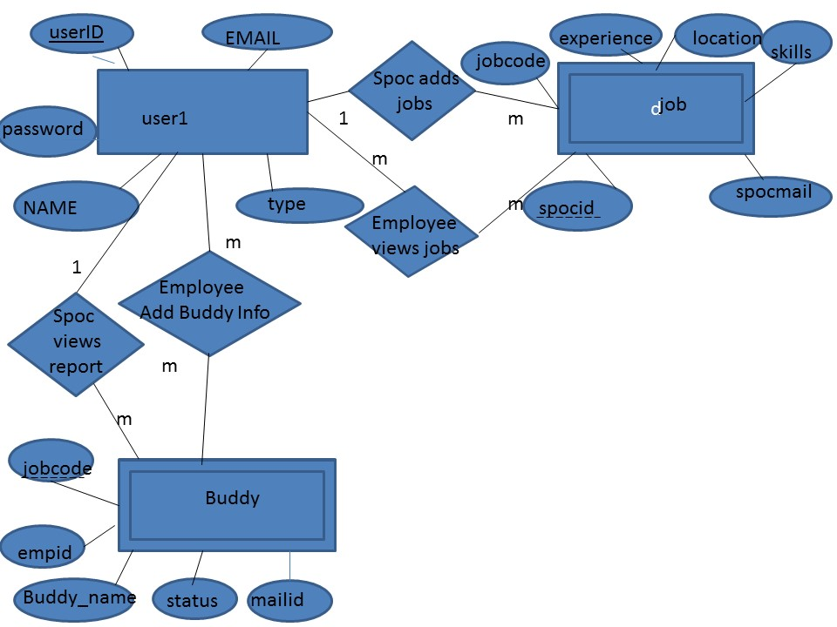

**Technology used:**

* Java
* Jsp
* Html
* Servlet

Softwares used

* Eclipse indigo
* Weblogic server 10.3.6
* Oracle XE

**The schema of project:**

create table user1(name varchar(10),userid varchar(20) primary key,password varchar(10),type varchar(15),email varchar(32));

insert into user1 values(‘priya’,’sonali’,’sonali’,’spoc’,’sonali@sonali.com’);

insert into user1 values('amit','amit','amit','emp','amit@amit.com');

insert into user1 values('sonali','sonali','sonali','spoc','sonali@sonali.com');

---------------------------------------------------------------------------------------------------------------------------------------

create table job(jobcode int ,skill varchar(10),experience varchar(20),location varchar(20), spocid varchar(15),spocmailId varchar(32), foreign key spocid references user1(userid));

----------------------------------------------------------------------------------------------------------------------------------------

create table buddy(jobcode int ,buddyname varchar(20),empId varchar(20),status varchar(20), mailid varchar(32), foreign key (jobcode) references job(jobcode));

----------------------------------------------------------------------------------------------------------------------------------------

**User Stories**

**As a spoc,**

I want to add job requirements so that

I can inform about the requirement to all the employees in an efficient manner.

**As a spoc,**

I want to modify job requirements so that

I can inform about the update in requirement to all the employees in an efficient manner.

**As a spoc,**

I want to delete job requirements so that

So that requirements which are not needed can no longer persist in the requirements list.

**As a spoc,**

I want to update the status in the employee application so that

So that employee can know that his/her referral has been selected or not.

**As an employee,**

I want to view all job requirements so that

I can refer my buddy for the desired job requirement.

**As an employee,**

I want add my buddy’s information so that

The company can view my buddy’s profile

**As an employee,**

I want to view the status of my buddy’s profile so that

I can know about the selection.

TEST CASES

|  |  |  |  |  |  |
| --- | --- | --- | --- | --- | --- |
| **S.No** | **User Stories** | **Test Case Description** | **Expected Result** | **Actual Result** | **Status** |
| **1.** | Admin Login link | A.)  Admin can view Login page  B.)  SPOC and Employee cannot be able to access the login page | Able to view login page  Cannot able to access the login page | Login page displayed  Login page not displayed properly if page not found | Positive  Negative |
| **2.** | SPOC Login page | A.)The SPOC should able to login as User  B.)  The Employee not able to login as User | SPOC login is to be made successfully if entered correct Spocid and password  User login is not success due to incorrect userid or password | SPOC logged in successfully  User login was unsuccessful | Positive  Negative |
| **3.** | Employee Login link | A.)  Both admin and Employee can access this link | SPOC login is to be made successfully if entered correct SPOCid and password | Login page displayed | Positive |
|  |  | B.)  The SPOC not able to login as User | User login is not success due to incorrect userid or password | User login was unsuccessful | Negative |
| **4.** | Add Job Details | A.)  SPOC has the access to this link  B.)  Employee cannot access to the link | SPOC can add the Job details  Employee doesn’t have the access | Job details added successfully  No access | Positive  Negative |
| **5.** | Modify Requirement | A)  SPOC can modify the job requirements  B)  Employee cannot access to the link | The page displayed with all modified details.  The page is not displayed instructing that employee cannot access the Spoc login page | Page details displayed properly.  Page details not displayed. | Positive  Negative |
| **6.** | Delete Requirement | A.)  SPOC can delete the job requirements  B.) Employee cannot access | Job details deleted successfully  The page is not displayed instructing that employee cannot access the Spoc login page | Page details display with deleted jobs  Page details not displayed. | Positive  Negative |
| **7.** | Update/View Reports | A.)  SPOC can update/view the job details  B.)  Employee cannot view this page | The page is displayed with job details    no access to the Employee | The page is displayed with job details  Employee cannot access | Positive  Negative |
| **8.** | View Job Details | A.)  Employee can access this facility  B.)  SPOC cannot this page | Can retrieve the information about the job    SPOC cannot access this tab | Job details is displayed  It will not show the Job details | Positive  Negative |
| **9.** | Add Buddy Details | A.)  Employee can add Buddy details  B.)  SPOC cannot access this tab | Employee can able to view the added buddy details  Invalid login | Page displayed properly  Page not displayed properly | Positive  Negative |
| **10.** | View Status | A.)Employee can view status of his/her Buddy  B.)  SPOCX cannot access this tab | Employee can able to view the status Buddy details table  Invalid login | Page displayed properly  Page not displayed properly | Positive  Negative |

**How Buddy Referral works:**

**HOW LOGIN PAGE WORKS:**



**Whenever anyone will enter buddy referral, login page will be displayed. In the login page the user will select type of user, then enter the user id and password. If the user id will be right, then it will redirect to spoc or employee depending on the type of user and if not it will redirect to invalid login page.**

**HOW SPOC LOGIN PAGE WORKS:**

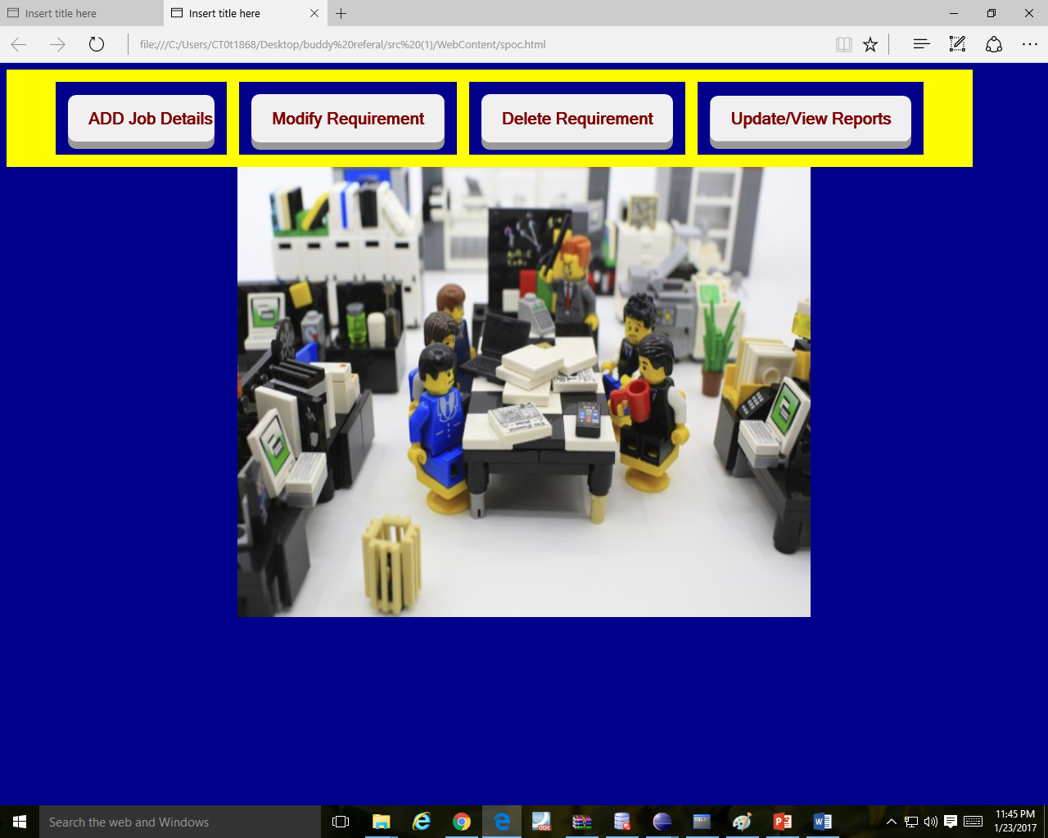

When the spoc will login, the spoc.html file will open and it has four type of submit buttons which will have functionality of add, modify, delete and update. Here lot of buttons are there and depending upon the button the spoc pressed like add, modify, delete, view the spoc will be redirected to respective pages.

**AddJob.html**



When the spoc will press add job button in spoc.html, then page will be redirected to addjob.html. Here the spoc will add skill, experience required and the respective location and it will be added in “job” table.The spocid and spocmailid will be automatically added in the job table with the help of httpsession attribute.

**Delete button**

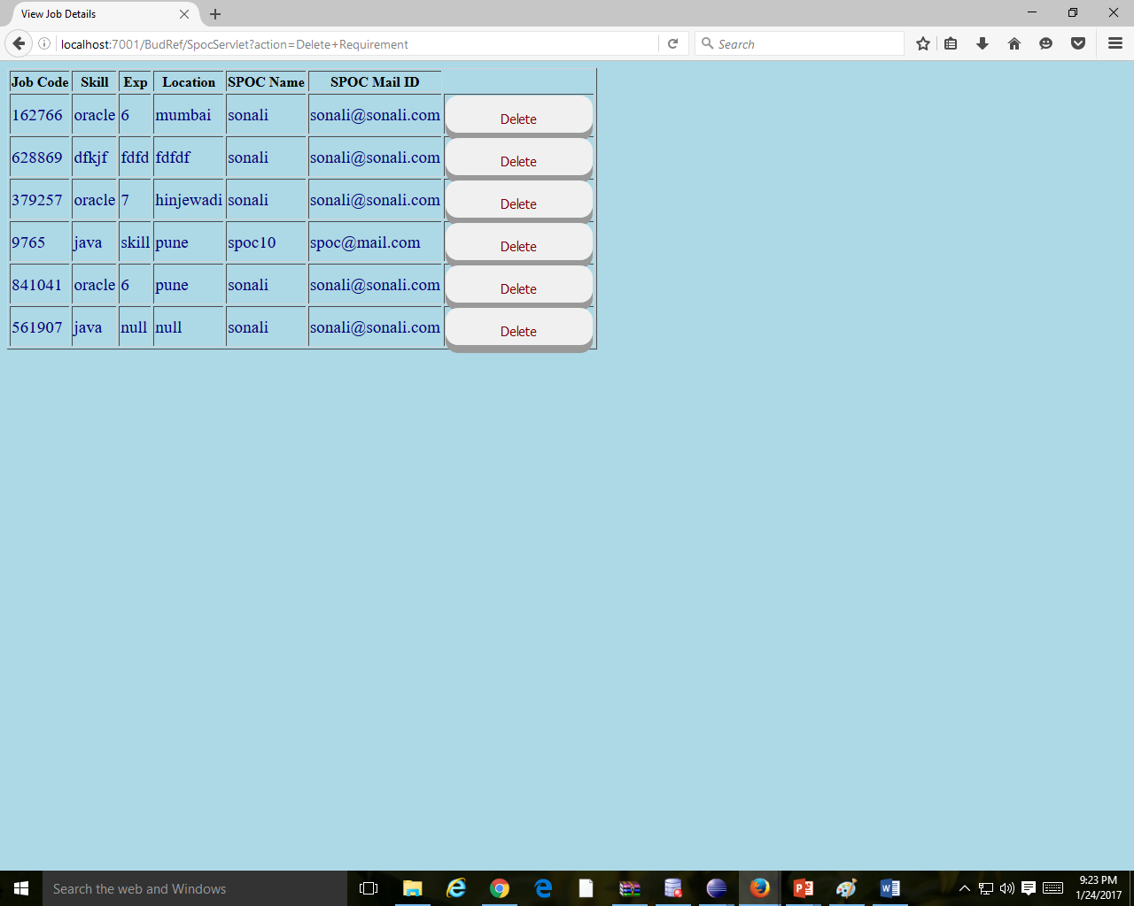

In the “spoc.html” when spoc will press “Delete” button, “delete.jsp” page will come. Here when the user will click on delete against any requirement, then that job requirement will be deleted from job table and the job table will be updated.

**Modify/delete requirements**

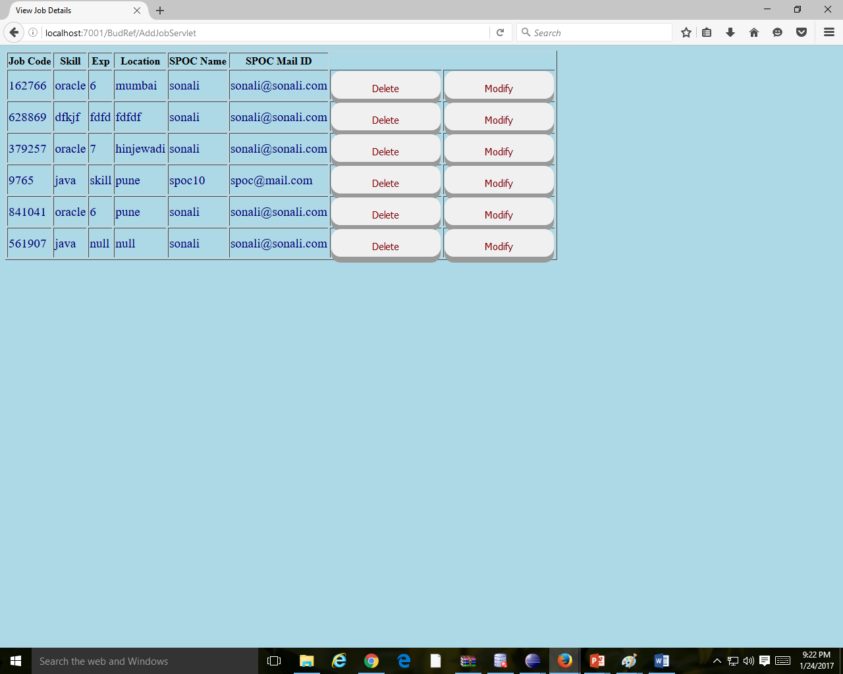

If the spoc in spoc.html will press the “modify/delete”, the page modify/delete jsp will open. Here if the user will press modify button, the user will be prompted to add new requirements having the same job code and the new changes will be reflected in “job” table.

**HOW EMPLOYEE LOGIN PAGE WORKS:**

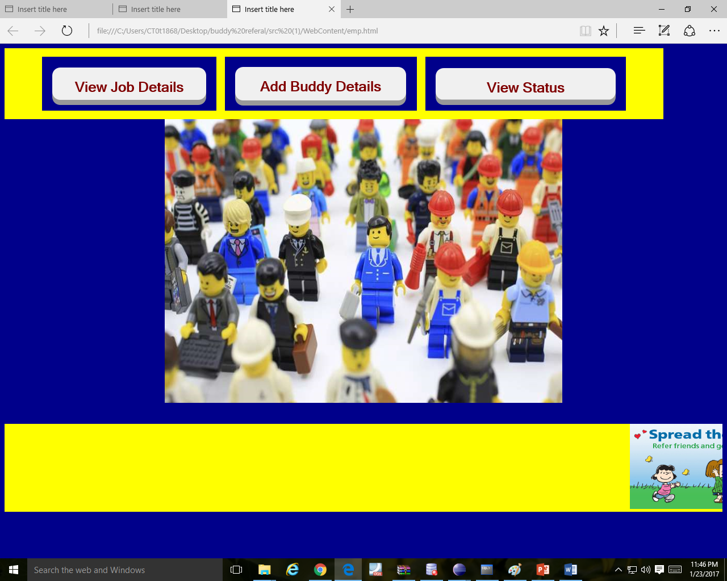

If the employee logins then the emp.html page will open and it has functions like viewing job requirements and adding buddy info.Depending upon the action of the button pressed by employee user , the page will be redirected.

**View Job Details**

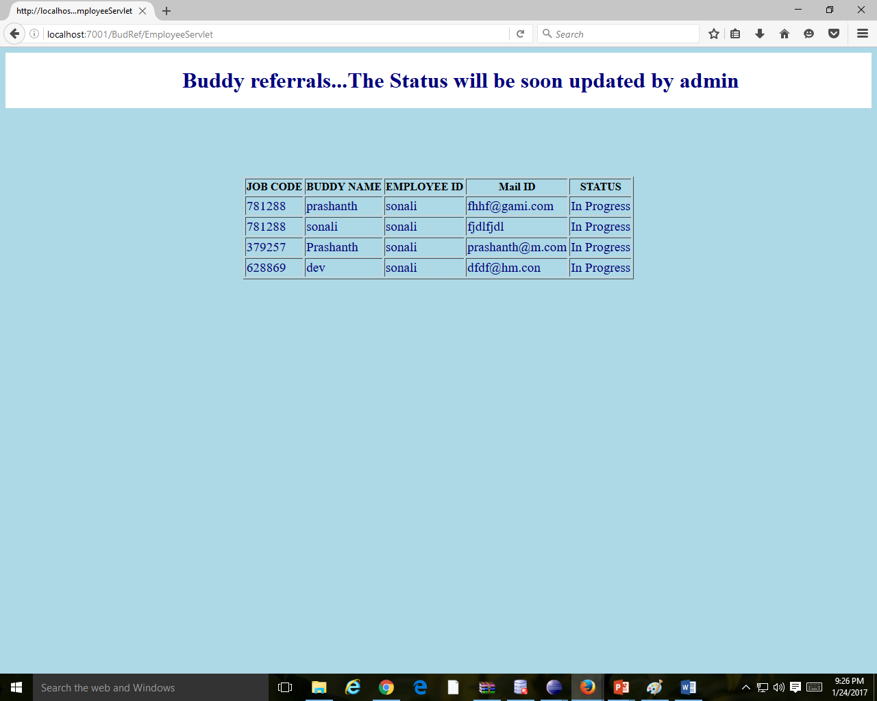

When the employee will click on “view job details” button then “viewjobdetails.jsp” will open. It will contain the “Buddy table” details. Here the jobcode acts as a link to add information of the buddy.

**ReferBuddy**

****After click on jobcode, whatever the jobcode the user will click, with thatJobcode the employee will fill details that will get inserted in the buddy details.

**Reports Generated**

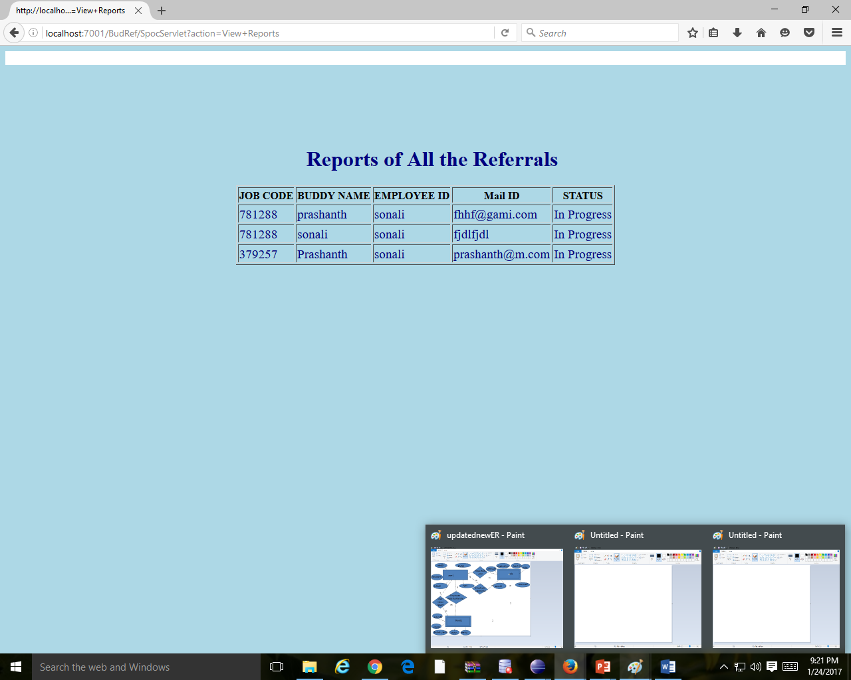

Whatever the referrals has been done, then that will get reflected in the buddy table.

**Benefits of the Buddy Referral**

* : One benefit of an employee-referral program is that it can provide the employer with a source of passive candidates, those workers who are not actively seeking new jobs. This not only expands the employer’s pool of potential candidates but also tends to produce higher-quality candidates.
* Candidates referred by employees also tend to be of higher quality because the referring employee usually screens his or her referrals closely. After all, his or her reputation is somewhat on the line with every person he refers for apposition. Referring a string of unqualified candidates reflects poorly on the referring employee’s judgment, which may affect his or her own career prospects.
* The usual monetary bonus paid to a referring employee for a successful referral can be a significant morale booster. It reinforces the tendency to refer high-quality candidates to one’s own company, even when no positions are available. This helps to establish an ongoing recruitment process
* .Employee-referral programs can replace more expensive recruitment channels such as newspaper advertising, employment agencies, and job fairs and so on.
* Employee-referral programs are especially effective in the case of highly specialized positions that might be difficult to fill through conventional channels. People tend to associate with others in their professions, which gives them access to specialized or rare talent.

**PITFALLS OF BUDDY-REFERRAL PROGRAMS**:

* There are some aspects of employee-referral programs that can cause problems for a company. Some are subtle, while others, like lawsuits, can literally slap a business in the face.
* Overreliance on an employee-referral program can lead to underrepresentation of certain protected groups in a company’s job-applicant pool. This can add credence to charges of employment discrimination from rejected candidates.
* Also, some competing businesses may retaliate against your company for stealing their happily employed workers via employee-referral programs.
* Excessive reliance upon an employee-referral program can lead to an inbred organization that lacks breadth of ideas, and it can foster a "stick-together “attitude that masks underlying problems in organizational behavior. Relying too heavily on an employee-referral program can also create cliques within an organization, leading to resentment and friction with other employees.
* Some managers may have biases against employee-referral programs, feeling that referrals are favors done for shiftless in-laws rather than for the company.
* Overly restrictive bonus qualifications or excessive qualifications for employee referrals can lead to disillusionment with an employee-referral program. Under such circumstances, an employee-referral program may actually become a source of employee discontent.
* Overall, the benefits of employee-referral programs decisively outweigh the potential pitfalls. A well-designed and highly visible employee-referral program is a critical part of any company’s recruitment strategy.

**CONCLUSIONS:**

It’s safe to say that every company/business has its own Employee Referral Program, whether formal or informal, that they promote to varying degrees at various times. Larger companies with hundreds of open positions, in some cases, have a full-time employee dedicated to running and optimizing theater. Smaller companies that hire a few people a year often rely on their employees to refer candidates for that position good referral program will have many benefits, both in cost and the time savings

**LEARNING OBJECTIVE**:

This topic has made me to learn about employee referral program and how it help the company in recruitment process Employee referrals provide a win situation to all the parties involved –Employer , Employee and the Candidate More and more firms are resorting to employee referrals and are reaping the benefits.

Technical Learning:

We learnt how to incorporate database connectivity, servlet/server side programming and various advanced java topics into one single unit and produce a working dynamic project.