Experiment 3
Implementation of Classification Algorithm (Decision Tree / Naïve Bayes)

Name : - Pranali Vinod Waghode
TY04-B-68
23UF18515CM124
Aim :
To implement and study classification algorithms using Decision Tree and Naïve Bayes on a given dataset and analyze their performance.

Introduction:
Classification is a supervised learning technique in Data Warehousing and Data Mining (DWM) used to predict the class label of new data based on training data. Two popular classification algorithms are:
- Decision Tree (DT) – builds a tree-like model of decisions.
- Naïve Bayes (NB) – a probabilistic classifier based on Bayes’ Theorem.
These algorithms are widely used in spam detection, medical diagnosis, sentiment analysis, etc.

Procedure:
- Import required Python libraries.
- Load the dataset.
- Split dataset into training and testing sets.
- Train the classifier model.
- Test the model.
- Calculate accuracy.
- Display results.

PART A: Decision Tree Classifier

Program Code (Decision Tree)

import numpy as np
import pandas as pd
from sklearn.datasets import load_iris
from sklearn.model_selection import train_test_split
from sklearn.tree import DecisionTreeClassifier
from sklearn.metrics import accuracy_score, classification_report
import matplotlib.pyplot as plt
from sklearn.tree import plot_tree

# Step 1: Load the dataset (Iris dataset)
iris = load_iris()
X = iris.data # Features (independent variables)
y = iris.target # Target labels (dependent variable)

# Step 2: Split the data into training and testing sets
X_train, X_test, y_train, y_test = train_test_split(
X, y, test_size=0.3, random_state=42
)

# Step 3: Initialize the Decision Tree Classifier
dt_classifier = DecisionTreeClassifier(random_state=42)

# Step 4: Train the classifier with training data
dt_classifier.fit(X_train, y_train)

# Step 5: Predict the target labels on the test data
y_pred = dt_classifier.predict(X_test)

# Step 6: Evaluate the model
accuracy = accuracy_score(y_test, y_pred)
print(f"Accuracy: {accuracy * 100:.2f}%")

# Additional evaluation: Classification Report
print("\nClassification Report:")
print(classification_report(y_test, y_pred, target_names=iris.target_names))

# Step 7: Plot the decision tree
plt.figure(figsize=(14, 14))
plot_tree(
dt_classifier,
filled=True,
feature_names=iris.feature_names,
class_names=iris.target_names,
rounded=True,
fontsize=10
)
plt.show()

Output Snapshot:
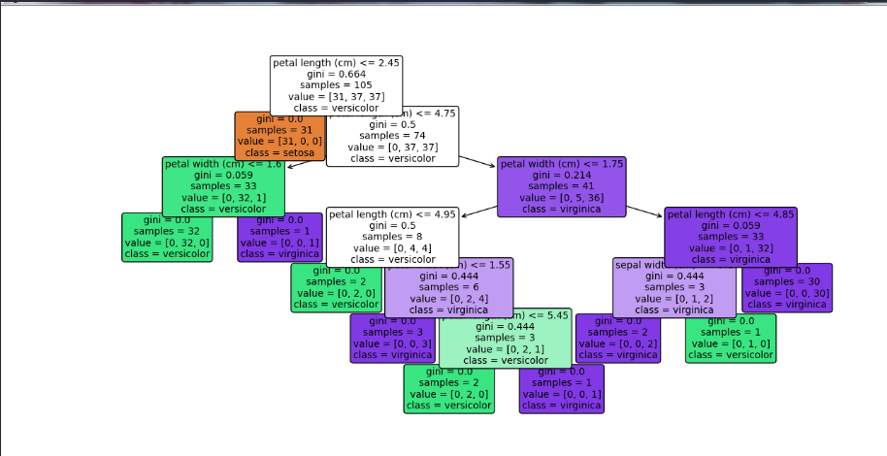
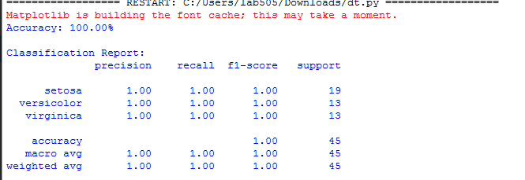

PART B: Naïve Bayes Classifier

Program Code (Naïve Bayes)
# Naive Bayes Classification on Iris Dataset

from sklearn.datasets import load_iris
from sklearn.model_selection import train_test_split
from sklearn.naive_bayes import GaussianNB
from sklearn.metrics import accuracy_score, classification_report
import numpy as np
import matplotlib.pyplot as plt

# Load the Iris dataset
iris = load_iris()
X = iris.data
y = iris.target

# Split the data into training and testing sets (70% train, 30% test)
X_train, X_test, y_train, y_test = train_test_split(
X, y, test_size=0.3, random_state=42
)

# Create a Gaussian Naive Bayes classifier
gnb = GaussianNB()

# Train the classifier
gnb.fit(X_train, y_train)

# Make predictions on the testing set
y_pred = gnb.predict(X_test)

# Evaluate the accuracy of the classifier
accuracy = accuracy_score(y_test, y_pred)
print(f"Accuracy: {accuracy * 100:.2f}%")

# Classification report
print("\nClassification Report:")
print(classification_report(y_test, y_pred, target_names=iris.target_names))

Output Snapshot:
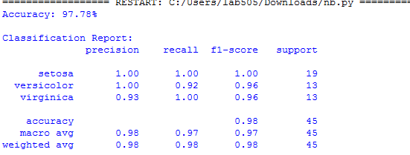

Conclusion:
In this experiment, Decision Tree and Naïve Bayes classifiers were successfully implemented using Python. Both algorithms achieved good accuracy on the dataset. Decision Tree performed slightly better than Naïve Bayes for this dataset. Hence, classification algorithms are effective tools for predictive data analysis.

Review Questions:
Q1. What is a Decision Tree classifier, and how does it work?
A: A Decision Tree classifier is a supervised learning algorithm that uses a tree-like structure to make decisions.Each internal node represents a feature, each branch represents a decision rule, and each leaf node represents a class label.The tree splits the data recursively based on the best feature.
Q2. Explain the Naïve Bayes algorithm and its underlying assumptions.
A: Naïve Bayes is a probabilistic classifier based on Bayes’ Theorem.
It assumes that:
- All features are independent of each other.
- Each feature contributes equally to the result.
Despite the "naive" assumption, it works well in many real-world problems.
Q3. Compare Decision Tree and Naïve Bayes classifiers.
A:
Feature | Decision Tree | Naive Bayes
Type | Rule - based | Probabilistic
Assumption | No assumption | Features inedependent
Speed | Slower | Very fast
Accuracy | High | Medium-High
Interpretability | Easy to understand | Less intuitive

Github link:

