**Instafeez Deployment Process**

**Prerequisites:**

-Having docker installed on your system, and docker engine is running. Note: On Windows System, you should have wsl2 enabled, because docker needs wsl2 rather than wsl version 1. Make sure that you have logged in to your docker account.

**To Log in:**

1. Run docker login -u worldfellow.
2. At the password prompt, enter the personal access token (You can get it from the Instafeez Team).

**Command for backup the volume’s data**

$ cp -r fs/*/root/

**Steps to follow:**

1. **Create two volumes: -**

Volumes are the preferred way to persist data in Docker containers and services.

* instafeez_data
* instafeez_codebase

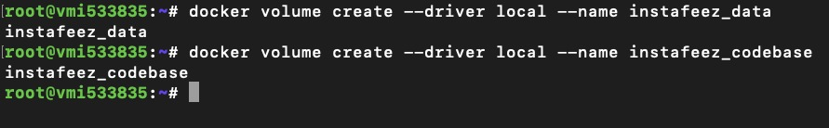

1. **Build the container with ports and volumes for instafeez: -**

Enter in container using docker exec -it command and specify the id.

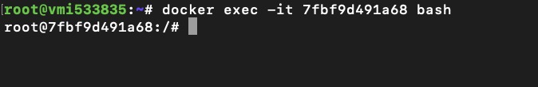

1. **Assign ports:**

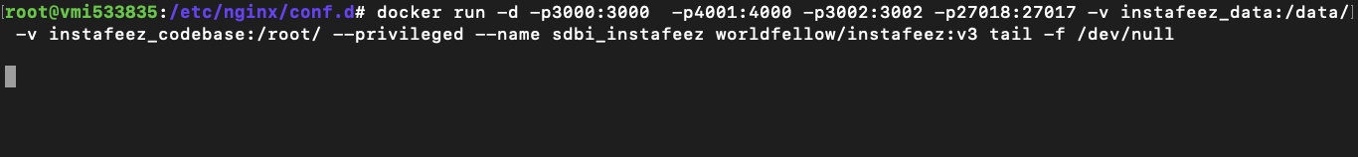

1. **Copy BUILDS, PROD and instascripts in instafeez_codebase/_data from root directory**

$ cd instafeez_codebase/

$ cp -r /root/PROD

$ cp -r /root/BUILDs

$ cp -r /root/instascripts

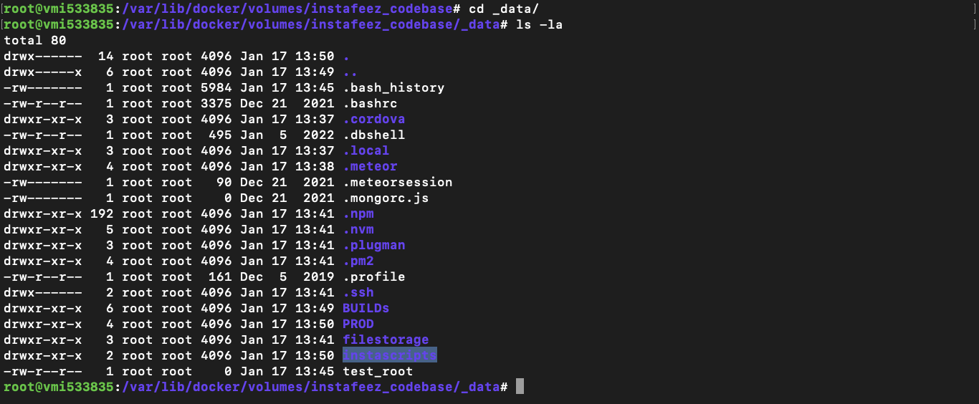

1. **Verify volume whether data is getting present or not.**
2. **Check whether MongoDB service to be work properly**

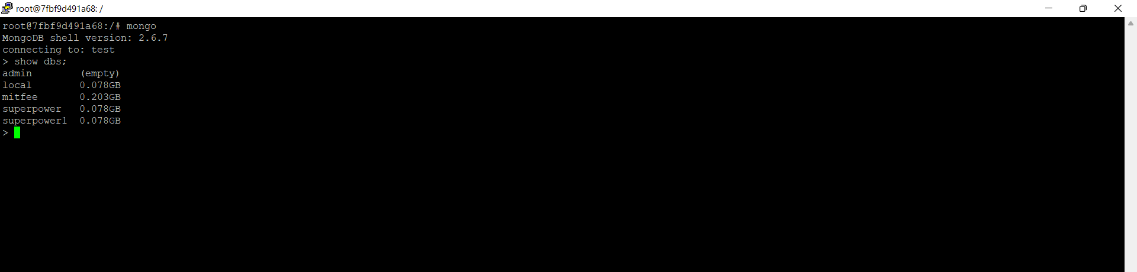

1. **Verify scripts**
2. **(instadeploy.sh): -**

$ Var/lib/docker/volumes/instafeez_codebase/_data/instascripts/instadeploy.sh

Process for removing and building project-

* Remove PM2 process & logs.
* Clearing old builds.
* Building the project.
* Installing required dependencies for build and creating required folders.

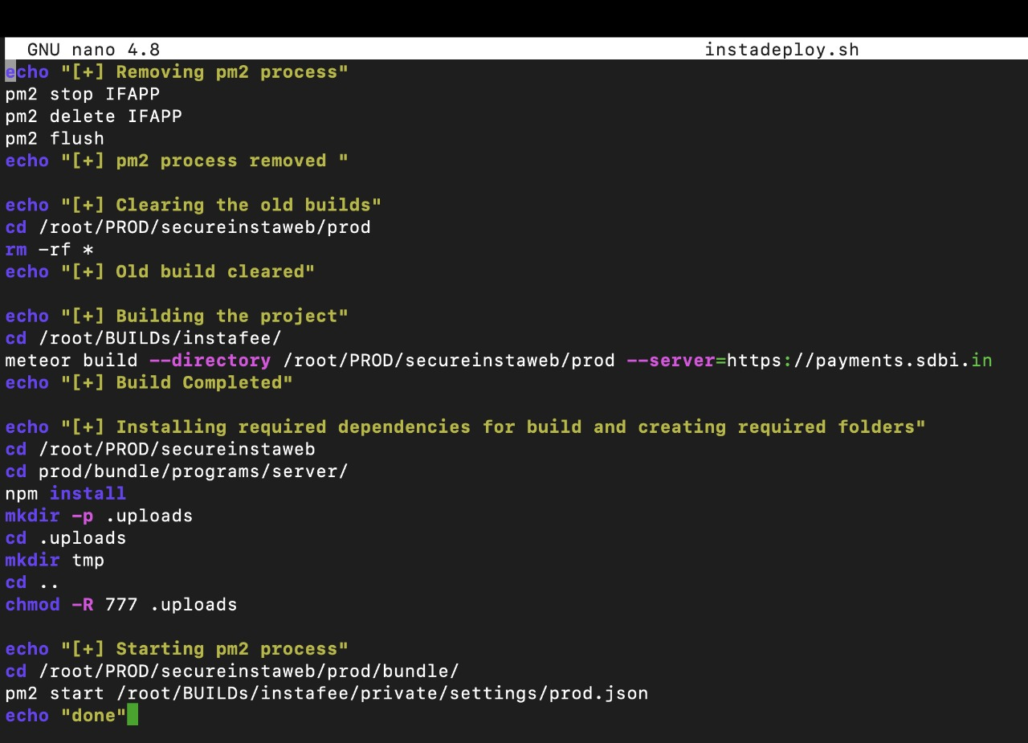

Need to verify the file (prod.json) for (instadeploy.sh)

**Run**: - ./Instadeploy.sh

1. **(superdeploy.sh)**

Var/lib/docker/volumes/instafeez_codebase/instascripts/superdeploy.sh

* Remove pm2 process & logs.
* Clearing old builds.
* Building the project.
* Installing required dependencies for build and creating required folders.

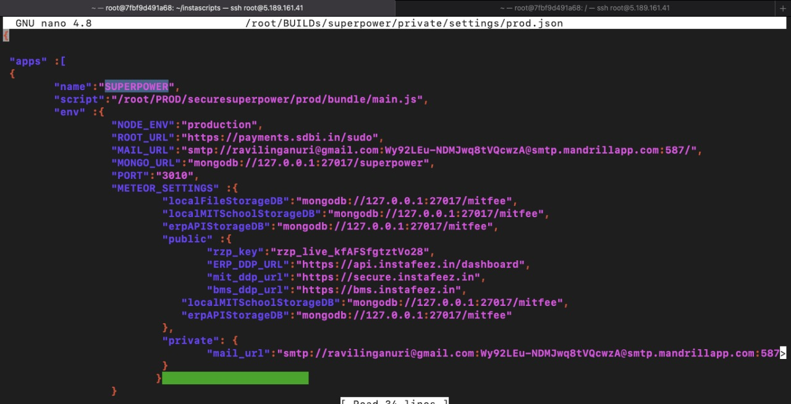

Need to verify the file(prod.json) for superdeploy.sh

**Run: -** ./superdeploy.sh

1. **Run script**

