Question 1 — IoT Sensor Dashboard
Problem 1 — Sensor Reading Classifier

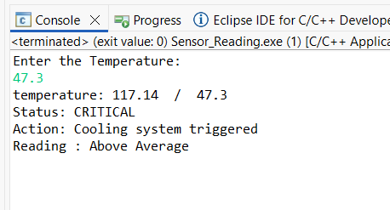

Problem 2 — Sensor Log Buffer
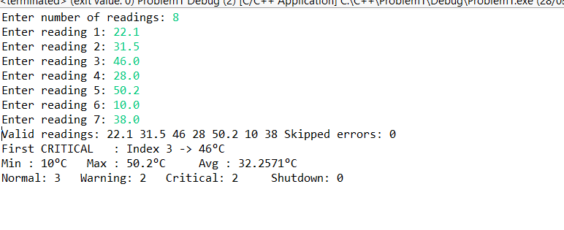

Problem 3 — Building Sensor Grid

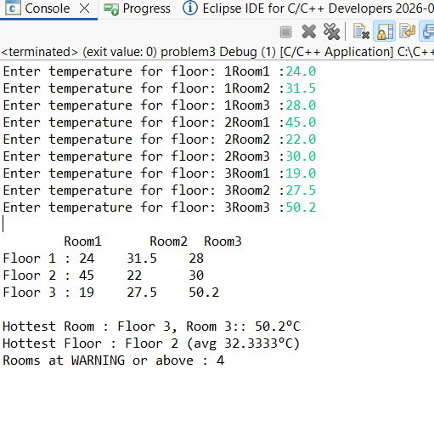
Problem 4 — Startup Configuration via CLI
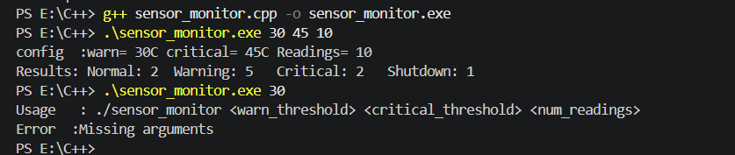

Question 2 — Embedded Memory Manager & Signal Processor

Problem 1 — The Bug in Sensor Recalibration
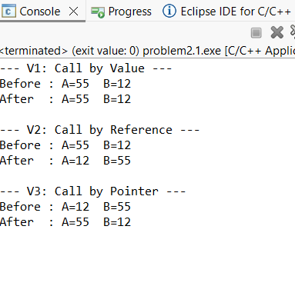

Problem 2 — Signal Processing Pipeline
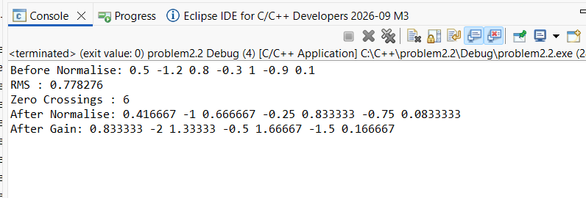

Problem 3 — Hardware Register Access
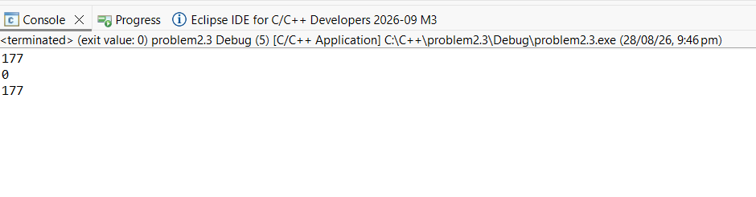
Problem 4 — Calibration Packet Parser
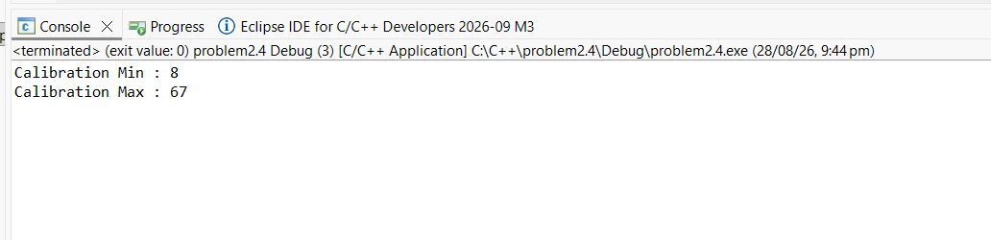

Problem 5 — Drone Navigation Utilities
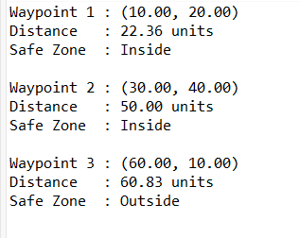

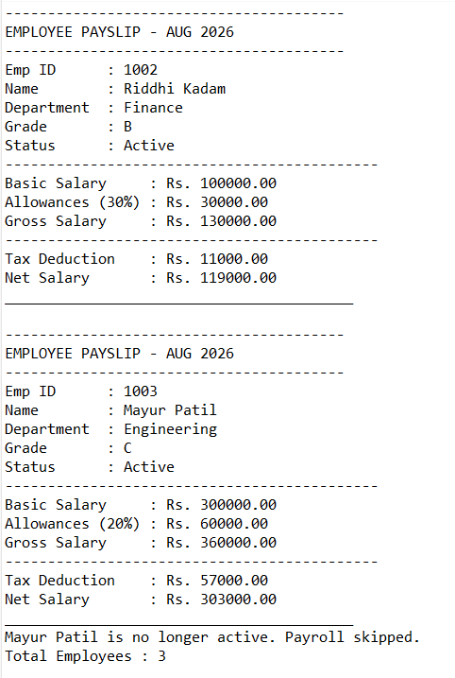
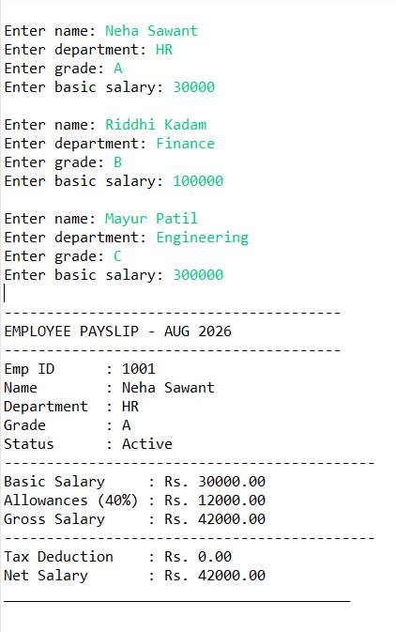
Question 3 — HR Payroll Engine

Bonus — Struct Padding (Optional, 5 marks)
