Application No 1: Finding id in sorted order
#include <stdio.h>
// Function to perform Binary Search
int binarySearch(int arr[], int size, int id) {
int low = 0, high = size - 1;
while (low <= high) {
int mid = (low + high) / 2;

if (arr[mid] == id)
return mid; // Found

if (arr[mid] < id)
low = mid + 1; // Search right half
else
high = mid - 1; // Search left half
}

return -1; // Not found
}

int main() {
int n, i, id;

printf("Enter number of students: ");
scanf("%d", &n);

int studentIDs[n];

printf("Enter %d student IDs in sorted order:\n", n);
for (i = 0; i < n; i++) {
scanf("%d", &studentIDs[i]);
}

printf("Enter student ID to search: ");
scanf("%d", &id);

int result = binarySearch(studentIDs, n, id);

if (result != -1)
printf("? Student ID %d found at index %d.\n", id, result);
else
printf("? Student ID %d not found in the list.\n", id);

return 0;
}
Output: 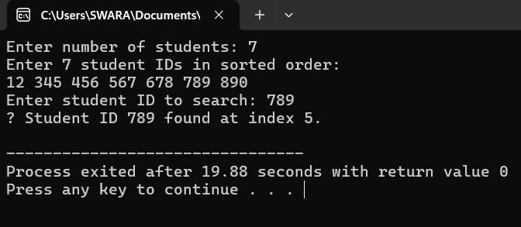

Application No: 02 Sorting Products by Price
#include <stdio.h>
#include <string.h>

// Define structure for Product
struct Product {
char name[50];
float price;
};

// Function to swap two products
void swap(struct Product *a, struct Product *b) {
struct Product temp = *a;
*a = *b;
*b = temp;
}

// Partition function (for QuickSort)
int partition(struct Product arr[], int low, int high) {
float pivot = arr[high].price; // Pivot = last element's price
int i = low - 1;
int j;
for (j = low; j < high; j++) {
if (arr[j].price < pivot) { // Ascending order
i++;
swap(&arr[i], &arr[j]);
}
}
swap(&arr[i + 1], &arr[high]);
return (i + 1);
}

// QuickSort function
void quickSort(struct Product arr[], int low, int high) {
if (low < high) {
int pi = partition(arr, low, high);
quickSort(arr, low, pi - 1);
quickSort(arr, pi + 1, high);
}
}

// Function to display products
void display(struct Product arr[], int n) {
printf("\n%-20s%-10s\n", "Product Name", "Price");
printf("------------------------------\n");
int i;
for (i = 0; i < n; i++) {
printf("%-20s$%.2f\n", arr[i].name, arr[i].price);
}
}

int main() {
int n,i;

printf("Enter number of products: ");
scanf("%d", &n);
getchar(); // consume newline

struct Product products[n];

// Input product details
for (i = 0; i < n; i++) {
printf("\nEnter name of product %d: ", i + 1);
fgets(products[i].name, sizeof(products[i].name), stdin);
products[i].name[strcspn(products[i].name, "\n")] = '\0'; // remove newline

printf("Enter price of product %d: $", i + 1);
scanf("%f", &products[i].price);
getchar(); // consume newline
}

printf("\n--- Product List Before Sorting ---");
display(products, n);

quickSort(products, 0, n - 1);
printf("\n--- Product List After Sorting by Price (Ascending) ---");
display(products, n);
return 0;
}
Output: 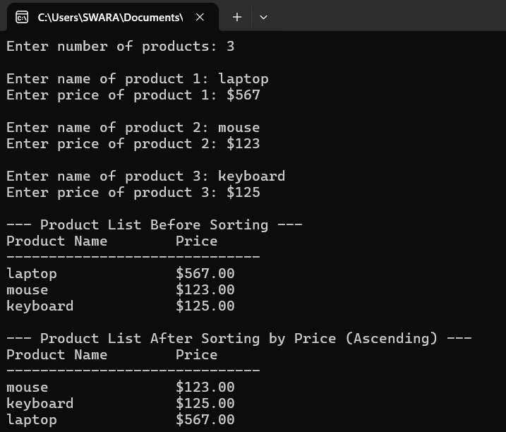
Application No: 3 Maximize profit by choosing items based on value-to-weight ratio)
#include <stdio.h>

// Structure to hold item details
struct Item {
char name[50];
float weight;
float value;
float ratio; // value-to-weight ratio
};

// Function to swap two items
void swap(struct Item *a, struct Item *b) {
struct Item temp = *a;
*a = *b;
*b = temp;
}

// Function to sort items by value/weight ratio (descending order)
void sortItems(struct Item items[], int n) {
int i,j;
for ( i = 0; i < n - 1; i++) {
for ( j = 0; j < n - i - 1; j++) {
if (items[j].ratio < items[j + 1].ratio) {
swap(&items[j], &items[j + 1]);
}
}
}
}
// Greedy Knapsack function
void greedyKnapsack(struct Item items[], int n, float capacity) {
float totalValue = 0.0;
float currentWeight = 0.0;
int i;
printf("\nSelected Items for the Truck:\n");
printf("%-15s%-10s%-10s%-10s\n", "Item", "Weight", "Value", "Taken(%)");
printf("----------------------------------------------------\n");

for (i = 0; i < n; i++) {
if (currentWeight + items[i].weight <= capacity) {
// Take the whole item
currentWeight += items[i].weight;
totalValue += items[i].value;
printf("%-15s%-10.2f%-10.2f%-10.0f\n", items[i].name, items[i].weight, items[i].value, 100.0);
} else {
// Take fractional part of the item
float remain = capacity - currentWeight;
float fraction = remain / items[i].weight;
totalValue += items[i].value * fraction;
printf("%-15s%-10.2f%-10.2f%-10.0f\n", items[i].name, remain, items[i].value * fraction, fraction * 100);
break;
}
}
printf("\nTotal weight in truck: %.2f / %.2f\n", currentWeight, capacity);
printf("Total profit earned: $%.2f\n", totalValue);
}
int main() {
int n,i;
float capacity;
printf("Enter the number of items available: ");
scanf("%d", &n);

struct Item items[n];
// Input item details
for (i = 0; i < n; i++) {
printf("\nEnter name of item %d: ", i + 1);
scanf("%s", items[i].name);
printf("Enter weight of %s (kg): ", items[i].name);
scanf("%f", &items[i].weight);
printf("Enter value of %s ($): ", items[i].name);
scanf("%f", &items[i].value);

items[i].ratio = items[i].value / items[i].weight;
}
printf("\nEnter maximum capacity of the truck (kg): ");
scanf("%f", &capacity);
// Sort by value-to-weight ratio
sortItems(items, n);
// Apply Greedy Knapsack
greedyKnapsack(items, n, capacity);

return 0;
}
Output:
: 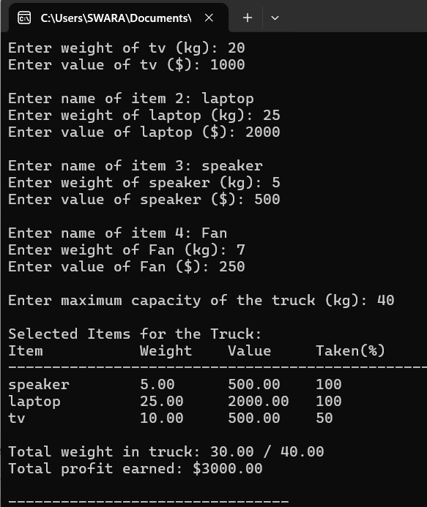
Application No 4: File Merging in External Sorting
#include <stdio.h>
#include <stdlib.h>

// Function to swap two integers
void swap(int *a, int *b) {
int temp = *a;
*a = *b;
*b = temp;
}

// Function to maintain min-heap property
void heapify(int arr[], int n, int i) {
int smallest = i;
int left = 2 * i + 1;
int right = 2 * i + 2;

if (left < n && arr[left] < arr[smallest])
smallest = left;

if (right < n && arr[right] < arr[smallest])
smallest = right;

if (smallest != i) {
swap(&arr[i], &arr[smallest]);
heapify(arr, n, smallest);
}
}

// Function to build a min heap
void buildMinHeap(int arr[], int n) {
int i;
for ( i = n / 2 - 1; i >= 0; i--)
heapify(arr, n, i);
}

// Function to extract the minimum element from the heap
int extractMin(int arr[], int *n) {
int root = arr[0];
arr[0] = arr[*n - 1];
(*n)--;
heapify(arr, *n, 0);
return root;
}

// Function to insert a new element into the heap
void insertHeap(int arr[], int *n, int key) {
(*n)++;
int i = *n - 1;
arr[i] = key;
while (i != 0 && arr[(i - 1) / 2] > arr[i]) {
swap(&arr[i], &arr[(i - 1) / 2]);
i = (i - 1) / 2;
}
}

// Function to calculate minimum cost of optimal merge pattern
int optimalMerge(int files[], int n) {
buildMinHeap(files, n);
int totalCost = 0;

while (n > 1) {
int first = extractMin(files, &n);
int second = extractMin(files, &n);

int cost = first + second;
totalCost += cost;

insertHeap(files, &n, cost);
}

return totalCost;
}

int main() {
int n,i;
printf("Enter number of files: ");
scanf("%d", &n);

int files[n];
printf("Enter the sizes of files: ");
for (i = 0; i < n; i++)
scanf("%d", &files[i]);

int minCost = optimalMerge(files, n);
printf("\nMinimum total cost for optimal merge pattern = %d\n", minCost);

return 0;
}
Output: 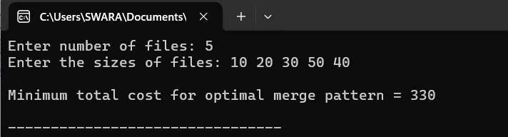
Application No 5: Real-Life MST Application in C — Connecting Cities
#include <stdio.h>
#include <limits.h>

#define MAX 100 // Maximum number of cities

// Function to find the vertex with minimum key value not included in MST
int minKey(int key[], int mstSet[], int n) {
int min = INT_MAX, min_index;
int i,v;
for (v = 0; v < n; v++)
if (mstSet[v] == 0 && key[v] < min)
min = key[v], min_index = v;

return min_index;
}

// Function to print MST and its total cost
void printMST(int parent[], int n, int graph[MAX][MAX], char cities[][50]) {
int totalCost = 0,i;
printf("\nEdges in the Minimum Spanning Tree:\n");
printf("%-20s%-20s%-10s\n", "City1", "City2", "Cost");
printf("---------------------------------------------\n");
for (i = 1; i < n; i++) {
printf("%-20s%-20s%-10d\n", cities[parent[i]], cities[i], graph[i][parent[i]]);
totalCost += graph[i][parent[i]];
}
printf("\nTotal minimum cost to connect all cities: %d\n", totalCost);
}

// Function to construct MST using Prim's algorithm
void primMST(int n, int graph[MAX][MAX], char cities[][50]) {
int parent[MAX]; // Array to store MST
int key[MAX]; // Key values used to pick minimum weight edge
int mstSet[MAX]; // To represent set of vertices included in MST
int i,count,v;
// Initialize all keys as infinite
for (i = 0; i < n; i++) {
key[i] = INT_MAX;
mstSet[i] = 0;
}

key[0] = 0; // Start from first city
parent[0] = -1; // First node is root

for (count = 0; count < n - 1; count++) {
int u = minKey(key, mstSet, n);
mstSet[u] = 1;

for (v = 0; v < n; v++)
if (graph[u][v] && mstSet[v] == 0 && graph[u][v] < key[v])
parent[v] = u, key[v] = graph[u][v];
}

printMST(parent, n, graph, cities);
}

int main() {
int n,i,j;

printf("Enter number of cities: ");
scanf("%d", &n);
getchar(); // consume newline

char cities[n][50];
for (i = 0; i < n; i++) {
printf("Enter name of city %d: ", i + 1);
fgets(cities[i], sizeof(cities[i]), stdin);
cities[i][strcspn(cities[i], "\n")] = '\0'; // remove newline
}
int graph[MAX][MAX];
printf("\nEnter adjacency matrix (0 if no direct road, cost otherwise):\n");
for (i = 0; i < n; i++)
for (j = 0; j < n; j++)
scanf("%d", &graph[i][j]);

primMST(n, graph, cities);

return 0;
}
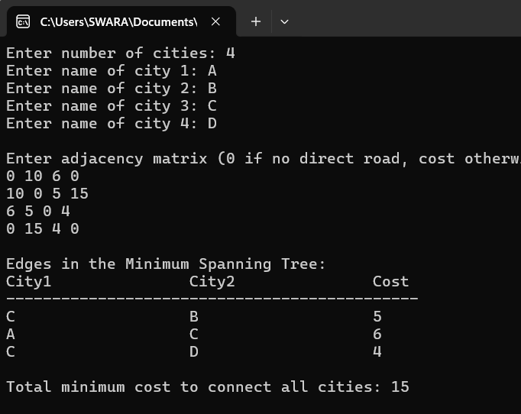
Application No 6 : Dijkstra’s Algorithm for GPS Navigation

#include <stdio.h>
#include <limits.h>

#define MAX 100
int n,v;// number of cities

// Function to find vertex with minimum distance not yet processed
int minDistance(int dist[], int visited[]) {
int min = INT_MAX, min_index;

for (v = 0; v < n; v++)
if (visited[v] == 0 && dist[v] <= min)
min = dist[v], min_index = v;
return min_index;
}

// Function to print shortest distances from source
void printDistances(int dist[], char cities[][50], int src) {
int i;
printf("\nShortest distance from %s to each city:\n", cities[src]);
printf("%-20s%-10s\n", "City", "Distance");
printf("----------------------------\n");
for (i = 0; i < n; i++) {
printf("%-20s%-10d\n", cities[i], dist[i]);
}
}

// Dijkstra's algorithm
void dijkstra(int graph[MAX][MAX], int src, char cities[][50]) {
int dist[MAX]; // Shortest distance from src
int visited[MAX];
int i,count,v;// Track visited nodes

for ( i = 0; i < n; i++) {
dist[i] = INT_MAX;
visited[i] = 0;
}
dist[src] = 0;

for (count = 0; count < n - 1; count++) {
int u = minDistance(dist, visited);
visited[u] = 1;

for (v = 0; v < n; v++)
if (!visited[v] && graph[u][v] && dist[u] != INT_MAX &&
dist[u] + graph[u][v] < dist[v])
dist[v] = dist[u] + graph[u][v];
}

printDistances(dist, cities, src);
}

int main() {
int i,j;
printf("Enter number of cities: ");
scanf("%d", &n);
getchar(); // consume newline

char cities[n][50];
for (i = 0; i < n; i++) {
printf("Enter name of city %d: ", i + 1);
fgets(cities[i], sizeof(cities[i]), stdin);
cities[i][strcspn(cities[i], "\n")] = '\0';
}

int graph[MAX][MAX];
printf("\nEnter adjacency matrix (0 if no direct road, distance otherwise):\n");
for (i = 0; i < n; i++)
for (j = 0; j < n; j++)
scanf("%d", &graph[i][j]);

int src;
printf("\nEnter source city index (0 to %d): ", n - 1);
scanf("%d", &src);

dijkstra(graph, src, cities);

return 0;
}
Output: 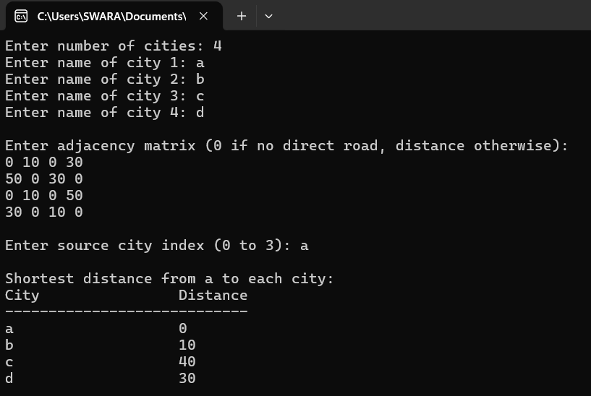

Output:

