Experiment No:01
Title: Binary search techniques using array and recursion. Analyse time and space complexity
Theory:
Binary search is an efficient algorithm used to find the position of a target element within a sorted array. The algorithm operates on the principle of divide and conquer, which means it repeatedly divides the search space into halves until the desired element is found or the search space becomes empty. To implement binary search, the array must be sorted either in ascending or descending order beforehand, as the logic of halving relies on the relative ordering of elements.
The process begins by initializing two variables, typically named low and high, to represent the first and last indices of the array. The algorithm then calculates the middle index using the expression (low + high) / 2. If the element at the middle index matches the key being searched for, the algorithm returns the position immediately. If the key is smaller than the middle element, it implies that the target lies in the left half of the array, and the high pointer is adjusted to mid-1. Conversely, if the key is greater than the middle element, the low pointer is set to mid + 1, restricting the search to the right half. This process repeats until either the element is found or low exceeds high, in which case the element does not exist in the array.
Binary search can be implemented in two ways: iterative and recursive. In the iterative version, the process continues within a loop until the element is located or the boundaries cross, making it more space-efficient as it does not involve function call overheads. The recursive version simplifies the logic conceptually by calling the same function repeatedly on smaller subarrays until the base condition is reached. However, recursion involves additional memory consumption due to the function call stack. Despite this, both approaches produce identical results and share the same time complexity characteristics.
The efficiency of binary search lies in the drastic reduction of the search interval after every iteration or recursive call. With each comparison, the algorithm eliminates half of the remaining elements, leading to a logarithmic growth rate in the number of comparisons required. The best-case time complexity of binary search occurs when the middle element of the array is the target itself, resulting in a constant time of O(1). The worst-case and average-case complexities both occur when the element is located near the start or end of the array, or is absent entirely, requiring O(log₂ n) comparisons, where n is the total number of elements.
The space complexity depends on the implementation. The iterative approach uses a constant amount of auxiliary space, resulting in O(1) space complexity. The recursive version, however, consumes additional space proportional to the depth of the recursive call stack, which in the worst case can reach O(log₂ n). Despite this minor overhead, binary search remains one of the most optimal searching methods for static, sorted data structures. It is extensively used in systems requiring fast data lookup, including databases, sorted lists, and search engines, due to its superior performance and predictable behavior.

Program:
#include <stdio.h>

int BinSearch(int arr[], int key, int low, int high)
{
if (low > high)
return -1;

int mid = (low + high) / 2;

if (key == arr[mid])
return mid;
else if (key < arr[mid])
return BinSearch(arr, key, low, mid - 1);
else
return BinSearch(arr, key, mid + 1, high);
}

int IterBinSearch(int arr[], int size, int key)
{
int low = 0, high = size - 1;

while (low <= high)
{
int mid = (low + high) / 2;

if (arr[mid] == key)
return mid;
else if (key < arr[mid])
high = mid - 1;
else
low = mid + 1;
}

return -1;
}

int main()
{
int i, size, key, res;

printf("Enter the size of the array: ");
scanf("%d", &size);

int arr[size];
printf("Enter %d sorted numbers: ", size);
for (i = 0; i < size; i++)
scanf("%d", &arr[i]);

printf("Enter the number to be found: ");
scanf("%d", &key);

res = BinSearch(arr, key, 0, size - 1);
if (res == -1)
printf("Using recursion: Element not found.\n");
else
printf("Using recursion: Element found at index %d\n", res);

res = IterBinSearch(arr, size, key);
if (res == -1)
printf("Using iteration: Element not found.\n");
else
printf("Using iteration: Element found at index %d\n", res);

return 0;
}

Output:
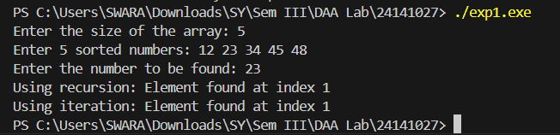
Advantages:
- Significantly faster than linear search for large sorted datasets.
- Reduces time complexity to logarithmic order (O(log n)).
- Simple and elegant implementation, especially with recursion.
- Works efficiently with large arrays stored in contiguous memory.
- Deterministic algorithm — performance does not depend on data distribution.
- Easy to adapt for searching in sorted files or databases.

Disadvantages:
- Requires the input data to be sorted beforehand.
- Inefficient for small datasets compared to linear search due to overhead.
- Not suitable for dynamic data that changes frequently (needs re-sorting).
- Poor performance on linked lists due to lack of random access.
- Recursive implementation may cause stack overflow for very large arrays.
- Cannot be used on unsorted or non-indexed data structures directly.

Applications:
- Used in searching elements within sorted databases and arrays.
- Commonly employed in implementing dictionary lookups and symbol tables.
- Forms the basis of binary search trees and balanced tree data structures.
- Applied in numerical methods such as root-finding and threshold detection.
- Used in system-level programming for locating addresses or keys efficiently.
- Implemented in libraries, APIs, and compiler optimization routines for fast lookups.

Conclusion:
From this experiment, I learned how binary search efficiently locates elements in a sorted array using the divide and conquer approach. I understood the difference between iterative and recursive implementations in terms of space usage and clarity. Analyzing its O(log₂ n) time complexity helped me grasp why binary search outperforms linear search for large datasets.

EXPERIMENT NO. 02

Title: Quick sort, merge sort using array as a data structure. Analyse time and space complexity.
Theory:
Sorting is one of the most fundamental operations in computer science, as it facilitates faster searching, efficient data organization, and optimized storage management. Among the various sorting algorithms, Quick Sort and Merge Sort are two highly efficient algorithms based on the divide and conquer paradigm, which decomposes a problem into smaller subproblems, solves them independently, and combines their results to form the final output.
Quick Sort works by selecting a pivot element from the array and partitioning the remaining elements into two subarrays—one containing elements smaller than the pivot and the other containing elements greater than the pivot. After partitioning, the pivot is placed in its correct sorted position. This process is then recursively applied to the left and right subarrays until the entire array becomes sorted. The efficiency of Quick Sort largely depends on the choice of pivot. A good pivot divides the array into nearly equal halves, achieving a logarithmic recursion depth. However, poor pivot selection (for example, always choosing the first or last element in an already sorted array) can result in unbalanced partitions and degrade performance.
Merge Sort, in contrast, divides the array into two halves, recursively sorts each half, and then merges the two sorted halves to produce the final sorted array. The merging process involves comparing elements from both halves and placing them in sorted order in a temporary array before copying them back to the original array. Merge Sort guarantees stable and consistent sorting performance regardless of input order, as its division process is always uniform. However, unlike Quick Sort, Merge Sort requires additional memory for the temporary arrays used during the merging phase.
From a complexity perspective, both algorithms operate efficiently on large datasets. Quick Sort, on average, has a time complexity of O(n log₂ n), as each partitioning step divides the array approximately in half. However, in the worst-case scenario—when partitions are highly unbalanced—its complexity can degrade to O(n²). Its best-case performance occurs when each pivot perfectly divides the array, maintaining the logarithmic recursion depth. The space complexity of Quick Sort is O(log₂ n), which accounts for the recursive call stack, making it more space-efficient than Merge Sort.
Merge Sort consistently achieves a time complexity of O(n log₂ n) in all cases (best, average, and worst) because the division and merging operations always follow a predictable pattern. However, it requires additional memory proportional to the size of the array, resulting in a space complexity of O(n) due to the auxiliary storage needed for merging. Merge Sort is particularly suitable for applications where stable sorting is essential, whereas Quick Sort is often preferred when memory efficiency and in-place sorting are required.
In conclusion, both Quick Sort and Merge Sort demonstrate the power of the divide and conquer approach in algorithm design. Their performance characteristics make them widely applicable across various computing environments, depending on whether execution speed or memory efficiency is the primary concern.
Program:
#include <stdio.h>
void quickSort(int arr[], int low, int high){
if (low < high) {
int pivot = arr[high];
int i = (low - 1);
for (int j = low; j < high; j++) {
if (arr[j] <= pivot){
i++;
int temp = arr[i];
arr[i] = arr[j];
arr[j] = temp;
}
}
int temp = arr[i + 1];
arr[i + 1] = arr[high];
arr[high] = temp;
int pi = i + 1;
quickSort(arr, low, pi - 1);
quickSort(arr, pi + 1, high);
}
}
void merge(int arr[], int low, int mid, int high){
int n1 = mid - low + 1;
int n2 = high - mid;
int L[n1], R[n2];
for (int i = 0; i < n1; i++)
L[i] = arr[low + i];
for (int j = 0; j < n2; j++)
R[j] = arr[mid + 1 + j];
int i = 0, j = 0, k = low;
while (i < n1 && j < n2) {
if (L[i] <= R[j])
arr[k++] = L[i++];
else
arr[k++] = R[j++];
}
while (i < n1)
arr[k++] = L[i++];
while (j < n2)
arr[k++] = R[j++];
}
void mergeSort(int arr[], int low, int high){
if (low < high){
int mid = (low + high) / 2;
mergeSort(arr, low, mid);
mergeSort(arr, mid + 1, high);
merge(arr, low, mid, high);
}
}
int main(){
int n, i;
printf("Enter size of array: ");
scanf("%d", &n);
int arr[n], arrCopy[n];
printf("Enter %d elements: ", n);
for (i = 0; i < n; i++) {
scanf("%d", &arr[i]);
arrCopy[i] = arr[i];
}
quickSort(arr, 0, n - 1);
printf("Array after Quick Sort: ");
for (i = 0; i < n; i++)
printf("%d ", arr[i]);
printf("\n");
mergeSort(arrCopy, 0, n - 1);
printf("Array after Merge Sort: ");
for (i = 0; i < n; i++)
printf("%d ", arrCopy[i]);
printf("\n");
return 0;
}
Output:
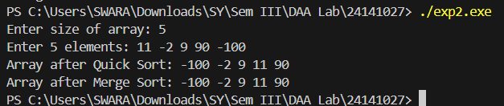
Advantages:
- Both Quick Sort and Merge Sort are based on efficient divide and conquer principles.
- Quick Sort performs in-place sorting, minimizing memory usage.
- Merge Sort guarantees consistent performance and stability.
- Both algorithms exhibit excellent average-case time complexity of O(n log₂ n).
- Highly suitable for large datasets where efficiency is critical.
- Merge Sort is ideal for linked lists and external sorting.
- Quick Sort can outperform other algorithms when pivot selection is optimized.

Disadvantages:
- Quick Sort may degrade to O(n²) performance in the worst case with poor pivot selection.
- Merge Sort requires additional memory, making it less space-efficient.
- Recursive implementation may lead to stack overflow for large datasets.
- Quick Sort is not stable unless specifically modified.
- Merge Sort’s merging process can be computationally expensive for smaller inputs.
- Quick Sort’s efficiency heavily depends on pivot selection strategy.
- Merge Sort has higher constant factors in runtime compared to in-place algorithms.

Applications:
- Used in sorting operations in system libraries and compilers.
- Commonly applied in database query optimization and data indexing.
- Merge Sort is preferred in external sorting for large datasets stored on disk.
- Quick Sort is used in real-time applications where memory usage must be minimized.
- Both algorithms are employed in data preprocessing for machine learning models.
- Merge Sort is useful in parallel computing due to its predictable structure.
- Quick Sort is applied in embedded systems where space optimization is important.

Conclusion:
From this experiment, I learned how Quick Sort and Merge Sort use the divide and conquer approach to efficiently organize data. I understood how pivot selection influences Quick Sort’s performance and how Merge Sort maintains stability through consistent merging. Analyzing their O(n log₂ n) time complexities helped me compare their trade-offs in speed and memory usage for different types of datasets.

EXPERIMENT NO. 03

Title: Knapsack Problem Using Greedy Method
Theory:
The Knapsack problem is a classic optimization problem in which the goal is to select items with given weights and values such that the total value is maximized without exceeding a specified capacity. The problem exists in two main forms: the 0/1 Knapsack and the Fractional Knapsack. The Greedy method is particularly effective for solving the Fractional Knapsack problem, where it is permissible to take fractional parts of items to maximize total profit.
The Greedy algorithm for the Knapsack problem operates by making the locally optimal choice at each step in the hope of reaching the global optimum. Specifically, it calculates the ratio of value to weight (also known as the profit-to-weight ratio) for each item and then selects items in descending order of this ratio. The algorithm continues adding items to the knapsack until it becomes full. If adding the next item exceeds the capacity, only a fractional part of that item is added to fill the remaining space. This approach ensures that the value gained per unit of weight is always maximized at each step.
The implementation begins with sorting the items based on their profit-to-weight ratios. The algorithm then iterates through the sorted list, continuously adding items to the knapsack and updating the total weight and profit. Once the knapsack reaches its capacity, the algorithm stops. The fractional part of the last item, if any, is calculated proportionally to the remaining capacity. This method guarantees an optimal solution for the fractional version because each decision is made based on the most efficient use of available capacity at that moment.
The time complexity of the Greedy method for the Knapsack problem primarily depends on the sorting operation, which takes O(n log₂ n) time, where n is the number of items. The subsequent selection and accumulation steps require linear time, O(n), resulting in an overall time complexity of O(n log₂ n). The space complexity is O(1) if sorting is performed in place, as only a few auxiliary variables are used to store the total profit and capacity.
While the Greedy approach efficiently solves the Fractional Knapsack problem, it fails to produce the optimal solution for the 0/1 Knapsack problem because it cannot account for the combinatorial nature of including or excluding entire items. In 0/1 Knapsack, local optimization does not necessarily lead to global optimization. Nonetheless, the Greedy method remains highly valuable due to its simplicity, speed, and optimality in cases where fractional selection is allowed.

Program:
#include <stdio.h>
void knapsack(int n, float weight[], float profit[], float capacity){
float ratio[20], totalProfit = 0, x[20];
int i, j; float temp;
for (i = 0; i < n; i++)
ratio[i] = profit[i] / weight[i];
for (i = 0; i < n - 1; i++){
for (j = i + 1; j < n; j++){
if (ratio[i] < ratio[j]){
temp = ratio[j];
ratio[j] = ratio[i];
ratio[i] = temp;
temp = weight[j];
weight[j] = weight[i];
weight[i] = temp;
temp = profit[j];
profit[j] = profit[i];
profit[i] = temp;
}
}
}
for (i = 0; i < n; i++)
x[i] = 0.0;
float remaining = capacity;
for (i = 0; i < n; i++) {
if (weight[i] > remaining)
break;
else {
x[i] = 1.0;
totalProfit += profit[i];
remaining -= weight[i];
}
}
if (i < n){
x[i] = remaining / weight[i];
totalProfit += x[i] * profit[i];
}
printf("The result vector is: ");
for (i = 0; i < n; i++)
printf("%.2f ", x[i]);
printf("\nMaximum profit is: %.2f\n", totalProfit);
}
int main(){
float weight[20], profit[20], capacity;
int n, i;
printf("Enter number of items: ");
scanf("%d", &n);
printf("Enter weights of items: ");
for (i = 0; i < n; i++)
scanf("%f", &weight[i]);
printf("Enter profits of items: ");
for (i = 0; i < n; i++)
scanf("%f", &profit[i]);
printf("Enter capacity of knapsack: ");
scanf("%f", &capacity);
knapsack(n, weight, profit, capacity);
return 0;
}
Output:
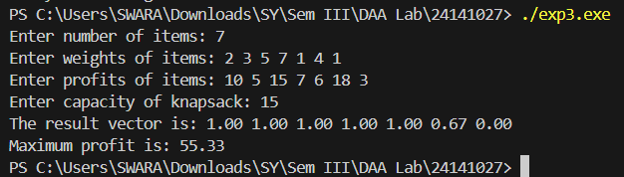
Advantages:
- Provides an optimal solution for the fractional Knapsack problem.
- Easy to implement and computationally efficient.
- Requires less memory compared to dynamic programming methods.
- Runs faster due to its O(n log₂ n) time complexity.
- Intuitive and simple to understand based on local optimization.
Disadvantages:
- Fails to yield the optimal solution for the 0/1 Knapsack problem.
- Dependent on the assumption that items can be divided fractionally.
- May lead to suboptimal solutions if problem conditions violate the Greedy choice property.
- Requires sorting, which adds computational overhead for very large datasets.
- Not adaptable for problems involving complex dependencies among items.
Applications:
- Resource allocation problems where partial allocation is possible.
- Cargo loading and inventory management systems.
- Financial portfolio optimization for maximizing profit-to-risk ratios.
- Data compression and bandwidth management applications.
- Task scheduling and CPU time-sharing systems.
Conclusion:
From this experiment, I learned how the Greedy method efficiently solves the fractional Knapsack problem using the value-to-weight ratio and how its O(n log₂ n) complexity reflects the impact of sorting on optimization.

EXPERIMENT NO. 04

Title: Greedy method to solve problems of Optimal Merge Pattern.
Theory:
The Optimal Merge Pattern problem focuses on minimizing the total cost of merging several sorted files or sequences into a single sorted file. Each merge operation involves a cost equal to the sum of the sizes of the two files being merged. The goal is to determine the sequence of merges that results in the least total cost.
The Greedy method is well-suited for this problem because at each step, it chooses to merge the two smallest files first, ensuring a locally optimal choice that leads to a globally optimal solution. To implement this efficiently, a min-heap (priority queue) is typically used to repeatedly extract the two smallest file sizes and insert their combined size back into the heap until only one file remains.
Implementation Steps:
- Store all file sizes in a min-heap.
- Repeatedly extract the two smallest sizes.
- Merge them, compute the merge cost, and insert the new size back into the heap.
- Accumulate the total cost after each merge.
- Continue until only one element remains in the heap.
Time Complexity Analysis:
If there are n files, each insertion and extraction operation from the min-heap takes O(log n) time. Since n–1 merges are required, the total time complexity is O(n log n). The space complexity is O(n) due to the heap storage requirement.
Program:
#include <stdio.h>
void optimalMerge(int files[], int n){
int totalCost = 0;
for (int i = 0; i < n - 1; i++){
int firstMin = 9999, secondMin = 9999;
int firstIndex = -1, secondIndex = -1;

for (int j = 0; j < n; j++){
if (files[j] != -1 && files[j] < firstMin) {
secondMin = firstMin;
secondIndex = firstIndex;
firstMin = files[j];
firstIndex = j;
}
else if (files[j] != -1 && files[j] < secondMin) {
secondMin = files[j];
secondIndex = j;
}
}
int newFile = firstMin + secondMin;
totalCost += newFile;
files[firstIndex] = newFile;
files[secondIndex] = -1;
}
printf("Minimum total cost of merging files: %d\n", totalCost);
}
int main(){
int n;
printf("Enter number of files: ");
scanf("%d", &n);
int files[n];
printf("Enter sizes of files: ");
for (int i = 0; i < n; i++)
scanf("%d", &files[i]);
optimalMerge(files, n);
return 0;
}
Output:
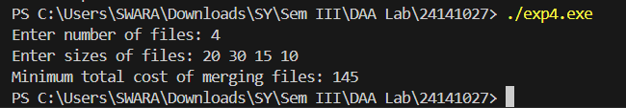
Advantages:
- Guarantees the minimum total cost of merging.
- Efficient in both computation and memory when implemented with a priority queue.
- Simple and systematic due to the Greedy approach.
- Useful for optimizing multi-file merge operations.
- Reduces overall computational time compared to arbitrary merging.
- Flexible and scalable for varying input sizes.
Disadvantages:
- Requires additional memory for maintaining the heap structure.
- Not suitable for problems where global optimization cannot be achieved through local decisions.
- The algorithm’s correctness heavily depends on the sorted property of input sizes.
- Can become inefficient for extremely large datasets if not implemented with an optimized heap.
- Lacks flexibility if merging costs vary based on factors other than size.
- Does not handle dynamic insertion of new files efficiently during execution.
Applications:
- Used in data compression techniques like Huffman coding.
- Applied in file management systems for merging sorted runs.
- Useful in external sorting where multiple sorted lists must be combined.
- Applied in compiler design and database query optimization.
- Used in minimizing total computation time in distributed systems.
- Helpful in network optimization and bandwidth allocation problems.

Conclusion:
From this experiment, I learned how the Greedy approach minimizes merge costs by merging the smallest files first. Implementing the Optimal Merge Pattern deepened my understanding of heap-based optimization and how local choices can lead to globally optimal results
EXPERIMENT NO. 05
Title: Minimum Cost Spanning Tree of a Given Undirected Graph Using Prim’s and Kruskal’s Algorithms
Theory:
A Minimum Spanning Tree (MST) of a connected, undirected, weighted graph is a subset of edges that connects all vertices with the minimum possible total edge weight and without forming any cycles. It has exactly (V − 1) edges, where V is the number of vertices in the graph.
Prim’s Algorithm:
Prim’s algorithm builds a Minimum Spanning Tree (MST) by starting from any vertex and repeatedly adding the smallest edge that connects a vertex in the tree to a vertex outside it. It grows one vertex at a time until all vertices are included. The algorithm uses a greedy approach and is efficient for dense graphs. Common implementations use a priority queue (min-heap) to find the minimum edge efficiently.

Kruskal’s Algorithm:
Kruskal’s algorithm constructs the MST by sorting all edges in non-decreasing order of weight and adding them one by one to the tree, ensuring that no cycle is formed. It also uses a greedy approach and is more efficient for sparse graphs. The Disjoint Set Union (Union-Find) data structure is typically used to detect and prevent cycles during edge addition
Time Complexity Analysis:
- Prim’s Algorithm:
  - Using adjacency matrix → O(V²)
  - Using min-heap (priority queue) → O(E log V)
- Kruskal’s Algorithm:
  - Sorting edges → O(E log E) or O(E log V) (since E ≤ V²)
  - Union-Find operations → O(E log V)
- Space Complexity:
  - Both algorithms require O(V + E) for storing the graph and auxiliary data structures.

Program:
#include <stdio.h>
#define INF 9999
#define MAX 20

void prims(int cost[MAX][MAX], int n){
int selected[MAX] = {0};
int noOfEdges = 0, totalCost = 0;
selected[0] = 1;
printf("\nEdges in MST using Prim's Algorithm:\n");
while (noOfEdges < n - 1) {
int min = INF, x = 0, y = 0;
for (int i = 0; i < n; i++) {
if (selected[i]) {
for (int j = 0; j < n; j++) {
if (!selected[j] && cost[i][j]) {
if (min > cost[i][j]) {
min = cost[i][j];
x = i;
y = j;
}
}
}
}
}
printf("%d - %d : %d\n", x, y, cost[x][y]);
totalCost += cost[x][y];
selected[y] = 1;
noOfEdges++;
}
printf("Total cost using Prim's: %d\n", totalCost);
}
int find(int parent[], int i){
while (parent[i] != i)
i = parent[i];
return i;
}
void unionSet(int parent[], int i, int j){
int a = find(parent, i);
int b = find(parent, j);
parent[a] = b;
}
void kruskal(int cost[MAX][MAX], int n){
int parent[MAX];
int edges = 0, totalCost = 0;
for (int i = 0; i < n; i++)
parent[i] = i;
printf("\nEdges in MST using Kruskal's Algorithm:\n");
while (edges < n - 1){
int min = INF, a = -1, b = -1;
for (int i = 0; i < n; i++){
for (int j = 0; j < n; j++){
if (cost[i][j] < min && i != j) {
min = cost[i][j];
a = i;
b = j;
}
}
}
int u = find(parent, a);
int v = find(parent, b);
if (u != v){
printf("%d - %d : %d\n", a, b, min);
totalCost += min;
unionSet(parent, u, v);
edges++;
}
cost[a][b] = cost[b][a] = INF;
}
printf("Total cost using Kruskal's: %d\n", totalCost);
}
int main(){
int n;
int cost[MAX][MAX];
printf("Enter number of vertices: ");
scanf("%d", &n);
printf("Enter cost adjacency matrix (0 for no edge):\n");
for (int i = 0; i < n; i++) {
for (int j = 0; j < n; j++) {
scanf("%d", &cost[i][j]);
if (cost[i][j] == 0)
cost[i][j] = INF;
}
}
prims(cost, n);
// Reset INF entries for Kruskal
for (int i = 0; i < n; i++)
for (int j = 0; j < n; j++)
if (cost[i][j] == INF)
cost[i][j] = 0;
// Convert back for Kruskal
for (int i = 0; i < n; i++)
for (int j = 0; j < n; j++)
if (cost[i][j] == 0)
cost[i][j] = INF;
kruskal(cost, n);
return 0;
}
Output:
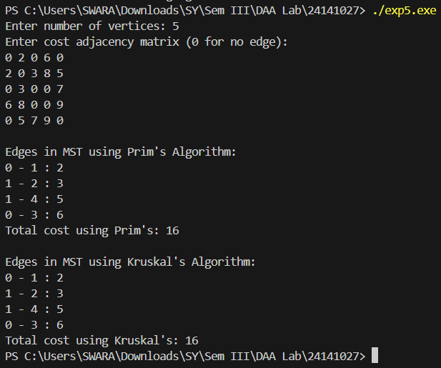
Advantages:
- Both algorithms guarantee an optimal solution for MST.
- Prim’s algorithm is suitable for dense graphs; Kruskal’s for sparse ones.
- The Greedy approach ensures step-by-step optimal edge inclusion.
- Easy to implement using priority queues or Union-Find structures.
- Helps reduce network cost and improve connectivity efficiency.
- Applicable to various real-world optimization problems.
- Flexible with different graph representations (matrix or list).

Disadvantages:
- Prim’s algorithm can be inefficient with sparse graphs if implemented without heaps.
- Kruskal’s requires sorting all edges, which can be time-consuming for large edge sets.
- Both algorithms assume the graph is connected; disconnected graphs need preprocessing.
- Managing cycle detection in Kruskal’s requires careful use of the Union-Find data structure.
- Memory usage can be high for dense graphs due to adjacency matrix representation.

Applications:
- Network design (telephone, electrical, or computer networks).
- Designing cost-efficient road, railway, or pipeline systems.
- Clustering in machine learning (e.g., single-link hierarchical clustering).
- Optimizing communication and data transmission networks.
- Applied in routing protocols and distributed systems.
- Forms the basis for many advanced graph optimization algorithms.

Conclusion:
Through this experiment, I learned how both Prim’s and Kruskal’s algorithms efficiently construct Minimum Spanning Trees using different Greedy strategies. Implementing and comparing them deepened my understanding of their time-space trade-offs and suitability for dense versus sparse graphs. This exercise enhanced my ability to choose the appropriate MST algorithm based on problem constraints.

EXPERIMENT NO. 06

Title: Shortest Paths to Other Vertices Using Dijkstra’s Algorithm from a Given Vertex in a Weighted Connected Graph
Theory:
Dijkstra’s algorithm, proposed by Edsger W. Dijkstra in 1956, is a Greedy-based shortest path algorithm used for finding the minimum distance from a single source vertex to all other vertices in a weighted, connected graph with non-negative edge weights.
The algorithm maintains two sets of vertices: one containing vertices whose minimum distance from the source is already determined, and the other containing remaining vertices. It repeatedly selects the vertex with the smallest tentative distance, updates the distances of its adjacent vertices, and continues until all vertices are processed.
Implementation Approach:
- Initialize distances of all vertices as infinity except the source vertex, which is set to 0.
- Use a min-priority queue (min-heap) to select the vertex with the minimum distance.
- For the selected vertex, relax all adjacent edges—if a shorter path is found, update the distance.
- Repeat until all vertices have been processed.
- The resulting distance array gives the shortest path cost from the source to every vertex.
Time Complexity Analysis:
- Using adjacency matrix: O(V²)
- Using adjacency list and min-heap (priority queue): O((V + E) log V), where V is the number of vertices and E is the number of edges.
Space Complexity:
- O(V + E) for storing the graph and auxiliary structures such as distance array and priority queue.
Program:
#include <stdio.h>
#define INF 9999
#define MAX 20

void dijkstra(int graph[MAX][MAX], int n, int start){
int cost[MAX][MAX], dist[MAX], visited[MAX], count, mindist, nextnode;
for (int i = 0; i < n; i++)
for (int j = 0; j < n; j++)
if (graph[i][j] == 0)
cost[i][j] = INF;
else
cost[i][j] = graph[i][j];
for (int i = 0; i < n; i++) {
dist[i] = cost[start][i];
visited[i] = 0;
}
dist[start] = 0;
visited[start] = 1;
count = 1;
while (count < n - 1) {
mindist = INF;
for (int i = 0; i < n; i++)
if (dist[i] < mindist && !visited[i]) {
mindist = dist[i];
nextnode = i;
}
visited[nextnode] = 1;
for (int i = 0; i < n; i++)
if (!visited[i])
if (mindist + cost[nextnode][i] < dist[i])
dist[i] = mindist + cost[nextnode][i];
count++;
}
printf("\nShortest distances from vertex %d:\n", start);
for (int i = 0; i < n; i++)
if (i != start)
printf("To vertex %d: %d\n", i, dist[i]);
}
int main(){
int n, start;
int graph[MAX][MAX];
printf("Enter number of vertices: ");
scanf("%d", &n);
printf("Enter adjacency matrix (0 for no edge):\n");
for (int i = 0; i < n; i++)
for (int j = 0; j < n; j++)
scanf("%d", &graph[i][j]);
printf("Enter starting vertex: ");
scanf("%d", &start);
dijkstra(graph, n, start);
return 0;
}
Output:
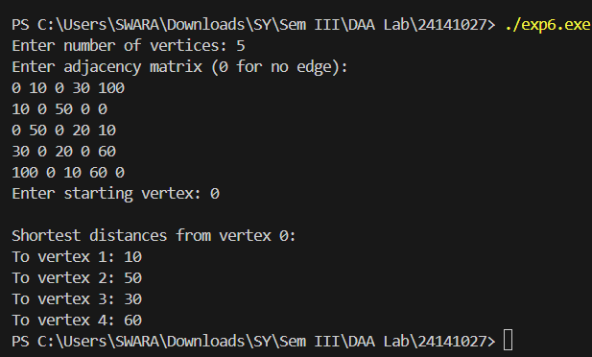
Advantages:
- Guarantees the shortest path in graphs with non-negative edge weights.
- Efficient when implemented with a min-heap or priority queue.
- Works well for both sparse and moderately dense graphs.
- Can be adapted for real-time routing and network optimization.
- Provides optimal results for single-source shortest path problems.
- Forms the foundation for advanced algorithms like A*.

Disadvantages:
- Cannot handle graphs with negative edge weights.
- Becomes computationally expensive for very large graphs.
- Requires additional space for maintaining the priority queue and distance arrays.
- Inefficient for dynamic graphs where edge weights frequently change.
- Does not directly handle multiple-source shortest path problems.
- Complexity increases with dense graphs using adjacency matrices.

Applications:
- Network routing (e.g., Internet packet transmission, GPS navigation).
- Flight and transportation scheduling systems.
- Robot motion planning and pathfinding in AI.
- Communication network optimization.
- Shortest route computation in map-based applications.
- Resource optimization in logistics and supply chains.
- Used in gaming for NPC movement and environment navigation.

Conclusion:
From this experiment, I learned how Dijkstra’s algorithm efficiently determines the shortest paths in a weighted graph using a Greedy strategy. Implementing it enhanced my understanding of priority queues, relaxation techniques, and graph traversal. The time and space complexity analysis deepened my grasp of how algorithmic efficiency depends on graph structure and data representation.
EXPERIMENT NO. 07

Title: Optimal Binary Search Trees Using Dynamic Programming
Theory:
A Binary Search Tree (BST) allows efficient searching, insertion, and deletion operations. However, its performance depends heavily on the structure of the tree. If the BST becomes unbalanced, search operations may degrade to linear time. To overcome this, an Optimal Binary Search Tree (OBST) is constructed to minimize the expected search cost based on the frequency of key accesses.
The Dynamic Programming (DP) approach is ideal for constructing OBSTs because the problem exhibits both optimal substructure and overlapping subproblems. The algorithm computes the minimum cost of searching for keys using a bottom-up method by considering all possible roots for subtrees.
For a set of n ordered keys $K_{1},K_{2},...,K_{n}$with access probabilities $P_{1},P_{2},...,P_{n}$, the goal is to minimize the total search cost:
$$\text{Cost}=\sum_{i=1}^{n}{}P_{i}×(\text{level of }K_{i})$$
The algorithm builds two DP tables — one for the minimum cost and another for the corresponding roots.
By solving all subproblems (i.e., all possible key intervals), the OBST is constructed by selecting the root that yields the least cost for each interval.
Time Complexity Analysis:
The OBST algorithm requires computing the cost for every possible pair of keys, leading to O(n³) time complexity. However, with optimized approaches, it can be reduced to O(n²).
Space Complexity:
Two tables of size n × n are required for storing costs and roots, giving O(n²) space complexity.
Program:
#include <stdio.h>
#include <limits.h>
#define MAX 10
int main() {
int n, i, j, k;
float p[MAX], q[MAX], w[MAX][MAX], c[MAX][MAX];
int r[MAX][MAX];
printf("Enter number of keys: ");
scanf("%d", &n);
printf("Enter probabilities for successful searches (p1 to p%d):\n", n);
for (i = 1; i <= n; i++)
scanf("%f", &p[i]);
printf("Enter probabilities for unsuccessful searches (q0 to q%d):\n", n);
for (i = 0; i <= n; i++)
scanf("%f", &q[i]);
for (i = 0; i <= n; i++) {
w[i][i] = q[i];
c[i][i] = 0;
r[i][i] = 0;
}
for (i = 0; i < n; i++) {
w[i][i + 1] = q[i] + q[i + 1] + p[i + 1];
c[i][i + 1] = w[i][i + 1];
r[i][i + 1] = i + 1;
}
for (int m = 2; m <= n; m++) {
for (i = 0; i <= n - m; i++) {
j = i + m;
w[i][j] = w[i][j - 1] + p[j] + q[j];
float min = INT_MAX;
int kmin = 0;

for (k = i + 1; k <= j; k++) {
float cost = c[i][k - 1] + c[k][j];
if (cost < min) {
min = cost;
kmin = k;
}
}
c[i][j] = w[i][j] + min;
r[i][j] = kmin;
}
}
printf("\nMinimum cost of OBST = %.2f\n", c[0][n]);
printf("\nRoot Table (r[i][j]):\n");
for (i = 0; i <= n; i++) {
for (j = 0; j <= n; j++)
printf("%d\t", r[i][j]);
printf("\n");
}
return 0;
}
Output:
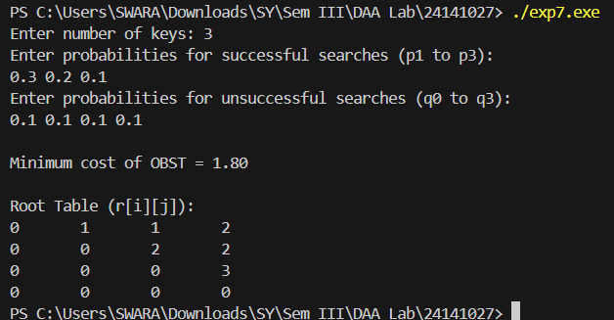
Advantages:
- Ensures minimum expected search cost for given access probabilities.
- Provides optimal performance for static search operations.
- Demonstrates the power of Dynamic Programming in optimization.
- Prevents performance degradation due to unbalanced trees.
- Offers predictable search efficiency compared to random BSTs.
- Useful in compiler and database applications where key frequencies are known.
- Facilitates systematic computation through subproblem reuse.
Disadvantages:
- Implementation is complex due to multiple nested loops and table construction.
- High time complexity (O(n³)) for large datasets.
- Requires prior knowledge of access probabilities.
- Space requirements increase quadratically with input size.
- Inefficient for dynamically changing data or insertion/deletion-heavy systems.
Applications:
- Used in compiler design for efficient symbol table lookups.
- Applied in database query optimization where key access probabilities are known.
- Improves search efficiency in static dictionaries.
- Useful in text compression and information retrieval systems.
- Applied in decision-making systems where access frequency impacts cost.
- Forms the basis for predictive search and autocomplete algorithms.
Conclusion:
Through this experiment, I learned how Dynamic Programming can be applied to construct an Optimal Binary Search Tree that minimizes expected search cost. Implementing the OBST enhanced my understanding of overlapping subproblems and optimal substructure. Analyzing its time and space complexities helped me appreciate the trade-off between computational efficiency and optimality in algorithm design.

EXPERIMENT NO. 08
Title: All-Pairs Shortest Paths Problem using Floyd's algorithm.
Aim:
To implement Floyd’s algorithm to find the shortest paths between all pairs of vertices in a weighted graph and analyze its time and space complexity.
Theory:
The All-Pairs Shortest Path (APSP) problem aims to find the shortest paths between every pair of vertices in a weighted graph. Floyd’s algorithm, also known as the Floyd–Warshall algorithm, provides an efficient Dynamic Programming-based solution for this problem. It systematically updates a distance matrix that stores the shortest known distances between vertex pairs, gradually improving it by considering intermediate vertices.
Initially, the algorithm assumes that the shortest path between any two vertices i and j is the direct edge weight $w(i,j)$. It then iteratively checks whether including another vertex k as an intermediate point yields a shorter path. This process is repeated for all vertices as intermediates.
Mathematically, the recursive relation used is:
$$D[i][j]=min⁡(D\left[i\right]\left[j\right], D\left[i\right]\left[k\right]+D[k][j]$$
where $D[i][j]$represents the current shortest distance from vertex i to vertex j.
The algorithm uses a distance matrix of size V × V, where V is the number of vertices, and progressively refines the shortest path estimates. It works for both directed and undirected graphs, provided there are no negative weight cycles.
Time Complexity Analysis:
Floyd’s algorithm requires three nested loops, each running V times, resulting in a time complexity of O(V³).
Space Complexity:
It maintains a V × V distance matrix, giving a space complexity of O(V²).
Program:
#include <stdio.h>
#define INF 99999
#define MAX 10
int main() {
int n, i, j, k;
int dist[MAX][MAX];
printf("Enter number of vertices: ");
scanf("%d", &n);
printf("Enter the adjacency matrix (use %d for infinity):\n", INF);
for (i = 0; i < n; i++)
for (j = 0; j < n; j++)
scanf("%d", &dist[i][j]);
for (k = 0; k < n; k++) {
for (i = 0; i < n; i++) {
for (j = 0; j < n; j++) {
if (dist[i][k] + dist[k][j] < dist[i][j])
dist[i][j] = dist[i][k] + dist[k][j];
}}}
printf("\nAll-Pairs Shortest Path Matrix:\n");
for (i = 0; i < n; i++) {
for (j = 0; j < n; j++) {
if (dist[i][j] == INF)
printf("INF\t");
else
printf("%d\t", dist[i][j]);}
printf("\n");}
return 0;}
Output:
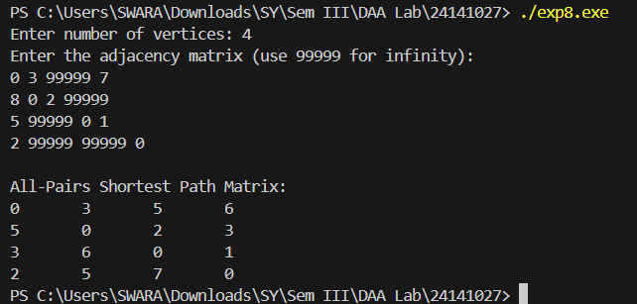
Advantages:
- Provides shortest paths between every pair of vertices in a single execution.
- Straightforward to implement using matrix representation.
- Works for both directed and undirected weighted graphs.
- Handles negative edge weights (but not negative cycles).
- Demonstrates the efficiency of Dynamic Programming in graph problems.
- Useful for dense graphs where other algorithms may require repeated computations.
Disadvantages:
- High time complexity (O(V³)) makes it unsuitable for very large graphs.
- Cannot handle graphs containing negative weight cycles.
- Requires substantial memory for storing the distance matrix.
- Inefficient for sparse graphs compared to repeated Dijkstra’s algorithm.
- Lacks flexibility for dynamic graphs where edges are frequently updated.
- Does not record actual path sequences unless a separate predecessor matrix is maintained.
Applications:
- Network routing for determining the shortest communication paths.
- Transportation and logistics for computing all-route distances.
- Flight scheduling and traffic flow analysis.
- Urban planning and navigation system optimization.
- Analysis of social network connectivity.
- Used in compiler optimization for control flow graphs.
- Helps detect the presence of negative cycles in weighted graphs.

Conclusion:
From this experiment, I learned how Floyd’s algorithm systematically computes shortest paths between all vertex pairs using Dynamic Programming principles. Implementing it deepened my understanding of matrix-based iterative refinement and its trade-off between simplicity and computational cost. Analyzing the O(V³) time and O(V²) space complexities clarified its suitability for smaller, dense graphs.
EXPERIMENT NO. 09

Title: Single Source Shortest Path Problem
Aim:
To implement and analyze algorithms for solving the Single Source Shortest Path (SSSP) problem in a weighted graph and evaluate their time and space complexities.
Theory:
The Single Source Shortest Path (SSSP) problem aims to find the shortest paths from one specified vertex (the source) to all other vertices in a weighted graph. The main objective is to minimize the total edge weight along each path. Depending on the nature of the graph (positive or negative weights), different algorithms are used to solve this problem.
For graphs with non-negative edge weights, Dijkstra’s algorithm is the preferred choice. It employs a Greedy approach, repeatedly selecting the vertex with the minimum tentative distance and updating the distances of its adjacent vertices using the relaxation technique. This continues until all vertices have been processed, ensuring that each vertex’s shortest distance from the source is determined.
For graphs that may contain negative edge weights, Bellman-Ford’s algorithm is used. It follows a Dynamic Programming approach, relaxing all edges V–1 times (where V is the number of vertices) to find the shortest paths. It can also detect the presence of negative weight cycles, which Dijkstra’s algorithm cannot handle.
Time Complexity Analysis:
- Dijkstra’s Algorithm:
  - With adjacency matrix → O(V²)
  - With adjacency list and min-heap → O((V + E) log V)
- Bellman-Ford Algorithm:
  - O(V × E), since it relaxes all edges (E) for (V–1) iterations.
Space Complexity:
- For both algorithms, space complexity is O(V + E) due to storage of distance arrays and graph representation.
Program:
#include <stdio.h>
#define INF 99999
#define MAX 10

int main() {
int n, i, j, src, min, u;
int cost[MAX][MAX], dist[MAX], visited[MAX];
printf("Enter number of vertices: ");
scanf("%d", &n);
printf("Enter the adjacency matrix (use %d for infinity):\n", INF);
for (i = 0; i < n; i++)
for (j = 0; j < n; j++)
scanf("%d", &cost[i][j]);
printf("Enter the source vertex: ");
scanf("%d", &src);
for (i = 0; i < n; i++) {
dist[i] = cost[src][i];
visited[i] = 0;
}
dist[src] = 0;
visited[src] = 1;
for (i = 1; i < n - 1; i++) {
min = INF;
for (j = 0; j < n; j++) {
if (dist[j] < min && !visited[j]) {
min = dist[j];
u = j;
}
}
visited[u] = 1;
for (j = 0; j < n; j++) {
if (!visited[j] && dist[u] + cost[u][j] < dist[j])
dist[j] = dist[u] + cost[u][j];
}
}
printf("\nShortest distances from vertex %d:\n", src);
for (i = 0; i < n; i++) {
if (dist[i] == INF)
printf("To %d: INF\n", i);
else
printf("To %d: %d\n", i, dist[i]);
}
return 0;
}
Output:
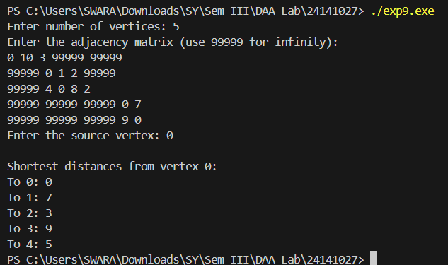
Advantages:
- Provides the shortest path from a single source to all other vertices.
- Dijkstra’s algorithm efficiently handles non-negative weighted graphs.
- Bellman-Ford algorithm can detect and handle negative weight edges.
- Helps in optimizing resource usage and path planning.
- Useful for both directed and undirected weighted graphs.
- Offers deterministic and repeatable results.
- Strengthens understanding of Greedy and Dynamic Programming paradigms.

Disadvantages:
- Dijkstra’s algorithm fails when negative edge weights are present.
- Bellman-Ford has higher time complexity for large graphs.
- Requires additional memory for storing edge and vertex information.
- Inefficient for dynamic graphs with frequent updates.
- Both algorithms assume connected graphs for meaningful output.
- May not scale well for very dense or high-dimensional graphs.

Applications:
- Network routing and communication systems.
- GPS navigation and map-based pathfinding.
- Traffic and logistics optimization.
- Airline and railway route cost minimization.
- Resource allocation in distributed systems.
- Project scheduling and dependency management.
- Used in AI pathfinding and game development.

Conclusion:
From this experiment, I learned how Single Source Shortest Path algorithms compute optimal routes from one vertex to all others in a graph. Implementing Dijkstra’s and Bellman-Ford algorithms enhanced my understanding of Greedy and Dynamic Programming approaches. I also gained insight into how edge weights affect algorithm choice and the trade-offs between speed and flexibility.

EXPERIMENT NO. 10

Title: 8-Queen's problem using Back Tracking.
Theory:
The 8-Queen’s problem is a classic example of a constraint satisfaction problem where the goal is to place eight queens on an 8×8 chessboard such that no two queens attack each other. This means that no two queens share the same row, column, or diagonal.
The Backtracking approach is used to solve this problem systematically. It builds the solution incrementally, placing one queen at a time in a valid position. At each step, it checks whether the current placement leads to a conflict. If it does, the algorithm backtracks—removing the last placed queen—and tries the next possible position. This continues until all queens are successfully placed or all possibilities are exhausted.
The recursive structure of the backtracking algorithm explores all possible configurations of queens while pruning invalid branches early, which significantly reduces computation.
Algorithm Steps:
- Place a queen in the first column.
- Move to the next column and place the queen in the first safe row.
- If no safe position is available, backtrack to the previous column.
- Repeat until all queens are placed safely on the board.
- Print or store the solution.
Time Complexity Analysis:
The worst-case time complexity of the 8-Queen’s problem using backtracking is O(N!), where N is the number of queens. This is because the algorithm may explore all possible placements before finding valid solutions. However, pruning reduces the average complexity significantly.
Space Complexity:
The space complexity is O(N) due to the recursive call stack and storage of the board configuration.

Program:
#include <stdio.h>
#include <stdlib.h>
#define N 8
int board[N][N];
void printSolution() {
int i, j;
printf("\nOne possible solution:\n");
for (i = 0; i < N; i++) {
for (j = 0; j < N; j++)
printf("%d ", board[i][j]);
printf("\n");
}
}
int isSafe(int row, int col) {
int i, j;
for (i = 0; i < col; i++)
if (board[row][i])
return 0;
for (i = row, j = col; i >= 0 && j >= 0; i--, j--)
if (board[i][j])
return 0;
for (i = row, j = col; j >= 0 && i < N; i++, j--)
if (board[i][j])
return 0;
return 1;
}
int solveNQUtil(int col) {
if (col >= N)
return 1;
for (int i = 0; i < N; i++) {
if (isSafe(i, col)) {
board[i][col] = 1;
if (solveNQUtil(col + 1))
return 1;
board[i][col] = 0; // Backtrack
}
return 0;
}
int main() {
if (!solveNQUtil(0)) {
printf("No solution exists.\n");
return 0;
}
printSolution();
return 0;
}
Output:
return 0;
}
int main() {
if (!solveNQUtil(0)) {
printf("No solution exists.\n");
return 0;
}
printSolution();
return 0;
}
Output:
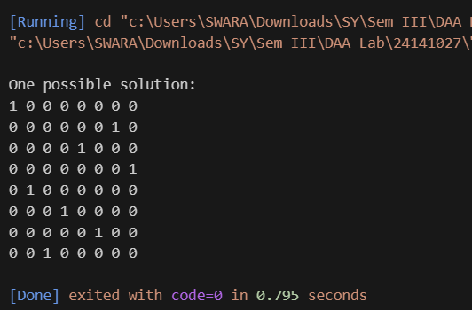

Advantages:
- Guarantees a correct and complete solution if one exists.
- Demonstrates the power of recursive problem-solving.
- Efficiently prunes infeasible solutions through constraints.
- Simple to understand and implement for small-scale problems.
- Can be generalized for other constraint satisfaction problems.
- Allows enumeration of all possible valid configurations.
- Provides insight into the structure of solution spaces.
Disadvantages:
- Computationally expensive for large problem sizes due to exponential growth.
- High recursion depth increases memory usage.
- May take significant time if pruning conditions are weak.
- Inefficient for real-time or large-scale combinatorial problems.
- Requires careful implementation to avoid redundant computations.
- Not suitable for problems where heuristic optimization is needed.
Applications:
- Constraint satisfaction problems such as Sudoku, N-Queens, and crosswords.
- Solving puzzles and games involving placement or arrangement.
- Pathfinding problems in robotics and AI.
- Scheduling and resource allocation under constraints.
- Circuit design and layout optimization.
- AI search algorithms involving state-space exploration.
Conclusion:
From this experiment, I learned how the backtracking technique systematically explores solution spaces by applying constraints and pruning invalid paths. Implementing the 8-Queen’s problem deepened my understanding of recursion and combinatorial search strategies. Analyzing its O(N!) time complexity helped me appreciate the trade-off between completeness and computation

