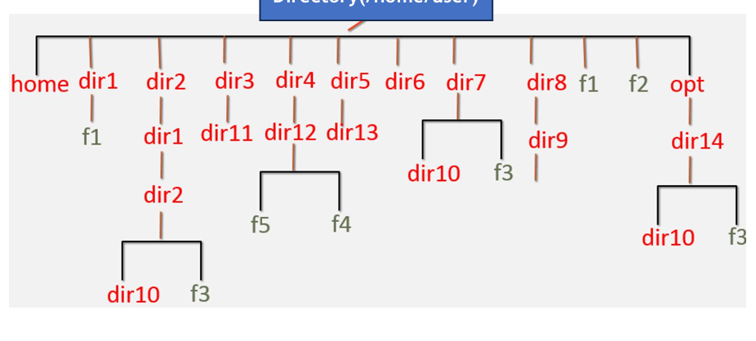

To create above mentioned structure, we have used commands as follow:
- mkdir : to create the directory
- touch : to create the file
- tree : to view the structure
- cd: to travel from one directory to other

Output:
