Lab 1: Team Collaboration – Missing Changes Scenario:
You and your teammate are working on the same project. Your teammate pushed an update to the README.md file directly to GitHub. You already made local changes to the same file but haven’t committed yet
Step 1: Clone the repository from GitHub.
git clone git@github.com:pranalpatankar0510-a11y/git_assignment_classroom.git

Step 2: Edit the README.md locally (don’t commit yet).
Changes in v-code in file locally
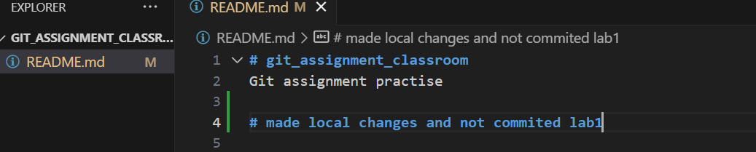
Verify the file is modified or not using
$ git status
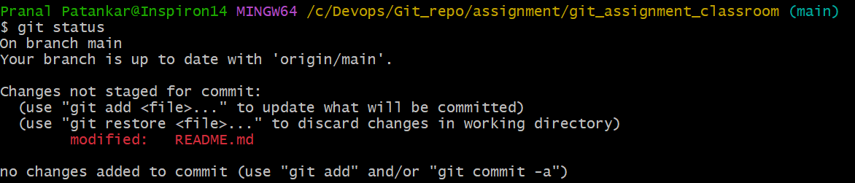

Step 3: Try to run git pull and observe the error.
Teammate directly made changes in readme.md on remote(GitHub).

Used git log –oneline to verify the last commit is not present in local repo.
Run git pull to verify the error, merge got abort and suggested to use git stash.
$ git pull
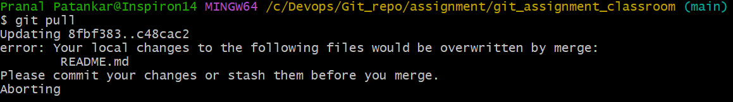
Step 4: Use git stash to save your local changes.
Check the status after error using git status.
Used git stash to save the incomplete file.
$ git stash
After running the git stash check the status using git status and working tree is clean
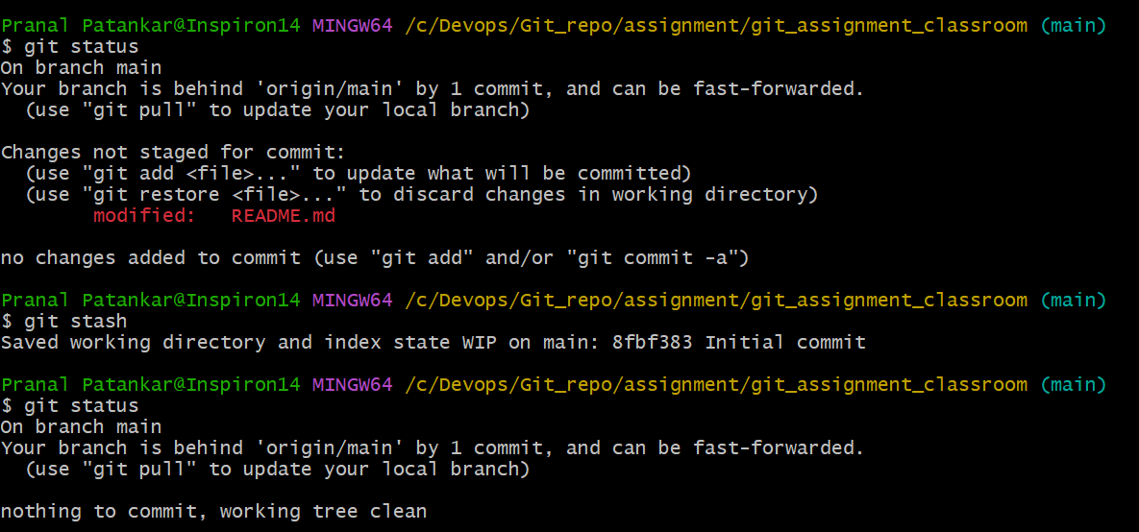
Step 5: Run git pull again to fetch the teammate’s changes.
$ git pull : Pull is successful and now remote changes are present in local repo.
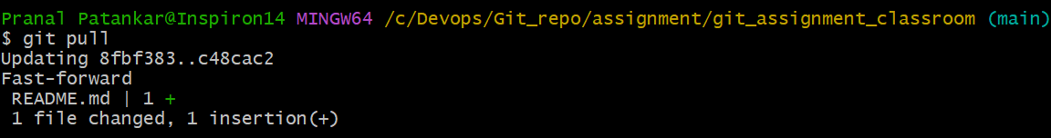
git log –oneline : to verify the logs.
Step 6: Apply your stashed changes and resolve any conflicts.
$ git stash pop : to unsaved the previous stash file.
Also we can use $ git stash apply : to reapply the unsaved changes in local file.
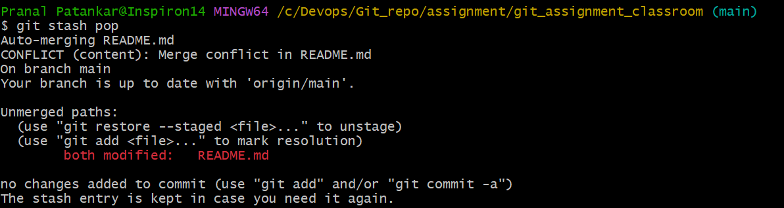
Conflict of local and remote
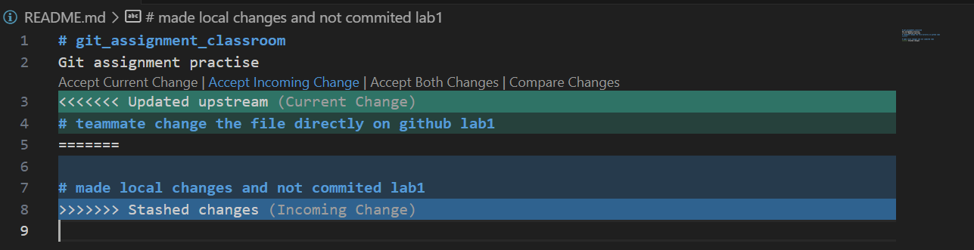
Resolve the conflict in vcode and accepted both the changes.
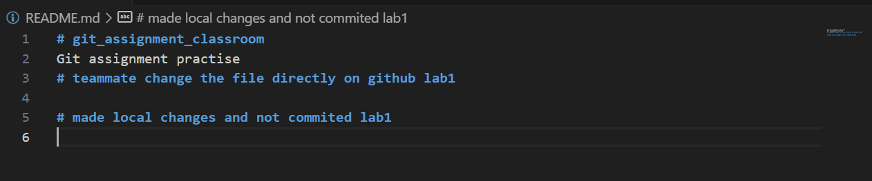

Step 7: Commit and push the final version.
$ git status : Verify the modified file is available in local repo.
$ git add README.md : Added the modified file in the staging area and ready for the commit.
$ git commit -m "Merged the readme.md file and resolved the conflict" : Resolved the conflict, accepted both the changes and file is in staging area. So use the commit and added the message and committed in the local repo

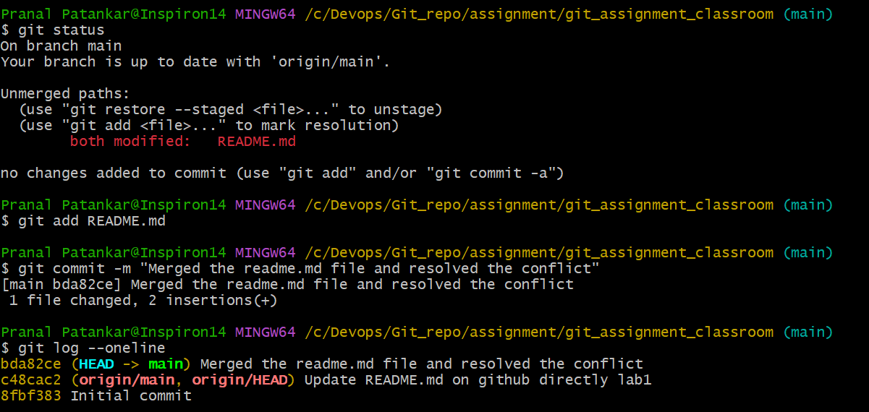
$ git push : used to push the latest changes on remote.
