Lab 2: Hotfix on Production Branch
A bug is reported in production. You need to fix it urgently without disrupting ongoing feature development.
Step 1: Clone the repo and checkout the main branch (production).
$ git clone <url> is use for clone, here we already did the git clone for the lab1 so used, $ git pull from main to take the latest change.
Step 2: Create a new branch called hotfix/urgent-bug.
$ git checkout -b hotfix : hotfix branch created to deliver the urgent bug.
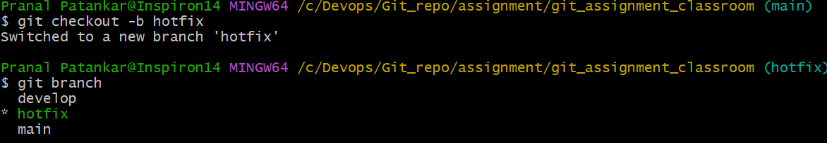

Step 3: Make a fix in app.js and commit it.
$ git status
$ git add app.js
$ git commit -m “urgent hot fix has been delivered through hotfix branch lab2”
$git log –oneline : to verify the logs and commits on local repo.
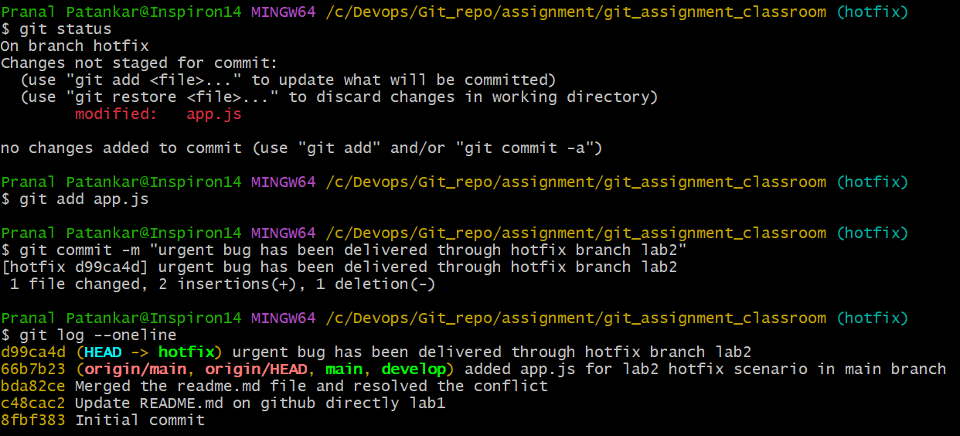

Step 4: Push the hotfix branch to GitHub.
$ git push --set-upstream origin hotfix : use this command to push the local branch to remote.
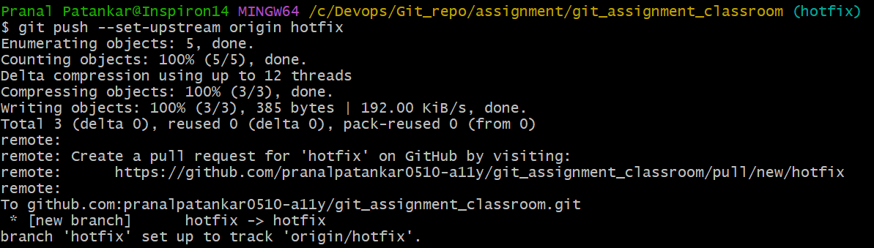
GitHub verification:
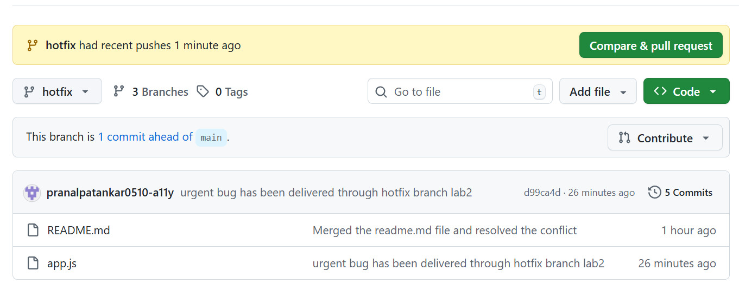
Step 5: Merge the hotfix branch into main locally.
$ git switch main : switch to main branch where we need to merge the hotfix changes
$ git merge hotfix : git merge used to merge the hotfix branch into the main, to use the merge command with the branch we need to present in the source branch, here we need to merge the hotfix branch with the main, so we have to be present in the main branch before initiating merging command.
$ git log –oneline : this command is used to verify the main branch merge is completed or not.
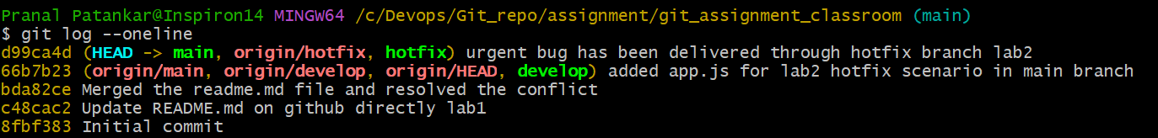
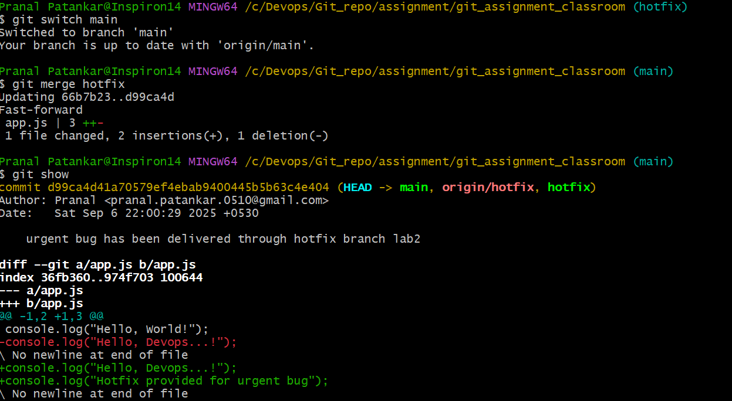

Step 6: Push the updated main to GitHub.
$ git push
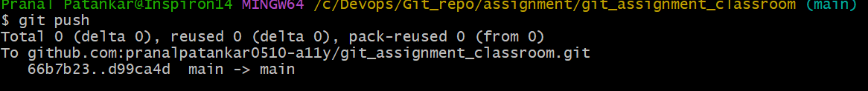

7. Also merge the fix into the develop branch to keep branches in sync
$ git switch develop
To sync the changes in develop branch: $ git merge hotfix
$ git push : after sync in local repo, push the changes on remote repo also to be in the sync.

