Lab 3: Feature Development with Merge Conflict
Scenario:
Two developers work on the same feature but update the same line of code in config.json. You must handle the conflict when merging.
Step 1: Create a branch feature/payment-gateway.
$ git checkout -b payment_gateway : use this command to create the branch
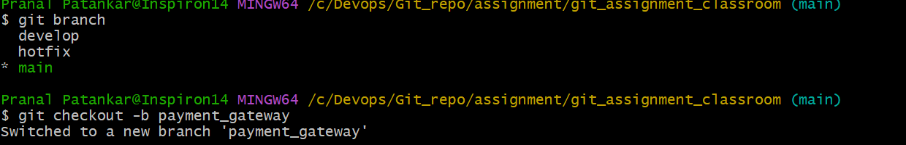
Step 2: Edit config.json to add payment settings and commit.
Changes in config.js in vcode.
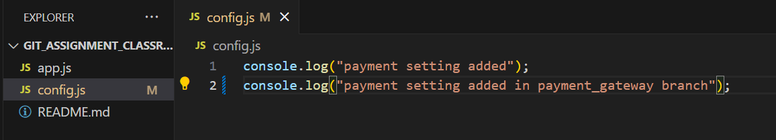
$ git status
$ git add .
$ git commit -m "payment setting added in config.js in payment_gateway branch for lab3" : check the changes on git and commit it on local repo using command.
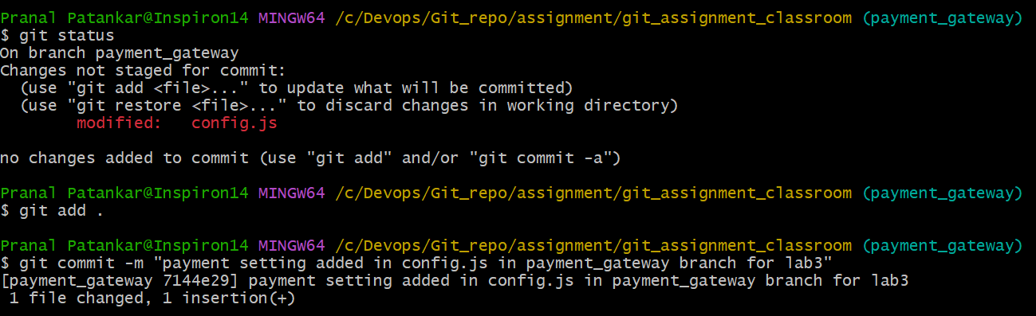
Step 3: Switch to main and also edit the same line in config.json , Commit changes.
$ git switch main :use for switch to main branch
$ git status
$ git add config.js
$ git commit -m "payment setting added in config.js in main branch for lab3" : to commit the changes in config.js in main branch

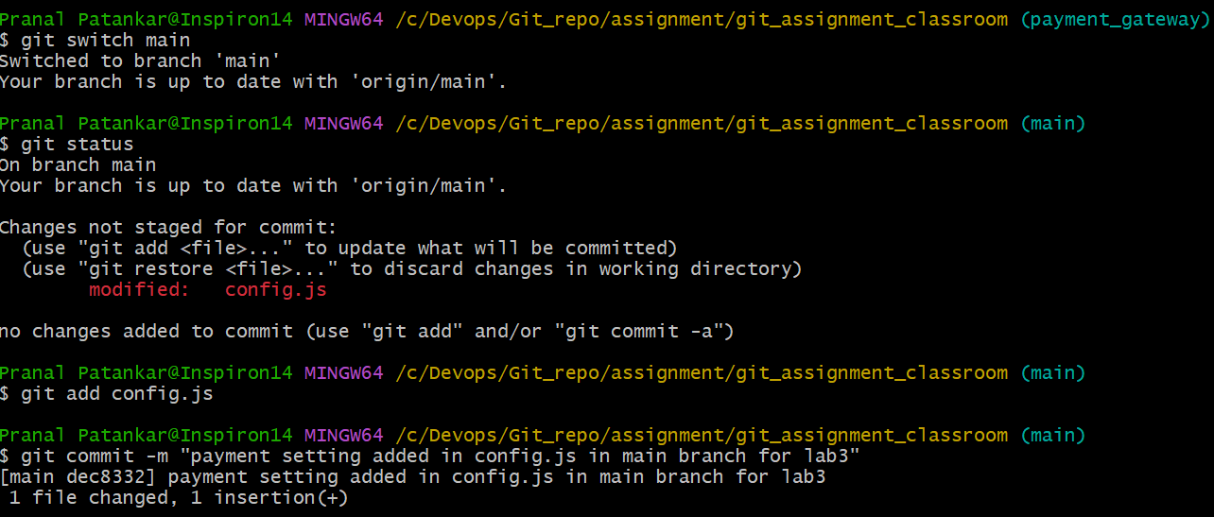
Step 4: Try merging feature/payment-gateway into main.
$ git merge payment_gateway : while merging observe the conflict.
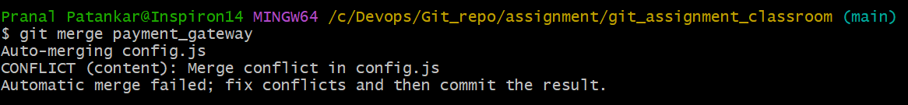
Step 5: Resolve the merge conflict manually.
Solve the conflict in vcode via accepting the both changes manually.
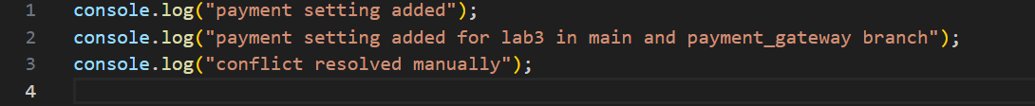
Step 6: Commit the resolution and push to GitHub.
$ git status
$ git add config.js
$ git commit -m "resolve the conflict for lab3 and merge the main branch with payment_gateway" : commit the file after solving the conflict in main branch.
$ git push
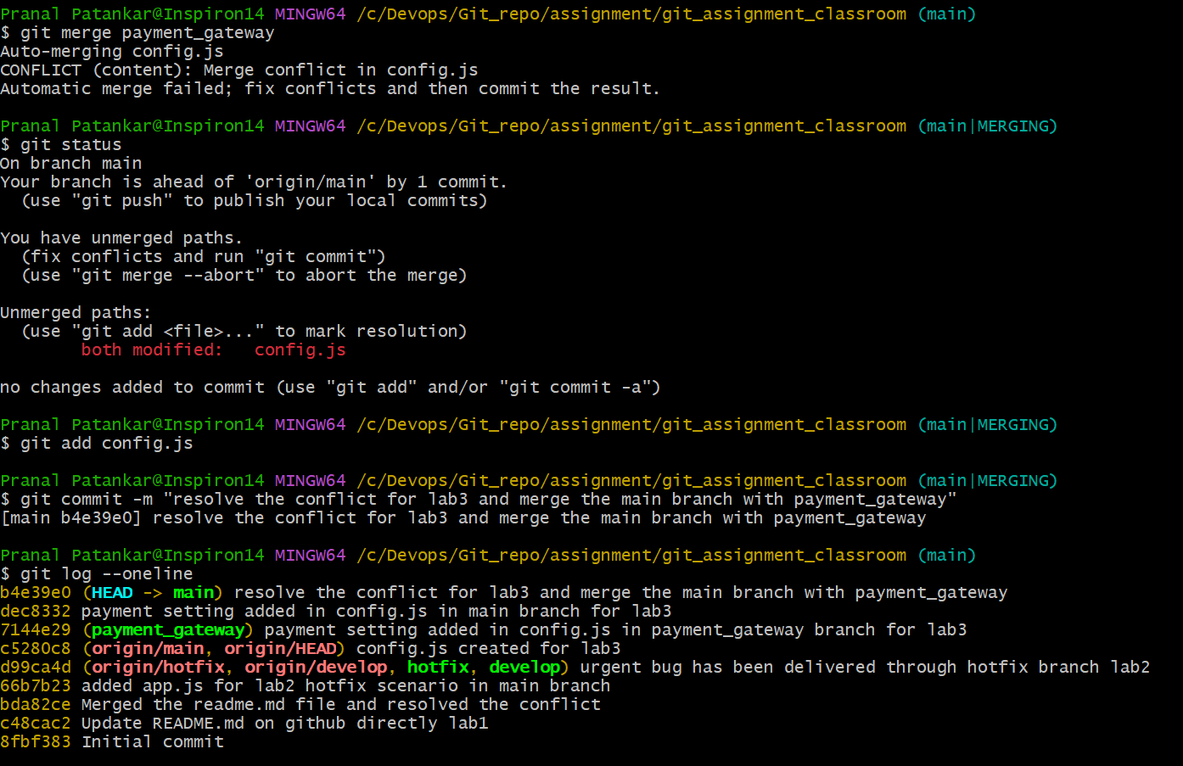
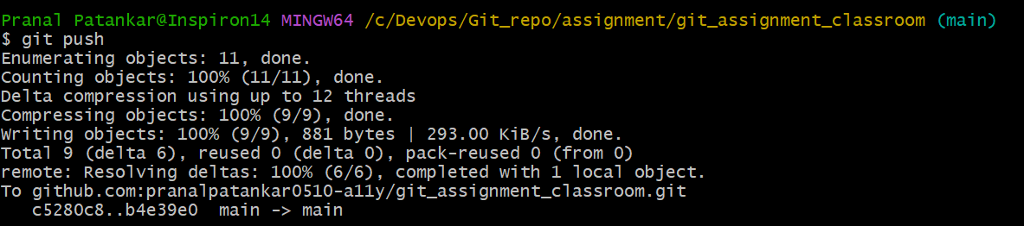

After resolving the same in main branch also pushed the newly created local payment_gateway branch to GitHub
