Lab 5: Working with Multiple Branches
Scenario: Your project uses Git Flow. New features are developed on feature branches, merged into develop, and only stable code is merged into main.
Step 1. Clone the repository.
Repository is already cloned for earlier assignment, so instead of clone used git pull to fetch the latest changes.
Step 2. Create a branch feature/user-profile.
Step 3. Add a new file profile.html and commit.
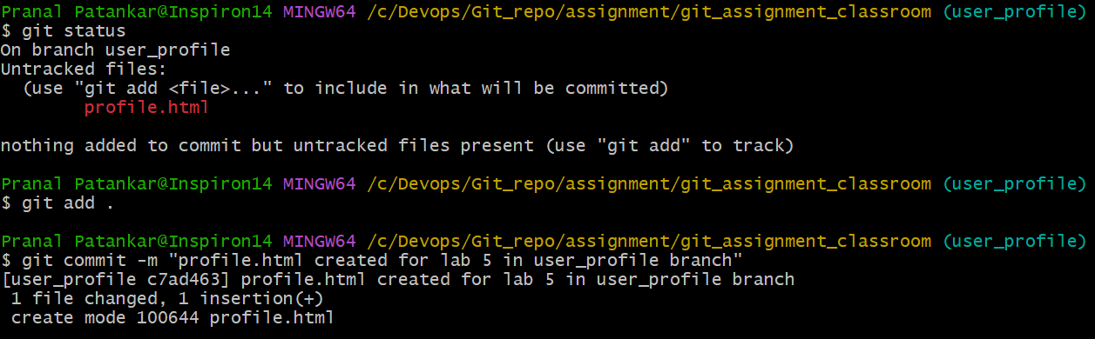
Step 4. Push the branch to GitHub.
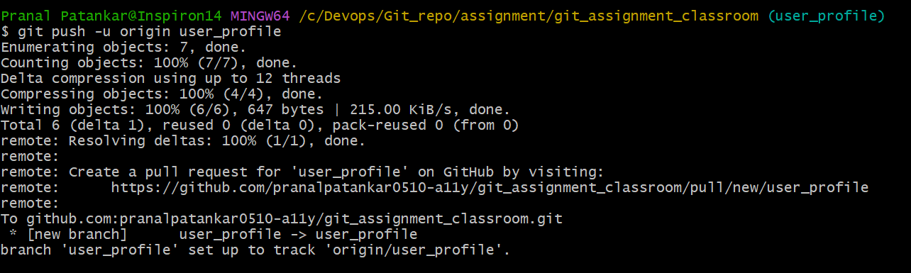
Step 5. Merge feature/user-profile into develop.
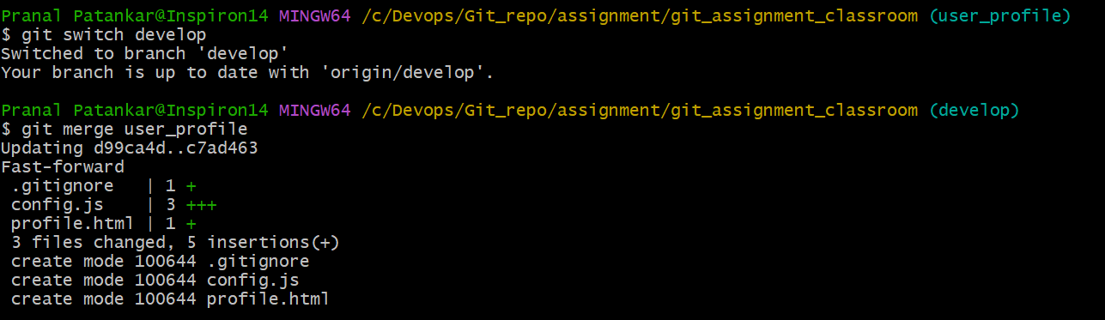
Step 6. Push the updated develop branch.
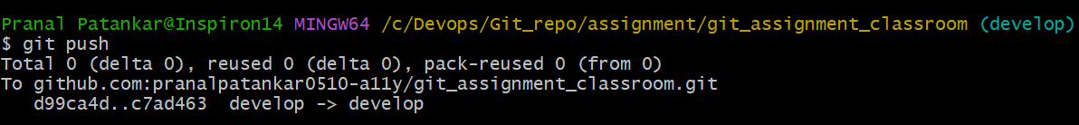
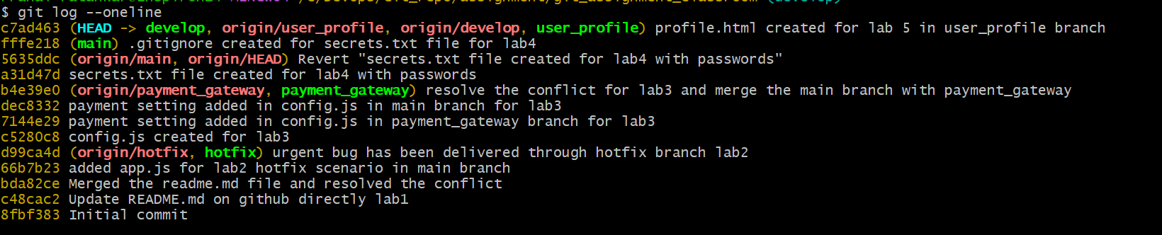
Step 7. After testing, merge develop into main.
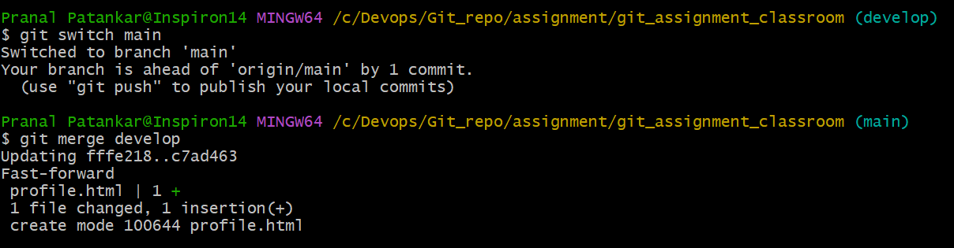
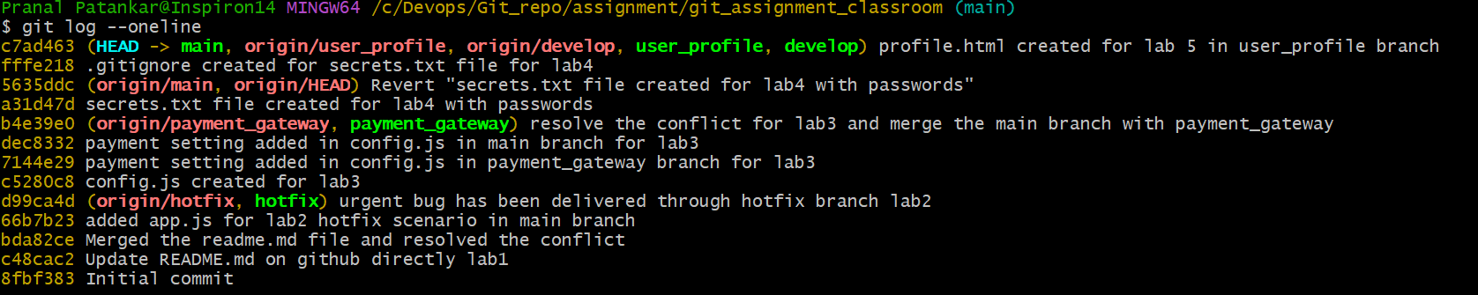
Step 8. Tag the new release as v1.1.0 and push the tag.
$ git tag v.1.1.0 : used git tag command for lightweights tag
$ git push origin –tags: used to push the tags on github.
We can also view the tag using git tag –list command on local and also use git tag -a for annotation tags,

