Lab 6: Stash for Quick Fix
Scenario: You’re working on a half-done feature when your manager asks for a quick fix on main. You don’t want to lose your unfinished changes.
Step 1. On the feature/new-dashboard branch, make some unfinished edits.
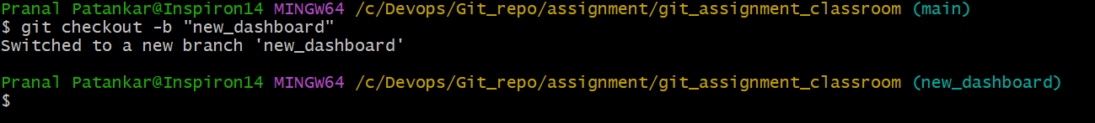
Step 2. Run git stash to save work temporarily.
$ git stash
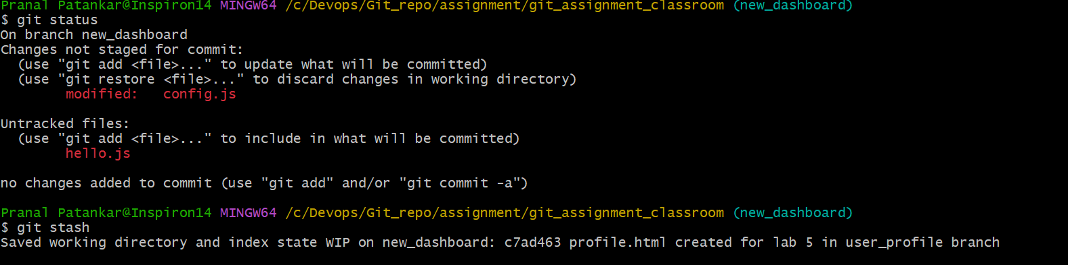
Step 3. Switch to main and apply the fix in bugfix.js. Commit and push it.
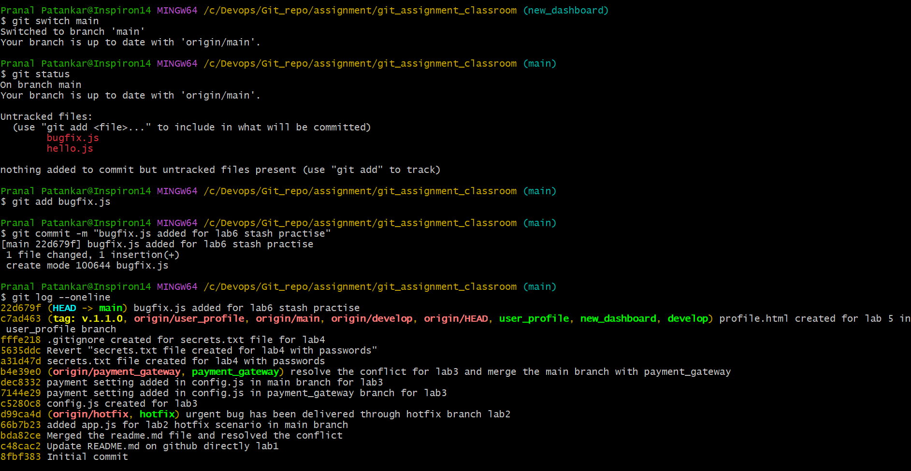
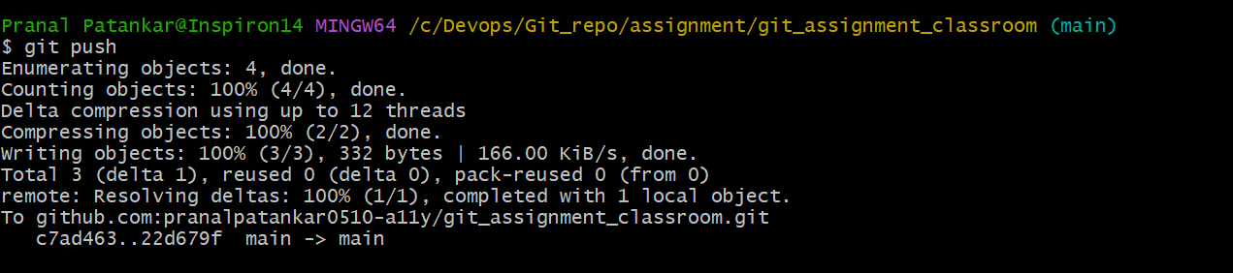
Step 4. Switch back to feature/new-dashboard.
Step 5. Apply your stashed changes.
$ git stash pop

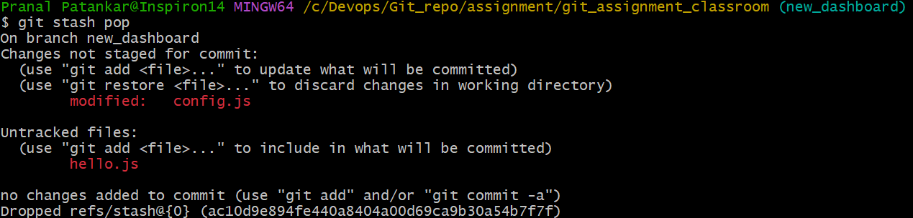
Step 6. Continue coding and commit when ready.
