Lab 7: Syncing Forked Repository
Scenario: You forked an open-source project but your fork is outdated compared to the original repository. You need to sync it.
Step 1. Fork a repo on GitHub.
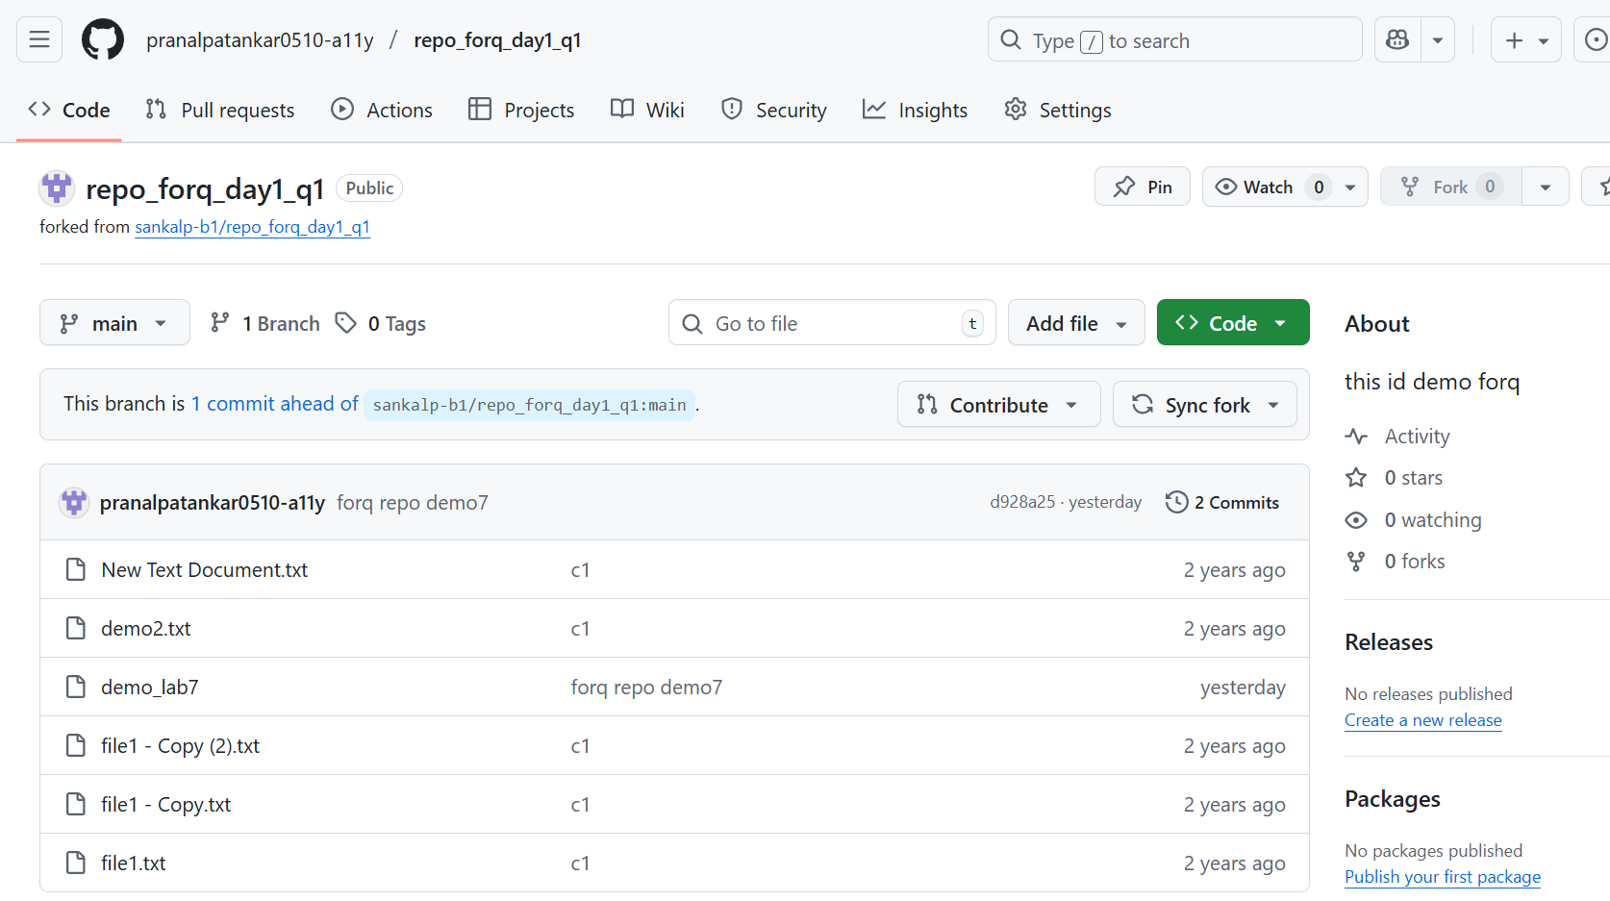
Step 2. Clone your fork locally.
Using git clone command setup the local repo for fork repo.
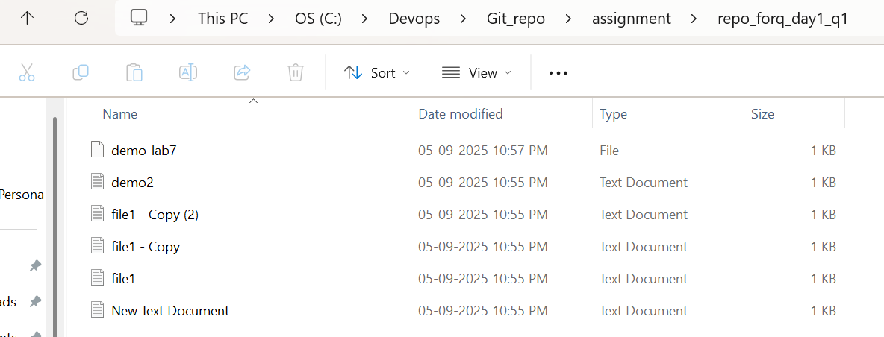

Step 3. Add the original repo as an upstream remote.
Added the same using git clone.

Step 4. Fetch updates from upstream.
Used git fetch to check the updates in fork.
Step 5. Merge upstream main into your fork’s main.
Git push -u origin main command is used for upstream the main local to fork repo.
Step 6. Push the updated code to your fork on GitHub
