Lab 4: Undoing Mistakes
Scenario: You accidentally committed a password in a file and pushed it to GitHub. Now you must undo it correctly.
Step 1. Create a file secrets.txt with dummy password.
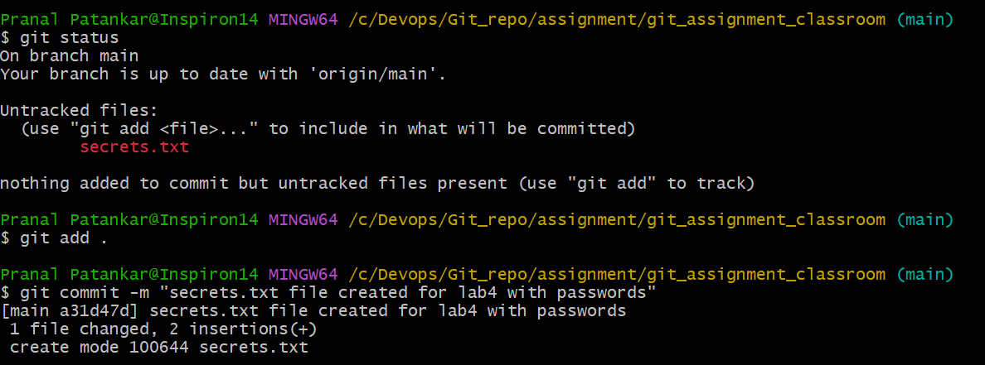
Step 2. Commit and push it to GitHub.
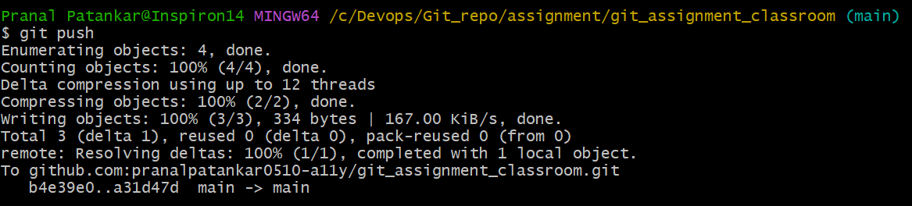
Step 3. Realize it’s a mistake.
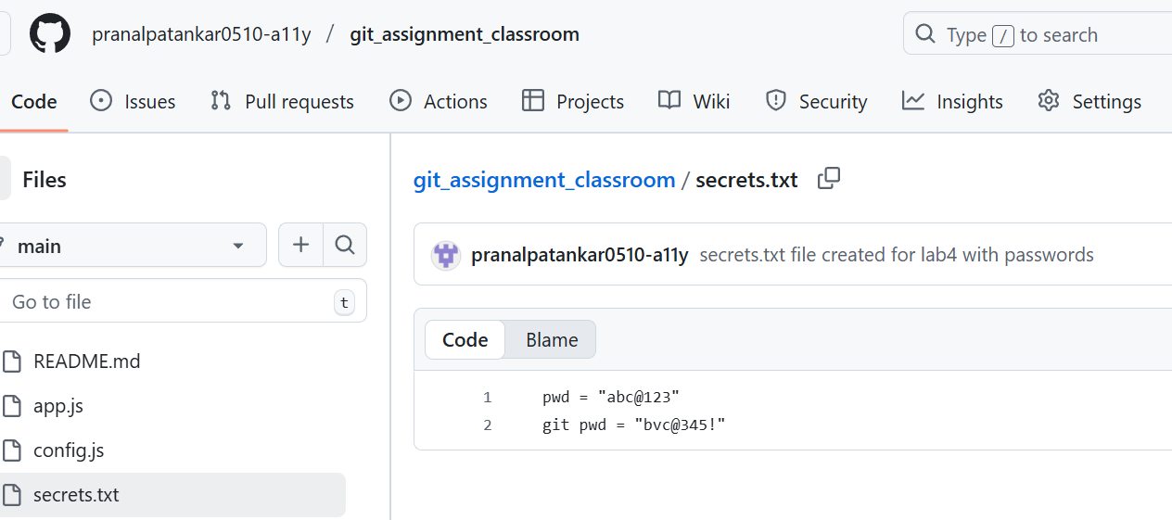
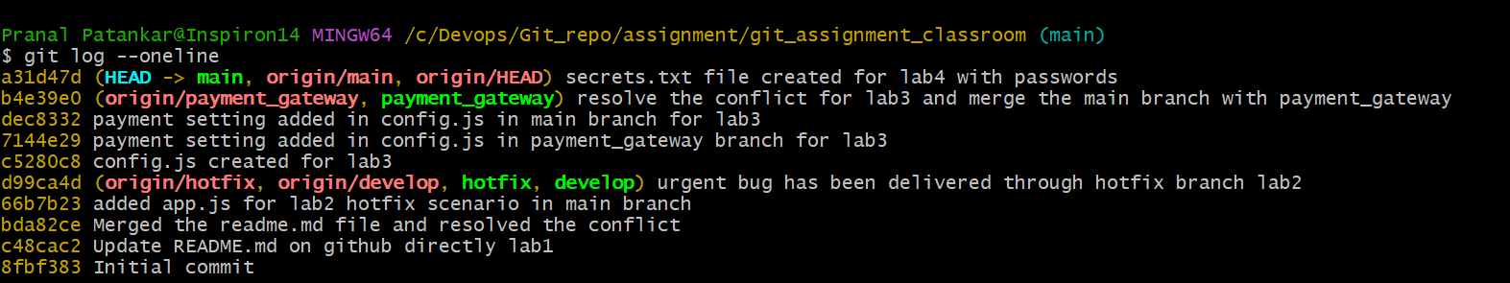
Step 4. Use git revert to undo the commit safely.
To revrert use $ git revert <commit id> command, here commit id can get from git log command and use the same to revert.

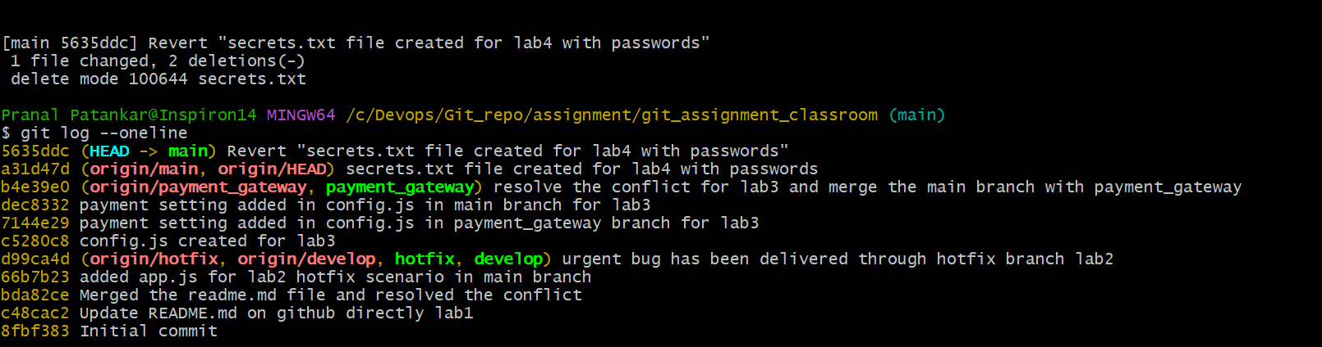
Step 5. Push the revert commit to GitHub.
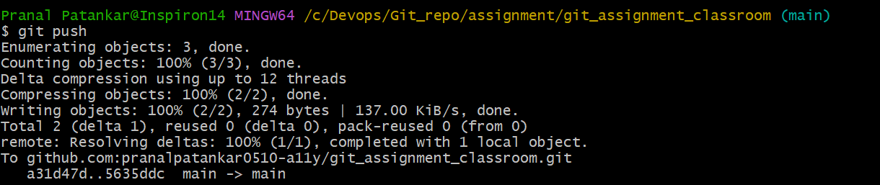
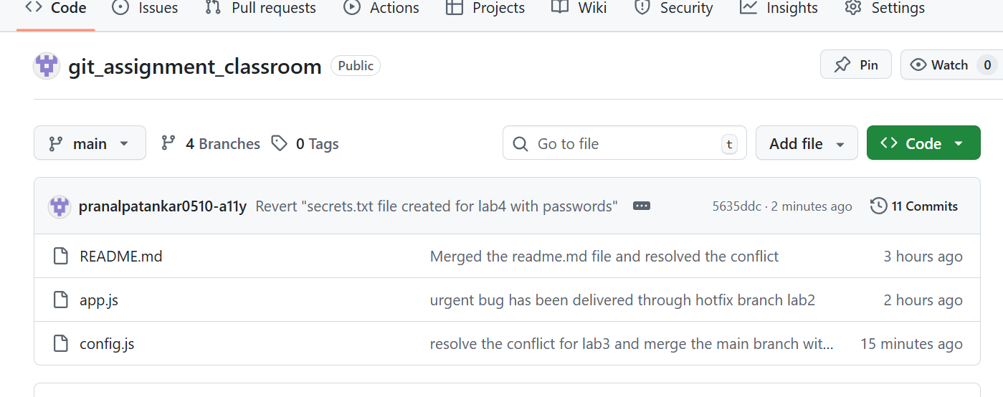
Step 6. Add secrets.txt to .gitignore to prevent future mistakes.
Added the file name in git ignore.
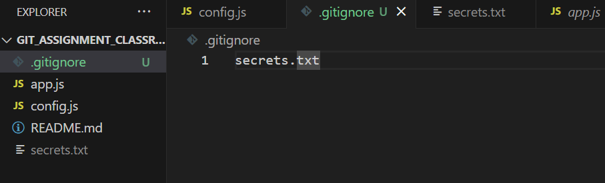
Step 7. Commit and push the .gitignore change.
