# Head Pose Image Prediction

# Assignment 1 : Deep Learning COSC2779

Steps to run the project:

Step 1 : Please upload all the data files onto google drive and mount the drive with this .ipynb file by running code cell 1.

Step 2: We have 3 data files : ‘train_data.csv’, ‘test_data.csv’ and ‘modified_data.zip’. Place all three files onto google cloud. And copy their absolute path. Provide the absolute path of train_data.csv and test_data.csv to the cell 4 read_csv() function as shown below.

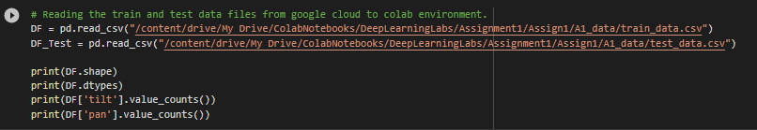

Step 3: unzip the ‘modified_data.zip’ and copy the absolute path of this folder to ImageDataGenerator directory for train, validation and test generators for both tilt and pan as shown in the below images.

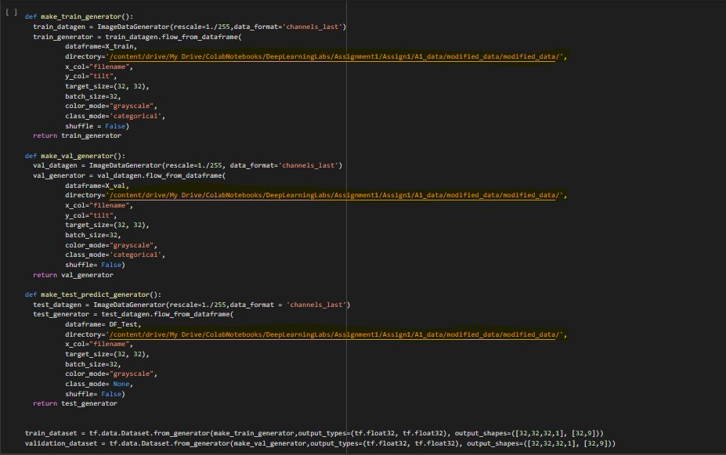

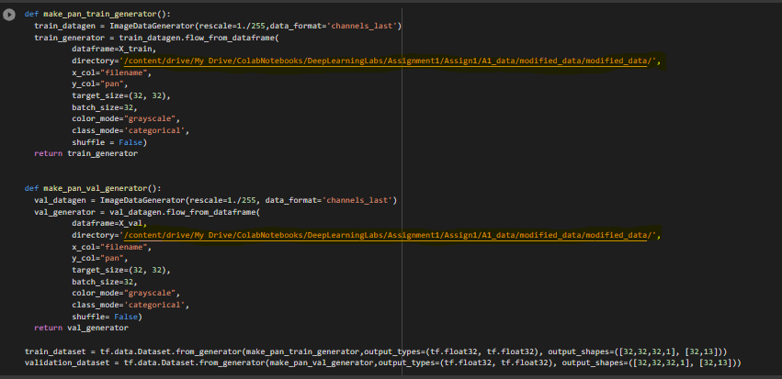

Step 4:

Connect the google Colab file with GPU runtime by changing the runtime type. And then run all the cells in the file using ‘Run All’ option from runtime.