Detection of COVID-19 from Chest X-Ray Images Using Convolutional Neural Networks

In this paper author is using Chest X-Ray dataset and Convolution Neural Network to predict Covid-19 disease. CNN gaining popularity in almost all fields for its better prediction accuracy compare to traditional machine learning algorithms such as SVM, Random Forest etc.

In propose paper author is training CNN model with chest X-Ray and then can apply new test images on that CNN model to predict whether image contains any viral infection and in dataset we have 21 different types of viral infections. Below screen shots showing all 21 names of viral infections

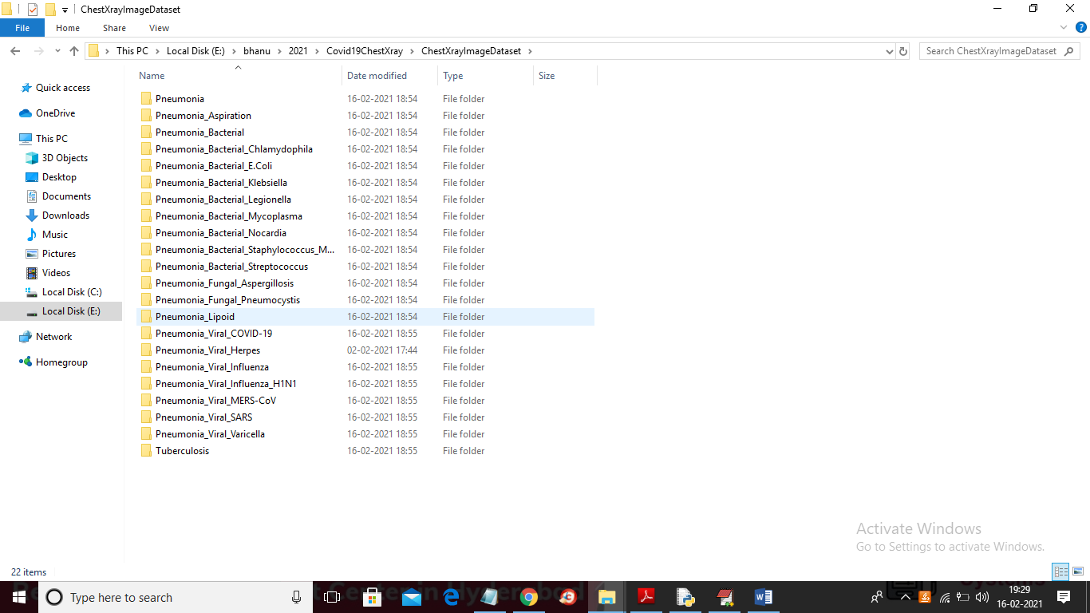

In above screen go inside any folder to see chest X-Ray of that disease

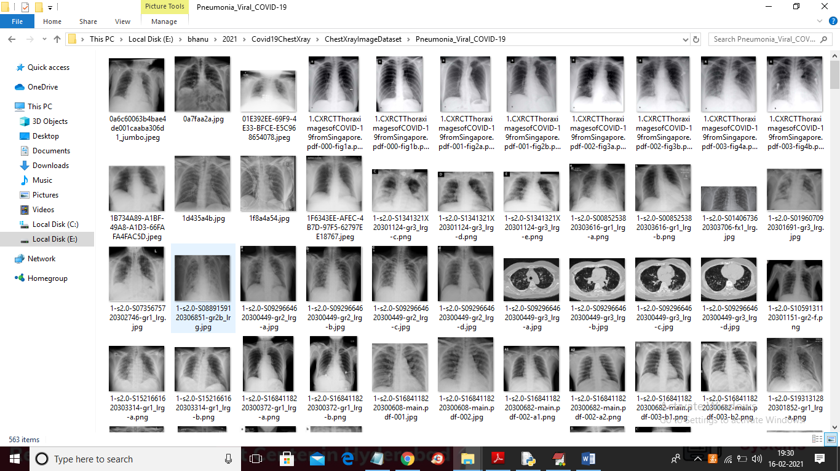

CNN model will take above images as input and then apply filtration to choose important features from dataset images and then remove all unimportant features. All important features will be collected at MAX POOLING layer and pass from one CNN layer to other CNN layer for further filtration using DENSE layer. Using FLATTEN layer all multi-dimensional images will be converted to single layer and then output prediction layer will be define to predict one class from 21 different classes of disease images. Below screen with comments show CNN model creation

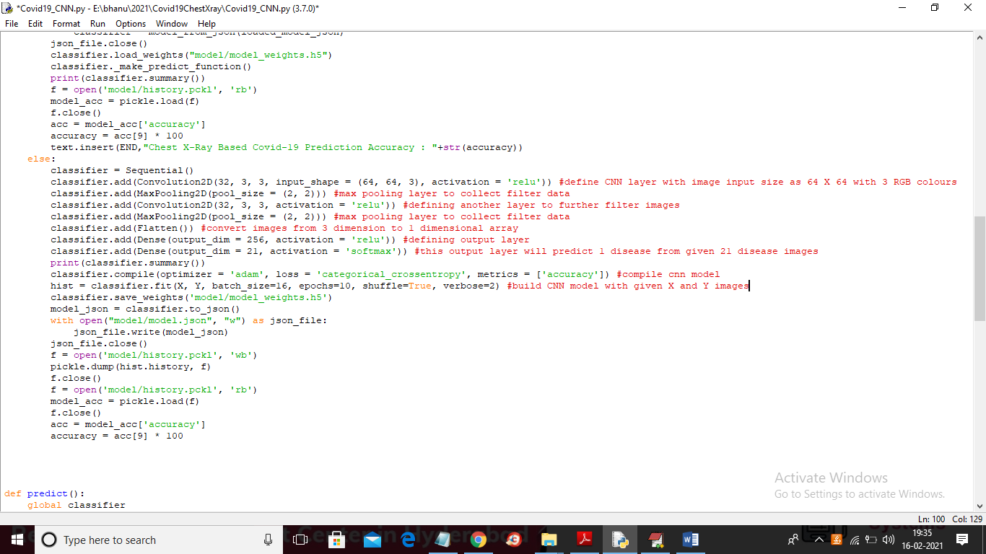

Read red colour line comments to understand CNN model creation.

SCREEN SHOTS

To run project double click on ‘run.bat’ file to get below screen

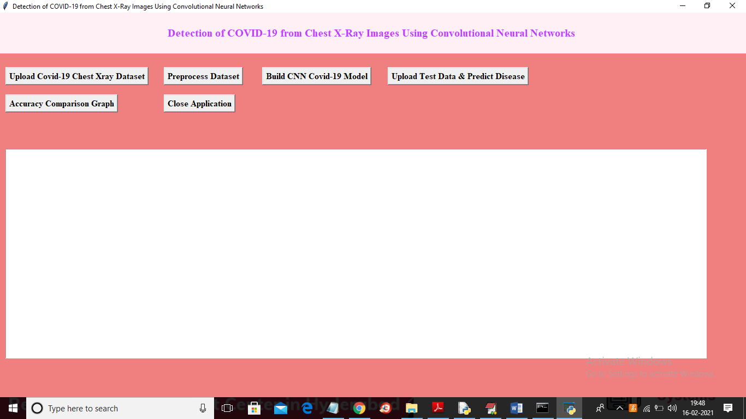

In above screen click on ‘Upload Covid-19 Chest X-ray Dataset’ button and upload dataset

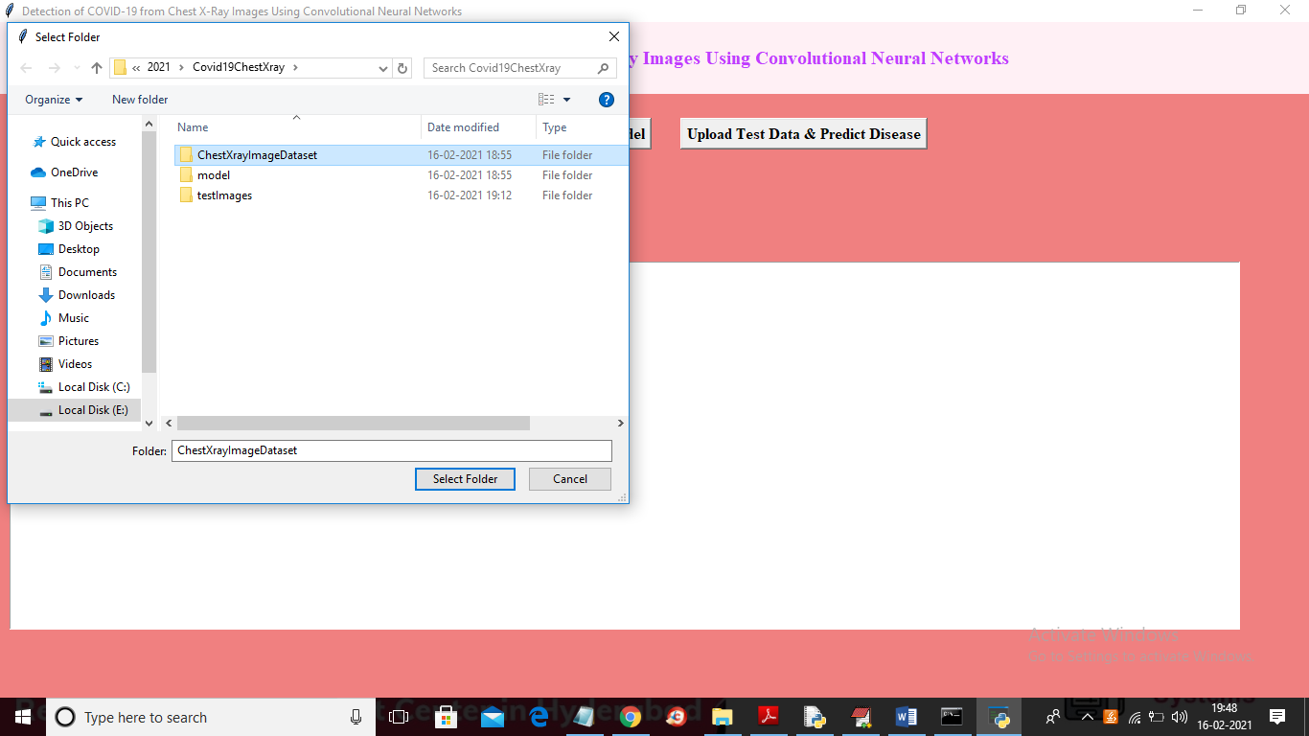

In above screen selecting and uploading ‘ChestXrayImageDataset’ folder which contains dataset images and then click on ‘Select Folder’ button to get below screen

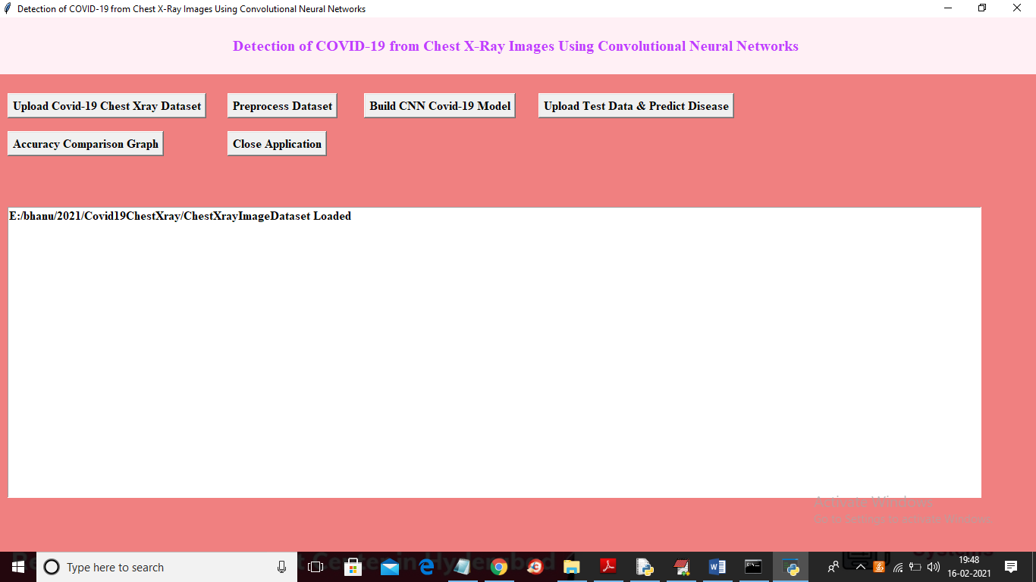

In above screen dataset loaded and now click on ‘Preprocess Dataset’ button to read all images and then convert all images into equal size and then normalize all pixels of images to have better prediction result

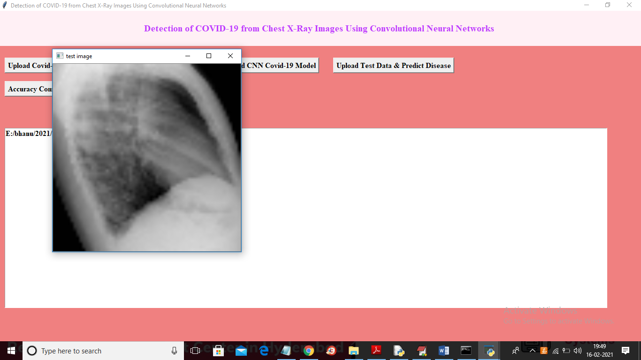

In above screen dataset processed and to test whether application reading all images properly so I am displaying one loaded sample image and now close above image to get below screen

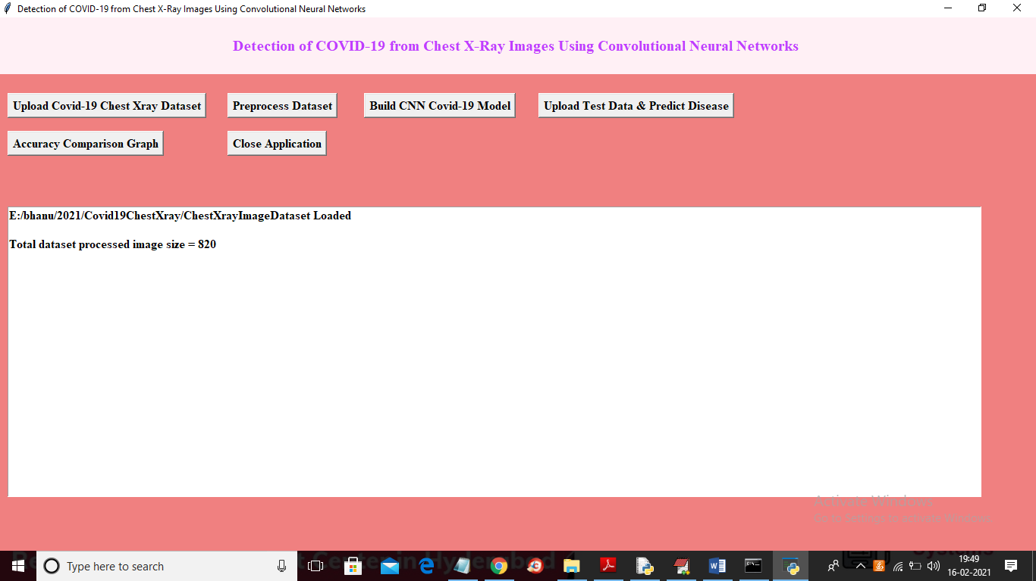

In above screen application found total 820 images and now images are ready and now click on ‘Build CNN Covid-19 Model’ button to generate CNN model on loaded dataset and to get below screen

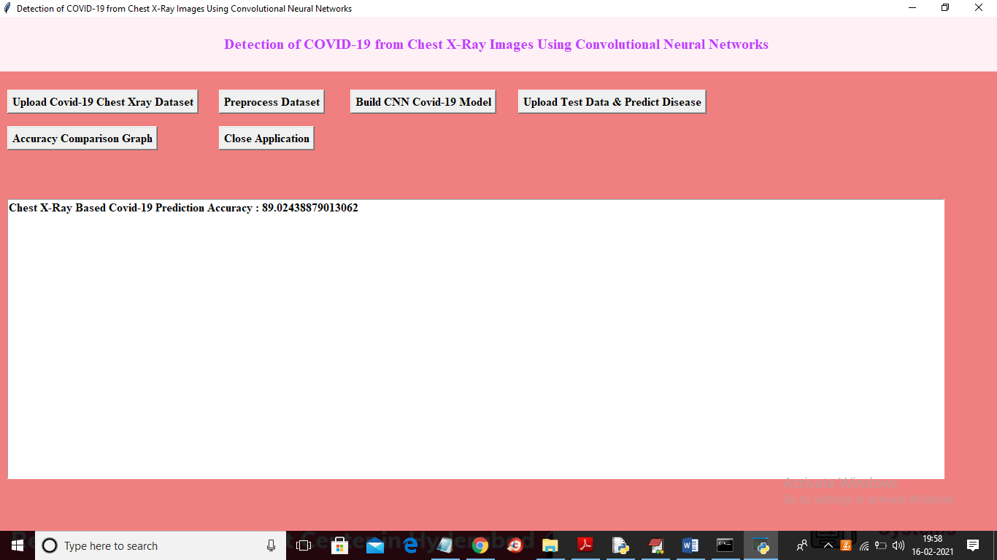

In above screen CNN model generated and its prediction accuracy is 89% and we can see below black console to see CNN layer details or its summary

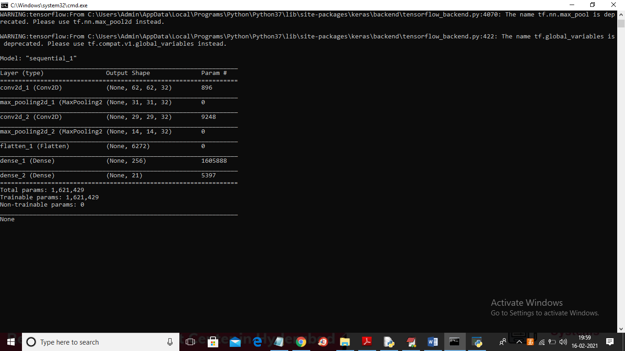

In above console we can see images are filtered at different layer with different image sizes where at first layer 62 X 62 image size was used and in second layer 31 X 31 and goes on. Now CNN model is ready and now click on ‘Upload Test Data & Predict Disease’ button to upload new test image and then application will predict disease from that image

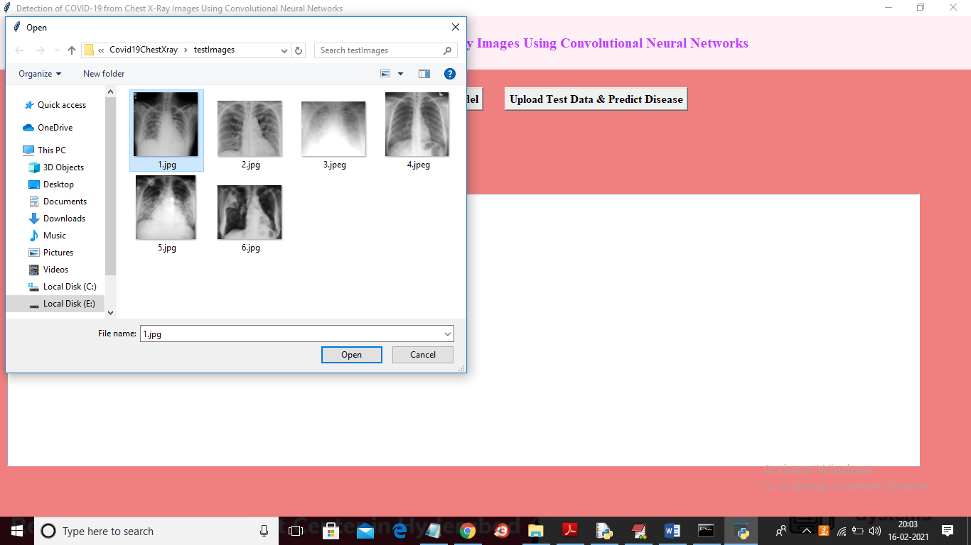

In above screen selecting and uploading ‘1.jpg’ and then click on ‘Open’ button to load image and to get below prediction result

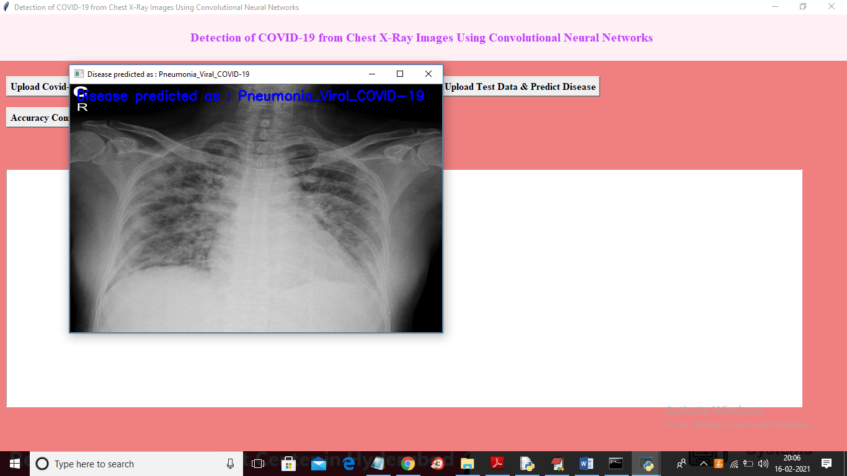

In above screen in blue colour text printing detected disease in uploaded image and now upload another image and test

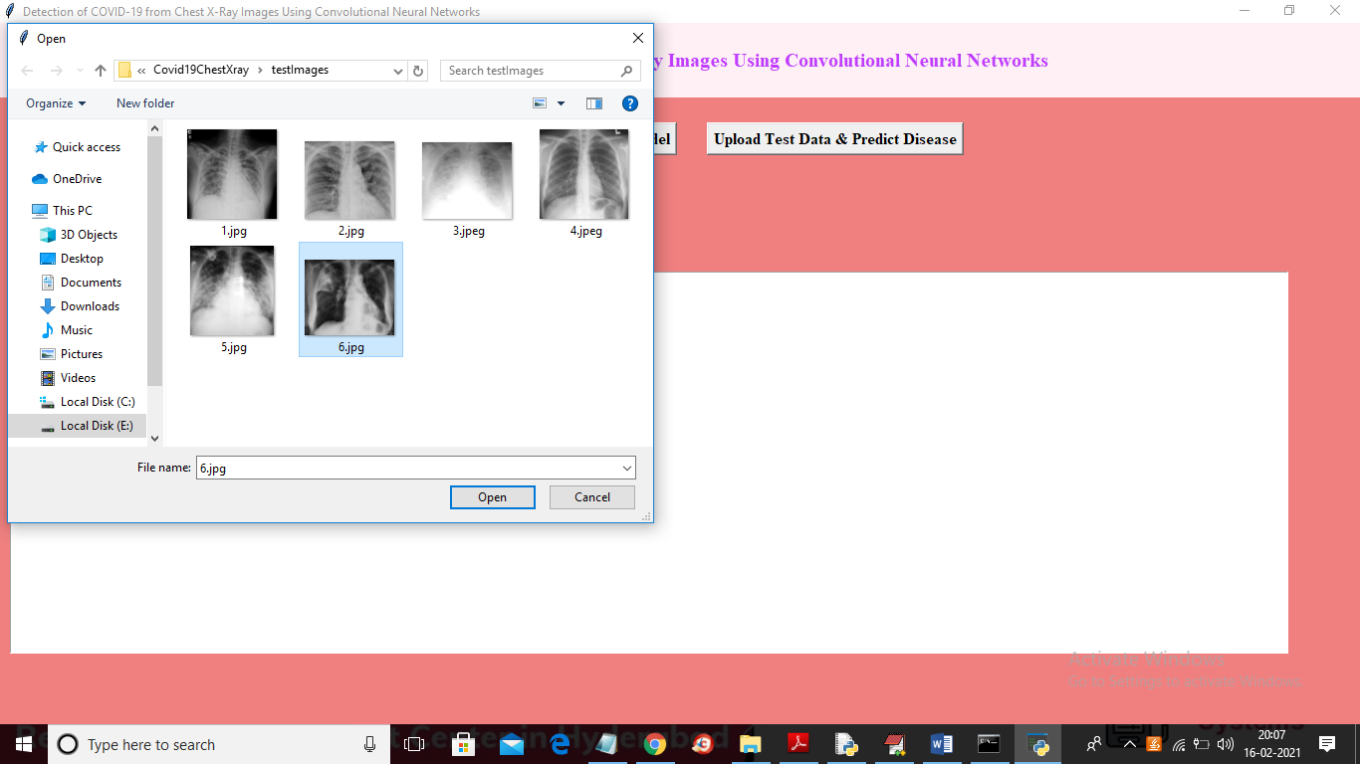

In above screen selecting and uploading ‘6.jpg’ and then click on ‘Open’ button to get below prediction result

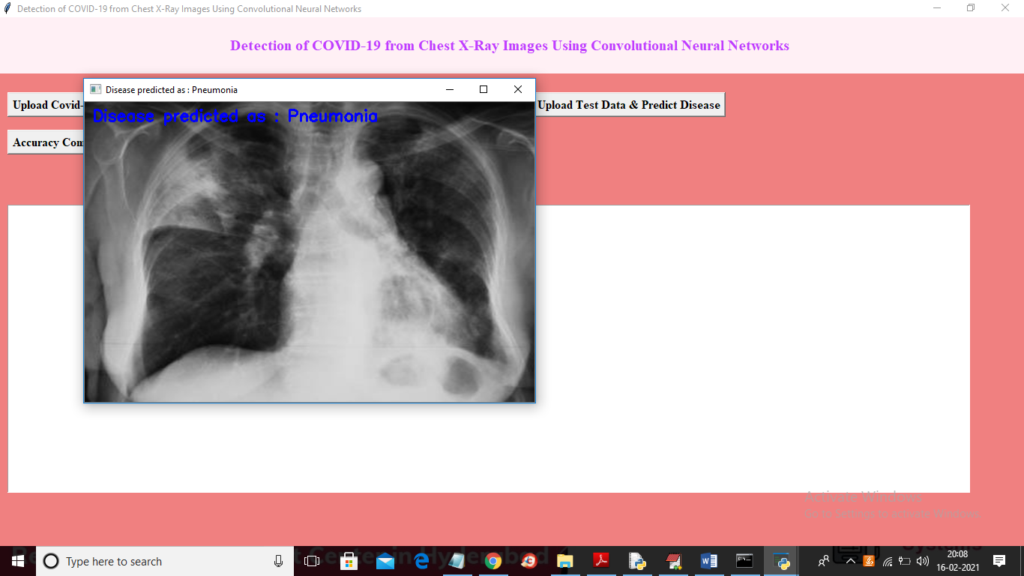

In above screen disease predicted as ‘Pneumonia’ and similarly you can upload other images and get prediction result. Now click on ‘Accuracy Comparison Graph’ button to get below graph

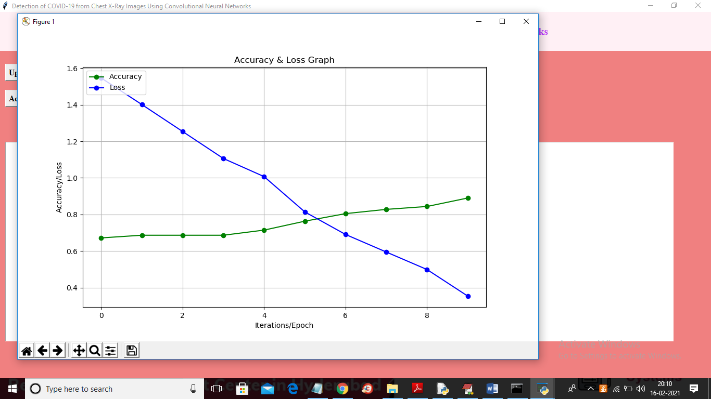

In above graph green line represents accuracy and blue line represents LOSS.In above graph x-axis represents epoch/iteration and y-axis represents accuracy and loss values and to build CNN i took 10 iterations and we can see at each increasing iteration Accuracy get increase and LOSS get decrease