ASSIGNMENT- 7.5
Name: Gaju Pranathi
HT. No: 2303A51609
Batch: 19

Task 1: Mutable Default Argument – Function Bug

The given function uses a mutable default argument, which causes data to persist across function calls and leads to unexpected behavior

# Bug: Mutable default argument def add_item(item, items=[]):
items.append(item) return items print(add_item(1)) print(add_item(2))
.Prompt: #Fix the Python function where a mutable default argument causes unexpected behavior.
Code:
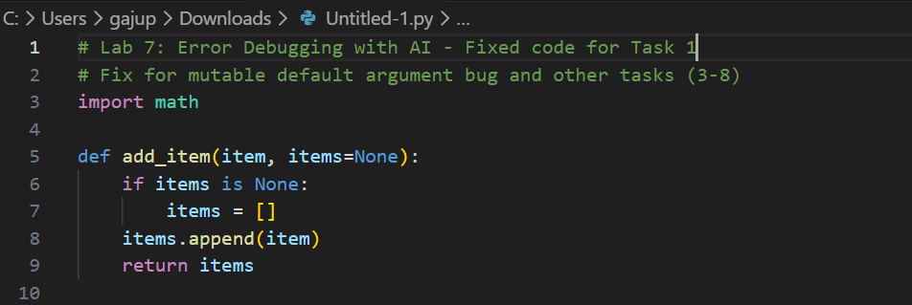

Result:
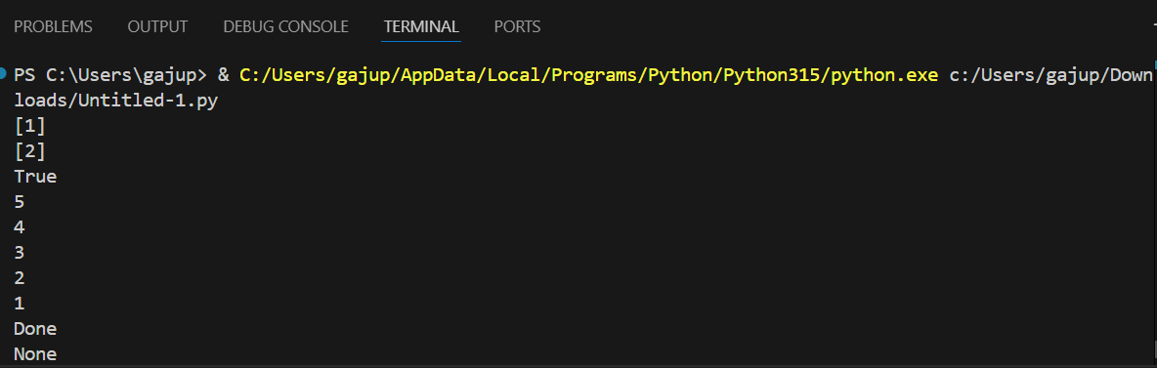

Observation:
The AI correctly identified that mutable default arguments are shared across function calls. Replacing the default list with None and initializing it inside the function prevents unintended data sharing and ensures correct behavior.

Task 2: Task 2: Floating-Point Precision Error

Direct comparison of floating-point numbers leads to incorrect results due to precision limitations.

# Bug: Floating point precision issue def check_sum(): return (0.1 + 0.2) == 0.3
print(check_sum())

Prompt: #Fix the floating-point comparison issue using tolerance Code:
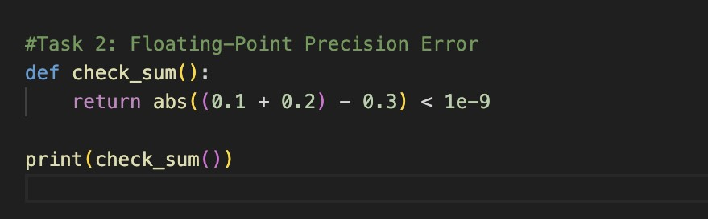

Result:



Observation:
The AI correctly addressed floating-point precision issues by using a tolerance-based comparison instead of direct equality, which is a recommended and reliable approach in numerical computing.

Task 3: Task 3: Recursion Error – Missing Base Case. The recursive function lacks a base case, resulting in infinite recursion.
Prompt: # Fix the recursion error caused by a missing base case.
# Bug: No base case
def countdown(n):
print(n)
return countdown(n-1)
countdown(5)

Code:
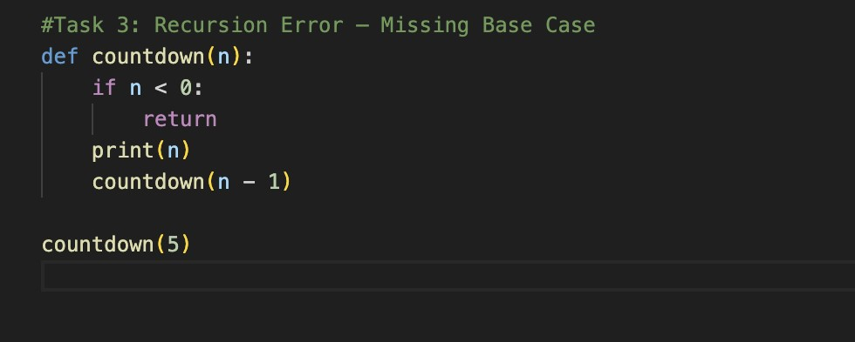

Result:

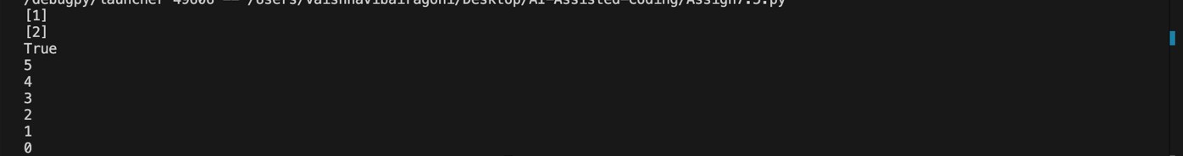

Observation:
The AI correctly identified the absence of a base condition and added a stopping condition, preventing infinite recursion and ensuring safe execution.

Task 4: Task 4: Dictionary Key Error. Accessing a non-existent key in a dictionary causes a runtime KeyError.

# Bug: Accessing non-existing key def get_value(): data = {"a": 1, "b": 2} return data["c"] print(get_value())
Prompt: #Fix the dictionary KeyError using safe access methods..

Code:

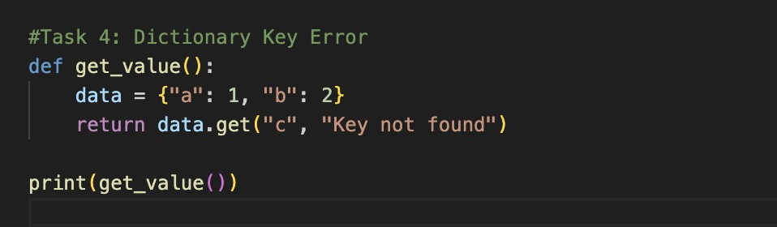

Result:

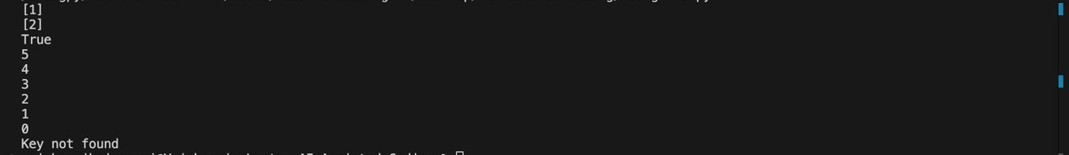

Observation
The AI resolved the issue by using the .get() method, which safely handles missing keys and prevents runtime errors.

Task 5: Task 5: Infinite Loop – Wrong Condition. The loop never terminates because the loop variable is not updated.

# Bug: Infinite loop def loop_example():
i = 0 while i < 5: print(i)
Prompt: #Fix the infinite loop by correcting the loop condition.

Code:

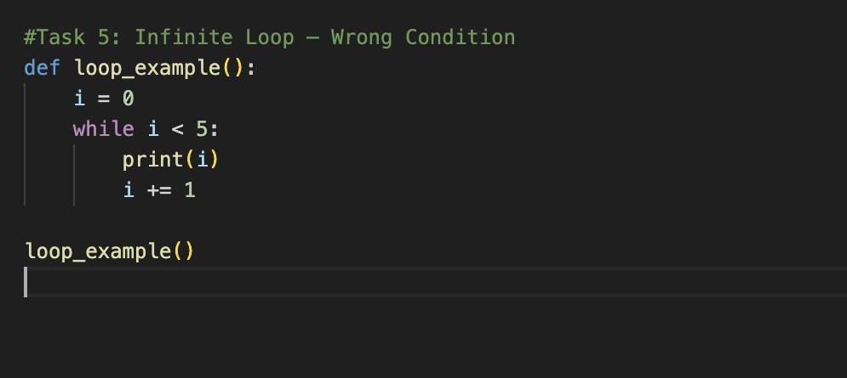
Result:

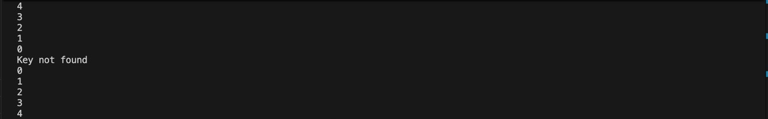

Observation:
The AI correctly identified the missing increment statement and fixed the infinite loop by updating the loop variable inside the loop
Task 6: Task 6: Unpacking Error – Wrong Variables

Tuple unpacking fails because the number of variables does not match the tuple size

# Bug: Wrong unpacking
a, b = (1, 2, 3)
Prompt: # Fix the tuple unpacking error caused by mismatched variables.
Code:
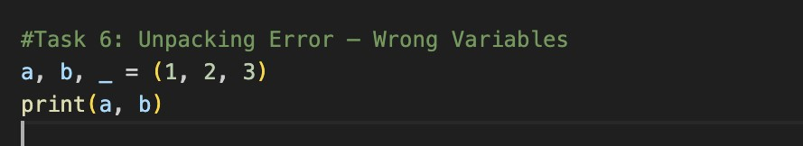

Result:

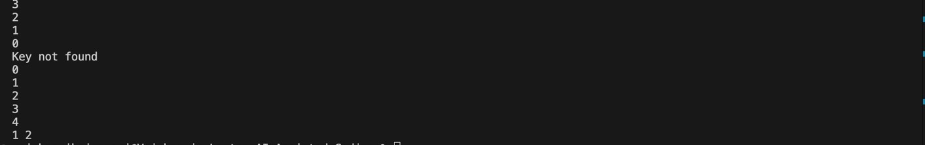

Observation:

The AI fixed the unpacking issue by using an underscore (_) to ignore extra values, which is a Pythonic and safe practice
Task 7: Task 7: Mixed Indentation – Tabs vs Spaces. Inconsistent indentation causes syntax or runtime errors in Python. # Bug: Mixed indentation
def func():
- = 5
- = 10
return x+y
Prompt: # Fix the Python code with mixed indentation.
Code:

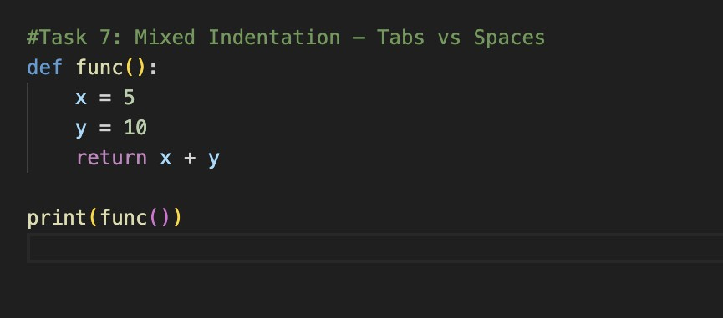

Result:

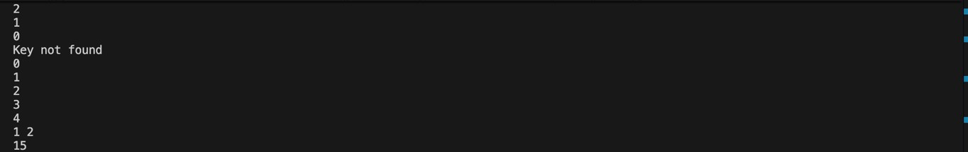
Observation:
The AI resolved the issue by applying consistent indentation using spaces, which is the recommended Python coding standard.

Task 8: Task 8: Import Error – Wrong Module Usage. The code attempts to import a nonexistent module, causing an import error.
Prompt: # Fix the incorrect module import in the Python code.
# Bug: Wrong import
import maths
print(maths.sqrt(16))
Code:
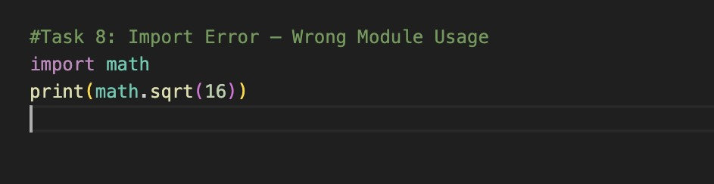

Result:

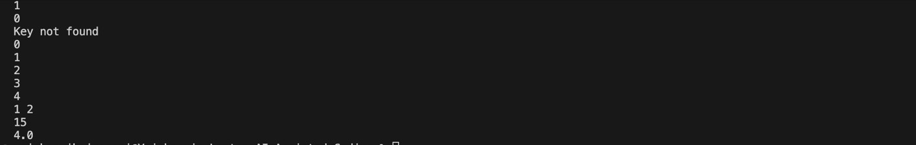

Observation:
The AI correctly identified the incorrect module name and replaced it with the standard math module, resolving the import error.

