## **Data Model & Table Relationships**

Tables and Keys

* **Product**: PROD_KEY (Primary Key)
* **Store**: STORE_KEY (Primary Key)
* **Sales**: TRANS_ID (PK), PROD_KEY (FK), STORE_KEY (FK)
* **Inventory**: CAL_DT (FK), STORE_KEY (FK), PROD_KEY (FK)
* **Calendar**: CAL_DT (PK)

Relationships

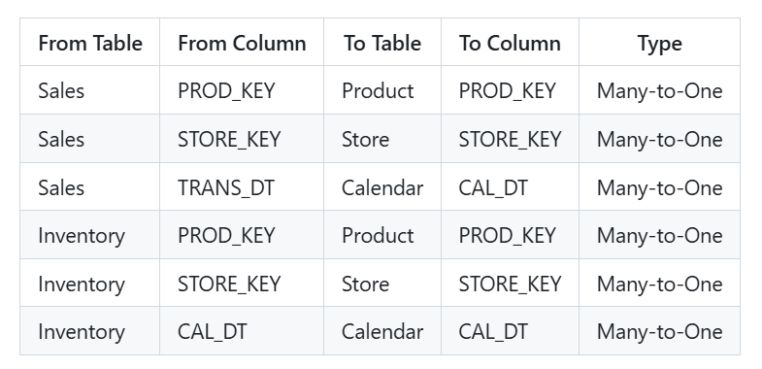

**Note**:

Sales is the Fact Table (transactions).

Inventory is another Fact Table (snapshot of stock/waste, etc.).

Product, Store, Calendar are Dimension Tables.

Star Schema: Both Sales and Inventory connect to Product, Store, and Calendar.

## **Import Data**

Load all 5 tables into Power BI.

* In the Model View, create 1-to-many relationships as specified above.
* Make sure all foreign keys are of matching data types.
* Cardinality: Each relationship should be Many-to-One (from Fact to Dimension).

## **Data Cleaning and Preparation**

* Format dates (ensure TRANS_DT and CAL_DT are Date type).
* Change the Store_key, Prod_key to text type.
* Create calculated columns/measures as needed.

## **PowerBI Report**

### Main Page

* **KPIs**:
  + Total Sales (`SALES_AMT`)
  + Total Units Sold (`SALES_QTY`)
  + Total Margin (`SALES_MGRN`)
  + Inventory on Hand (`INVENTORY_ON_HAND_QTY`)
* **Sales Trend**: Line chart (xaxis: `CAL_DT` from Calendar; yaxis: `SALES_AMT`)
* **Sales by Store**: Map or filled map (Location: `REGION`/`STORE_DESC`; Value: `SALES_AMT`)
* **Top 5 Products by Sales**: Bar/column chart (`PROD_NAME` vs. `SALES_AMT`)
* **Slicers**: Year, City,
* **Drillthrough Targets**:
  + Product Details
  + Store Details

### Product Details

Drillthrough Field: `PROD_KEY` (Product)

* **KPI**:
  + Selected Product’s Total Sales
  + Selected Product’s Total Units Sold
  + Selected Product’s Total Margin
* **Sales Trend**: Line chart `CAL_DT` vs. `SALES_AMT` (filtered for the selected product)
* **Sales by Store**: Line chart (`STORE_DESC` vs. `SALES_AMT`)
* **Out of Stock Events**: Table (`CAL_DT`, `OUT_OF_STOCK_FLG`)
* **Product Attributes**: Table (`PROD_NAME`, ` PROD_KEY`, `CATEGORY_NAME`, `SUBCATEGORY_NAME`, `STATUS_CODE `)
* **Slicers**: Category, Sub category

### Store Details

Drillthrough Field: `STORE_KEY` (Store)

* **KPI**:
  + Store’s Total Sales
  + Store’s Total Units Sold
  + Store’s Total Margin
* **Sales Trend**: Line chart (`CAL_DT` vs. `SALES_AMT`)
* **Top Products Sold**: Bar chart (`PROD_KEY` vs. `SALES_AMT`)
* **Inventory Over Time**: Line chart (`CAL_DT` vs. `INVENTORY_ON_HAND_QTY`)
* **Out of Stock/Waste/PROMO**: Stacked bar (`OUT_OF_STOCK_FLG`, `WASTE_QTY`, `PROMOTION_FLG`)
* **Store Info**: Card (`STORE_DESC`, `STORE_TYPE_CD`, `STORE_KEY`)
* **Slicers**: Year