Assignment-9.3
Name:k.pranathi
Rollno:2303A51615
Batch-20
Task1: Basic Docstring Generation

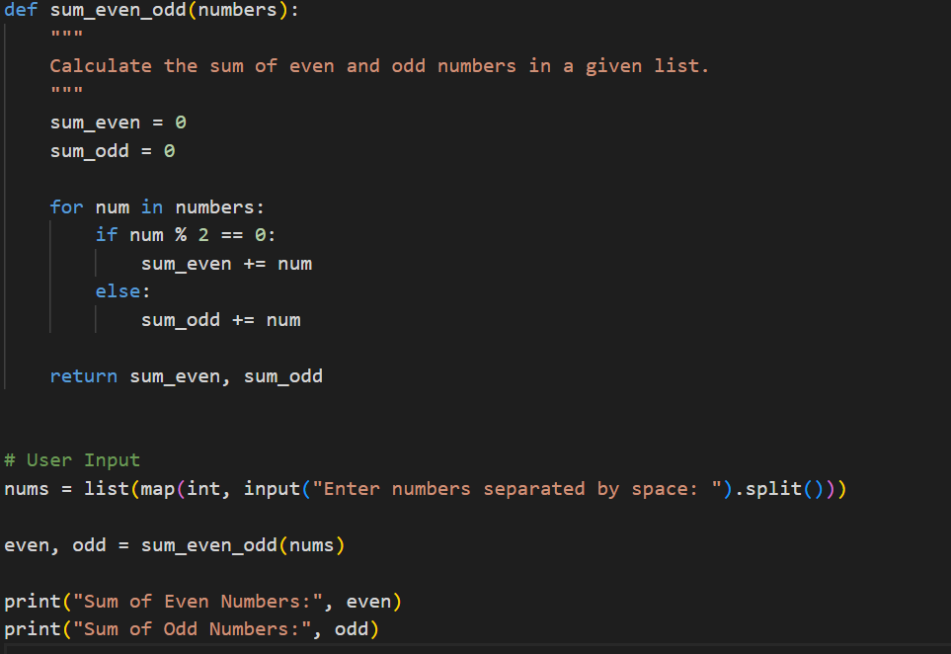
Output:
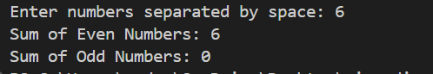
Observation: Docstrings clearly describe the purpose, inputs, and outputs of a function.
They improve code readability and make the function easier to maintain.

Task2: Automatic Inline Comments Scenario
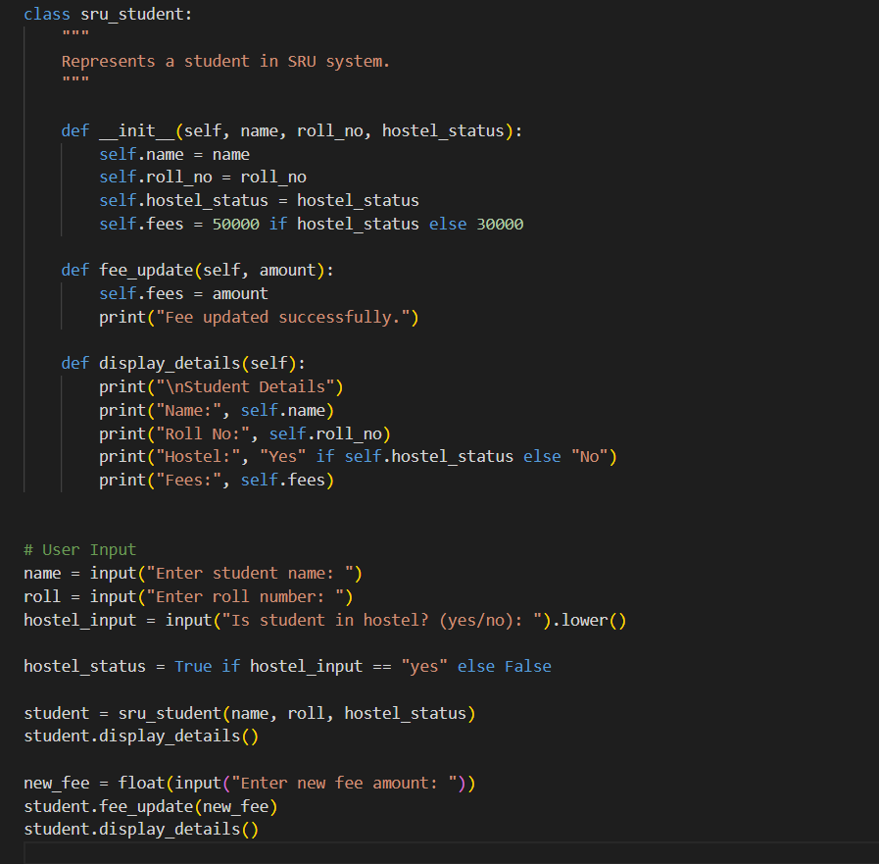output:
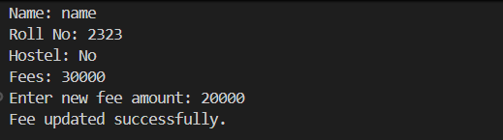
Observation: Inline comments explain the logic of the program step-by-step.
They make object-oriented code easier to understand and debug.

Task-3: Module-Level and Function-Level Documentation
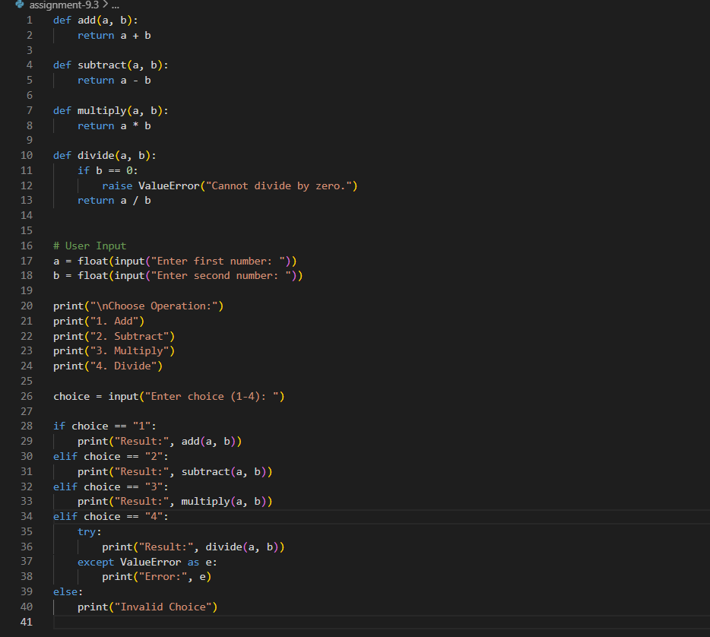
Output:
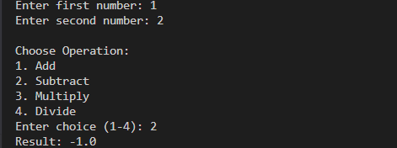
Observation: Module and function documentation provide a clear structure to the program.
Proper documentation improves code quality and professional standards.

