Task Description:
Create a dockerfile, docker-compose file which when executed must display your basic details in the website.

Creating EC2 instance
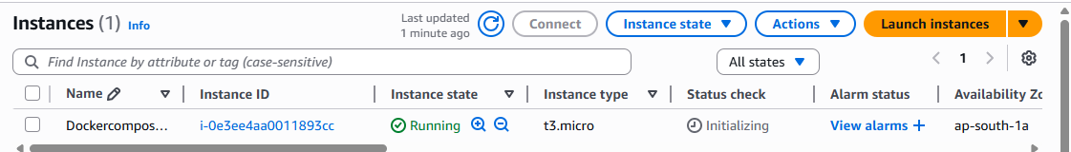
Installed docker and docker compose
Commands – apt update
apt install docker.io
docker --version
apt install docker-compose
docker-compose --version
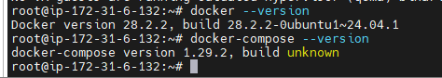
Docker File
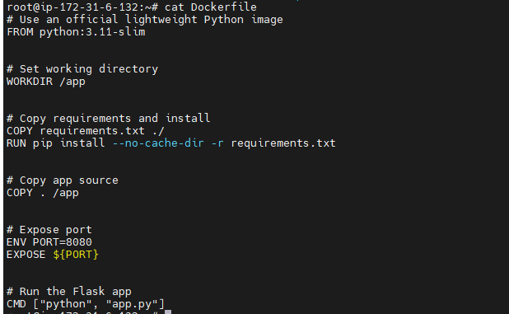
Docker-compose file
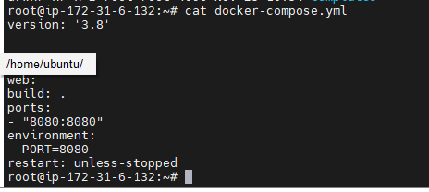
Files created, Inside templates created index.html file
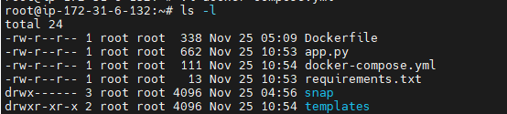
Creating docker compose
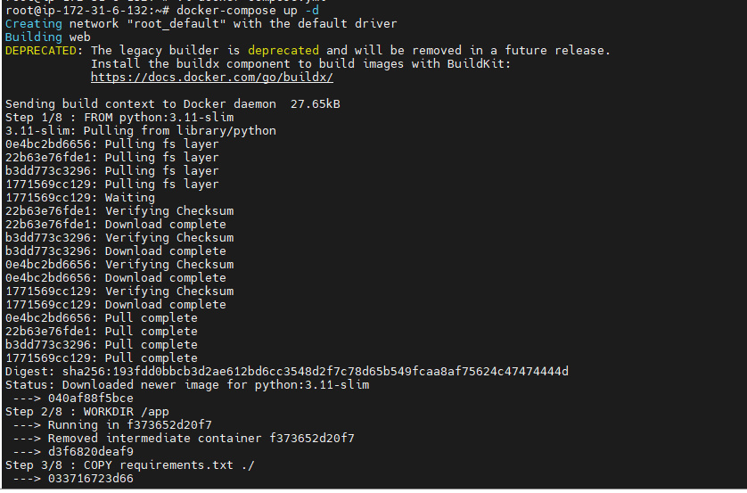
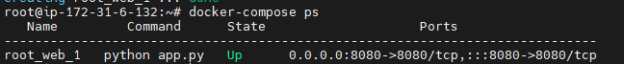
Webpage
