**INTRODUCTION**

1.1 Overview

The project, the “WEATHER FORCASTING APP” is a cutting edge and versatile Weather application fundamentally designed to help people to travel long distances connect with their near place ones in a very friendly, easy and hassle-free manner. This application is compatible with all the Android versions.

# 1.2 Purpose

The purpose of a weather app is to provide users with accurate and up-to-date information about the current and forecasted weather conditions in a specific location or multiple locations.

* Weather Forecast: Weather apps offer detailed forecasts for various time periods, usually ranging from hourly to weekly predictions. This helps users plan their activities and make informed decisions based on expected weather conditions.

* Current Conditions: Weather apps display real-time data on the current weather, including temperature, humidity, wind speed, atmospheric pressure, and other relevant metrics.

*Location-Based Services: Weather apps can use GPS or user input to provide weather information specific to a user's current location or any location of their interest.

*Weather Maps: Many weather apps include interactive weather maps that allow users to view radar images, satellite imagery, and other visualizations of weather patterns.

*Severe Weather Alerts: Weather apps can send alerts and notifications to users in the event of severe weather conditions like storms, hurricanes, tornadoes, or extreme temperatures, helping users stay safe and take necessary precautions.

*Travel Planning: For travelers, weather apps are valuable tools to check the weather conditions in their destination or along their route before and during their journey.

*Outdoor Activities: Weather apps assist users in planning outdoor activities such as hiking, biking, or picnics by providing weather forecasts to ensure optimal conditions.

*Climate Monitoring: Weather apps can also track historical weather data, allowing users to monitor climate trends and changes over time.

*User-Friendly Interface: The best weather apps present all this information in a user-friendly and visually appealing manner, making it easy for users to understand and navigate.

Overall, weather apps are designed to provide convenience, safety, and useful information for individuals and businesses alike, helping them make well-informed decisions based on current and future weather conditions.

# **LITERATURE SURVEY**

## 2.1 Existing problem

**User Interface and User Experience (UI/UX):** Studies might assess the design and usability of weather apps, exploring how different UI/UX elements affect user satisfaction and engagement. This includes research on the use of icons, colors, layouts, and information presentation.

**Accuracy and Reliability:** Evaluations of the accuracy and reliability of weather data provided by various weather apps are crucial. Researchers might compare forecasts from different apps with actual weather conditions to gauge their effectiveness.

**Severe Weather Alerting:** Studies may focus on the effectiveness of severe weather alerting systems within weather apps and assess users' responses to such alerts.

**Location-Based Services:** Research might investigate the use of GPS and location-based services in weather apps, examining how these features impact user experience and data accuracy.

**Personalization and Customization:** Some studies might explore how weather apps provide personalized forecasts based on user preferences and how customization options influence user satisfaction.

**Impact on Decision Making:** Researchers might examine how users' decisions, such as outdoor activities, travel plans, or clothing choices, are influenced by the information provided by weather apps.

**Performance and Resource Usage:** Studies could analyze the performance of weather apps concerning data retrieval, processing, and resource usage (e.g., battery consumption).

**Weather Data Sources:** Literature surveys might investigate the sources of weather data used by different apps and assess the quality and reliability of those sources.

**Integration with Other Apps and Services:** Research could explore how weather apps integrate with other apps or services (e.g., calendars, event planners) to enhance user experience and convenience.

**Accessibility:** Some studies might assess the accessibility features of weather apps, ensuring they are usable by people with disabilities.

**Privacy and Data Security:** Researchers might analyze the privacy policies and data security practices of weather app providers to address user concerns.

**Market Analysis and User Adoption:** Literature surveys could include a market analysis of weather apps, examining trends, user preferences, and the factors that influence app adoption.

**2.2 Proposed solution:**

**Based on the aspects covered in a literature survey on weather apps, here are some potential solutions and improvements that could be implemented.**

**1.Improved User Experience and user interface.**

**2.Enhanced Accuracy and Reliability.**

**3.Effective severe Weather Alerting.**

**4.Optimized Location-Based services.**

**5.Personalization and Customization.**

**6.Informed Decision Making.**

**7.Performance and Resource Optimization.**

**8.Integration with other apps and services.**

**9.Accessibility Features.**

**10.Privacy and Data Security.**

**11.Market Analysis and user adoption.**

Regular market analysis can help app developers identify trends and user preferences, enabling them to adapt and improve their offerings accordingly.

By addressing these areas and continuously gathering feedback from users, weather app developers can create more reliable, user-friendly, and feature-rich applications that meet the diverse needs .

## THEORITICAL ANALYSIS

3.1 Block diagram

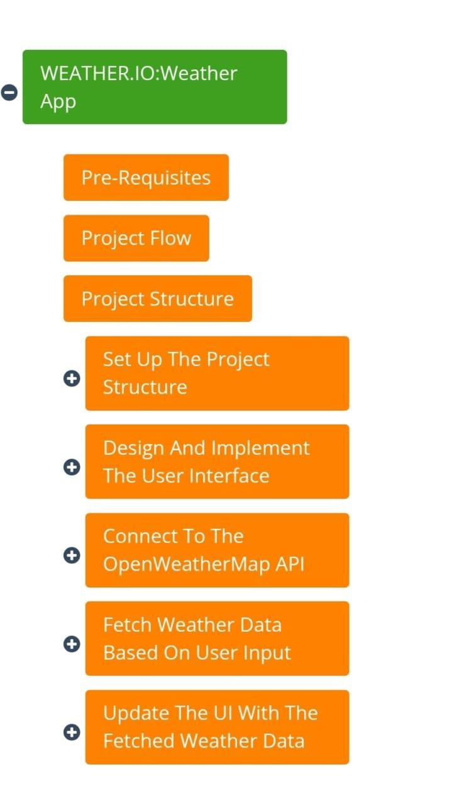

3.2 Hardware and Software requirements of the project

The hardware and software requirements for a weather app can vary depending on the complexity of the application and the platforms it targets. Here are some general guidelines for both hardware and software requirements:

Hardware Requirements:

1. Processor: The app should be designed to run on various processors, such as ARM and x86, to be compatible with a wide range of devices.

1. Memory (RAM): Depending on the app's features and the size of the data it handles, it should be optimized to work with different memory capacities. For basic weather apps, 1GB of RAM should be sufficient.

1. Storage: Weather data and the app itself may occupy storage space, so it should be efficient in its use. A few hundred megabytes of storage space should be enough for most weather apps.

1. GPS/Location Services: If the app provides location-based weather forecasts, it will require access to GPS or location services. This is available on most modern smartphones and tablets.

Software Requirements:

1. Operating System: The app should be designed to work on various operating systems. For mobile devices, this often means targeting iOS and Android, while for desktop computers, it could be Windows, macOS, or Linux.

1. Development Framework: Choose a suitable development framework that supports crossplatform development if you want your app to work on multiple platforms with a single codebase. Examples include React Native, Flutter, Xamarin, etc.

1. Weather Data API: The app will need to connect to a reliable weather data API to fetch weather information. Popular weather APIs include OpenWeatherMap, WeatherAPI, and The Weather Channel API.

1. Programming Languages: The app can be built using programming languages like Java, Kotlin, Swift, Objective-C, Python, or JavaScript, depending on the platform and development framework.

1. User Interface: Design the user interface (UI) to be intuitive and responsive, ensuring it adapts well to various screen sizes and orientations.

1. Network Connectivity: Weather apps heavily rely on internet connectivity to fetch realtime weather data. The app should handle various network conditions gracefully.

1. Permissions: For location-based weather apps, make sure to handle permissions properly to request access to the user's location.

It's essential to consider the hardware and software constraints of the target devices while developing a weather app to ensure optimal performance and user experience. Additionally, adhering to best practices for coding and design will result in a better overall app performance.

RESULT

Screenshots of output:

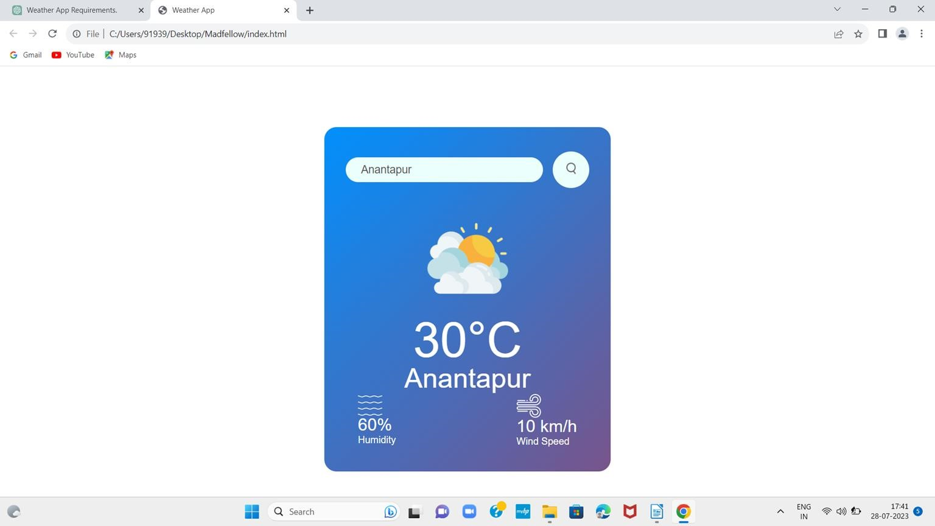

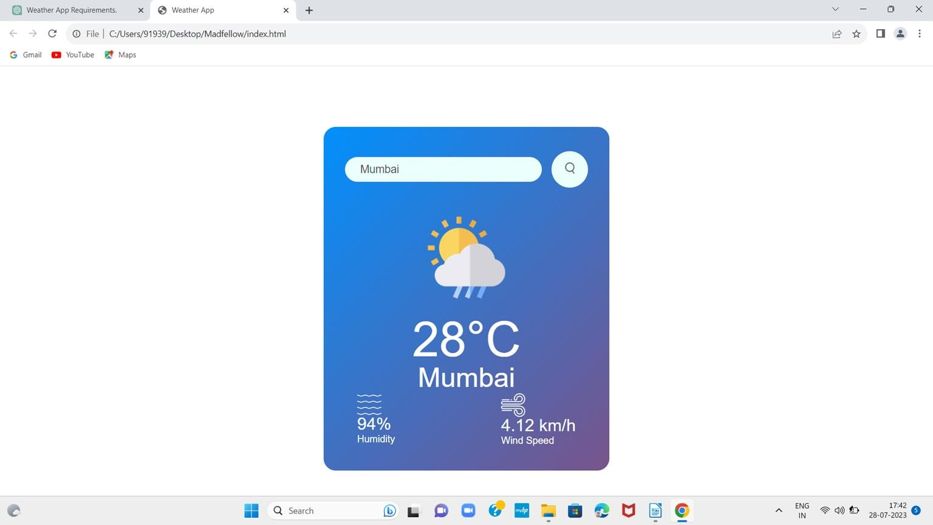

Advantages and disadvantages:

Advantages of a Weather App:

1. Accessibility: Weather apps provide instant access to weather information from anywhere and at any time. Users can quickly check the current conditions or forecasts with just a few taps on their smartphones.
2. Customization: Many weather apps allow users to personalize the information they receive, such as setting preferred locations, units of measurement, and weather alerts. This customization enhances the user experience and makes the app more relevant to individual needs.
3. Real-time Updates: Weather apps can provide real-time updates, ensuring that users have the latest and most accurate weather data available.
4. Forecasting: Weather apps offer detailed weather forecasts for multiple days ahead, helping users plan their activities, events, and travel accordingly.
5. Weather Alerts: Some weather apps include alert systems that notify users of severe weather conditions, such as storms, hurricanes, or extreme temperatures. This feature helps users stay informed and take necessary precautions.
6. User-Friendly Interfaces: Well-designed weather apps present weather information in a visually appealing and easy-to-understand manner, making it accessible to people of all ages and technological proficiency.
7. Integration with Smart Devices: Many weather apps can integrate with smart devices, such as smartwatches or voice-activated assistants, making it convenient for users to access weather information hands-free.

Disadvantages of a Weather App:

1. Accuracy Issues: Weather forecasts are not always 100% accurate due to the complexity of weather patterns. Users may experience discrepancies between predicted weather and actual conditions.
2. Dependency on Data Sources: Most weather apps rely on external weather data providers and APIs. If these sources encounter issues or experience downtime, it can affect the app's functionality and the availability of weather information.
3. Battery Drain: Continuous updates and location services in weather apps can consume significant battery power, especially if users enable frequent real-time updates and background location tracking.
4. Privacy Concerns: Some weather apps may collect user data, including location information, to improve their services or for marketing purposes. This raises privacy concerns, and users should be cautious about the apps they choose and the permissions they grant.
5. Internet Dependency: Weather apps typically require an internet connection to fetch data and provide updates. If users are in areas with poor or no internet connectivity, they may not have access to weather information.
6. App Overload: With numerous weather apps available, users might find it challenging to select one that best meets their needs. Installing multiple apps can lead to device clutter and confusion.
7. Limited Long-Term Planning: While weather apps offer forecasts for several days ahead, long-term weather predictions (beyond a week or two) can be less accurate and may not be suitable for long-term planning purposes.

6.APPLICATIONS

Weather apps serve various purposes and find applications in multiple areas. Some of the key applications of weather apps include:

1. Personal Weather Forecasting
2. Travel Planning
3. Outdoor Activities
4. Agricultural Planning
5. Construction and Infrastructure
6. Emergency Preparedness
7. Air Travel
8. Marine Navigation
9. Event Planning
10. Academic and Scientific Research
11. Energy Sector
12. Health and Wellness.

Overall, weather apps have become an essential tool for individuals and businesses alike, helping them make informed decisions based on current and forecasted weather conditions. The accessibility and accuracy of weather information through these apps significantly impact various aspects of daily life and various industries.

**7.CONCLUSION**

*In conclusion, weather apps have become indispensable tools in our daily lives, providing us with instant access to crucial weather information. These applications offer a wide range of benefits, enhancing our ability to plan and make informed decisions based on current and forecasted weather conditions.*

*The applications of weather apps span various domains, including personal use, travel planning, emergency preparedness, outdoor activities, agriculture, construction, marine navigation, academic research, energy sector optimization, and health and wellness. By integrating weather forecasts into these areas, weather apps contribute to improved safety, efficiency, and decisionmaking.*

*My sincere thanks to my college faculty, Faculty Guide, and special thanks to SHIVANI KAPOOR madam, and my team members without you it seems impossible.*

8. Future Scope...

The future scope of frontend development looks promising, as it continues to evolve rapidly to meet the demands of modern web and application development.

1. Progressive Web Apps (PWAs): PWAs are web applications that offer a native app-like experience while being accessible through web browsers. They can work offline, provide push notifications, and load quickly. As internet connectivity improves and users expect seamless experiences across devices, PWAs will gain more traction.
2. Mobile-First Approach: With the increasing dominance of mobile devices, frontend developers will focus more on building mobile-friendly and responsive interfaces. The mobile-first approach ensures that the user experience is optimized for mobile devices while maintaining compatibility with desktops.
3. WebAssembly (Wasm): WebAssembly is a binary instruction format that allows high-performance execution of code on web browsers. It enables frontend developers to bring performance-intensive tasks, like complex computations or video editing, to the browser without relying on traditional JavaScript. As browser support improves, Wasm will play a significant role in enhancing frontend capabilities.
4. Voice Interfaces and Virtual Reality: Frontend development will extend beyond traditional screens to support voice-based interactions and virtual reality environments. Voice user interfaces (VUI) and virtual reality interfaces (VRI) will present new design and development challenges.
5. Component-Based Architecture: Component-based frontend frameworks, like React and Vue.js, will continue to dominate as they promote reusability and modularity. This architecture streamlines development, making it easier to manage complex applications and collaborate with larger development teams.
6. Low-Code and No-Code Solutions: The rise of low-code and no-code platforms will enable nondevelopers to create frontend applications with minimal coding knowledge. Frontend developers will increasingly work on integrating and customizing these solutions while focusing on more complex and custom development tasks.
7. Web Accessibility (A11y): The importance of web accessibility will continue to grow, with frontend developers emphasizing inclusive design and ensuring that web applications are usable by people with disabilities.
8. Web Performance: As users expect faster loading times and smoother interactions, frontend developers will prioritize web performance optimization techniques, such as lazy loading, code splitting, and improved caching strategies.
9. Cross-Browser Compatibility: With various web browsers in the market, ensuring consistent user experiences across different platforms will remain a priority for frontend developers.
10. Augmented Reality (AR) and WebXR: The integration of augmented reality experiences on the web will gain momentum, opening new possibilities for frontend development in sectors like ecommerce, education, and entertainment.