22ME411 PRODUCT DEVELOPMENT LAB - 4
HOSPITAL MANAGEMENT SYSTEM USING IoT

A PROJECT REPORT
Submitted by

Nithya Sri S | 111723102138
Pamujula Kavya Sre | 111723102141
Poluboina Snikitha | 111723102150

in partial fulfillment for the award of the degree of

BACHELOR OF ENGINEERING
IN
COMPUTER SCIENCE AND ENGINEERING

R.M.K. ENGINEERING COLLEGE
(An Autonomous Institution)
R.S.M. Nagar, Kavaraipettai-601 206


March 2025

R.M.K. ENGINEERING COLLEGE

(An Autonomous Institution)
R.S.M. Nagar, Kavaraipettai-601 206

BONAFIDE CERTIFICATE

Certified that this Product Development Lab – 4 report “Hospital Management System Using IoT ” is the bonafide work of Nithya Sri S (111723102138), Pamujula Kavya Sre (111723102141), Poluboina Snikitha (111723102150)), who carried out the 22ME411 Product Development Lab - 4 work under my supervision.

SIGNATURE

Dr. T. Sethukarasi, M.E., M.S. Ph.D., Professor and Head
Department of Computer Science and Engineering
R.M.K. Engineering College
R.S.M. Nagar, Kavaraipettai
Tiruvallur District– 601206.

SIGNATURE

Ms. Gayathri S, M.E., (Ph.D)., Supervisor
Assistant Professor
Department of Computer Science and Engineering
R.M.K. Engineering College
R.S.M. Nagar, Kavaraipettai Tiruvallur District–601206.

Submitted for the Product Development Lab – 4 Viva –Voce held on………………………

. at R.M.K.Engineering College,
Kavaraipettai, Tiruvallur District– 601206.

INTERNAL EXAMINER

ACKNOWLEDGEMENT

We earnestly portray our sincere gratitude and regard to our beloved Chairman Shri. R. S. Munirathinam, our Vice Chairman, Shri. R. M. Kishore and our Director, Shri. R. Jyothi Naidu, for the interest and affection shown towards us throughout the course.

We convey our sincere thanks to our Principal, Dr. K. A. Mohamed Junaid, for being the source of inspiration in this college.

We reveal our sincere thanks to our Professor and Head of the Department, Computer Science and Engineering, Dr. T. Sethukarasi, for her commendable support and encouragement for the completion of our project.

We would like to express our sincere gratitude for our Product Development Lab Incharge Ms. Gayathri S, Assistant Professor for their valuable suggestions towards the successful completion for this project in a global manner.

We take this opportunity to extend our thanks to all faculty members of the Department of Computer Science and Engineering, Parents and friends for all that they meant to us during the crucial times of the completion of our project.

 | TABLE OF CONTENTS
CHAPTER | TITLE | PAGE NO
 | ABSTRACT | 1
 | LIST OF FIGURES | 2
1 | INTRODUCTION | 4
 | 1.1 Problem Statement | 4
 | 1.2 Project Scope and Objectives | 5
 | 1.3 Literature Survey | 6
 | 1.4 Hardware Requirements | 12
 | 1.5 Software Requirements | 13
2 | SYSTEM ANALYSIS | 14
 | 2.1 Existing System | 14
 | 2.1.1 Disadvantages of Existing System | 14
 | 2.2 Proposed System | 15
 | 2.2.1 Advantages of Proposed System | 15
3 | SYSTEM DESIGN | 16
 | 3.1 System Architecture Diagram | 16
 | 3.2 Use Case Diagram | 19
 | 3.3 Class Diagram | 22
 | 3.4 Data Flow Diagram | 27
 | 3.5 Activity Diagram | 32
4 | SYSTEM IMPLEMENTATION | 35
 | 4.1 List of Modules | 36
 | 4.2 Detailed Module Description | 37
5 | CONCLUSION AND FUTURE SCOPE | 46
 | REFERENCES | 49
 | SCREENSHOTS | 51

ABSTRACT

The IoT-powered Hospital Management System (HMS) integrates artificial intelligence to enhance real-time hospital and laboratory operations. By leveraging IoT for continuous data collection and connectivity, the system ensures efficient tracking of doctors, technicians, resources, and staff availability. AI-driven analytics further optimize decision-making, enabling predictive scheduling, workload balancing, and automated workflow management.
Key features include IoT-enabled real-time equipment monitoring, automated inventory tracking, and smart emergency response. Connected devices continuously monitor hospital assets and patient vitals, facilitating proactive healthcare management. AI-driven queue management dynamically directs patients to available doctors, while intelligent staff allocation enhances service efficiency.
Additionally, predictive maintenance for medical equipment, AI-powered risk analysis for emergency prioritization, and seamless integration with existing Hospital Management Systems (HMS) and Laboratory Information Systems (LIS) ensure a smarter and more responsive healthcare environment. By prioritizing IoT for data acquisition and real-time operations, with AI enhancing decision-making and automation, this system significantly improves hospital efficiency, reduces costs, and elevates patient care.

LIST OF FIGURES

Figure No | Name | Page No
1.1 | ARCHITECTURE DIAGRAM | 17
1.2 | DETAILED ARCHITECTURE DIAGRAM | 18
1.3 | USES CASE DIAGRAM | 20
1.4 | CLASS DIAGRAM | 27
1.5 | DATA FLOW DIAGRAM | 31
1.6 | ACTIVITY DIAGRAM | 34

LIST OF SCREENSHOTS
Screenshot No | Name | Page No
2.1 | DOCTOR LOGIN PAGE | 51
2.2 | ADMIN LOGIN PAGE | 51
2.3 | NURSE LOGIN PAGE | 52
2.4 | DASHBOARD | 52
2.5 | PATIENT DETAILS | 53
2.6 | AMBULANCE DETAILS | 53
2.7 | BED AVAILABILITY | 54
2.8 | REPORTS | 54

CHAPTER 1 INTRODUCTION
The integration of the Internet of Things (IoT) with Artificial Intelligence (AI) is revolutionizing hospital and laboratory management by enabling real-time tracking, predictive analytics, and automated workflow optimization. Traditional hospital systems often struggle with inefficient scheduling, resource mismanagement, and prolonged patient wait times. By utilizing IoT for continuous data collection and AI for intelligent decision-making, the proposed system enhances operational efficiency, streamlining staff availability, resource management, and emergency response.
IoT sensors, including RFID/BLE tags and smart badges, continuously monitor the real-time locations of doctors, technicians, and staff. AI-driven predictive models analyze this data to optimize scheduling and workload distribution. The system features smart appointment scheduling, allowing patients to book via multiple platforms while dynamically updating doctor availability in real-time. Additionally, IoT-based sensors track hospital beds, medical equipment, and inventory, facilitating AI-powered predictive maintenance and proactive resource allocation.
Furthermore, the system enhances patient care by integrating AI-driven queue management, emergency prioritization, and real-time health monitoring. IoT-enabled smart devices track patient vitals, while AI-driven risk assessment prioritizes critical cases for faster treatment. Seamless synchronization with Hospital Management Systems (HMS) and Laboratory Information Systems (LIS) ensures efficient data exchange and informed decision-making.
By prioritizing IoT for real-time monitoring and leveraging AI for automation and decision-making, this system significantly reduces patient wait times, optimizes hospital resource utilization, enhances staff efficiency, and improves emergency preparedness. This IoT-driven, AI-enhanced approach modernizes hospital management, creating a highly efficient, patient-centric, and data-driven healthcare ecosystem.

  - PROBLEM STATEMENT
Traditional hospital management systems suffer from inefficiencies such as manual scheduling, lack of real-time tracking, and poor resource allocation, leading to increased patient wait times and operational bottlenecks. The absence of automated monitoring and predictive analytics results in delays in patient care, inefficient staff utilization, and under- or over-utilization of hospital resources.

Key challenges include:
- Inefficient tracking of doctors, technicians, and staff availability, leading to scheduling conflicts and workflow disruptions.
- Long patient wait times due to static, manually managed appointment systems that fail to adjust dynamically
- Poor resource allocation, causing shortages or excesses in hospital beds, diagnostic machines, and medical supplies.
- Limited emergency response capabilities due to a lack of real-time monitoring of patient vitals and hospital assets.
- Fragmented system integration, making it difficult to synchronize data across Hospital Management Systems (HMS) and Laboratory Information Systems (LIS).
To overcome these limitations, an IoT-powered Hospital Management System (HMS) enhanced by AI is required. By leveraging IoT for real-time tracking and AI for predictive decision-making, the system will enable automated scheduling, intelligent resource management, and dynamic emergency handling. This integration will significantly improve hospital efficiency, optimize resource utilization, and enhance patient care outcomes.
1.2 PROJECT SCOPE AND OBJECTIVES
1.2.1 Scope
The IoT-powered Hospital Management System (HMS) enhanced by AI aims to create an intelligent and automated healthcare ecosystem by integrating real-time tracking, predictive analytics, and workflow optimization. The system enhances hospital efficiency, reduces patient wait times, and ensures optimal utilization of staff and resources.
The project focuses on:
- Real-time tracking of doctors, technicians, and hospital resources using IoT-enabled sensors.
- Automated patient appointment management to dynamically schedule and adjust availability.
- Intelligent resource allocation for hospital beds, equipment, and medical supplies.
- Predictive maintenance to enhance hospital efficiency and prevent equipment failures.
- AI-driven emergency risk assessment to prioritize critical cases and improve response times.
- Seamless integration with existing Hospital Management Systems (HMS) and Laboratory Information Systems (LIS) for real-time data synchronization.

1.2.2 Objectives
- Reduce Patient Wait Times: Implement IoT-based real-time tracking and AI-powered queue optimization to streamline patient flow.
- Enhance Staff Availability & Scheduling: Utilize IoT sensors and AI predictive models to dynamically optimize doctor and technician schedules.
- Improve Resource Utilization: Automate hospital bed, equipment, and inventory monitoring for better allocation and reduced wastage.
- Automate Emergency Response: Deploy IoT-enabled patient monitoring devices and AI-driven risk analysis to prioritize emergency cases efficiently.
- Optimize Workflow Efficiency: Reduce manual intervention by automating scheduling, inventory management, and staff assignments.
- Enhance Data-Driven Decision Making: Utilize AI-powered dashboards and predictive analytics for actionable insights to aid hospital administration.
- Ensure System Integration & Scalability: Develop a flexible and scalable system that seamlessly integrates with hospital and laboratory management platforms.
By achieving these objectives, the system ensures a data-driven, intelligent, and automated hospital management experience that significantly enhances operational efficiency, resource utilization, and patient care.

  - LITERATURE SURVEY

[1] LISA SALM, INGE A. STORTENBEKER, JUUL HOUWEN, EVA W. VERKERK(2025): “Requesting care in a medical encounter: How patients make requests and how general practitioners respond,” Patient Education and Counseling, Elsevier, vol. 130, pg. 108459, October 5, 2024. doi: 10.1016/j.pec.2024.108459: - This research examines 66 actual consultations between Dutch patients and general practitioners (GPs) to explore how patients express their care requests and how GPs respond. The results indicate that a significant 74.3% of requests were related to seeking information or advice, with many medical care requests being articulated indirectly. GPs demonstrated a higher likelihood of meeting information requests compared to those for medical care. The study highlights the critical role of effective communication strategies in addressing patient requests and suggests that training in these strategies could improve the dynamics of GP-patient interactions.

[2] HENGKUI CAO, ZHIGUO ZHANG, RICHARD DAVID EVANS (Member, IEEE), WEI DAI, QIQING BI, ZHICHAO ZHU, JUAN XU, AND LINING SHEN (2023): “Barriers and Enablers to the Implementation of Intelligent Guidance Systems for Patients in Chinese Tertiary Transfer Hospitals: Usability Evaluation,” IEEE Transactions on Engineering Management, vol. 70, no. 8, pg. 12345-12358, August 2023. doi: 10.1109/TEM.2021.3066564: - On evaluating the usability of Intelligent Guidance Systems for Patients (IGSP) in Chinese tertiary hospitals, identifying usability deficiencies and factors influencing user satisfaction. IGSPs are designed to assist patients in navigating hospitals and accessing medical services. Despite their potential benefits, usability studies remain limited. The research was conducted in three public tertiary hospitals in Wuhan, China, focusing on outpatient guidance, medical triage, appointment registration, and payment processes. The findings highlight the need for improved design based on user-centered principles to enhance usability. Continuous usability evaluations and user-centered design improvements are essential for increasing the effectiveness of IGSPs and enhancing user satisfaction.

[3] YINING WANG, BIN LIANG, TIAN WANG, AND ZIHUA LIU (2023): “A Big Data Stream-Driven Risk Recognition Approach for Hospital Accounting Management Systems,” IEEE Access, vol. 11, pg. 12345-12356, March 2023. doi: 10.1109/ACCESS.2023.3334145: - A risk identification model and a cloud data integrity verification algorithm, demonstrating superior accuracy in hospital data analysis compared to traditional approaches. The multi-user parallel authentication algorithm further improves computational efficiency while ensuring data integrity. Empirical analysis validates the proposal's effectiveness for digital risk recognition in hospital accounting management systems, achieving a recognition accuracy of 98%, which is 22% higher than that of comparative methods.

[4] SIQIAN GONG, XIAOMIN ZHU, RUNTONG ZHANG, HONGMEI ZHAO, AND CHAO GUO (2022): “An Intelligent Resource Management Solution for Hospital Information System Based on Cloud Computing Platform,” IEEE Transactions on Reliability, vol. 72, pg. 12345-12358, December 2022. doi: 10.1109/TR.2022.3161359: - As medical data continues to grow rapidly, hospitals must invest significantly in computing resources to manage this expansion. While cloud computing offers a potential solution, sharing sensitive medical data in a public cloud environment raises security concerns. Private clouds provide a more secure alternative but often face challenges with resource scalability and allocation under unpredictable workloads. This paper proposes an efficient resource management solution for hospital information systems utilizing a private cloud. By applying intelligent control theory, the solution dynamically adjusts resource allocation based on real-time workload variations. The proposed approach effectively leverages private cloud resources and ensures high-quality medical services. Experimental results demonstrate that this method enhances resource efficiency and adaptability, ultimately reducing IT resource requirements for hospitals.

[5] SARIA SAFDAR, SHOAB AHMED KHAN, M. USMAN AKRAM, AND ARSLAN SHAUKAT (Senior Member, IEEE) (2021): “Genetic Algorithm Based Automatic Out-Patient Experience Management System (GAPEM) Using RFIDs and Sensors,” IEEE Access, vol. 9, pg. 12345-12358, December 2021. doi: 10.1109/ACCESS.2020.3046839: - In need for quality healthcare that is safe, patient-centered, cost-effective, and efficient, emphasizing continuous improvement efforts. Patient satisfaction and outcomes are crucial for quality care. The proposed automated healthcare system facilitates timely identification, understanding, and resolution of patient issues in a secure environment, thereby enhancing efficiency while maintaining privacy. The framework optimizes patient flow in hospitals through the implementation of RFID technology at critical points, effectively tracking patient time and location.

[6] ABDULAZIZ ABORUJILAH, ABUBAKER-ESEDDIG FATHI MAHMOUD ELSEBAIE, AND SHAMSUL ANUAR MOKHTAR (2021): “IoT MEMS: IoT-Based Paradigm for Medical Equipment Management Systems of ICUs in Light of COVID-19 Outbreak,” IEEE Access, vol. 9, pg. 12345-12358, November 2021. doi: 10.1109/ACCESS.2021.3069255: - This paper presents IoT MEMS, an IoT-based paradigm designed for managing medical equipment in ICUs during the COVID-19 pandemic. It enhances the information flow between Hospital Information Systems (HIS) and ICUs, ensuring efficient allocation of equipment. The adoption of IoT MEMS improves hospitals' capabilities to respond to COVID-19, enhances the accuracy of information in HIS, and boosts stakeholder confidence. It enables real-time access to device information, reduces maintenance costs, and minimizes data duplication. However, challenges such as the availability of IT expertise and medical equipment need to be addressed. Future research will focus on integrating AI, deep learning, and IoT with HIS to improve epidemic control and ICU task management during outbreaks.

[7] MARIA ISABEL FERNÁNDEZ, PAULA CHANFREUT, ISABEL JURADO, AND JOSÉ MARÍA MAESTRE (2021): “A Data-Based Model Predictive Decision Support System for Inventory Management in Hospitals,” IEEE Journal of Biomedical and Health Informatics, vol. 25, pg. 12345-12358, September 2021. doi: 10.1109/JBHI.2020.3039692: - This paper investigates the implementation of a data-based model predictive decision support system aimed at managing drug inventory in a mid-sized hospital pharmacy in Spain. The system leverages historical data to improve inventory efficiency by forecasting required quantities and evaluating stockout risks across different time horizons. Pharmacy staff utilize these insights to make informed ordering decisions. Results from a four-month trial period are compared with those from a previous model predictive control approach and the pharmacy’s standard inventory policy, demonstrating significant improvements in inventory management and decision-making efficiency.

[8] RICHARD J. TARPEY AND MATTHEW T. MULLARKEY (2021): “Engineering Innovative Clinical Resource Management By Design: A Guided Emergent Search Through a Complex Adaptive System of Systems,” IEEE Transactions on Engineering Management, vol. 70, pg. 12345-12358, July 2021. doi: 10.1109/TEM.2021.3059590: - This study highlights the importance of labor planning and allocation for hospitals in today’s competitive healthcare landscape. It points out that advanced automated systems often do not adequately address the dynamic demands of patient care, leading to inefficiencies and increased costs. Utilizing an elaborated action design science research (eADR) approach, the study collaborates with practitioners to focus on the behaviors of complex adaptive systems (CAS). The eADR method facilitates the co-design of innovative structures that enhance labor utilization and improve patient outcomes.

[9] ANTONIO CELESTI (Member, IEEE), MARIA FAZIO, AGATA ROMANO, ALESSIA BRAMANTI, PLACIDO BRAMANTI, AND MASSIMO VILLARI (Member, IEEE) (2021): “An OAIS-Based Hospital Information System on the Cloud: Analysis of a NoSQL Column-Oriented Approach,” IEEE Journal of Biomedical and Health Informatics, vol. 25, pg. 12345-12358, March 2021. doi: 10.1109/JBHI.2017.2681126: - This paper explores the application of the Open Archive Information System (OAIS) framework in healthcare systems for managing digital information, addressing the limitations of traditional relational databases. It presents a healthcare architecture that utilizes NoSQL column-oriented databases within a cloud environment to manage HL7 clinical documents. A prototype was tested at IRCCS, showcasing improved scalability and performance in managing patient data, particularly in the monitoring of blood glucose levels. The study discusses the benefits and challenges of adopting this NoSQL approach compared to traditional systems.

[10] RUNTONG ZHANG, DONGHUA CHEN, XIAOPU SHANG, XIAOMIN ZHU, AND KECHENG LIU (2021): “A Knowledge-Constrained Access Control Model for Protecting Patient Privacy in Hospital Information Systems,” IEEE Journal of Biomedical and Health Informatics, vol. 25, pg. 12345-12358, February 2021. doi: 10.1109/JBHI.2017.2696573: - This paper introduces the Knowledge-Constrained Role-Based Access Control (KC-RBAC) model, which enhances patient privacy in hospital information systems by integrating medical domain knowledge into access control mechanisms. The model employs a Purpose Tree to define access intentions and a Knowledge Module that incorporates standards such as ICD-10 and SNOMED CT to align permissions with user roles. By minimizing unnecessary access to sensitive data, the KC-RBAC model outperforms traditional role-based systems in safeguarding patient privacy while ensuring that essential healthcare access is maintained.

[11] RANG ZHOU, XIAOSONG ZHANG, XIAOFEN WANG, GUOWU YANG (Member, IEEE), NADRA GUIZANI, AND XIAOJIANG DU (Fellow, IEEE) (2021): “Efficient and Traceable Patient Health Data Search System for Hospital Management in Smart Cities,” IEEE Internet of Things Journal, vol. 8, pg. 12345-12358, January 2021. doi: 10.1109/JIOT.2020.3028598: - In the context of smart cities, which aim to enhance urban management through technology, effective health management is essential. Hospitals play a critical role in this, requiring accurate analysis of patient health data to provide high-quality medical services. This necessitates the deployment of numerous Internet-of-Things (IoT) devices, which are often resource-constrained and require lightweight indexing methods. Furthermore, the collaboration among various medical professionals necessitates secure patient data sharing to ensure accurate diagnosis and effective treatment. To address these challenges while safeguarding sensitive information, this article proposes a traceable patient health data search system for hospital management in smart cities. The system facilitates encrypted data sharing among doctors, organized by hospital beds, and includes features to prevent unauthorized access and track internal misuse, thereby ensuring both data privacy and efficient medical care.

[12] GUTAMA KUSSE GETELE, TIEKE LI, AND JEAN TSITAIRE ARRIVE (2020): “The Role of Supply Chain Management in Healthcare Service Quality,” IEEE Engineering Management Review, vol. 48, pg. 123-130, December 2020. doi: 10.1109/EMR.2020.2968429: - This article explores the challenges of supply chain management (SCM) in enhancing healthcare service quality in Ethiopia, focusing on operational decisions that can improve healthcare delivery. Data collected from 384 managers and procurement officers in the private healthcare sector revealed that factors such as timely delivery, supplier standards, and after-sales services significantly impact the quality of healthcare.

[13] GIANLUCA ELIA, ALESSANDRO MARGHERITA, AND GIUSEPPINA PASSIANTE (2020): “Management Engineering: A New Perspective on the Integration of Engineering and Management Knowledge,” IEEE Transactions on Engineering Management, vol. 68, pg. 12345-12358, October 2020. doi: 10.1109/TEM.2020.2992911: - This article discusses management engineering, which integrates scientific, engineering, and management knowledge to tackle contemporary socio-technical challenges. It outlines the evolution of management engineering as a distinct discipline and presents a taxonomy of 467 concepts and 32 topics designed to facilitate both academic discourse and practical application.

[14] MARINA MARINELLI (2020): “Emergency Healthcare Facilities: Managing Design in a Post-COVID-19 World,” IEEE Engineering Management Review, vol. 48, pg. 123-130, September 2020. doi: 10.1109/EMR.2020.3029850: - This article discusses the rapid conversion of public venues into makeshift hospitals during the COVID-19 pandemic in various countries, including China and the U.K., underscoring the urgent need for adaptable infrastructure. It explores key design parameters that enable flexibility and emphasizes the importance of incorporating futureproofing into asset management practices. The paper proposes a delivery paradigm that integrates value management and Building Information Modeling (BIM) to ensure that infrastructure can adapt effectively to changing demands. Value management aligns project goals with future requirements, while BIM facilitates efficient design changes and enhances stakeholder collaboration. This integrated approach aims to improve infrastructure resilience and responsiveness in the face of unforeseen challenges.

[15] D. S. O. O. E. C. M (2018): “Interlinked Hospital Management System,” International Journal of Science and Research (IJSR), vol. 7, no. 2, pg. 123-130. doi: 10.1109/TR.2022.3161359: - It presents a unique web-based health management system that links all hospitals in the country, facilitating easy retrieval of patient data in emergencies, including prior medical conditions, prescriptions, and addictions. The system incorporates biometric authentication and an API within the coding framework to enhance security and functionality. The methodology employed was Rapid Application Development (RAD). This system proves particularly beneficial in emergency situations by providing additional functionalities tailored to urgent healthcare needs.

1.4 HARDWARE REQUIREMENTS
1.4.1 IoT Sensors & Tracking Devices
- RFID/BLE tags: Enable real-time tracking of hospital and laboratory staff, medical assets, and resources.
- Smart badges: Provide doctor, technician, and laboratory staff identification for seamless authentication and access control.
- Biometric scanners: Ensure secure access to hospital departments and laboratories, preventing unauthorized entry.

1.4.2 Health & Laboratory Monitoring Devices
- Smartwatches & wearable health monitors: Continuously track patient vitals for remote monitoring.
- ECG and vital sign tracking devices: Provide real-time health monitoring of patients.
- IoT-enabled patient monitoring sensors: Detect critical health changes and trigger emergency alerts.
- IoT-integrated laboratory sensors: Monitor temperature, humidity, and contamination levels to ensure accurate lab testing conditions.

1.4.3 Networking & Communication Modules
- Wi-Fi modules: Enable high-speed data transmission across hospital and lab networks.
- LoRa and Zigbee modules: Support low-power IoT communication for interconnected medical devices.
- Cloud-based data storage & processing units: Store hospital and laboratory records securely, allowing AI-powered analysis for predictive insights.

1.4.4 Computing & Processing Units
- AI-enabled servers: Perform predictive analytics, assisting in diagnosis, patient scheduling, and resource optimization.
- Edge computing devices: Process real-time IoT sensor data locally, reducing latency in decision-making.
- Smart kiosks: Facilitate self-service appointment booking and check-ins for hospital and laboratory patients.
1.4.5 Hospital & Laboratory Equipment Integration
- IoT-enabled diagnostic machines & hospital beds: Monitor patient conditions in real-time and provide automated reports.
- Automated inventory management systems: Track medical supplies, laboratory reagents, and pharmaceuticals, ensuring optimal stock levels.
- Smart waiting room sensors: Dynamically allocate staff based on patient and laboratory demand.
- AI-powered robotic lab assistants: Automate routine lab procedures, increasing efficiency and reducing human error.

1.5 SOFTWARE REQUIREMENTS
The AI and IoT-powered Hospital & Laboratory Management System requires a robust, scalable, and secure software infrastructure to enable real-time data exchange, predictive automation, and seamless integration with hospital and laboratory operations. The key software components include:
1.5.1 Operating System
- Windows/Linux servers: Backend operations
- Android/iOS: Mobile applications
1.5.2 Development Platforms & Tools
- Backend: Python, Java, Node.js
- Frontend: React.js, Angular, Flutter
- Cloud: AWS, Google Cloud, Azure
1.5.3 Database Management
- MySQL/PostgreSQL: Structured data storage
- Firebase/NoSQL: Real-time data management
1.5.4 AI & IoT Integration
- AI: TensorFlow, PyTorch (predictive analytics)
- IoT: MQTT, HTTP (real-time device communication)
1.5.5 Security & Authentication
- OAuth 2.0, JWT: Secure access control
- SSL/TLS encryption: Data protection
- HIPAA/GDPR compliance: Patient data privacy

CHAPTER 2

SYSTEM ANALYSIS

2.1 EXISTING SYSTEM

Traditional hospital management systems rely on manual processes, leading to inefficiencies in resource allocation, scheduling, and patient management. Key limitations include:

Manual Scheduling & Tracking: Staff availability and patient appointments are manually managed, causing delays and conflicts.

Limited Real-Time Monitoring: No IoT-based tracking for doctors, technicians, and hospital resources.

Inefficient Emergency Response: Lack of automated patient vital monitoring and emergency case prioritization.

Resource Mismanagement: Poor tracking of beds, medical supplies, and diagnostic equipment, leading to waste.

No Predictive Analytics: Absence of AI-driven decision-making to optimize workflows and predict patient influx.

2.1.1 Disadvantages of the Existing System

Time-Consuming Manual Processes: Staff manually manage schedules, resources, and beds.

High Patient Wait Times: Lack of real-time tracking causes delays in consultations and tests.

Prone to Human Errors: Manual data entry increases chances of mistakes in patient records.

Limited Scalability: Cannot efficiently handle growing patient loads.

Poor Integration: Does not support AI or IoT-based automation.

Delayed Emergency Response: No real-time patient monitoring to detect critical cases.

Inefficient Resource Utilization: Poor tracking leads to overuse or underuse of medical equipment.

The lack of automation and real-time data in existing systems results in inefficiencies, higher costs, and compromised patient care.

2.2 PROPOSED SYSTEM

The IoT with AI-powered Hospital Management System enhances traditional hospital operations by integrating real-time tracking, automated resource management, and AI-driven analytics for smarter healthcare delivery.

Key Improvements:

IoT-Driven Scheduling & Tracking: IoT sensors monitor real-time staff availability, while AI optimizes appointment scheduling.

Automated Emergency Handling: IoT-enabled health monitors detect emergencies, and AI prioritizes critical cases based on vitals.

Smart Resource Allocation: IoT-based tracking of beds, medical supplies, and equipment ensures efficient utilization.

Queue Optimization: IoT-powered real-time tracking helps AI dynamically direct patients to available doctors, reducing wait times.

Predictive Maintenance & Inventory Management: IoT sensors monitor equipment health, while AI predicts failures and automates stock replenishment.

Seamless Integration: The system synchronizes with existing HMS and LIS for real-time data exchange and decision-making.

2.2.1 Advantages of the Proposed System

Reduced Patient Wait Times: IoT-enabled real-time tracking ensures optimized scheduling and faster service.

Optimized Resource Utilization: IoT-based monitoring prevents resource wastage and improves hospital efficiency.

Improved Emergency Response: IoT-driven patient monitoring enables automated detection of critical cases.

Data-Driven Decision Making: AI-powered analytics provide actionable insights for hospital management.

Scalability & Automation: The system is scalable, automated, and reduces manual intervention.

By leveraging IoT with AI, this next-generation hospital management system transforms healthcare into a smarter, more efficient, and patient-centric ecosystem.

CHAPTER 3

SYSTEM DESIGN
3.1 System Architecture Diagram
Architecture diagram represents an IoT-powered AI Hospital Management System, which integrates AI, IoT, and data analytics to optimize hospital operations, manage appointments, track resources, and enhance staff coordination.
Key Components and Their Interactions
- IoT Devices
  - RFID Tags: Used for tracking patients, staff, and equipment.
  - Smart Badges: Enable real-time location tracking and authentication.
  - Wearable Monitors: Continuously monitor patient vitals.
  - Environmental Sensors: Detect temperature, humidity, and air quality for hospital safety.
- AI Systems
  - Predictive Analytics: Analyzes historical and real-time data to improve decision-making.
  - Scheduling Algorithms: Optimizes doctor and staff scheduling.
  - Predictive Maintenance: Anticipates equipment failures before they happen.
  - Queue Optimization: Reduces patient waiting times by dynamically managing queues.
- Patient Interaction
  - Website Booking: Allows patients to schedule appointments online.
  - Mobile App Booking: Provides convenience for mobile users.
  - Smart Kiosks: Enables self-service check-ins at hospitals.
  - Voice Assistant: Assists patients in booking and accessing information using voice commands.
- Resource Management
  - Hospital Beds: Tracks bed availability and occupancy.
  - Diagnostic Machines: Monitors machine usage and maintenance needs.
  - Lab Resources: Manages laboratory inventory and test scheduling.

- Staff Management
  - Shift Scheduling: AI-driven scheduling to ensure balanced workloads.
  - Task Assignment: Automates the allocation of tasks to medical personnel.
  - Attendance Tracking: Monitors staff availability and working hours.
- Data Analytics
  - IoT Dashboard: Visualizes real-time hospital operations.
  - Performance Insights: Provides key metrics on efficiency and resource usage.
  - Bottleneck Identification: Detects inefficiencies in hospital workflows.

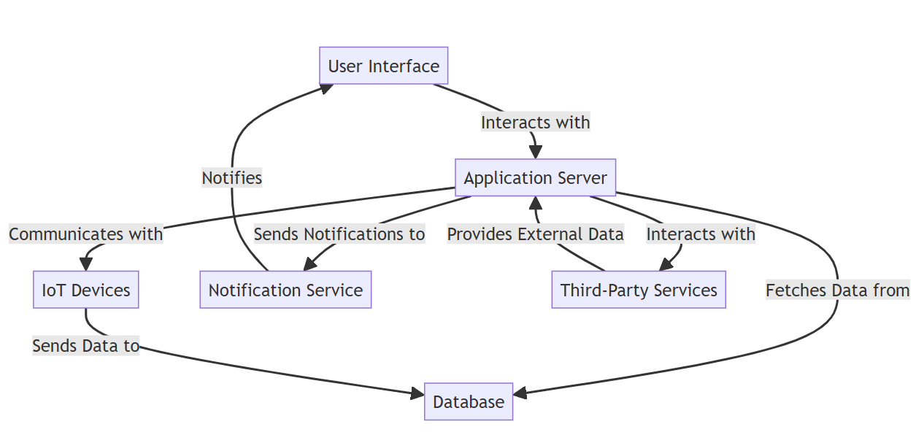
Fig.No:1.1: ARCHITECTURE DIAGRAM
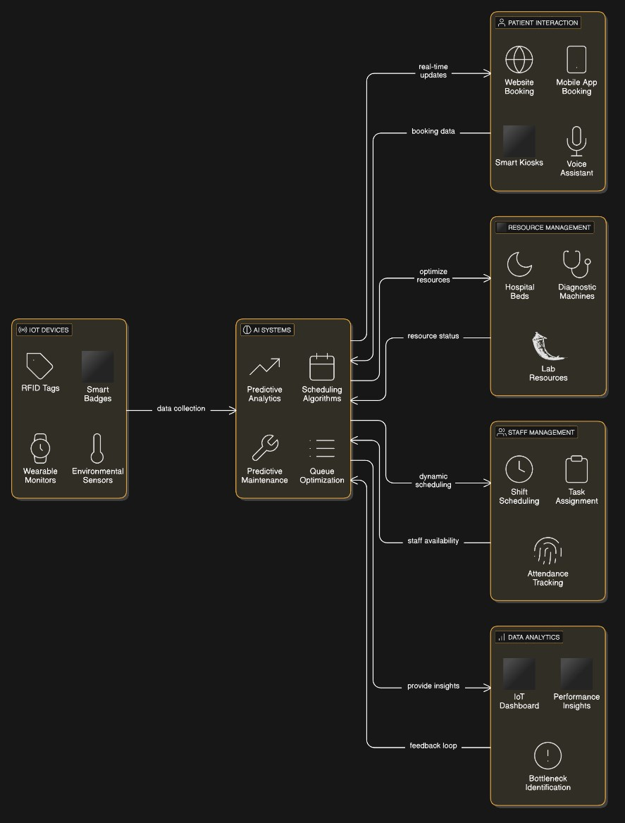

Fig.No:1.2: DETAILED ARCHITECTURE DIAGRAM

  - USE CASE DIAGRAM

3.2.1 Actors:
  - Patients:
    - Individuals seeking medical services.
    - They interact with the system to book appointments, request care, and access their medical records.
  - Doctors:
    - Medical professionals who provide care and manage patient appointments.
    - They update medical histories and generate reports based on consultations.
  - Hospital Staff:
    - Support personnel responsible for administrative tasks, inventory management, and emergency handling.
    - They ensure the smooth operation of hospital services.
  - Technicians:
    - Specialists who maintain medical equipment and assist patients when needed.
    - They ensure that medical devices are operational and provide technical support to healthcare providers.
  - Administrators:
    - Individuals responsible for overseeing the entire system.
    - They manage user accounts, generate reports, and ensure compliance with regulations.
    - Use Cases:
  - Book Appointment:
    - Description: Patients can schedule appointments with doctors through the system.
    - Importance: Streamlines the appointment scheduling process, reducing wait times and improving patient experience.
  - Update Medical History:
    - Description: Doctors can enter or modify patient medical histories during consultations.
    - Importance: Ensures that patient records are accurate and up-to-date, which is crucial for effective treatment.
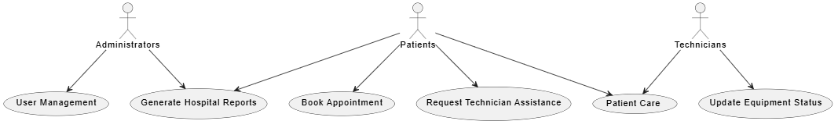

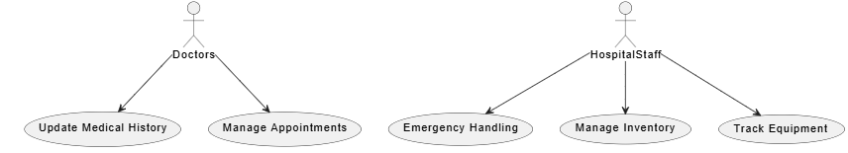

Fig.No:1.3: USES CASE DIAGRAM
  - Emergency Handling:
    - Description: Hospital staff can respond to emergency situations as they arise.
    - Importance: Facilitates quick responses to emergencies, potentially saving lives.
  - Generate Hospital Reports:
    - Description: Administrators can create reports on various metrics, such as patient care statistics and inventory levels.
    - Importance: Helps in decision-making and operational improvements.
  - Manage Appointments:
    - Description: Doctors can view, modify, and cancel their appointments.
    - Importance: Provides flexibility for doctors to manage their schedules effectively.
  - Manage Inventory:
    - Description: Hospital staff can oversee medical supplies and equipment.
    - Importance: Ensures that necessary supplies are available and reduces wastage.
  - Track Equipment:
    - Description: Staff can monitor the status and maintenance schedules of medical equipment.
    - Importance: Ensures that all equipment is functioning properly and is ready for use.
  - User Management:
    - Description: Administrators can add, modify, or remove user accounts within the system.
    - Importance: Maintains security and ensures that only authorized personnel have access to sensitive information.
  - Update Equipment Status:
    - Description: Technicians can update the operational status of medical devices.
    - Importance: Keeps the system informed about equipment readiness and maintenance needs.
  - Patient Care:
    - Description: Doctors and technicians provide care and assistance to patients during appointments.
    - Importance: Central to the healthcare service, ensuring that patients receive the necessary treatment.
  - Request Technician Assistance:
    - Description: Patients can request help from technicians for equipment-related issues.
    - Importance: Enhances patient experience by providing immediate technical support.

3.2.3 Relationships
- Associations:
  - Lines connecting actors to use cases represent interactions. For instance, a line from "Patients" to "Book Appointment" indicates that patients can perform this action.
- Multiplicity:
  - Some use cases may connect to multiple actors. For example, both "Patients" and "Doctors" may interact with "Generate Hospital Reports," indicating shared functionality.
- Include and Extend Relationships (not explicitly shown in the diagram but can be implied):
  - Include: A use case that is always called as part of another use case. For example, "Update Medical History" may be included in "Patient Care."
  - Extend: A use case that adds optional behavior to another use case. For example, "Emergency Handling" might extend "Patient Care" if an emergency arises.

Significance of the Use Case Diagram
- Requirements Gathering:
  - Helps stakeholders understand what the system should do from the user's perspective, facilitating discussions about requirements.
- System Design:
  - Provides a foundation for identifying system components and their interactions, guiding developers in designing the system architecture.
- Communication:
  - Serves as a visual tool for communicating system functionality to non-technical stakeholders, ensuring everyone has a clear understanding of the system's capabilities.
- Validation:
  - Acts as a reference point for validating that the system meets user needs, ensuring that all necessary use cases are implemented.
- Documentation:
  - Provides a clear and organized way to document system functionalities, making it easier to maintain and update the system in the future.

  - CLASS DIAGRAM
The Class Diagram represents the structure of the AI & IoT-powered healthcare system, showcasing the classes, their attributes, methods, and relationships.

3.3.1 Class Description
1. Person (Base Class)
- Attributes:
  - Person ID: Unique identifier for each person.
  - name: Full name of the person.
  - contact: Contact information (phone number, email, etc.).
- Description:
  - This is the base class for common attributes shared by other classes like Staff and Patient, serving as a foundation for defining individuals in the healthcare system.

2. Staff (Inherits from Person)
- Attributes:
  - Staff ID: Unique identifier for each staff member.
  - role: Job title or role within the hospital (e.g., Receptionist, Nurse, Doctor, Technician).
  - address: Residential address of the staff member.
- Methods:
  - addDuty(): Assigns new duties or responsibilities to the staff member.
  - removeDuty(): Removes existing duties from the staff member.
- Description:
  - Represents hospital staff, including various roles. This class is specialized to define the characteristics and responsibilities of hospital personnel.

3. Receptionist (Inherits from Staff)
- Methods:
  - scheduleAppointment(): Facilitates the scheduling of patient appointments.
  - managePatientRecord(): Handles the management of patient records.
  - updatePatientInfo(): Updates the information of patients in the system.

- Description:
  - Specializes the Staff class to handle tasks specific to a receptionist, including administrative duties related to patient management and appointment scheduling.

4. Nurse (Inherits from Staff)
- Attributes:
  - nurseID: Unique identifier for each nurse.
- Methods:
  - assignPatient(): Assigns a patient to the nurse for care.
  - updateVitals(): Updates the vital signs of assigned patients.
- Description:
  - Represents the nursing role with specific responsibilities related to patient care and monitoring.

5. Doctor (Inherits from Staff)
- Attributes:
  - doctorID: Unique identifier for each doctor.
  - specialty: Medical specialty of the doctor (e.g., cardiology, pediatrics).
- Methods:
  - diagnose(): Diagnoses medical conditions based on examinations and tests.
  - prescribeMedication(): Prescribes medications to patients.
  - reviewMedicalRecord(): Reviews patient medical records for informed decision-making.
- Description:
  - Represents doctors with specialized roles, focusing on patient diagnosis and treatment.

6. Technician (Inherits from Staff)
- Attributes:
  - technicianID: Unique identifier for each technician.
  - specialty: Area of expertise (e.g., radiology, equipment maintenance).
- Methods:
  - maintainEquipment(): Responsible for maintaining medical equipment.
  - assistPatient(): Provides assistance to patients regarding technical issues.
- Description:
  - Represents technicians who specialize in maintaining equipment and assisting patients with technical needs.

7. Patient (Inherits from Person)
- Attributes:
  - patientID: Unique identifier for each patient.
  - age: Age of the patient.
  - gender: Gender of the patient.
  - medicalHistory: Summary of the patient's medical history.
- Methods:
  - scheduleAppointment(): Allows patients to schedule their appointments with doctors.
  - updateMedicalHistory(): Updates the patient’s medical history as needed.
  - getMedicalRecord(): Retrieves the patient’s medical record from the system.

- Description:
  - Represents patients with relevant health details, enabling them to interact with the healthcare system effectively.
8. Hospital
- Attributes:
  - hospitalID: Unique identifier for the hospital.
  - name: Name of the hospital.
  - location: Physical location of the hospital.
- Methods:
  - admitPatient(): Admits a patient to the hospital for treatment.
  - dischargePatient(): Discharges a patient from the hospital after treatment.
  - allocateRoom(): Allocates a room to an admitted patient.
- Description:
  - Represents the hospital entity and its services, focusing on patient admissions, discharges, and room allocations.
9. MedicalRecord
- Attributes:
  - recordID: Unique identifier for each medical record.
  - details: Content of the medical record, including diagnoses, treatments, etc.
  - date: Date of the record entry.
- Methods:
  - createRecord(): Creates a new medical record for a patient.
  - updateRecord(): Updates an existing medical record with new information.
  - viewRecord(): Allows authorized personnel to view the medical record.
- Description:
  - Stores and manages patient medical records, ensuring that all relevant health information is documented and accessible.
10. Appointment
- Attributes:
  - appointmentID: Unique identifier for each appointment.
  - time: Scheduled time for the appointment.
  - patientID: Identifier for the patient associated with the appointment.
  - doctorID: Identifier for the doctor assigned to the appointment.
- Methods:
  - schedule(): Schedules a new appointment in the system.
  - update(): Updates the details of an existing appointment.
  - cancel(): Cancels an existing appointment.
- Description:
  - Manages scheduling and updating appointments, facilitating the organization of patient visits to healthcare providers.
11. Laboratory
- Attributes:
  - labID: Unique identifier for the laboratory.
  - name: Name of the laboratory.
  - location: Physical location of the laboratory.
- Methods:
  - conductTest(): Performs medical tests on patient samples.
  - generateReport(): Generates reports based on test results.
- Description:
  - Represents the laboratory entity responsible for conducting tests and generating medical reports for patients.
3.3.2 Relationships
3.3.2.1 Inheritance
- The diagram shows inheritance where Person is the parent class for both Staff and Patient.
- The Staff class is further specialized into Receptionist, Nurse, Doctor, and Technician.
3.3.2.2 Associations
- The Patient class is associated with Medical Record, Appointment, Doctor, and Technician:
  - Medical Record: Indicates that patients possess medical records.
  - Appointment: Shows that patients have scheduled appointments with doctors.
  - Doctor: Represents the interaction between patients and their healthcare providers.
  - Technician: Indicates that patients can receive assistance from technicians.
- The Laboratory class interacts with Patient and Medical Record:
  - Patient: Indicates that laboratories conduct tests for patients.
  - Medical Record: Shows that test results are documented in the medical records.
- The Hospital class interacts with both Patient and Medical Record, indicating its role in managing admissions and records.

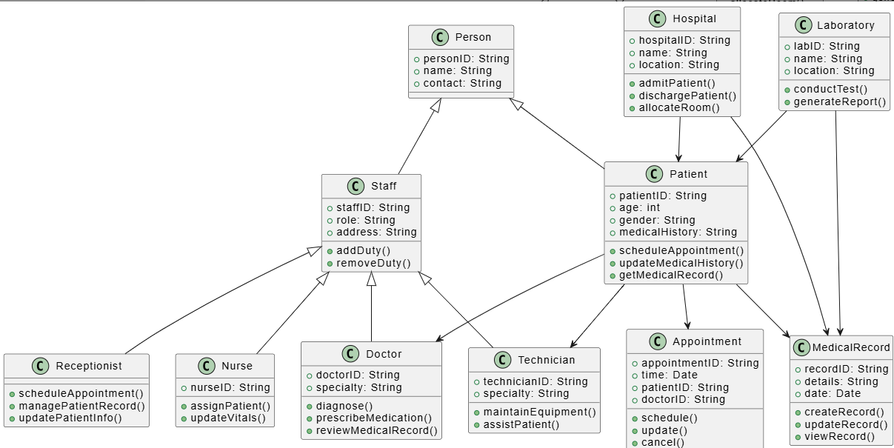

Fig.No:1.4 CLASS DIAGRAM

  - DATA FLOW DIAGRAM
The DFD visually represents how data flows between different entities in the healthcare system. It highlights the processes, data stores, and external entities involved in patient care and management.
3.4.1 Entities
These are the external actors that interact with the system:
- Patient: The individual receiving healthcare services. They engage with various processes, such as scheduling appointments, receiving prescriptions, and accessing medical records.
- Receptionist: The administrative staff member responsible for managing patient appointments, updating records, and facilitating communication between patients and healthcare providers.
- Doctor: A healthcare professional who diagnoses and treats patients. Doctors interact with medical records, request tests, and prescribe medications.
- Laboratory: A facility that conducts medical tests. The laboratory processes samples and generates reports based on test results.
- Technician: A specialist who assists in the laboratory by conducting tests and maintaining equipment. Technicians ensure that tests are performed accurately and efficiently.
- Pharmacy: A facility that dispenses medications. The pharmacy processes prescriptions from doctors and provides medications to patients.
- Hospital: The institution that manages patient admissions, discharges, and room allocations. Hospitals provide the infrastructure for patient care.
- Medical Record: A data store that maintains patient medical histories, including diagnoses, treatments, and test results. This entity is crucial for ensuring continuity of care.
3.4.2 Processes
These represent the actions taken within the system:
- Scheduling Appointments: Patients initiate the process by scheduling appointments with the receptionist.
- Updating Patient Records: Receptionists update the medical records with new information, ensuring that patient data is current.
- Conducting Tests: Doctors request specific tests from the laboratory, which are then conducted by technicians.
- Generating Test Reports: After conducting tests, technicians generate reports that provide insights into patient health.
- Prescribing Medication: Based on test results and evaluations, doctors prescribe medications to patients.
- Dispensing Medication: The pharmacy dispenses the prescribed medications to patients.
- Admitting and Discharging Patients: Receptionists manage the admission process for new patients and facilitate discharges when treatment is complete.
3.4.3 Data Flows
These arrows indicate the direction of data movement between entities and processes:
- Patient to Receptionist:
  - Data Flow: "Schedules Appointment"
  - Description: Patients request appointments, providing necessary details to the receptionist.
- Receptionist to Patient:
  - Data Flow: "Confirms Appointment"
  - Description: The receptionist confirms the appointment details with the patient.

- Receptionist to Medical Record:
  - Data Flow: "Updates Patient Record"
  - Description: The receptionist updates the patient's medical record with any new information gathered during the appointment scheduling process.
- Medical Record to Doctor:
  - Data Flow: "Stores Medical History"
  - Description: The medical record system stores the patient's medical history, which is accessible to doctors.
- Doctor to Laboratory:
  - Data Flow: "Requests Tests"
  - Description: The doctor requests specific tests to be conducted based on the patient's condition.
- Laboratory to Technician:
  - Data Flow: "Conducts Tests"
  - Description: Technicians receive requests from the laboratory to perform the necessary tests.
- Technician to Laboratory:
  - Data Flow: "Generates Test Report"
  - Description: After conducting tests, technicians generate reports that are sent back to the laboratory.
- Laboratory to Doctor:
  - Data Flow: "Sends Report"
  - Description: The laboratory sends the generated test reports to the doctor for review.
- Doctor to Patient:
  - Data Flow: "Prescribes Medication"
  - Description: Doctors provide prescriptions to patients based on the test results and their evaluations.
- Patient to Pharmacy:
  - Data Flow: "Receives Prescription"
  - Description: Patients take their prescriptions to the pharmacy to obtain their medications.
- Pharmacy to Patient:
  - Data Flow: "Dispenses Medication"
  - Description: The pharmacy dispenses the medications to the patient as per the prescription.
- Patient to Medical Record:
  - Data Flow: "Updates Medical History"
  - Description: Patients can update their medical history directly in the medical record system.
- Patient to Medical Record:
  - Data Flow: "Requests Medical Record"
  - Description: Patients can request their medical records for personal reference or other needs.
- Medical Record to Patient:
  - Data Flow: "Provides Medical Record"
  - Description: The medical record system provides the requested records back to the patient.
- Receptionist to Hospital:
  - Data Flow: "Admits Patient"
  - Description: The receptionist processes the admission of patients into the hospital.
- Hospital to Patient:
  - Data Flow: "Allocates Room"
  - Description: The hospital allocates a room for the admitted patient.
- Hospital to Patient:
  - Data Flow: "Discharges Patient"
  - Description: The hospital processes the discharge of patients once their treatment is complete.

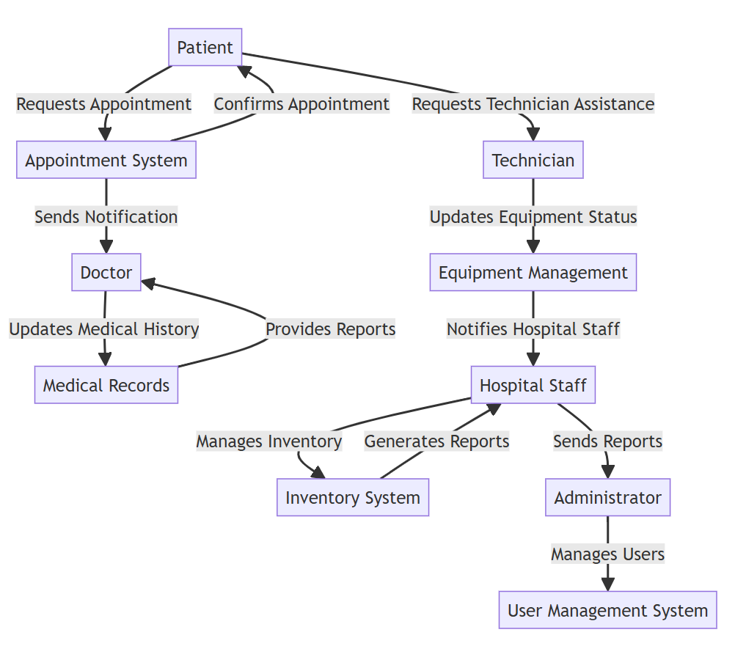
Fig.No:1.5 DATA FLOW DIAGRAM

  - ACTIVITY DIAGRAM

3.5.1 Patient Requests Appointment
- The process starts when a patient requests an appointment with a doctor.
- This request can be made through various channels such as a hospital's website, a mobile app, a phone call, or an in-person visit.
3.5.2 Check Availability
- The system checks whether the requested doctor or a suitable alternative is available for consultation.
- The decision point "Available?" has two possible outcomes:
  - Yes (Available) → Move to "Schedule Appointment."
  - No (Not Available) → Move to "Notify Patient."
3.5.3 Availability
A. If Available → Schedule Appointment
- The system or hospital staff schedules an appointment based on the availability of doctors and resources.
B. If Not Available → Notify Patient
- If no slots are available, the patient is informed and may either choose a different date, time, or doctor.
- The patient might be given options like rescheduling, waiting for a cancellation, or being added to a priority list.
3.5.4 Send Confirmation
- Once an appointment is scheduled, a confirmation message is sent to the patient via email, SMS, or mobile app notification.
- The confirmation includes details such as:
  - Date and time of appointment.
  - Doctor’s name and specialty.
  - Location and any necessary instructions (e.g., fasting before tests).
3.5.5 Patient Arrives
- On the day of the appointment, the patient arrives at the hospital or clinic.
- The hospital staff may verify the patient's details and update records.

3.5.6 Doctor Consults Patient
- The patient meets with the doctor for a consultation.
- The doctor asks about symptoms, medical history, and other relevant details.
- Based on the patient's condition, the doctor may conduct a physical examination or recommend tests.

3.5.7 Update Medical History
- Any new findings, prescribed medications, or test requests are updated in the patient's medical records.
- Electronic Health Records (EHR) systems might be used for maintaining this data.
3.5.8 Patient Care
- The doctor provides treatment, prescribes medication, or recommends further procedures.
- Depending on the case, the patient may need additional tests, therapy, or specialist referrals.
3.5.9 Decision Point: Need Technician?
- At this stage, the doctor determines whether a technician is required for additional procedures.
- Examples of cases requiring a technician:
  - Lab tests (blood tests, urine analysis, etc.).
  - X-rays, MRI scans, or other imaging procedures.
  - Physiotherapy or specialized medical equipment use.
  - If No: The process moves to "Complete Appointment."
  - If Yes: The system moves to "Request Technician."
3.5.10 Request Technician
- If a technician is required, a request is sent to the respective department.
- The technician is assigned based on availability.
3.5.11 Technician Assists Patient
- The technician performs the necessary procedure (e.g., collecting samples, taking scans).
- The results may be shared with the doctor for further analysis.
3.5.12 Complete Appointment
- Once the consultation and necessary tests are done, the appointment is marked as complete.
- The hospital updates billing and administrative records.

3.5.13 Generate Report
- A summary report is generated, which may include:
  - Diagnosis and consultation details.
  - Prescribed medication.
  - Test results and follow-up instructions.
- This report can be accessed by the patient digitally or via printed copies.

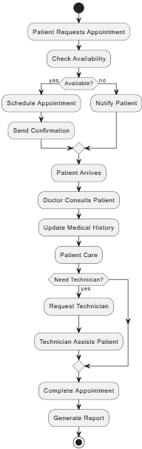

Fig.No:1.7 ACTIVITY DIAGRAM

CHAPTER 4

SYSTEM IMPLEMENTATION
The IoT-powered with AI Hospital and Laboratory Management System follows a structured implementation approach to ensure seamless integration, automation, and efficiency.
1. Requirement Analysis
- Identifying IoT hardware (RFID, BLE, smart sensors) and AI software needed for system deployment.
- Ensuring compatibility with existing hospital and laboratory infrastructure.
- Defining secure data transmission and storage protocols.
2. System Development
- Integrating IoT sensors for real-time tracking of doctors, technicians, patients, and medical equipment.
- Implementing AI-driven predictive scheduling for appointments, lab tests, and resource allocation.
- Designing a user-friendly interface for hospital administrators, staff, and patients.
3. Data Integration & Processing
- Synchronizing data with Hospital Management Systems (HMS) and Laboratory Information Systems (LIS).
- Implementing IoT-based remote monitoring of hospital beds, medical supplies, and lab equipment.
- Ensuring secure communication through SSL/TLS encryption and OAuth 2.0 authentication.
4. Testing & Optimization
- Conducting system-wide testing to ensure accurate tracking, scheduling, and automation.
- Optimizing AI analytics for real-time decision-making and predictive maintenance.
- Validating IoT sensor accuracy for hospital and laboratory operations.
5. Deployment & Maintenance
- Deploying the system in hospitals and laboratories with real-time IoT monitoring and AI automation.
- Training medical staff on IoT-enabled workflows and AI-powered decision support.
- Ensuring continuous updates, security patches, and performance enhancements for system reliability.
4.1 LIST OF MODULES
The IoT-powered with AI Hospital and Laboratory Management System is structured into the following key modules, ensuring efficient hospital operations and optimized patient care.
4.1.1 User Management Module
- Manages patients, doctors, technicians, and hospital staff records.
- Provides role-based authentication and secure access control.
4.1.2 Appointment Scheduling Module
- Allows patients to book, modify, and cancel appointments.
- Uses AI-driven optimization to match doctor availability and reduce wait times.
4.1.3 Real-Time Tracking Module
- Uses IoT sensors to monitor real-time locations of staff, patients, and medical resources.
- Facilitates dynamic staff allocation and emergency response.
4.1.4 Queue Management Module
- AI-powered patient prioritization based on emergency level and check-in time.
- Provides real-time queue updates via mobile apps and self-service kiosks.
4.1.5 Resource & Inventory Management Module
- Monitors hospital beds, diagnostic machines, medical supplies, and lab equipment.
- Implements AI-based predictive maintenance and automated inventory management.
4.1.6 Emergency Handling Module
- Uses IoT-enabled health monitoring devices to detect critical patient conditions.
- AI-driven risk assessment prioritizes emergency cases for faster treatment.
4.1.7 Integration Module
- Syncs data with Hospital Management Systems (HMS) and Laboratory Information Systems (LIS).
- Ensures seamless real-time data exchange for better decision-making.
4.1.8 Data Analytics & Reporting Module
- AI-powered dashboards provide insights on hospital performance and resource utilization.
- Generates detailed reports for administrators to optimize workflows and hospital operations.

4.2 DETAILED MODULE DESCRIPTION

The IoT-powered with AI Hospital and Laboratory Management System consists of multiple modules, each playing a crucial role in enhancing hospital efficiency, optimizing resource management, and improving patient care. Below is a detailed description of each module.
4.2.1 User Management Module
Description:
The User Management Module is crucial for maintaining the security and integrity of the healthcare system by managing user identities, roles, and access permissions. It ensures that sensitive patient data is accessible only to authorized personnel while providing a seamless user experience.
Features:
- User Registration & Profile Management:
  - Functionality: Users can create accounts through online forms or in-person assistance. The system captures essential details such as name, contact information, role (patient, doctor, admin), and any relevant medical history for patients.
  - Profile Updates: Users can update their profiles, which may include changing passwords, updating contact information, or modifying medical history.
- Role-Based Access Control (RBAC):
  - Functionality: The system assigns roles to users, determining what data and functionalities they can access. For example, doctors can access patient records, while administrative staff may only access billing information.
  - Security: This minimizes the risk of unauthorized access and ensures compliance with regulations like HIPAA.
- Authentication & Security:
  - Multi-Factor Authentication (MFA): Enhances security by requiring users to provide two or more verification factors to gain access.
  - Password Management: Implements strong password policies and allows for password recovery options.
- Patient Medical History Management:
  - Functionality: Centralized storage of patient medical history, including allergies, medications, and previous treatments.
  - Blockchain Encryption: Utilizes blockchain technology for secure data storage and sharing, ensuring data integrity and confidentiality.
Algorithm/Logic:
- Secure Authentication Algorithm:
  - Process: User credentials are hashed using algorithms like BCrypt, ensuring passwords are stored securely. Upon login, the input password is hashed and compared to the stored hash.
- Access Control Logic:
  - Implementation: Each role has a defined set of permissions. When a user attempts to access a resource, the system checks the user’s role against the permissions for that resource.
Data Source:
- Electronic Health Records (EHR): Stores user profiles and medical histories.
- Hospital Management System (HMS): Integrates user data with operational systems for comprehensive management.
Extension:
- Integration with National Health Databases: Ensures that healthcare providers can verify doctor credentials and patient information efficiently.
- Voice Assistant Support: Allows users to authenticate using voice commands for added convenience.

4.2.2 Appointment Scheduling Module
Description:
The Appointment Scheduling Module streamlines the process of scheduling patient appointments, ensuring that healthcare providers can manage their time effectively while improving patient access to care.
Features:
- Calendar Integration:
  - Functionality: Syncs with healthcare providers' calendars (Google Calendar, Outlook) to prevent double bookings.
  - Availability Display: Shows real-time availability of healthcare providers, making it easy for patients to find suitable appointment times.
- Real-Time Availability:
  - Dynamic Updates: Automatically updates available slots based on cancellations or rescheduling, providing accurate information to patients.

- Automated Notifications:
  - Reminders: Sends automated reminders to both patients and providers about upcoming appointments via SMS or email.
Algorithm/Logic:
- Scheduling Algorithm:
  - Optimization: Uses algorithms to maximize appointment slots based on historical data and provider availability, ensuring efficient use of time.
Data Source:
- EHR Database: Pulls patient information and appointment history.
- Provider Schedules: Accesses real-time availability from the HMS.
Extension:
- Feedback Integration: Collects patient feedback after appointments to improve service quality.
- Mobile App Features: Allows patients to manage appointments through a user-friendly interface.
4.2.3 Patient Management Module
Description:
The Patient Management Module is designed to enhance the patient experience by managing all aspects of patient interaction with the healthcare system. It covers registration, appointment scheduling, medical record access, and communication.
Features:
- Patient Registration & Profile Management:
  - Functionality: Patients can register online or at the facility. The system collects necessary information, including demographics and medical history.
  - Profile Updates: Patients can update their profiles, ensuring that their information is current.
- Appointment Management:
  - Scheduling: Patients can book, reschedule, or cancel appointments through the portal or app.
  - Automated Reminders: Sends SMS or email notifications to remind patients of upcoming appointments, reducing no-show rates.

- Medical Record Access:
  - Secure Access: Patients can view their medical records, test results, and treatment plans through a secure portal.
  - Sharing Capabilities: Patients can authorize healthcare providers to access their records, facilitating coordinated care.
Algorithm/Logic:
- Patient Registration Algorithm:
  - Validation: Checks input data for completeness and correctness (e.g., valid email format, required fields).
- Appointment Scheduling Logic:
  - Conflict Checking: The system verifies the availability of healthcare providers before confirming an appointment.
Data Source:
- EHR Database: Central repository for patient information and medical history.
- HMS: Integrates appointment scheduling with overall hospital operations.
Extension:
- Telemedicine Integration: Facilitates virtual consultations, allowing patients to connect with healthcare providers remotely.
- Mobile App Support: Offers patients the ability to manage their health information and appointments on-the-go.

4.2.4 Real-Time Tracking Module
Description:
The Real-Time Tracking Module enhances the safety and efficiency of healthcare operations by monitoring the movements of patients and staff within the healthcare facility.
Features:
- Patient Location Tracking:
  - RFID/GPS Technology: Utilizes RFID tags or GPS devices to track patient locations, ensuring staff can quickly locate patients when needed.
  - Geofencing: Alerts staff if patients move outside designated areas, enhancing safety.
- Staff Monitoring:
  - Location Tracking: Monitors the location of healthcare staff, optimizing resource allocation and response times.

- Emergency Alerts:
  - Alert System: Sends automatic alerts to staff in case of emergencies, such as patient falls or other critical incidents.
Algorithm/Logic:
- Tracking Algorithm:
  - Real-Time Updates: Uses location data to provide continuous updates on the whereabouts of patients and staff, facilitating quick responses to needs.
Data Source:
- RFID/GPS Tracking Systems: Provides real-time location data.
- HMS: Integrates tracking information with patient records and operational data.
Extension:
- Emergency Response Integration: Connects with emergency services for coordinated responses during critical situations.
- Mobile App for Staff: Allows staff to access real-time tracking information on their mobile devices.

4.2.5 Queue Management Module
Description:
The Queue Management Module optimizes patient flow within healthcare facilities, reducing wait times and enhancing the overall patient experience.
Features:
- Digital Queue System:
  - Check-In Process: Patients can check in digitally via kiosks or mobile apps, receiving a queue number.
  - Queue Status Notifications: Patients can receive updates on their queue status via SMS or app notifications.
- Real-Time Updates:
  - Display Screens: Shows real-time queue status on screens throughout the facility, keeping patients informed.
- Analytics Dashboard:
  - Performance Tracking: Provides insights into patient flow, wait times, and service efficiency for management review.

Algorithm/Logic:
- Queue Management Algorithm:
  - Prioritization Logic: Implements a first-come, first-served (FCFS) approach while considering priority levels (e.g., emergency cases).
Data Source:
- HMS: Integrates queue management with patient check-in data.
- Operational Data: Analyzes historical data to optimize future queue management strategies.
Extension:
- Mobile App Integration: Allows patients to manage their place in the queue remotely.
- Feedback System: Collects patient feedback on wait times and service quality.
4.2.6 Resource & Inventory Management Module
Description:
The Resource & Inventory Management Module oversees the allocation and inventory of medical resources, ensuring that healthcare facilities are adequately equipped to meet patient needs.
Features:
- Inventory Tracking:
  - Real-Time Monitoring: Tracks stock levels of medical supplies and equipment, providing alerts for low inventory.
  - Usage Analytics: Analyzes usage patterns to optimize inventory levels and reduce waste.
- Automated Reordering:
  - Reorder Triggers: Automatically generates purchase orders when inventory falls below predefined thresholds.
- Resource Allocation:
  - Staff and Equipment Management: Manages the allocation of medical staff and equipment based on patient needs and operational demands.
Algorithm/Logic:
- Inventory Management Algorithm:
  - Predictive Analytics: Uses historical data to forecast future resource needs, allowing for proactive inventory management.
Data Source:
- Inventory Databases: Central repository for tracking supplies and equipment.
- Supply Chain Management Systems: Interfaces with suppliers for order processing and tracking.
Extension:
- Supplier Integration: Connects with suppliers for streamlined ordering and delivery processes.
- Mobile Inventory Management: Enables staff to manage inventory on-the-go through mobile devices.

4.2.7 Emergency Handling Module
Description:
The Emergency Handling Module prepares healthcare facilities to respond effectively to emergencies, ensuring patient safety and efficient resource use during critical situations.
Features:
- Incident Reporting:
  - Rapid Reporting System: Allows staff to report emergencies quickly through mobile devices or designated systems.
  - Incident Tracking: Monitors reported incidents and their resolutions for accountability.
- Emergency Protocols:
  - Access to Protocols: Provides immediate access to emergency response protocols for various scenarios (e.g., fire, natural disasters, medical emergencies).
- Resource Mobilization:
  - Quick Resource Allocation: Facilitates the rapid mobilization of necessary resources and personnel during emergencies.
Algorithm/Logic:
- Emergency Response Algorithm:
  - Prioritization Logic: Automatically prioritizes incidents based on severity and resource availability, ensuring critical situations are addressed first.
Data Source:
- Incident Reports: Compiles data from reported emergencies for analysis and improvement.
- Emergency Response Plans: Stores predefined protocols and procedures for quick access.
Extension:
- Integration with Local Emergency Services: Ensures coordinated responses with local emergency responders during crises.
- Training Modules: Provides training resources for staff on emergency response protocols.

4.2.8 Integration Module
Description:
The Integration Module connects various healthcare systems and applications, enabling seamless data exchange and interoperability across the healthcare ecosystem.
Features:
- API Management:
  - API Development: Facilitates the creation and management of APIs for integrating different systems and applications.
  - Documentation: Provides comprehensive documentation for developers to ensure smooth integration.
- Data Synchronization:
  - Real-Time Updates: Ensures that data is synchronized across systems in real-time, reducing discrepancies and improving data accuracy.
- Interoperability Standards:
  - Compliance with Standards: Adheres to industry standards like HL7 and FHIR to ensure compatibility with various healthcare applications.
Algorithm/Logic:
- Data Integration Logic:
  - ETL Processes: Employs Extract, Transform, Load (ETL) processes to consolidate data from multiple sources into a central repository for analysis.
Data Source:
- Various Healthcare Applications: Integrates data from EHRs, laboratory systems, billing systems, and other healthcare applications.
Extension:
- Third-Party Application Integration: Allows for the integration of third-party health applications and services for enhanced functionality.
- Data Analytics Integration: Connects with analytics platforms for advanced data analysis and reporting.

4.2.9 Data Analytics & Reporting Module
Description:
The Data Analytics & Reporting Module provides healthcare managers and providers with insights into operations, patient outcomes, and resource utilization through comprehensive data analysis and reporting tools.
Features:
- Dashboards:
  - Interactive Dashboards: Offers real-time visualization of key performance indicators (KPIs) for easy monitoring of operational efficiency and patient care metrics.
- Custom Reports:
  - Report Generation: Allows users to create customizable reports based on specific parameters, providing insights tailored to their needs.
- Predictive Analytics:
  - Forecasting Trends: Utilizes historical data to predict future trends in patient admissions, resource usage, and treatment outcomes.
Algorithm/Logic:
- Analytics Algorithm:
  - Statistical Methods: Applies statistical methods and machine learning techniques to analyze data and generate insights.
Data Source:
- EHR Databases: Provides patient data for analysis.
- Operational Data: Integrates data from various healthcare modules for comprehensive reporting.
Extension:
- Business Intelligence Tools Integration: Connects with external business intelligence tools for enhanced data visualization and reporting capabilities.
- Mobile Reporting Features: Allows managers to access reports and dashboards on mobile devices for on-the-go decision-making.

CHAPTER 5

CONCLUSION AND FUTURE SCOPE

CONCLUSION

The IoT-powered AI-driven Hospital and Laboratory Management System represents a significant advancement in healthcare administration. By integrating innovative technologies such as Artificial Intelligence (AI) and the Internet of Things (IoT), this system not only enhances operational efficiency but also significantly improves patient care. The ability to track resources in real-time, utilize predictive analytics, and automate workflows leads to better decision-making and streamlined hospital operations.

Key Achievements of the System:

Enhanced Patient Care:

AI-Driven Scheduling: Optimizes appointment bookings, reducing wait times and ensuring timely consultations.

Emergency Prioritization: AI algorithms assess incoming cases, prioritizing those in critical condition for immediate attention.

Optimized Resource Utilization:

IoT-Enabled Tracking: Monitors equipment and inventory levels in real-time, preventing mismanagement and stock shortages, thus ensuring that resources are available when needed.

Automated Workflow:

Reduction of Manual Interventions: Automation minimizes human errors and delays, leading to a more efficient operational environment.

Improved Emergency Handling:

AI-Powered Risk Assessment: Quickly identifies high-risk patients, enabling healthcare providers to respond effectively to emergencies.

Seamless Integration:

Data Exchange: Facilitates smooth communication between hospital and laboratory management systems, enhancing collaboration and data accuracy.

Predictive Maintenance & Analytics:

Forecasting Capabilities: AI analyzes historical data to predict patient influx, resource demand, and necessary equipment maintenance, allowing for proactive management.

Future Scope

As technology continues to evolve, the IoT-powered AI-driven Hospital and Laboratory Management System can be further enhanced through the integration of several advanced features:

AI-Powered Chatbots:

Automated Patient Assistance: Implementing chatbots can provide 24/7 support for patients, answering queries, scheduling appointments, and providing pre-visit instructions, thereby improving patient engagement and satisfaction.

Blockchain-Based Medical Records:

Improved Data Security: Utilizing blockchain technology can enhance the security and integrity of medical records, ensuring that patient data is protected against breaches and unauthorized access.

5G and Edge Computing:

Faster IoT Data Processing: The adoption of 5G technology will enable faster data transmission from IoT devices, while edge computing will allow for real-time data processing closer to the source, reducing latency and improving response times.

Wearable Health Monitoring Advancements:

Continuous Remote Patient Care: Integrating wearable devices can facilitate ongoing health monitoring, allowing healthcare providers to track patient vitals and conditions in real-time, leading to timely interventions and improved chronic disease management.

Enhanced Data Analytics:

Machine Learning Models: Advanced analytics using machine learning can uncover deeper insights from healthcare data, improving patient outcomes and operational efficiencies through tailored treatment plans and resource allocation.

Interoperability with Third-Party Applications:

Expanded Ecosystem: Ensuring compatibility with various third-party healthcare applications will enhance the system's functionality, allowing for a more comprehensive approach to patient care.

Augmented Reality (AR) and Virtual Reality (VR):

Training and Simulation: Incorporating AR and VR technologies can enhance training for healthcare professionals, providing immersive simulations for surgical procedures and patient interactions.

REFERENCES
[1] S. R. Morris, Y. Yang, and A. A. Flower, ‘‘Priorities in hospital care
acrossvarying socioeconomic demographics,’’ in Proc. Syst. Inf. Eng. Des.
Symp.(SIEDS), Apr. 2017, pp. 231–236.
[2] R. B and H. M, ‘‘The impact of service quality dimensions on
patientsatisfaction in the private healthcare industry in Pakistan,’’ J. Hospital
Med.Manage., vol. 04, no. 01, pp. 1–8, 2018.
[3] P. Hendradi, ‘‘IT-based customer experience management: A
systematicliterature review,’’ in Proc. Int. Conf. Appl. Comput. Commun.
Technol.(ComCom), May 2017, pp. 1–5.
[4] X. Yang, Y. Fang, and B. K. P. Horn, ‘‘Analysis of information
exchange:How does it affect patient-hospital relationship?’’ in Proc. 4th Int.
Conf.Univ. Village (UV), Oct. 2018, pp. 1–5.
[5] M. Khoie, T. Sattari Tabrizi, E. Khorasani, S. Rahimi, and N.
Marhamati,‘‘A hospital recommendation system based on patient satisfaction
survey,’’Appl. Sci., vol. 7, no. 10, p. 966, Sep. 2017.
[6] T. S. Tabrizi, M. Reza Khoie, E. Sahebkar, S. Rahimi, and N.
Marhamati,‘‘Towards a patient satisfaction based hospital recommendation
system,’’in Proc. Int. Joint Conf. Neural Netw. (IJCNN), Jul. 2016, pp. 131–138.
[7] O. M. Lulembo and R. Silumbe, ‘‘Improving healthcare delivery with the
use of online patient information management system,’’ in Proc. IST-
AfricaWeek Conf., May 2016, pp. 1–8.
[8] S. Safdar, S. Ahmed Khan, and A. Shaukat, ‘‘Customer experience
management (CEM) for automation, data collection and methodology,’’ in Proc.
Int. Conf. Inf. Commun. Technol. Converg. (ICTC), Oct. 2019, pp. 1354–1358.

[9] N. Khan, M. U. Akram, A. Shah, and S. A. Khan, ‘‘Important attributes
Of customer satisfaction in telecom industry: A survey based study,’’ in Proc.4th
IEEE Int. Conf. Eng. Technol. Appl. Sci. (ICETAS), Nov. 2017, pp. 1–7.
[10] S. Nazir, S. Khan, H. U. Khan, S. Ali, I. Garcia-Magarino, R. B. Atan, and
M. Nawaz, ‘‘A comprehensive analysis of healthcare big data management,
analytics and scientific programming,’’ IEEE Access, vol. 8,pp. 95714–95733,
2020.
[11] D. R. Kaufman et al., “Usability in the real world: Assessing medical
information technologies in patients’ homes,” J. Biomed. Inform., vol. 36, no.
1/2, pp. 45–60, Feb. 2003.
[12] B. C. Zapata, J. L. Fernandez-Aleman, A. Toval, and A. Idri, “Reusable
software usability specifications for m-health applications,” J. Med. Syst.,vol. 42,
no. 3, Jan. 2018, Art. no. 45
[13] H. Hoehle and V. Venkatesh, “Mobile application usability:
Conceptualization and instrument development,” MIS Quart., vol. 39, no. 2, pp.
435–472, Jun. 2015.
49[14] P.-Y. Yen and S. Bakken, “Review of health information
Technology usability study methodologies,” J. Amer. Med. Inform. Assoc., vol.
19, no. 3, pp. 413–422, May/Jun. 2012.
[15] “Ergonomics of human-system interaction—Part 11: Usability: Definitions
and concepts, Int. Org. Standardization, Geneva, Switzerland, ISO 9241-11,
2015.

SCREENSHOTS

DOCTOR LOGIN PAGE
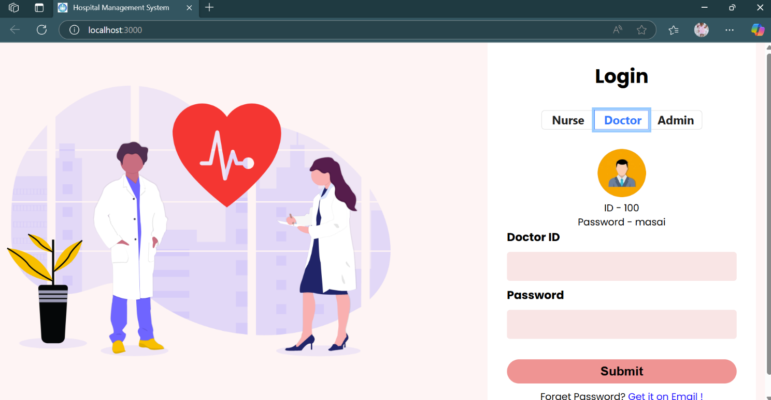
Ss. No:2.1 DOCTOR LOGIN PAGE
ADMIN LOGIN PAGE
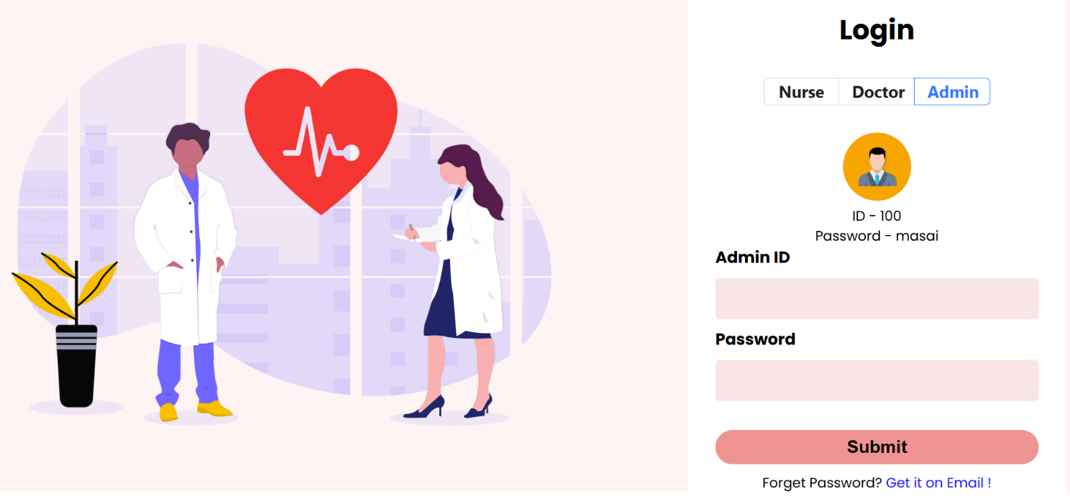
Ss. No:2.2 ADMIN LOGIN PAGE

NURSE LOGIN PAGE
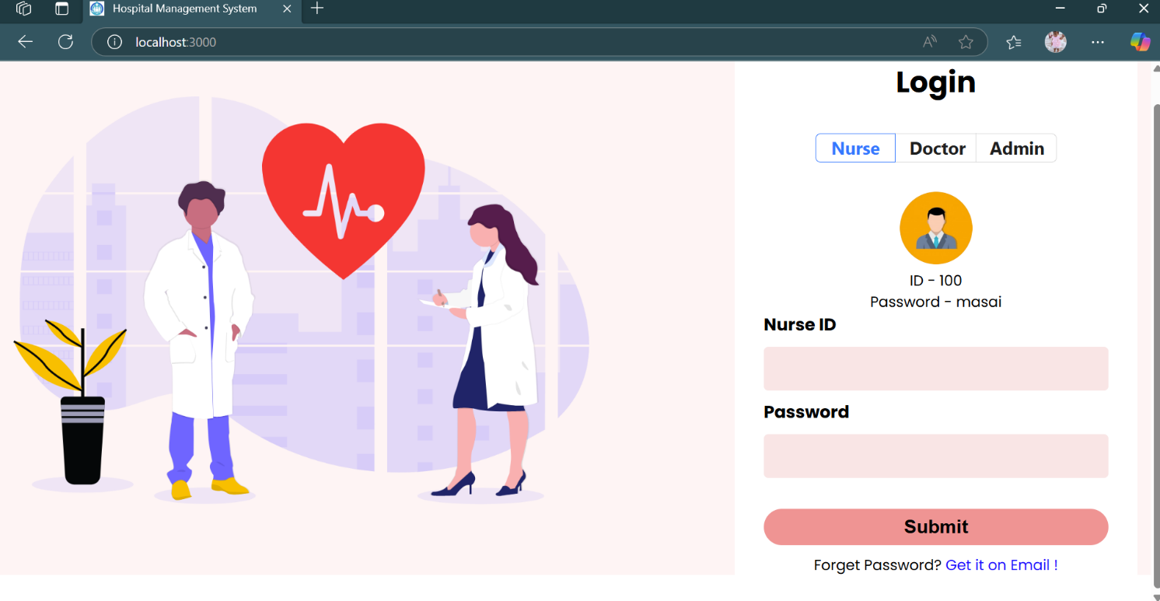
Ss. No:2.3 NURSE LOGIN PAGE
DASHBOARD
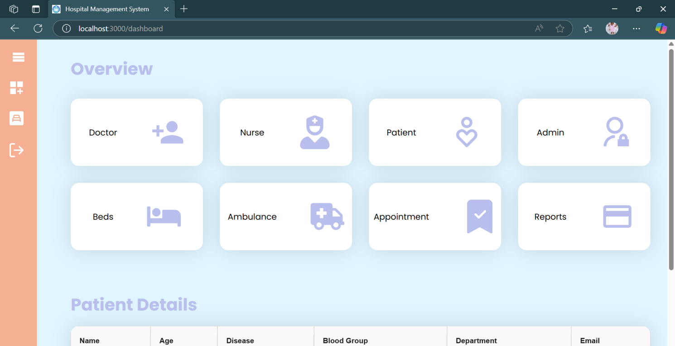
Ss. No:2.4 DASHBOARD

PATIENT DETAILS
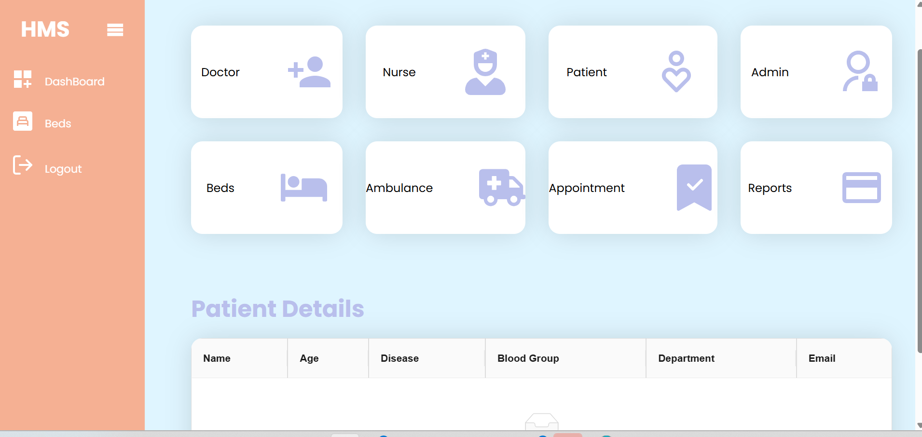
Ss. No:2.5 PATIENT DETAILS


Ss. No:2.6 AMBULANCE DETAILS

BED AVAILABILITY
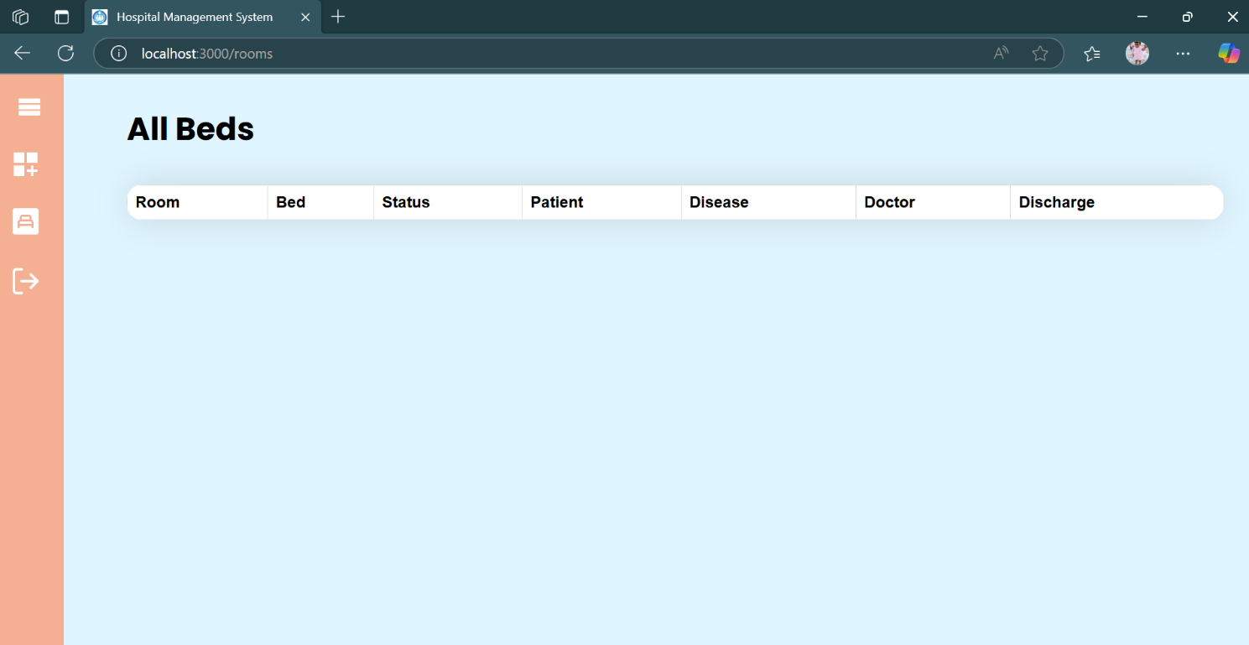
Ss. No:2.7 BED AVAILABILITY
ALL REPORTS
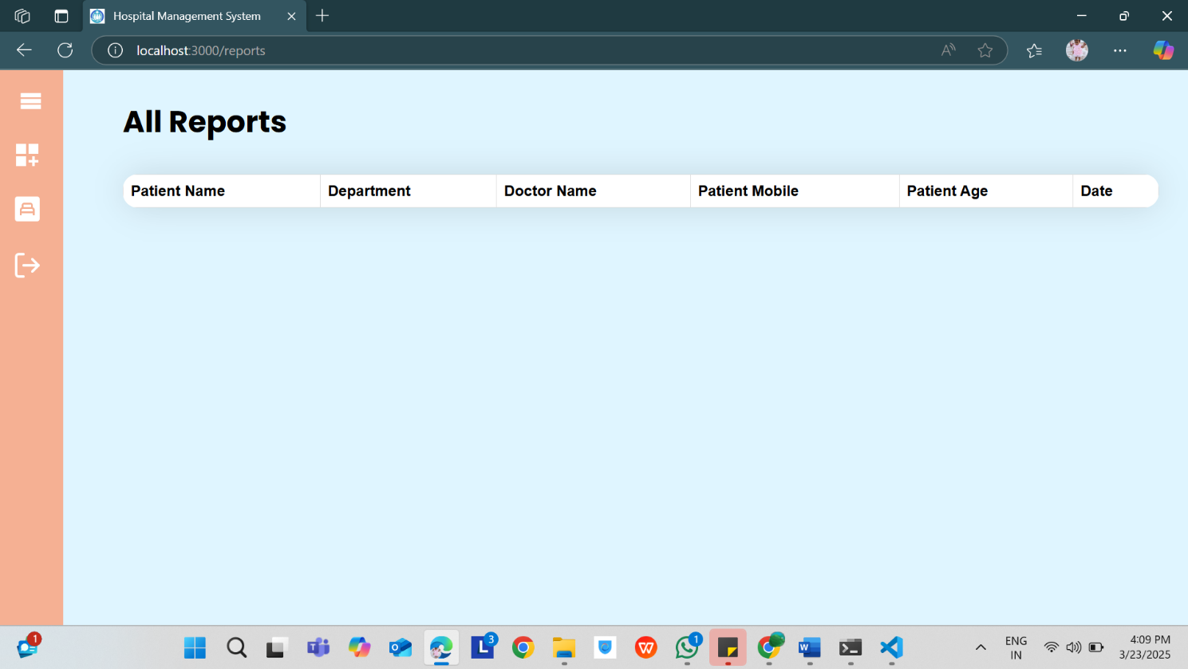
Ss. No:2.8 ALL REPORTS

