Contents

1.1.System API – (TravelOnTip)

1.1.2.getroutes

1.1.3.getSchedules

1.2.System API - (FastGo)

1.2.1.getRoutes

1.2.2.getSchedules

1.3. Process API

1.4.Experirnce API – (Web Application)

1.4.1.Experience API – (Mobile Application)

**Objective :**

**From the project,I understood the requirement is that Trip Easy is a startup company transport providers providing three ways to travel (land,air,sea) tieup with TravelOnTip and FastGo.**

**So,in three ways Trip easy is going to provide the routes and schedules for passengers according to their convenience.**

**SYSTEMLAYER_API _TRAVELONTIP:**

**RAML for travelontip:**

#%RAML 1.0

title: TravelonTip-sysapi

/{transportType}:

   /{transportCompany}:

    /routes:

      get:

        headers:

          transactionId:

            type: string

            required: true

        responses:

          200:

            body:

              application/json:

                example: !include responses/getroutes.json

    /schedules:

      get:

        headers:

          transactionId:

            type: string

            required: true

        queryParameters:

              departureLocationCode:

                type: string

                required: false

              destinationLocationCode:

                 type: string

                 required: false

        responses:

          200:

            body:

              application/json:

                example: !include responses/getschedules.json

**design downloaded from raml:**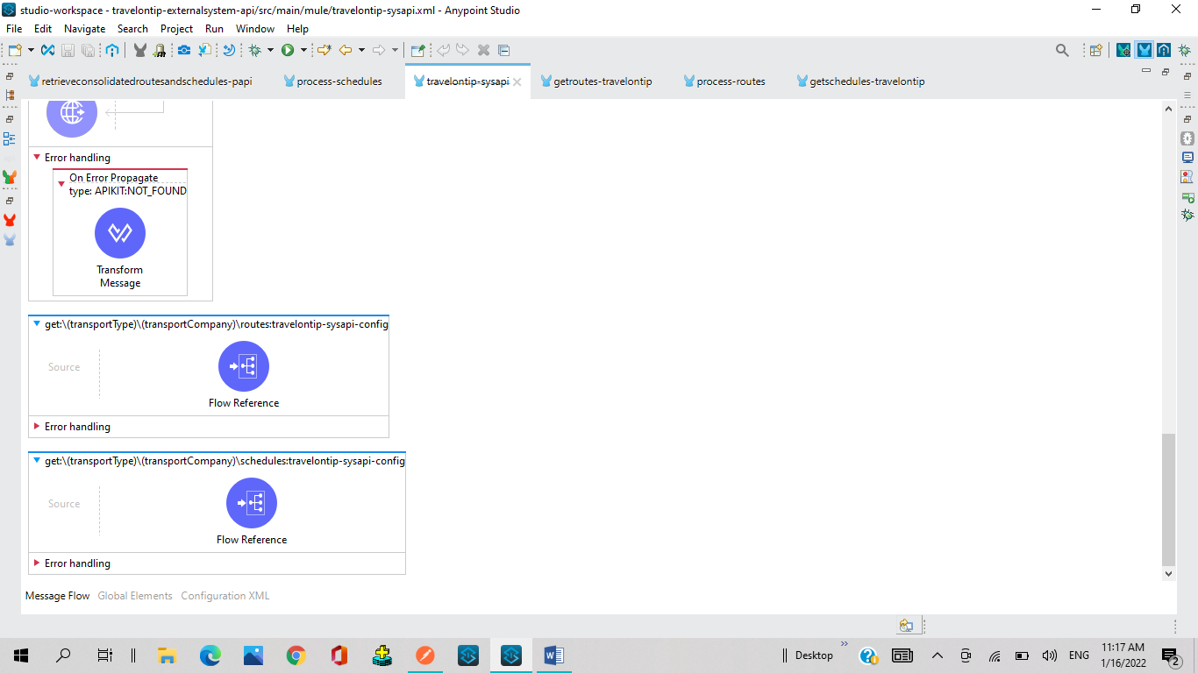

**Developed a flow for travelontip_routes:**

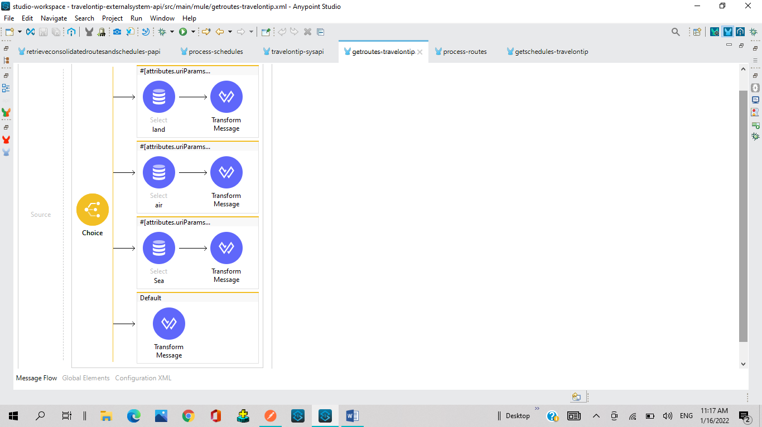

**Developed a flow for travelontip_schedules:**

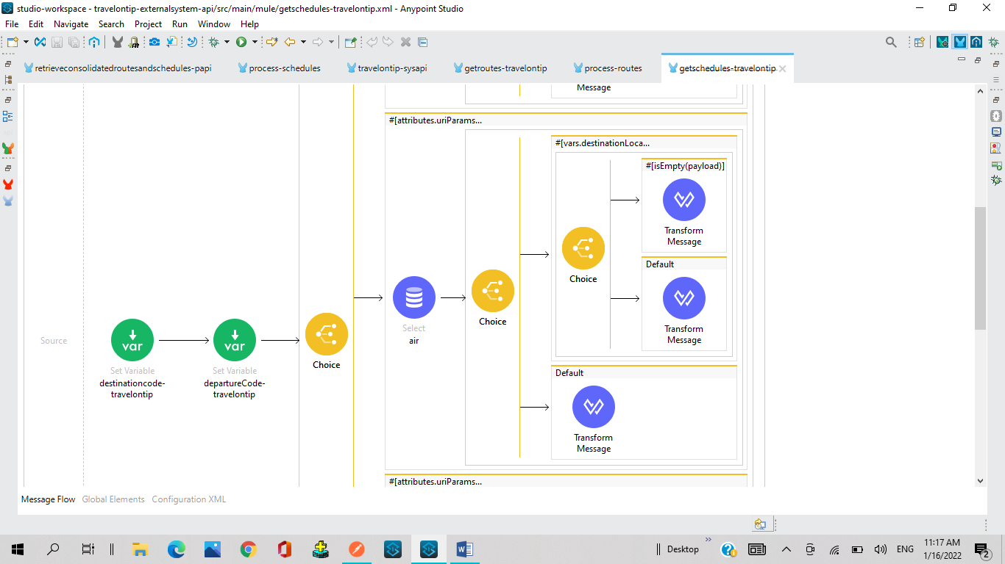

**Output response obtained for TravelOnTip_routes/schedules:**

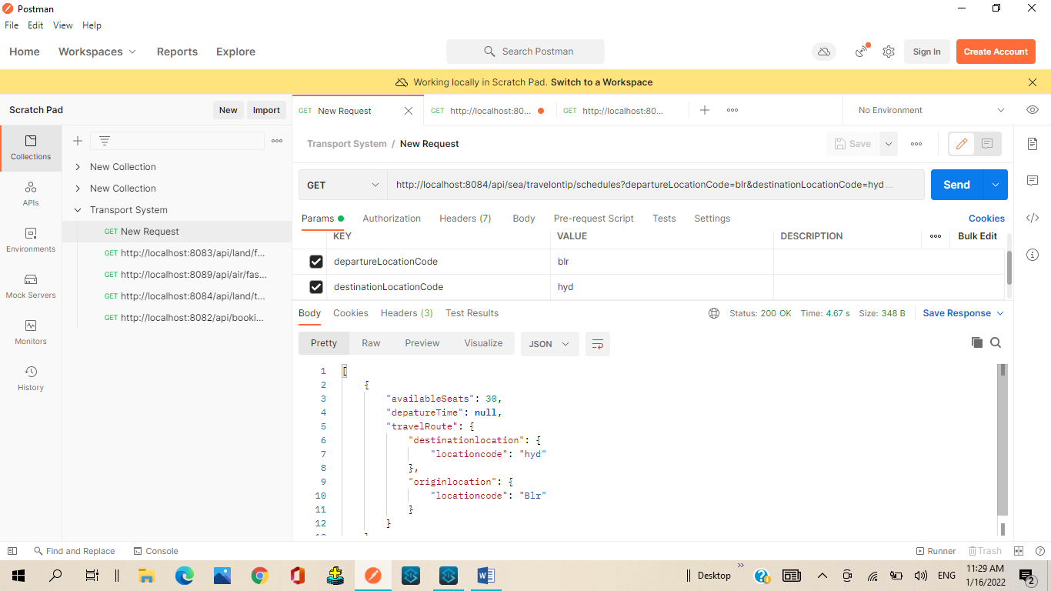

**Designed RAML for fastgo-system-API:**

#%RAML 1.0

title: FastGo-sysapi

/{transportType}:

   /{transportCompany}:

    /routes:

     get:

      headers:

       transactionId :

          type: string

          required: true

      responses:

       200:

        body:

          application/json:

              example: !include responses/getroutesfastgo.json

    /schedules:

     get:

      headers:

       transactionId :

          type: string

          required: true

      queryParameters:

        departureLocationCode:

         type: string

         required: false

        destinationLocationCode:

         type: string

         required: false

      responses:

       200:

        body:

          application/json:

            example: !include responses/getschedulesfastgo.json

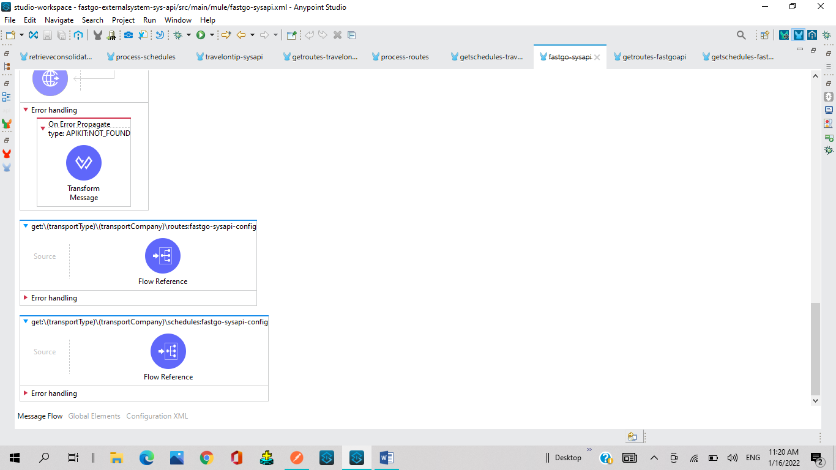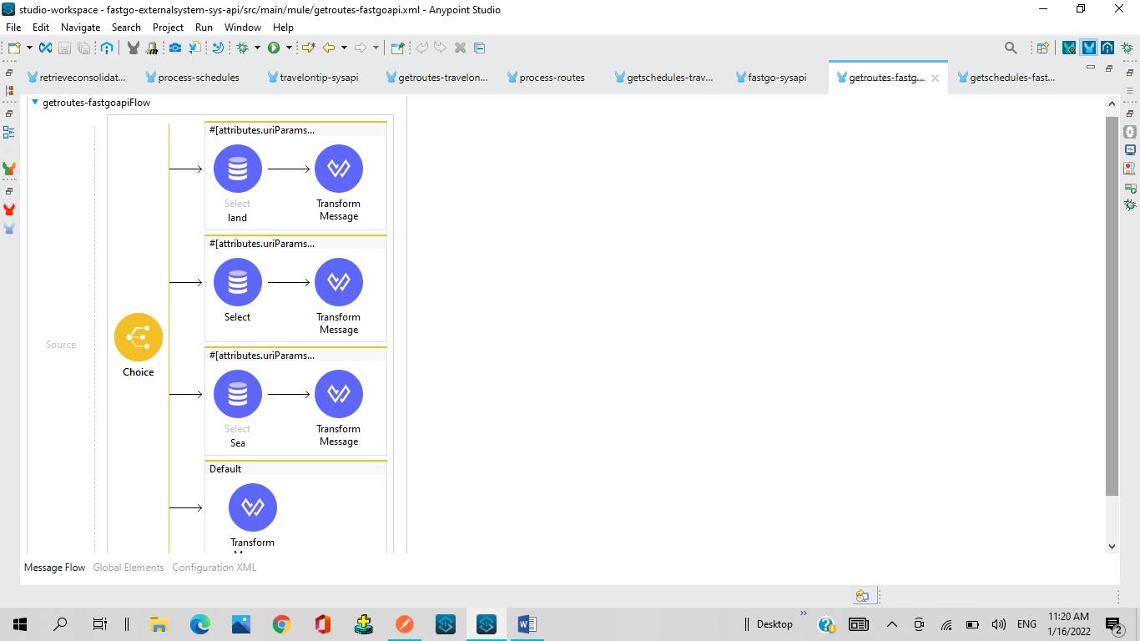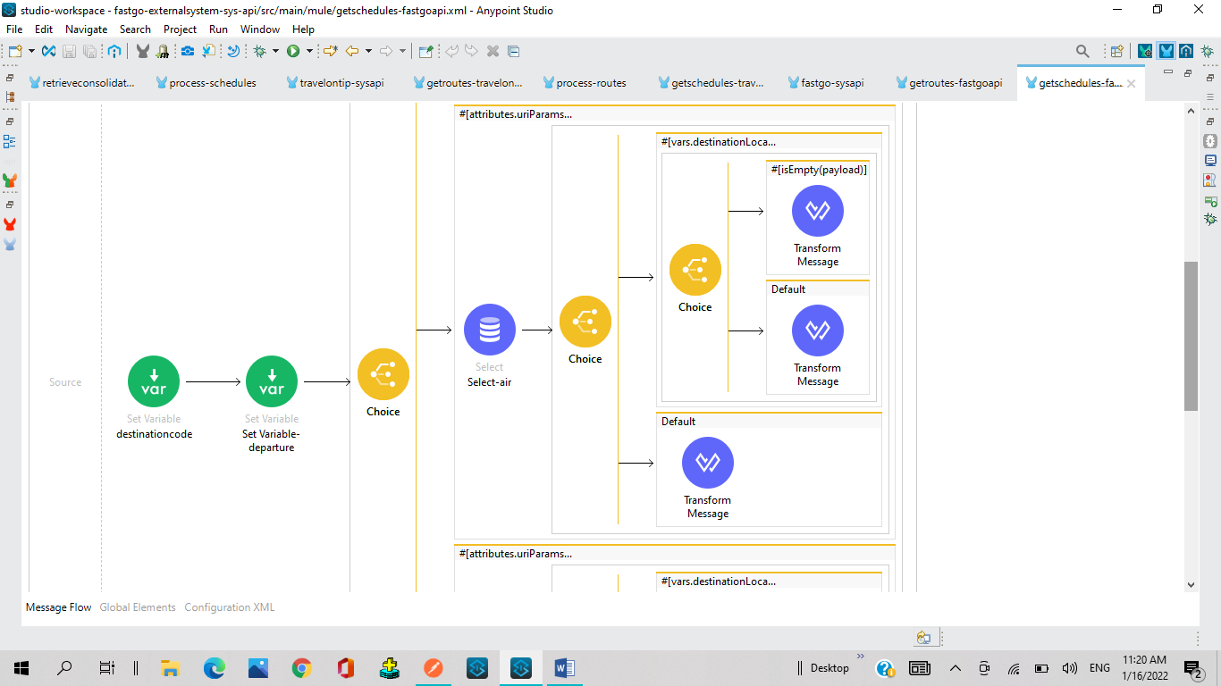

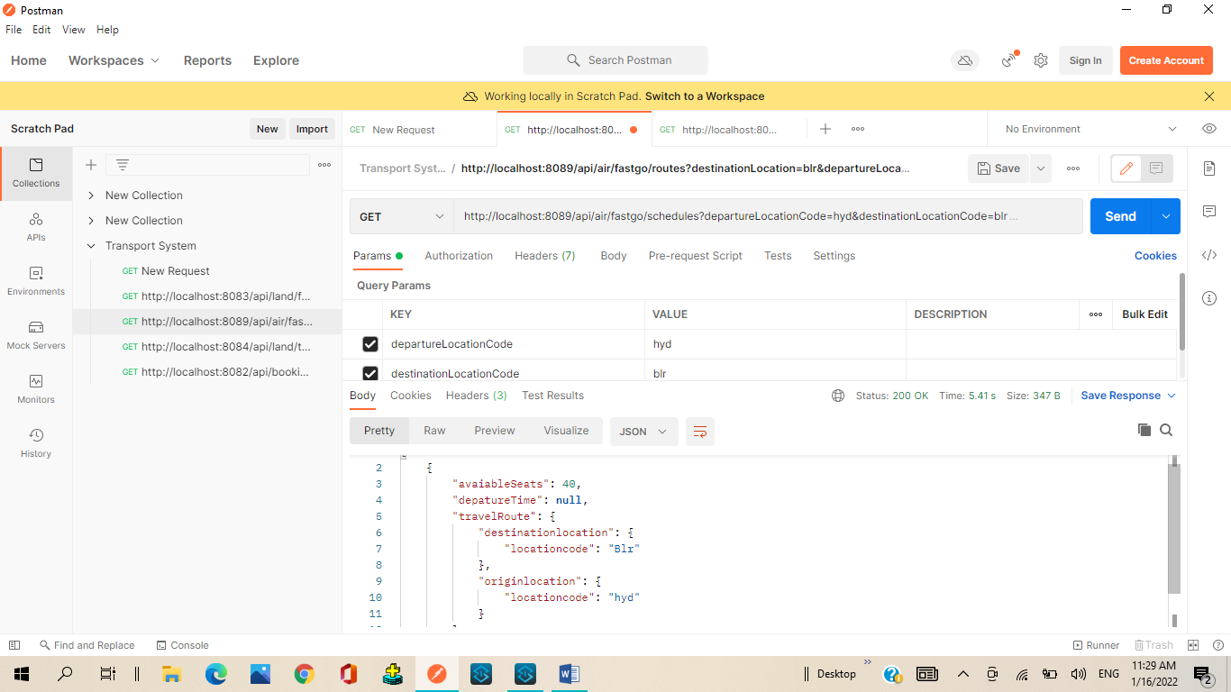

#%RAML 1.0

title: retrieveconsolidatedroutesandschedules-papi

description: This file will retrieve consolidated routes and schedules

/booking:

  uriParameters:

  /{transportType}:

    /routes:

      get:

        headers:

          transactionId:

            type: string

            required: true

        queryParameters:

              companyName:

                type: string

                required: false

              departureLocation:

                type: string

                required: false

              destinationLocation:

                 type: string

                 required: false

        responses:

          200:

            body:

              application/json:

                example: !include responses/getroutes.json

    /schedules:

      get:

        headers:

          transactionId:

            type: string

            required: true

        queryParameters:

              companyName:

                type: string

                required: false

              departureLocation:

                type: string

                required: false

              destinationLocation:

                 type: string

                 required: false

        responses:

          200:

            body:

              application/json:

                example: !include responses/getschedules.json

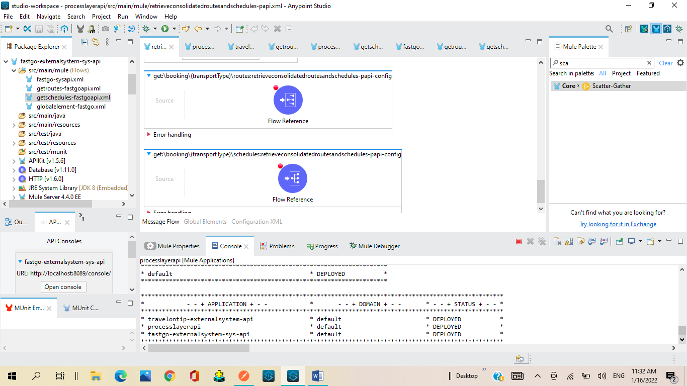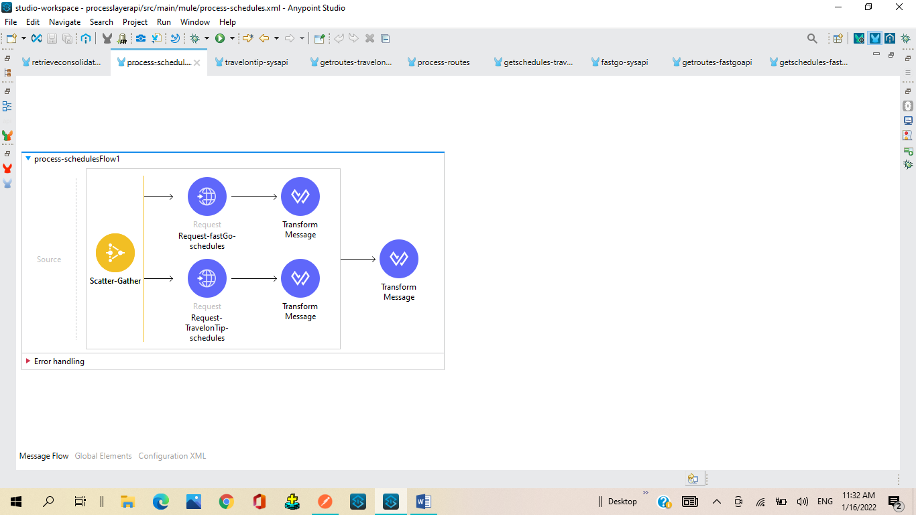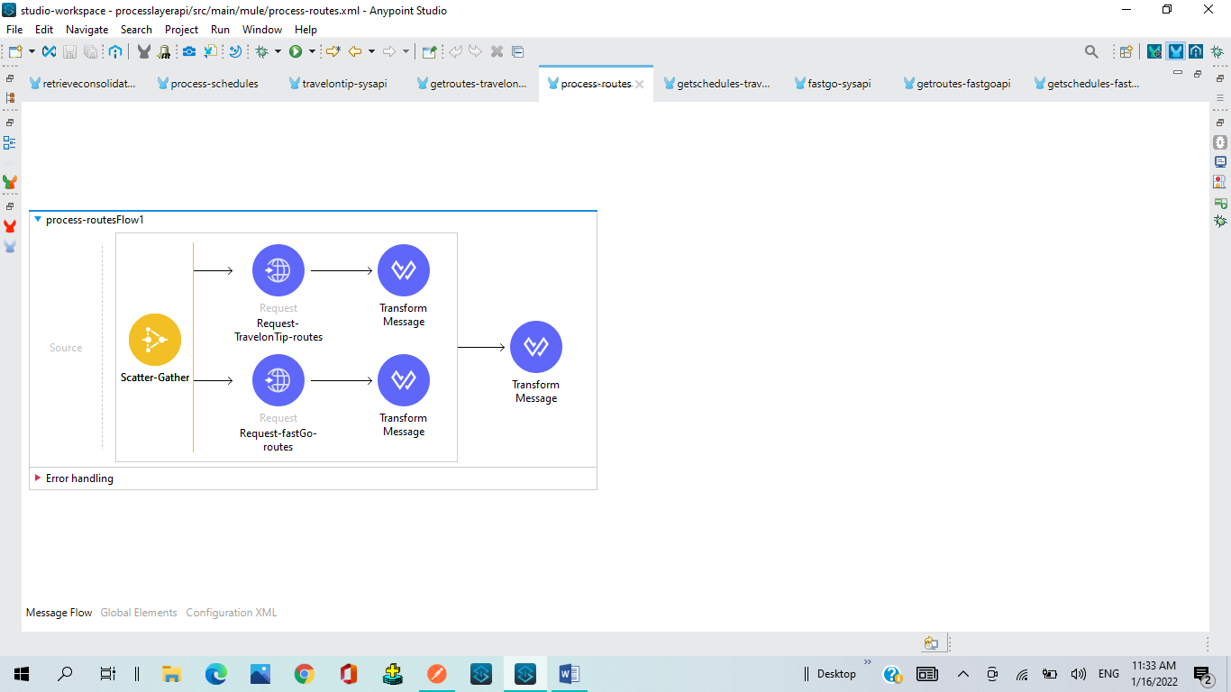

#%RAML 1.0

title: RetrieveConsolidatedRoutesandSchedules-mobileapp-expApi

description: This file will Retrieve Consolidated Routes and schedules.

/booking:

  uriParameters:

  /{transportType}:

    /routes:

      get:

        headers:

          transactionId:

            type: string

            required: true

        queryParameters:

              companyName:

                type: string

                required: false

              departureLocation:

                type: string

                required: false

              destinationLocation:

                 type: string

                 required: false

        responses:

          200:

            body:

              application/json:

                example: !include responses/getroutes.json

    /schedules:

      get:

        headers:

          transactionId:

            type: string

            required: true

        queryParameters:

              companyName:

                type: string

                required: false

              departureLocation:

                type: string

                required: false

              destinationLocation:

                 type: string

                 required: false

        responses:

          200:

            body:

              application/json:

                example: !include responses/getschedules.json

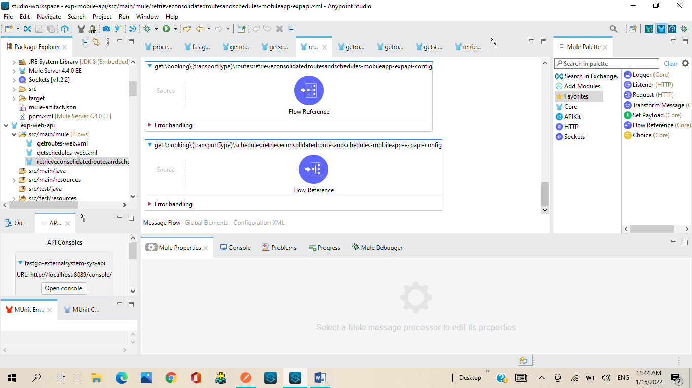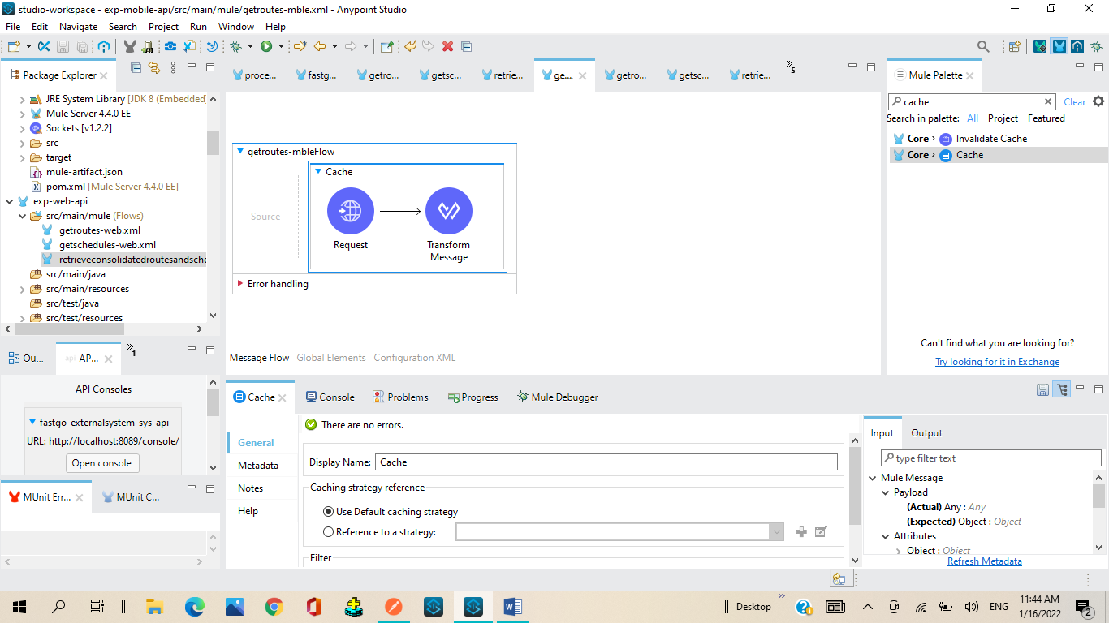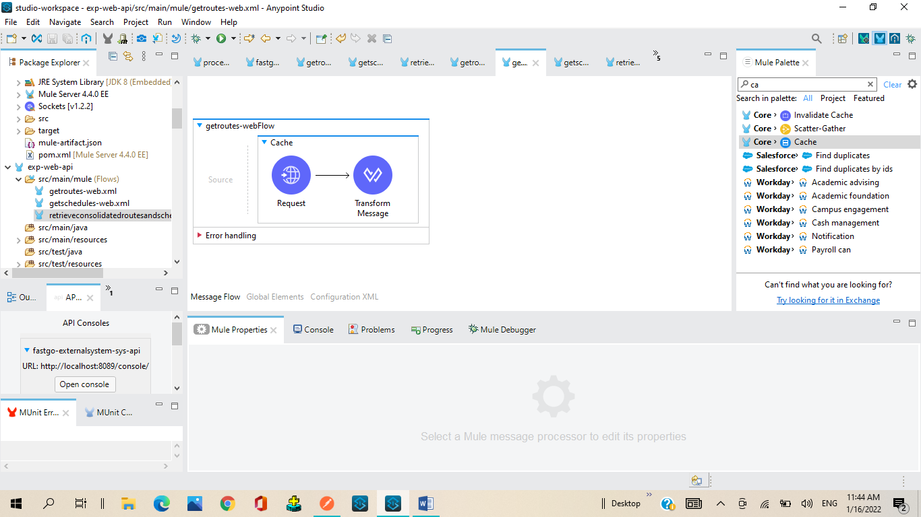

#%RAML 1.0

title: RetrieveConsolidatedRoutesandSchedules-expAPI

description: This RAML file will retrieve Routes and Schedules

/bookings:

  uriParameters:

  /{transportType}:

    /routes:

     get:

      headers:

        transcationId :

          type: string

          required: true

      queryParameters:

        companyName:

          type: string

          required: false

        departureLocation:

          type: string

          required: false

        destinationLocation:

          type: string

          required: false

      responses:

       200:

        body:

          application/json:

              example: !include responses/getroutes.json

    /schedules:

     get:

      headers:

       transcationId :

          type: string

          required: true

      queryParameters:

        companyName:

          type: string

          required: false

        departureLocation:

          type: string

          required: false

        destinationLocation:

          type: string

          required: false

        requestTimeZone:

          type: string

          required: false

      responses:

       200:

        body:

          application/json:

            example: !include responses/getschedules.json

