-- Queries

-- 1. Number of Stores in Each State

SELECT State, COUNT(*) AS StoreCount

FROM storelocations

GROUP BY State;

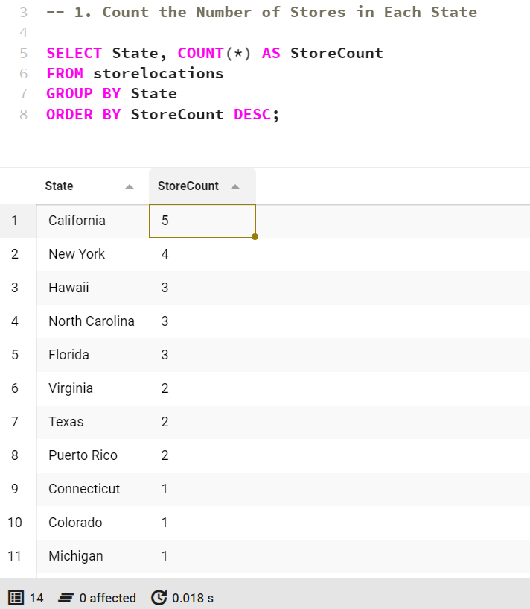

-- 2. Average Revenue Generated by Each Product

SELECT ProductID, AVG(Revenue) AS AvgRevenue

FROM sales_data

GROUP BY ProductID;

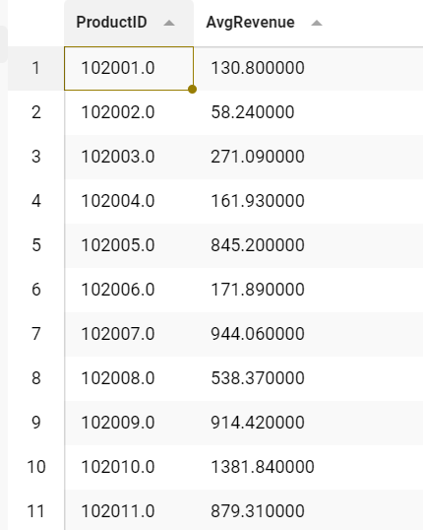

-- 3. Competitors with a Profit Margin Above 50%

SELECT Brand, Product_Name, Estimated_Profit_Margin

FROM competitors

WHERE Estimated_Profit_Margin > 50;

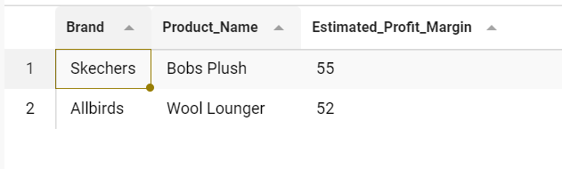

-- 4. Customer Reviews for Products with Ratings Above 4.5

SELECT Title, Rating, Number_of_Reviews

FROM CustomerReviews

WHERE Rating > 4.5;

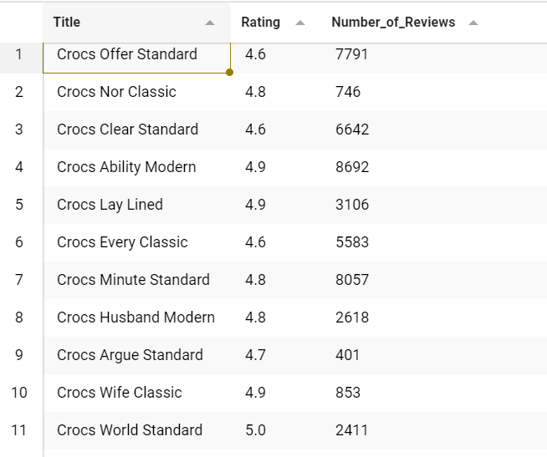

-- 5. Top 5 Most Sold Products by Quantity

SELECT ProductID, SUM(Quantity) AS TotalQuantity

FROM sales_data

GROUP BY ProductID

ORDER BY TotalQuantity DESC

LIMIT 5;

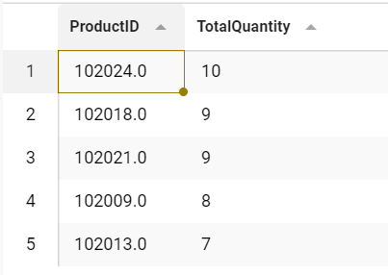

-- 6. All Marketing Campaigns Targeting Gen Z

SELECT BrandCollabID, Brand_Collab, StartYear, EndYear

FROM marketingcampaign

WHERE TargetAudience = 'Gen Z';

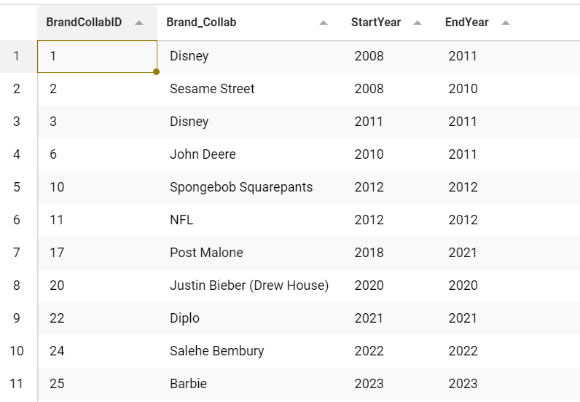

-- 7. Customers Who Have Made VIP Purchases

SELECT DISTINCT c.Name, c.Email, c.CustomerType

FROM customer_demographics c

JOIN sales_data s ON c.CustomerType = s.CustomerType

WHERE s.CustomerType = 'VIP';

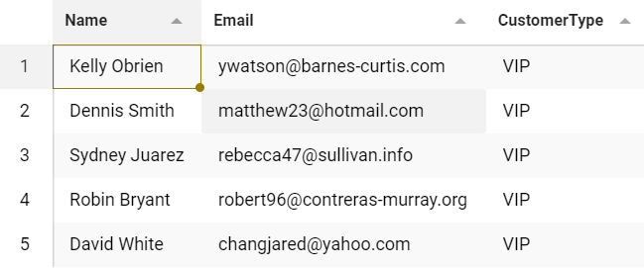

-- 8. Total Revenue and Profit for Each State

SELECT State, SUM(Revenue) AS TotalRevenue, SUM(Revenue - Cost_of_Sales) AS TotalProfit

FROM business

GROUP BY State;

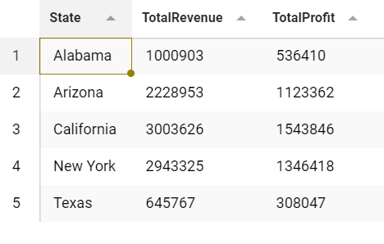

-- 9. Competitors Selling Products in Arizona

SELECT Brand, Product_Name, State

FROM competitors

WHERE State = 'Arizona';

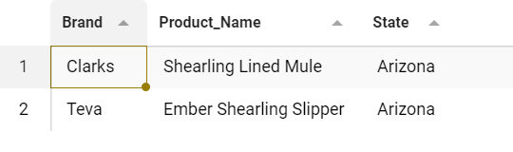

-- 10. Top 3 Best-Selling Products in Each State

SELECT s.State, p.ProductName, SUM(s.Quantity) AS TotalSold

FROM sales_data s

JOIN ProductCatalog p ON s.ProductID = p.ProductID

GROUP BY s.State, p.ProductName

ORDER BY s.State, TotalSold DESC;

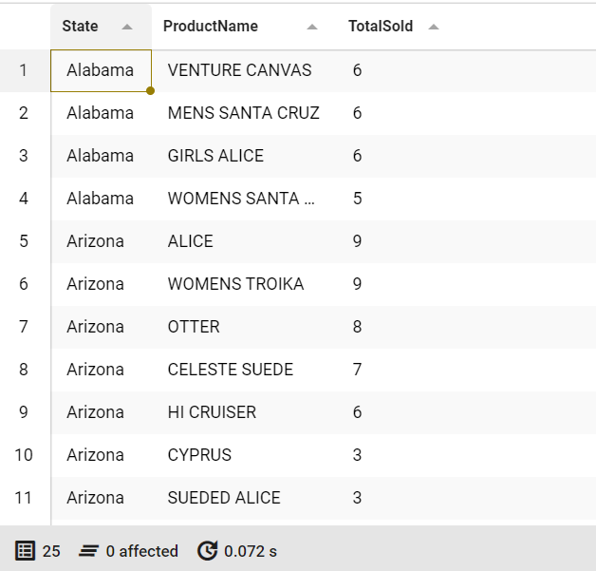

-- 11. Customers with Purchases in More Than Four Stores

SELECT cd.Name, cd.Email, COUNT(DISTINCT s.Store_PK) AS StoreCount

FROM customer_demographics cd

JOIN sales_data s ON cd.CustomerType = s.CustomerType

GROUP BY cd.Name, cd.Email

HAVING StoreCount > 4

ORDER BY StoreCount DESC;

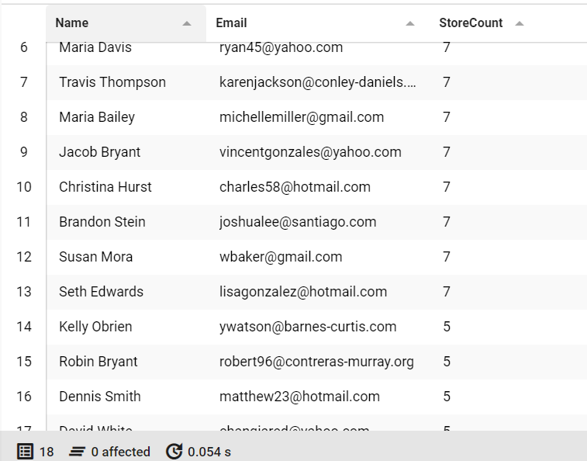

-- 12. State-Level Profit and Loss Report

SELECT b.State, SUM(b.Revenue) AS TotalRevenue, SUM(b.Cost_of_Sales) AS TotalCosts,

SUM(b.Revenue - b.Cost_of_Sales) AS NetProfit

FROM business b

GROUP BY b.State

ORDER BY NetProfit DESC;

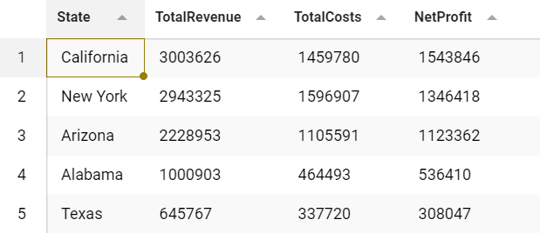

-- 13. Products with No EBay Listings

SELECT p.ProductName

FROM ProductCatalog p

LEFT JOIN EBayProducts ep ON p.ProductName = ep.ProductName

WHERE ep.ProductName IS NULL;

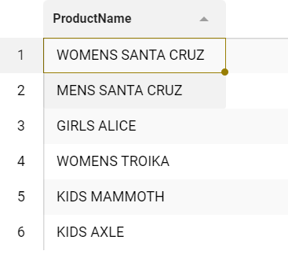

-- 14. Count the Number of Products Listed on EBay by Competitor

SELECT c.Brand, COUNT(ep.ProductName) AS ProductCount

FROM competitors c

JOIN EBayProducts ep ON c.Brand_ID = ep.CompetitorID

GROUP BY c.Brand

ORDER BY ProductCount DESC;

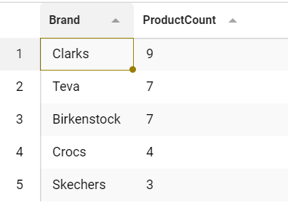

-- 15. eBay products with prices greater than $75

SELECT ep.ProductName, c.Price_in_USD, ep.PurchaseLink

FROM EBayProducts ep

JOIN competitors c ON ep.CompetitorID = c.Brand_ID

WHERE c.Price_in_USD > 75

AND ep.PurchaseLink IS NOT NULL

AND ep.PurchaseLink NOT IN ('Unavailable', '-');

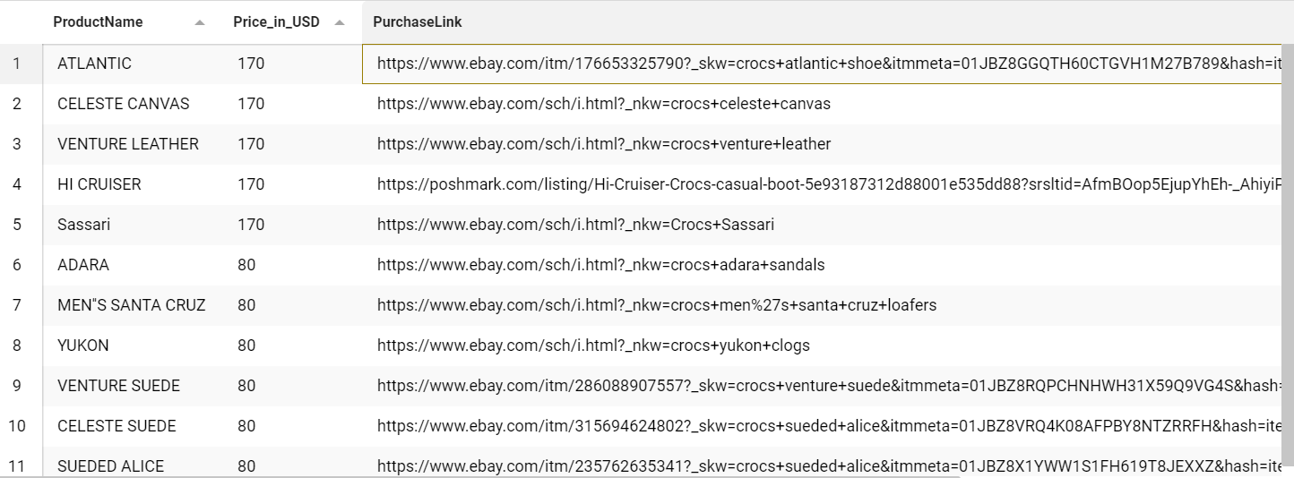

-- 16. EBay Products Grouped by Competitor Material

SELECT c.Material, COUNT(ep.ProductName) AS ProductCount

FROM competitors c

JOIN EBayProducts ep ON c.Brand_ID = ep.CompetitorID

GROUP BY c.Material

ORDER BY ProductCount DESC;

