PYTHON CASE STUDIES
Algorithms • Pseudocode • Flowcharts • Python Programs
Prepared from the supplied case-study material

1. Problem Statement
Develop a Python program to calculate an electricity bill based on the number of units consumed. Different charges are applied for different consumption slabs.

2. Objectives
1. Accept the number of electricity units consumed.
2. Calculate charges based on unit slabs.
3. Apply different rates for different units.
4. Calculate the total electricity bill.
5. Display the final bill.

3. Assumptions
• Electricity units must be positive.
• First 100 units cost ₹2 per unit.
• Next 100 units cost ₹3 per unit.
• Above 200 units cost ₹5 per unit.
• The bill is calculated in Indian Rupees.

4. Algorithm
1. Start.
2. Input the number of units consumed.
3. If units are less than or equal to 100, calculate bill at ₹2 per unit.
4. If units are between 101 and 200, calculate the first 100 units at ₹2 and remaining units at ₹3.
5. If units are above 200, calculate the first 100 units at ₹2, next 100 units at ₹3, and remaining units at ₹5.
6. Display the electricity bill.
7. Stop.

Flowchart 1
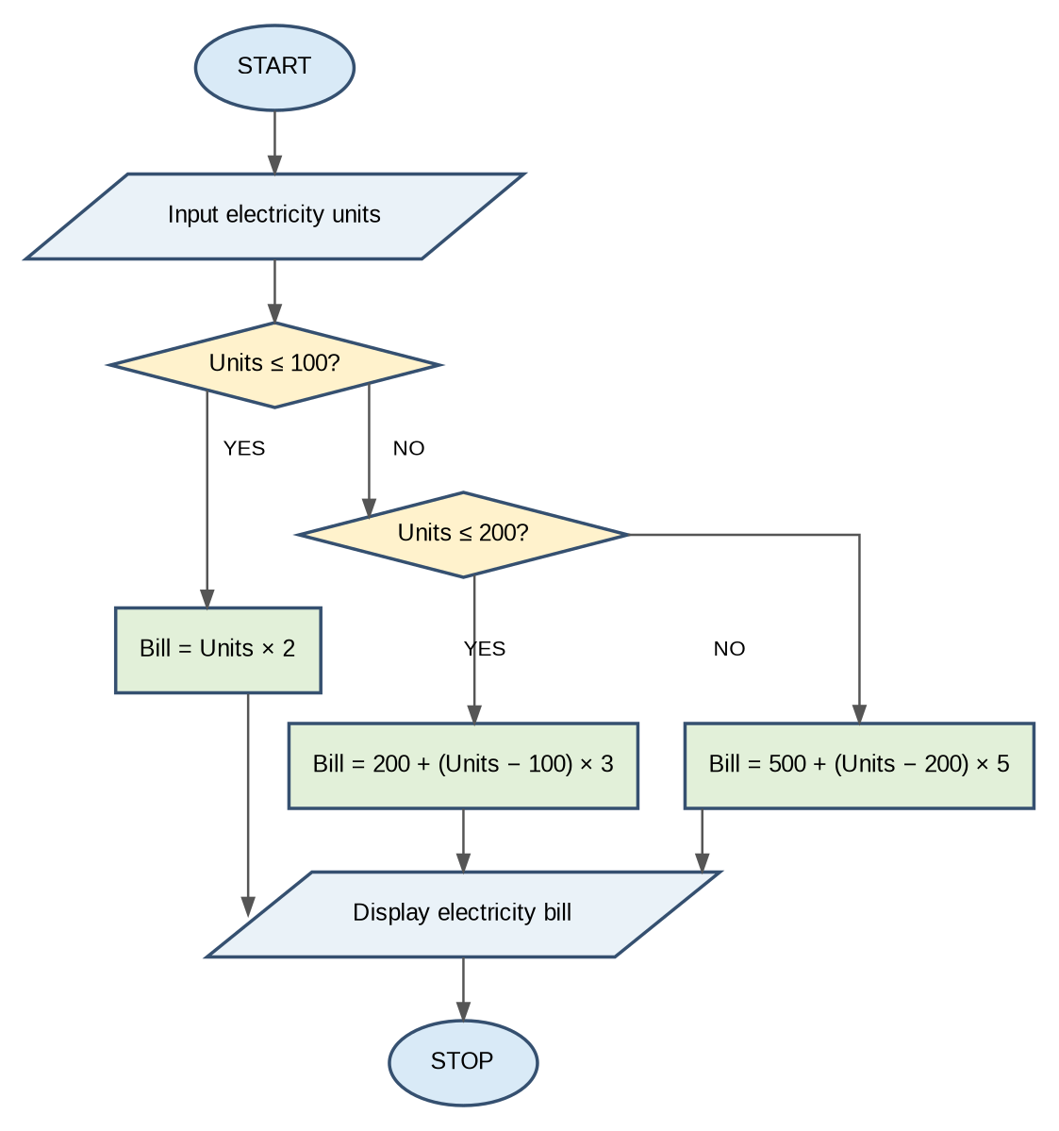

6. Pseudocode
START
INPUT units
IF units <= 100:
bill = units * 2
ELSE IF units <= 200:
bill = 200 + (units - 100) * 3
ELSE:
bill = 500 + (units - 200) * 5
DISPLAY bill
STOP

7.Python Source Codeunits = int(input("Enter units: "))
if units <= 100:
bill = units * 2
elif units <= 200:
bill = 200 + (units - 100) * 3
else:
bill = 500 + (units - 200) * 5
print("Electricity Bill: Rs.", bill)

8. Test Cases
Test Case 1:
Enter units: 80
Electricity Bill: Rs. 160
Test Case 2:
Enter units: 150
Electricity Bill: Rs. 350
Test Case 3:
Enter units: 250
Electricity Bill: Rs. 750

9. Conclusion
The Electricity Billing System calculates electricity charges based on the units consumed. It uses arithmetic operators and conditional statements (if, elif, else) to apply different rates for different consumption slabs. This program helps students understand decision-making in Python.
2.Employee’s gross salary
Develop a Python program to calculate an employee's gross salary and net salary based on basic salary, House Rent Allowance (HRA), Dearness Allowance (DA), and deductions.
1. Objective
1. Accept basic salary from the employee.
2. Calculate HRA (20% of basic salary).
3. Calculate DA (10% of basic salary).
4. Calculate gross salary.
5. Calculate 5% deduction.
6. Calculate and display net salary.

2. Assumptions
• Basic salary must be positive.
• HRA is 20% of basic salary.
• DA is 10% of basic salary.
• Deduction is 5% of basic salary.
• All amounts are calculated in Indian rupees.

3. Algorithm
1. Start.
2. Input basic salary.
3. Calculate HRA = Basic salary × 20%.
4. Calculate DA = Basic salary × 10%.
5. Calculate gross salary = Basic + HRA + DA.
6. Calculate deduction = Basic salary × 5%.
7. Calculate net salary = Gross salary − Deduction.
8. Display gross salary and net salary.
9. Stop.

Flowchart 2
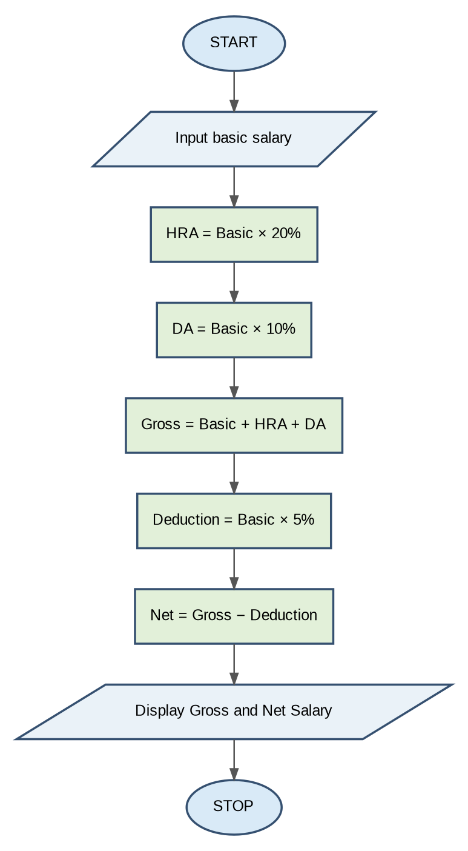

5. Pseudocode
START
INPUT basic
hra = basic * 0.20
da = basic * 0.10
gross = basic + hra + da
deduction = basic * 0.05
net = gross - deduction
DISPLAY gross
DISPLAY net
STOP

6. Python Source Code
basic = float(input("Enter basic salary: "))
hra = basic * 0.20
da = basic * 0.10
gross = basic + hra + da
net = gross - basic * 0.05
print("Gross Salary:", gross)
print("Net Salary:", net)

7. Test Cases
Test Case 1
Enter basic salary: 10000
Gross Salary: Rs. 13000.0
Net Salary: Rs. 12500.0
Test Case 2
Enter basic salary: 20000
Gross Salary: Rs. 26000.0
Net Salary: Rs. 25000.0

8. Conclusion
The Employee Salary Calculation System calculates gross and net salary using Python. It demonstrates arithmetic operations, variables, and input/output statements.

Case Study3: Student Marks and Result Calculation
Problem Statement
Develop a Python program to accept marks of three subjects, calculate the total and average marks, and display whether the student has passed or failed.
Objectives
1. Accept marks of three subjects.
2. Store marks in a list.
3. Calculate total marks.
4. Calculate average marks.
5. Check pass or fail status.
6. Display the total, average, and result.
Assumptions
• The student has three subjects.
• Each subject is considered out of 100 marks.
• Minimum passing mark is 35 in each subject.
• The student must score at least 35 in all subjects to pass.
Algorithm
1. Start.
2. Create an empty list called marks.
3. Repeat three times:
o Input subject marks.
o Add marks to the list.
4. Calculate the total using sum().
5. Calculate the average by dividing total by 3.
6. Check whether minimum marks are greater than or equal to 35.
7. If true, display PASS; otherwise, display FAIL.
8. Display total and average.
9. Stop.

Flowchart 3
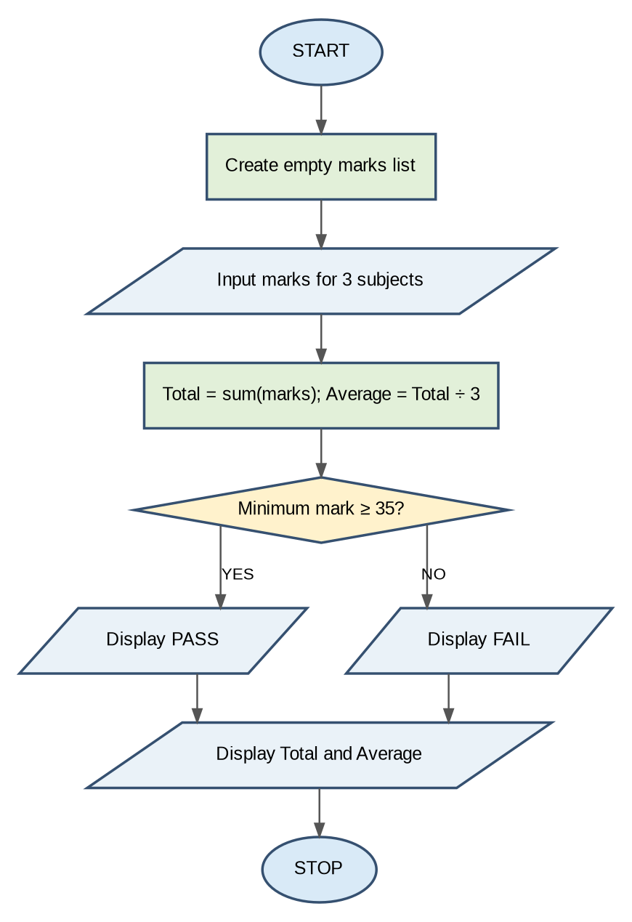

Pseudocode
START
marks = empty list
FOR i = 1 to 3:
INPUT m
Add m to marks
total = SUM(marks)
average = total / 3
DISPLAY total
DISPLAY average
IF minimum(marks) >= 35:
DISPLAY "PASS"
ELSE:
DISPLAY "FAIL"
STOP
Python Source Codmarks = []
for i in range(3):
m = int(input("Enter marks: "))
marks.append(m)
total = sum(marks)
average = total / 3
print("Total:", total)
print("Average:", average)
if min(marks) >= 35:
print("Result: PASS")
else:
print("Result: FAIL")
Test Cases
Test Case 1: PASS
Enter marks: 80
Enter marks: 70
Enter marks: 90
Total: 240
Average: 80.0
Result: PASS
Test Case 2: FAIL
Enter marks: 80
Enter marks: 30
Enter marks: 90
Total: 200
Average: 66.6666666667
Result: FAIL

Output Screenshots
Run the Python program in IDLE or VS Code and capture the output for both test cases.
Conclusion
The Student Marks Calculation System calculates total and average marks and checks the student's result. This case study helps students understand Python lists, loops, built-in functions (sum() and min()), conditional statements, and input/output operations.

Case Study: Bank Account Deposit and Withdrawal System
Problem Statement
Develop a Python program to perform deposit and withdrawal operations in a bank account. Calculate and display the final account balance after completing the transactions.
Objectives
1. Initialize the bank account balance.
2. Accept the deposit amount from the customer.
3. Add the deposit amount to the balance.
4. Accept the withdrawal amount.
5. Check whether sufficient balance is available.
6. Display the final account balance.
Assumptions
• Initial bank balance is ₹1,000.
• Deposit amount must be positive.
• Withdrawal amount must be positive.
• Withdrawal is allowed only if sufficient balance is available.
• All amounts are in Indian rupees.
Algorithm
1. Start.
2. Initialize balance to 1000.
3. Input deposit amount.
4. Add deposit amount to the balance.
5. Input withdrawal amount.
6. Check whether withdrawal is less than or equal to balance and greater than zero.
7. If true:
o Subtract withdrawal from balance.
o Display withdrawal successful.
8. Otherwise, display invalid withdrawal.
9. Display final balance.
10. Stop.

Flowchart 4
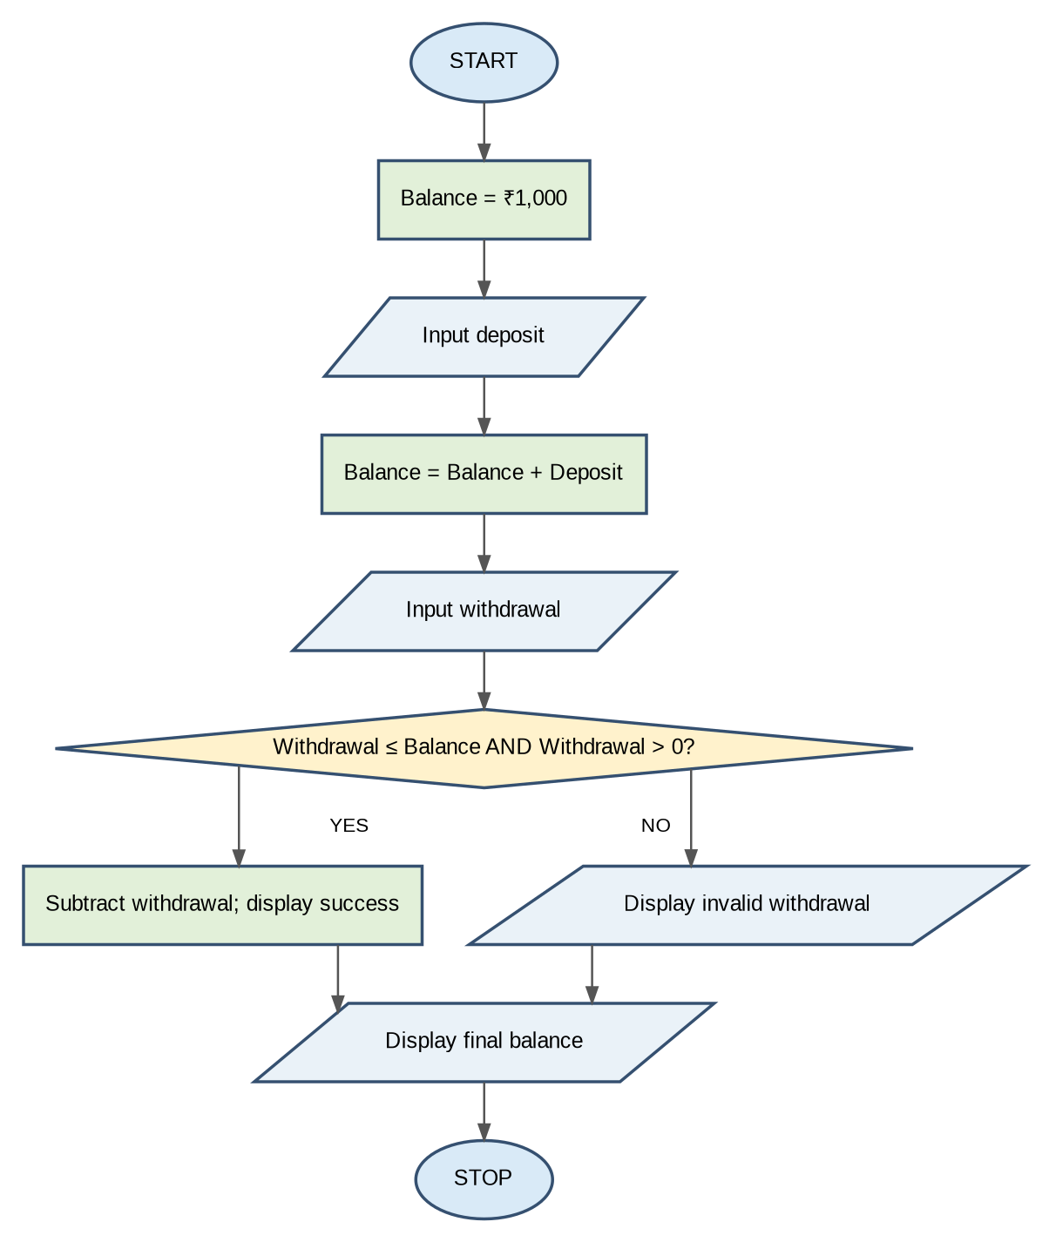

Pseudocode
START
balance = 1000
INPUT deposit
balance = balance + deposit
INPUT withdraw
IF withdraw <= balance AND withdraw > 0:
balance = balance - withdraw
DISPLAY "Withdrawal successful"
ELSE:
DISPLAY "Invalid withdrawal"
DISPLAY balance
STOP
Python Source Code
balance = 1000
deposit = int(input("Enter deposit amount: "))
balance = balance + deposit
withdraw = int(input("Enter withdrawal amount: "))
if withdraw <= balance and withdraw > 0:
balance = balance - withdraw
print("Withdrawal successful")
else:
print("Invalid withdrawal")
print("Final Balance:", balance)
Test Cases
Test Case 1: Successful Withdrawal
Enter deposit amount: 500
Enter withdrawal amount: 300
Withdrawal successful
Final Balance: 1200
Test Case 2: Invalid Withdrawal
Enter deposit amount: 200
Enter withdrawal amount: 2000
Invalid withdrawal
Final Balance: 1200

Output Screenshots
Run the Python program in IDLE or VS Code and capture screenshots of both test cases.
Conclusion
The Bank Account System performs deposit and withdrawal operations and displays the final balance. This case study helps students understand variables, arithmetic operators, conditional statements, and input/output functions in Python.
Note: The given program can be improved by checking that the deposit amount is also positive before adding it to the balance.

Case Study: Shopping Bill Calculation with Discount
Problem Statement:
Develop a Python program to calculate a customer's shopping bill based on product price and quantity. Apply a 10% discount if the total purchase amount is ₹1,000 or more and display the final bill.

1. Objectives
1. Accept product price from the customer.
2. Accept product quantity.
3. Calculate the total cost.
4. Check the discount condition.
5. Apply a 10% discount if the total is ₹1,000 or more.
6. Display the final bill.

2. Assumptions
• Product price must be positive.
• Quantity must be positive.
• A 10% discount applies when the total is ₹1,000 or more.
• No discount is applied below ₹1,000.
• All amounts are calculated in Indian rupees.

3. Algorithm
1. Start.
2. Input product price.
3. Input quantity.
4. Calculate total = Price × Quantity.
5. If total is greater than or equal to ₹1,000, apply a 10% discount.
6. Otherwise, keep the total unchanged.
7. Display the final bill.
8. Stop.

Flowchart 5
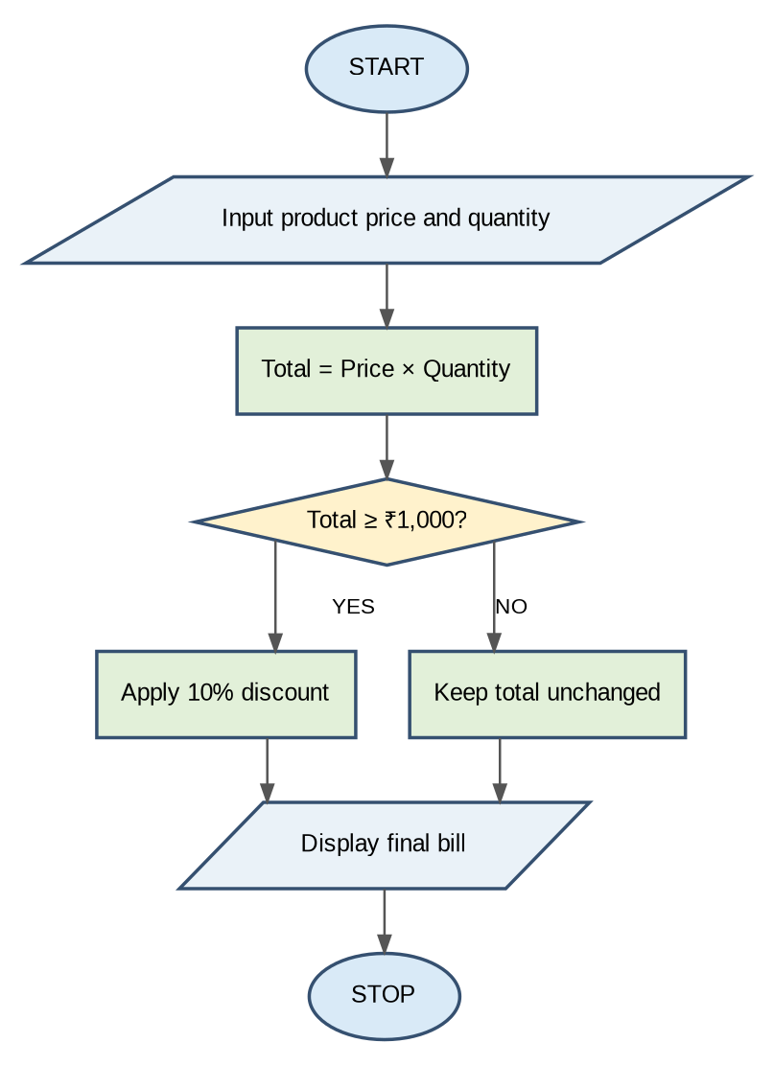

5. Pseudocode
START
INPUT price
INPUT quantity
total = price * quantity
IF total >= 1000:
total = total * 0.90
DISPLAY total
STOP

6. Python Source Code
price = float(input("Enter product price: "))
quantity = int(input("Enter quantity: "))
total = price * quantity
if total >= 1000:
total = total * 0.90
print("Final Bill: Rs.", total)

7. Test Cases
Test Case 1
Enter product price: 200
Enter quantity: 2
Final Bill: Rs. 400.0
Test Case 2
Enter product price: 500
Enter quantity: 3
Final Bill: Rs. 1350.0
Calculation:
• Total = 500 × 3 = ₹1,500
• Discount = 10% of 1,500 = ₹150
• Final Bill = ₹1,350

8. Conclusion
The Shopping Bill Calculation System calculates the total product cost and applies a discount based on the purchase amount. This program demonstrates variables, arithmetic operators, conditional statements, and input/output functions in Python.

Case Study: Student Attendance Eligibility System
Problem Statement:
Develop a Python program to calculate a student's attendance percentage based on the number of classes attended and total classes conducted. Check whether the student is eligible for examinations based on the minimum attendance requirement of 75%.

1. Objectives
1. Accept the number of classes attended.
2. Accept the total number of classes.
3. Calculate attendance percentage.
4. Check the minimum attendance requirement.
5. Display whether the student is eligible or not eligible.
6. Validate the attendance details.

2. Assumptions
• Total classes must be greater than zero.
• Attended classes cannot be negative.
• Attended classes cannot exceed total classes.
• Minimum attendance required is 75%.
• Attendance percentage is calculated in percentage.

3. Algorithm
1. Start.
2. Input classes attended.
3. Input total classes.
4. Check whether total is greater than zero and attended classes are valid.
5. If valid, calculate attendance percentage.
6. Display attendance percentage.
7. If percentage is greater than or equal to 75%, display "Eligible".
8. Otherwise, display "Not Eligible".
9. If attendance data is invalid, display "Invalid attendance data".
10. Stop.

Flowchart 6
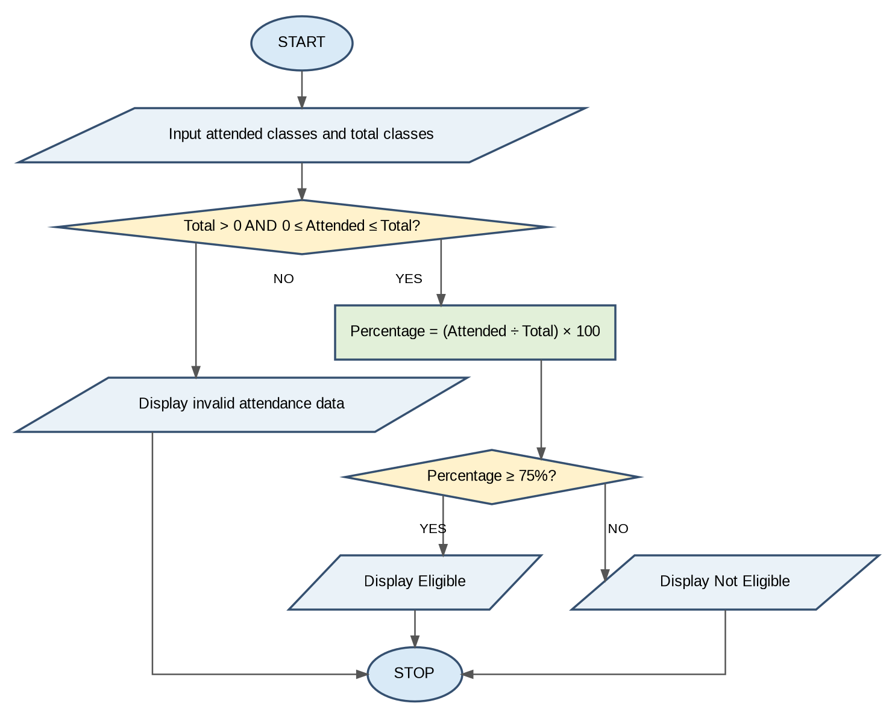

5. Pseudocode
START
INPUT attended
INPUT total
IF total > 0 AND 0 <= attended <= total:
percentage = attended / total * 100
DISPLAY percentage
IF percentage >= 75:
DISPLAY "Eligible"
ELSE:
DISPLAY "Not Eligible"
ELSE:
DISPLAY "Invalid attendance data"
STOP

6. Python Source Code
attended = int(input("Classes attended: "))
total = int(input("Total classes: "))
if total > 0 and 0 <= attended <= total:
percentage = attended / total * 100
print("Attendance:", percentage, "%")
if percentage >= 75:
print("Eligible")
else:
print("Not Eligible")
else:
print("Invalid attendance data")

7. Test Cases
Test Case 1
Classes attended: 80
Total classes: 100
Attendance: 80.0 %
Eligible
Test Case 2
Classes attended: 60
Total classes: 100
Attendance: 60.0 %
Not Eligible
Test Case 3
Classes attended: 110
Total classes: 100
Invalid attendance data

8. Conclusion
The Student Attendance Eligibility System calculates attendance percentage and checks examination eligibility. It demonstrates variables, arithmetic operators, conditional statements, logical operators, and input/output functions in Python.

Case Study 7: Fuel Consumption and Route Cost Calculation
Problem Statement:
Develop a Python program to calculate the fuel required and total fuel cost for a journey based on distance, vehicle mileage, and fuel price. Display the total fuel consumption and journey cost.

1. Objectives
1. Accept journey distance.
2. Accept vehicle mileage.
3. Accept fuel price per litre.
4. Calculate fuel required.
5. Calculate total fuel cost.
6. Display the final journey cost.

2. Assumptions
• Distance must be positive.
• Vehicle mileage must be positive.
• Fuel price must be positive.
• Fuel required is calculated using distance divided by mileage.
• All costs are calculated in Indian rupees.

3. Algorithm
1. Start.
2. Input journey distance.
3. Input vehicle mileage.
4. Input fuel price per litre.
5. Calculate fuel required = Distance / Mileage.
6. Calculate fuel cost = Fuel required × Fuel price.
7. Display fuel required.
8. Display total fuel cost.
9. Stop.

Flowchart 7
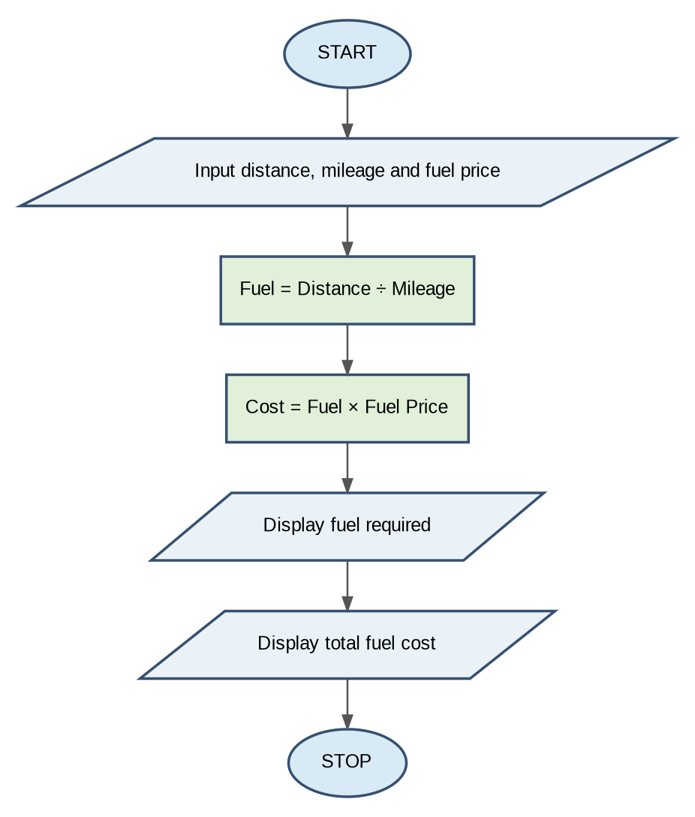

5. Pseudocode
START
INPUT distance
INPUT mileage
INPUT fuel_price
fuel = distance / mileage
cost = fuel * fuel_price
DISPLAY fuel
DISPLAY cost
STOP

6. Python Source Code
distance = float(input("Enter journey distance (km): "))
mileage = float(input("Enter vehicle mileage (km/l): "))
fuel_price = float(input("Enter fuel price per litre: "))
fuel = distance / mileage
cost = fuel * fuel_price
print("Fuel Required:", round(fuel, 2), "litres")
print("Total Fuel Cost: Rs.", round(cost, 2))

7. Test Cases
Test Case 1
Enter journey distance (km): 100
Enter vehicle mileage (km/l): 20
Enter fuel price per litre: 100
Fuel Required: 5.0 litres
Total Fuel Cost: Rs. 500.0
Test Case 2
Enter journey distance (km): 200
Enter vehicle mileage (km/l): 25
Enter fuel price per litre: 100
Fuel Required: 8.0 litres
Total Fuel Cost: Rs. 800.0

8. Conclusion
The Fuel Consumption and Route Cost Calculation System calculates the fuel required and total journey cost using Python. It demonstrates variables, arithmetic operators, and input/output functions.

Case Study: Warehouse Inventory and Stock Management System
Problem Statement:
Develop a Python program to calculate the closing stock of a product based on opening stock, stock received, and stock sold. Check whether the available stock is low, sufficient, or invalid.

1. Objectives
1. Accept opening stock.
2. Accept stock received.
3. Accept stock sold.
4. Calculate closing stock.
5. Check stock availability.
6. Display whether stock is low or sufficient.

2. Assumptions
• Opening stock must be zero or positive.
• Stock received must be zero or positive.
• Stock sold must be zero or positive.
• Closing stock is calculated by subtracting sold stock from available stock.
• If closing stock is below zero, the record is invalid.
• If closing stock is below 10, stock is low.
• Otherwise, stock is sufficient.

3. Algorithm
1. Start.
2. Input opening stock.
3. Input stock received.
4. Input stock sold.
5. Calculate closing stock = Opening stock + Received stock − Sold stock.
6. Display expected closing stock.
7. If closing stock is less than zero, display "Stock record is invalid".
8. Else if closing stock is less than 10, display "Stock is low".
9. Otherwise, display "Stock is sufficient".
10. Stop.

Flowchart 8
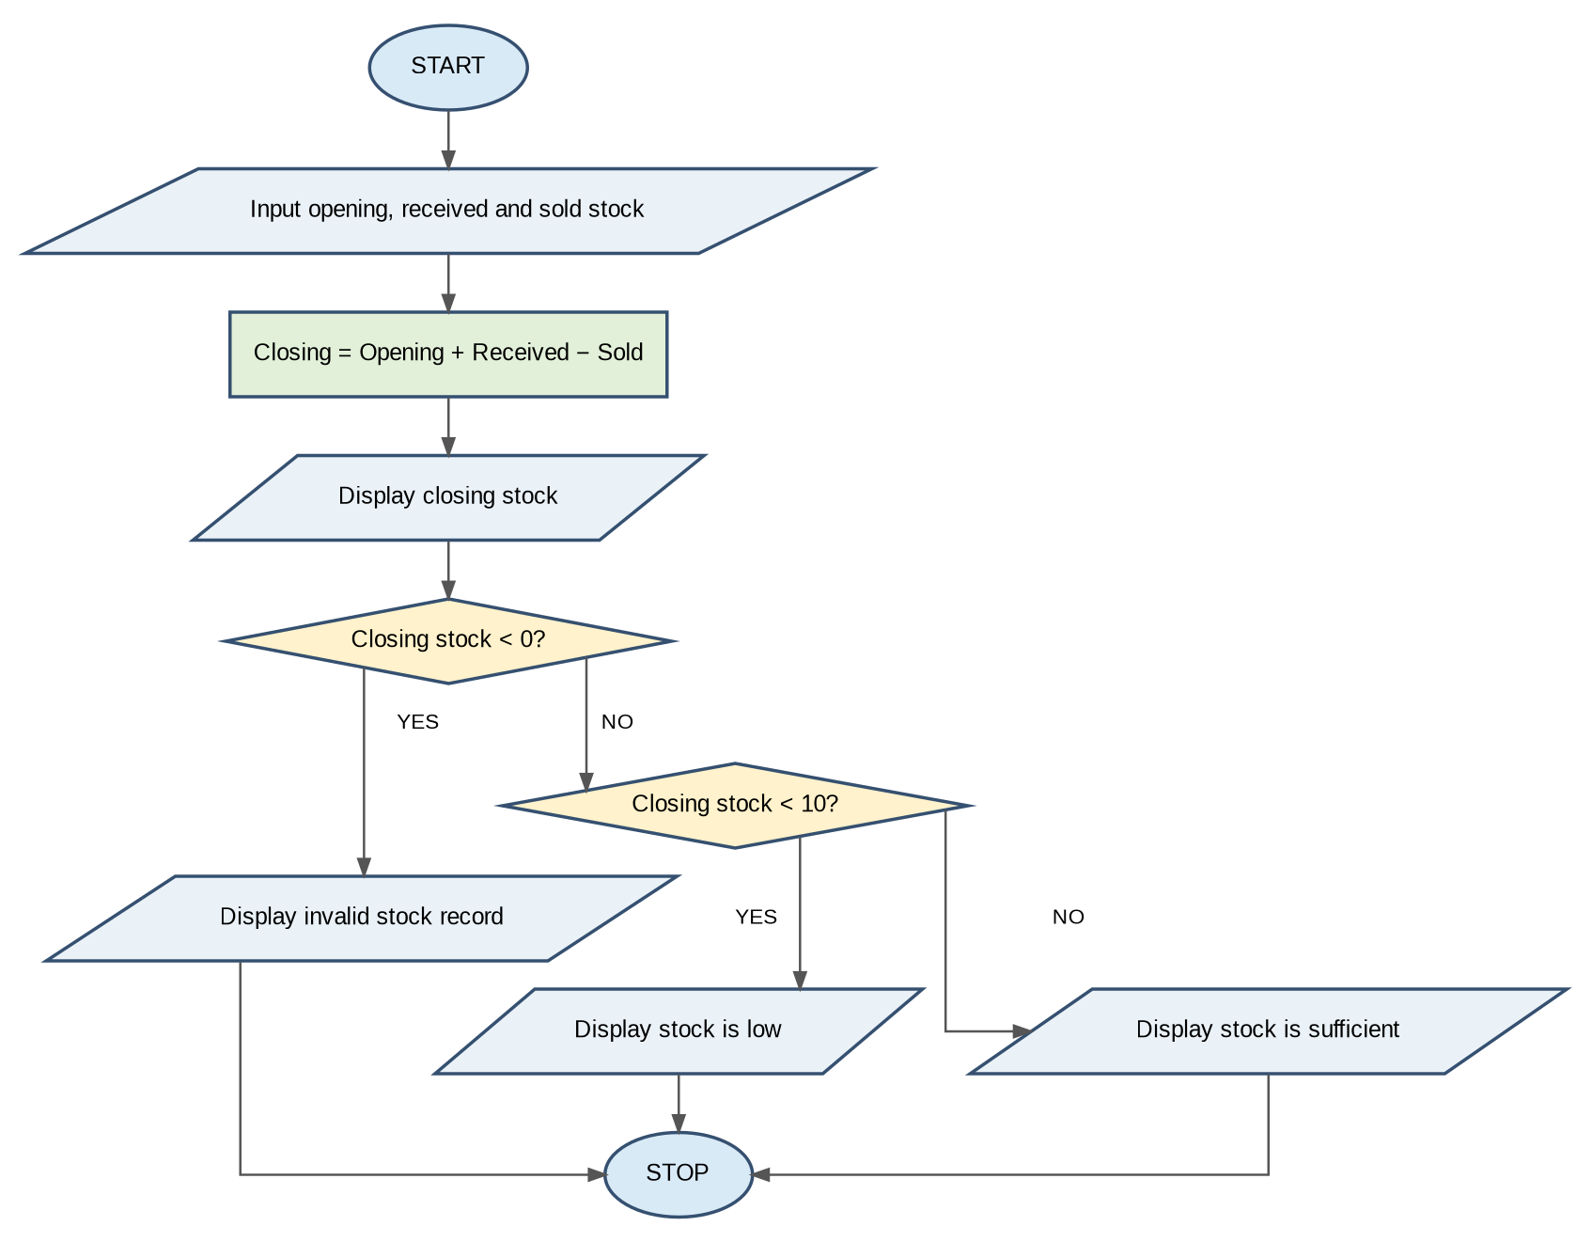

5. Pseudocode
START
INPUT opening
INPUT received
INPUT sold
closing = opening + received - sold
DISPLAY closing
IF closing < 0:
DISPLAY "Stock record is invalid"
ELSE IF closing < 10:
DISPLAY "Stock is low"
ELSE:
DISPLAY "Stock is sufficient"
STOP

6. Python Source Code
opening = int(input("Opening stock: "))
received = int(input("Stock received: "))
sold = int(input("Stock sold: "))
closing = opening + received - sold
print("Expected Closing Stock:", closing)
if closing < 0:
print("Stock record is invalid")
elif closing < 10:
print("Stock is low")
else:
print("Stock is sufficient")

7. Test Cases
Test Case 1
Opening stock: 50
Stock received: 20
Stock sold: 30
Expected Closing Stock: 40
Stock is sufficient
Test Case 2
Opening stock: 15
Stock received: 5
Stock sold: 15
Expected Closing Stock: 5
Stock is low
Test Case 3
Opening stock: 10
Stock received: 5
Stock sold: 20
Expected Closing Stock: -5
Stock record is invalid

8. Conclusion
The Warehouse Inventory Management System calculates closing stock using Python. It identifies low stock, sufficient stock, and invalid stock records. This program demonstrates variables, arithmetic operators, conditional statements, and input/output functions.

Case Study: Food Waste Monitoring System
Problem Statement:
Develop a Python program to calculate food waste based on the number of meals prepared and meals served. Calculate the number of wasted meals and waste percentage. Validate the input values before performing calculations.

1. Objectives
1. Accept the number of meals prepared.
2. Accept the number of meals served.
3. Calculate wasted meals.
4. Calculate waste percentage.
5. Validate the input values.
6. Display wasted meals and waste percentage.

2. Assumptions
• Meals prepared must be greater than zero.
• Meals served must be zero or positive.
• Meals served cannot exceed meals prepared.
• Waste is calculated by subtracting meals served from meals prepared.
• Waste percentage is calculated based on meals prepared.

3. Algorithm
1. Start.
2. Input meals prepared.
3. Input meals served.
4. Check whether prepared meals are greater than zero and served meals are within the valid range.
5. If valid, calculate wasted meals = Prepared − Served.
6. Calculate waste percentage = (Wasted meals / Prepared meals) × 100.
7. Display wasted meals.
8. Display waste percentage.
9. Otherwise, display "Invalid input".
10. Stop.

Flowchart 9
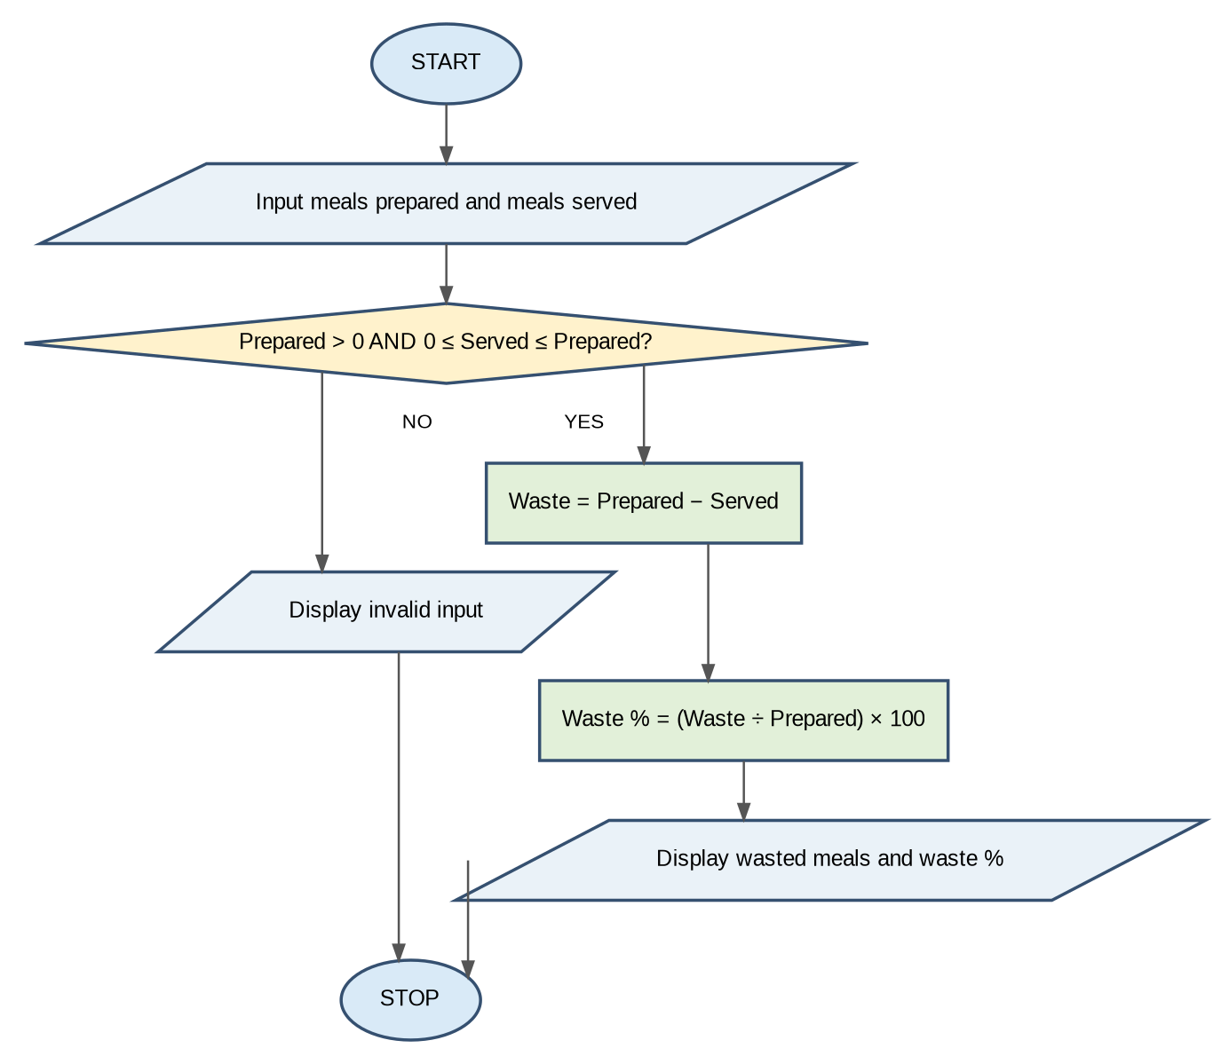

5. Pseudocode
START
INPUT prepared
INPUT served
IF prepared > 0 AND 0 <= served <= prepared:
waste = prepared - served
percentage = waste / prepared * 100
DISPLAY waste
DISPLAY percentage
ELSE:
DISPLAY "Invalid input"
STOP

6. Python Source Code
prepared = int(input("Meals prepared: "))
served = int(input("Meals served: "))
if prepared > 0 and 0 <= served <= prepared:
waste = prepared - served
percentage = waste / prepared * 100
print("Wasted Meals:", waste)
print("Waste Percentage:", round(percentage, 2), "%")
else:
print("Invalid input")

7. Test Cases
Test Case 1
Meals prepared: 100
Meals served: 80
Wasted Meals: 20
Waste Percentage: 20.0 %
Test Case 2
Meals prepared: 200
Meals served: 150
Wasted Meals: 50
Waste Percentage: 25.0 %
Test Case 3
Meals prepared: 100
Meals served: 120
Invalid input

8. Conclusion
The Food Waste Monitoring System calculates wasted meals and waste percentage using Python. It helps identify food wastage and validates the input data. This program demonstrates variables, arithmetic operators, conditional statements, logical operators, and input/output functions.

Case Study: Campus Event Financial Planning System
Problem Statement:
Develop a Python program to calculate the total expenses of a campus event based on venue cost, food cost, and other expenses. Subtract the sponsorship amount from the total expenses and calculate the fee per student if sponsorship does not cover all expenses.

1. Objectives
1. Accept venue cost.
2. Accept food cost.
3. Accept other expenses.
4. Accept sponsorship amount.
5. Accept the number of participants.
6. Calculate total expenses.
7. Calculate the remaining amount after sponsorship.
8. Calculate the fee per student.
9. Display the final result.

2. Assumptions
• All expenses must be zero or positive.
• Sponsorship amount must be zero or positive.
• Number of participants must be zero or positive.
• Total expenses are calculated by adding all expenses.
• Sponsorship is subtracted from total expenses.
• If sponsorship covers all expenses, no student fee is required.
• Otherwise, the remaining amount is divided equally among participants.

3. Algorithm
1. Start.
2. Input venue cost.
3. Input food cost.
4. Input other expenses.
5. Input sponsorship amount.
6. Input number of participants.
7. Calculate total expenses = Venue + Food + Other expenses.
8. Calculate remaining amount = Total expenses − Sponsorship.
9. Display total expenses.
10. If remaining amount is less than or equal to zero, display "Sponsorship covers all expenses".
11. Else if students are greater than zero, calculate fee per student.
12. Otherwise, display "No participants available to share the cost".
13. Stop.

Flowchart 10
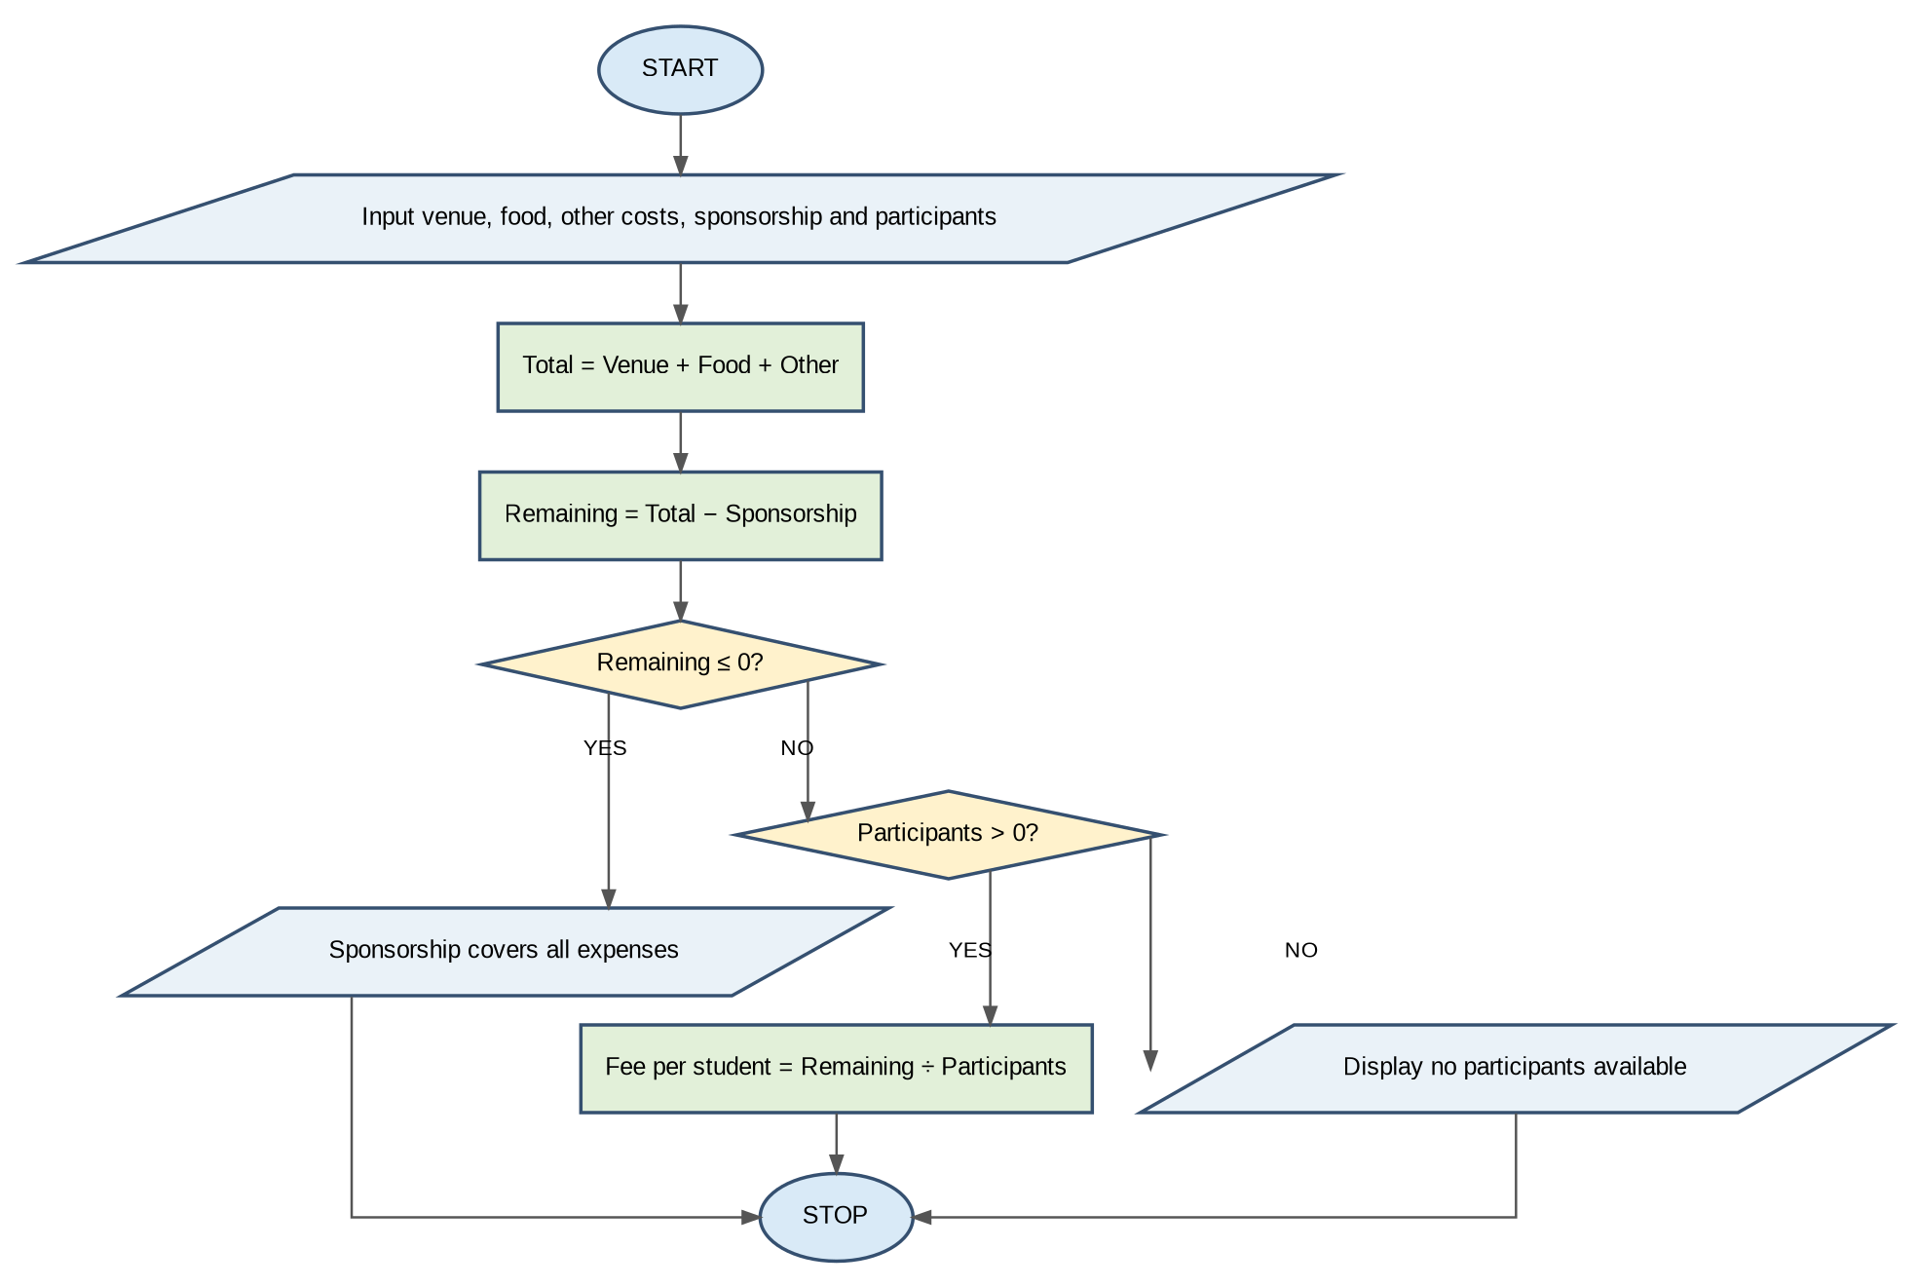

5. Pseudocode
START
INPUT venue
INPUT food
INPUT other
INPUT sponsorship
INPUT students
total = venue + food + other
remaining = total - sponsorship
DISPLAY total
IF remaining <= 0:
DISPLAY "Sponsorship covers all expenses"
ELSE IF students > 0:
fee = remaining / students
DISPLAY fee
ELSE:
DISPLAY "No participants available to share the cost"
STOP

6. Python Source Code
venue = float(input("Venue cost: "))
food = float(input("Food cost: "))
other = float(input("Other expenses: "))
sponsorship = float(input("Sponsorship amount: "))
students = int(input("Number of participants: "))
total = venue + food + other
remaining = total - sponsorship
print("Total Expenses:", total)
if remaining <= 0:
print("Sponsorship covers all expenses")
elif students > 0:
print("Fee per student:", round(remaining / students, 2))
else:
print("No participants available to share the cost")

7. Test Cases
Test Case 1
Venue cost: 10000
Food cost: 15000
Other expenses: 5000
Sponsorship amount: 10000
Number of participants: 100
Total Expenses: 30000.0
Fee per student: 200.0
Test Case 2
Venue cost: 5000
Food cost: 3000
Other expenses: 2000
Sponsorship amount: 12000
Number of participants: 50
Total Expenses: 10000.0
Sponsorship covers all expenses
Test Case 3
Venue cost: 10000
Food cost: 5000
Other expenses: 2000
Sponsorship amount: 5000
Number of participants: 0
Total Expenses: 17000.0
No participants available to share the cost

8. Conclusion
The Campus Event Financial Planning System calculates total event expenses and sponsorship contributions using Python. It determines whether sponsorship covers all expenses or calculates the fee required from each student. This program demonstrates variables, arithmetic operators, conditional statements, and input/output functions.

