EduGenie
AI-Powered Personalized Learning Platform
Project Report
Submitted in partial fulfillment of the requirements for the
SmartBridge Virtual Internship Program
Submitted By
Parimi Venkata Pranathi
Vignan's Nirula Institute of Technology and Science for Women
Technologies Used
Python | Flask | Google Gemini AI | HTML | CSS | JavaScript
Academic Year: 2025 – 2026

ACKNOWLEDGEMENT
I express my sincere gratitude to SmartBridge for providing me with the opportunity to work on this innovative AI-based project as part of the virtual internship program. This project has significantly enhanced my technical knowledge and practical understanding of Artificial Intelligence, Web Development, and Prompt Engineering.
I would also like to thank my faculty mentors and the management of Vignan's Nirula Institute of Technology and Science for Women for their continuous encouragement, valuable suggestions, and support throughout the project development process.
Finally, I thank my family and friends for their constant motivation and encouragement, which helped me successfully complete this project.

ABSTRACT
EduGenie is an AI-powered personalized learning platform developed to improve students' learning experience through intelligent educational assistance. Traditional learning systems often provide the same content for every learner without considering individual learning needs. EduGenie solves this challenge by integrating Google's Gemini AI to generate personalized explanations, learning paths, quizzes, summaries, and interactive question-answer sessions.
The platform allows users to enter any academic topic and receive simplified explanations tailored to their understanding level. It automatically generates structured learning paths that guide students from basic concepts to advanced topics. Students can also assess their understanding using AI-generated quizzes and receive concise summaries for quick revision.
The project is developed using Flask for the backend, HTML, CSS, and JavaScript for the frontend, Google Gemini 2.5 Flash for reasoning-based generative tasks, and a locally-run LaMini-Flan-T5 model for summarization. EduGenie provides an engaging, interactive, and adaptive learning environment, making education more accessible, personalized, and efficient.

TABLE OF CONTENTS
1. Introduction 5
1.1 Project Overview 6
1.2 Purpose 7
2. Ideation Phase 8
2.1 Problem Statement 8
2.2 Empathy Map Canvas 9
2.3 Brainstorming 9
3. Requirement Analysis 10
3.1 Customer Journey Map 10
3.2 Solution Requirement 11
3.3 Data Flow Diagram 12
3.4 Technology Stack 12
4. Project Design 13
4.1 Problem Solution Fit 13
4.2 Proposed Solution 13
4.3 Solution Architecture 14
5. Project Planning & Scheduling 15
5.1 Project Planning 15
6. Functional and Performance Testing 16
6.1 Performance Testing 16
7. Results 17
7.1 Output Screenshots 17
8. Advantages & Disadvantages 18
9. Conclusion 18
10. Future Scope 19
11. Appendix 19

1. INTRODUCTION
Artificial Intelligence has transformed many industries, including education. Students today require personalized learning experiences rather than traditional one-size-fits-all teaching methods. Modern AI technologies enable educational platforms to understand user requirements and generate customized learning content.
EduGenie is an AI-powered educational platform designed to provide students with intelligent learning assistance. The platform integrates Google Gemini AI to generate topic explanations, summaries, quizzes, personalized learning paths, and interactive question-answer support. By leveraging generative AI, EduGenie makes learning more engaging, adaptive, and efficient.
The project focuses on improving knowledge acquisition while reducing the time students spend searching for learning resources across multiple websites.

1.1 Project Overview
EduGenie is a web-based AI learning assistant developed using Python Flask and Google Gemini AI. The platform provides intelligent educational support by generating personalized explanations, structured learning paths, concise summaries, AI-generated quizzes, and interactive question-answer sessions.
The application allows students to input any academic topic and receive high-quality educational content instantly. Unlike traditional educational websites, EduGenie dynamically generates responses according to the student's learning needs.
The project demonstrates the integration of Artificial Intelligence with modern web technologies to create an adaptive learning environment that supports self-paced education.

1.2 Purpose
The primary purpose of EduGenie is to simplify the learning process using Artificial Intelligence. Many students struggle to find accurate explanations, structured learning paths, and practice questions from multiple online resources. EduGenie combines all these educational services into a single intelligent platform.
The platform aims to reduce learning complexity, improve understanding, encourage self-learning, and provide instant educational assistance. By using Google Gemini AI, EduGenie delivers personalized content that adapts to the user's input, making learning more efficient and engaging.

2. IDEATION PHASE
The idea behind EduGenie originated from the growing need for intelligent educational support systems. Students often spend significant time searching across various websites for explanations, notes, quizzes, and learning materials. Existing educational platforms usually provide static content that does not adapt to individual learning requirements.
The objective was to build an AI-powered platform capable of generating personalized educational content in real time. By integrating Google Gemini AI with a Flask-based web application, EduGenie provides students with a single platform for intelligent learning assistance.

2.1 Problem Statement
Students frequently encounter difficulties while learning new concepts because educational resources are scattered across multiple websites. Searching for explanations, practice questions, summaries, and learning plans consumes valuable study time. Moreover, traditional learning systems do not personalize content based on individual learner requirements.
The lack of interactive educational assistance often leads to reduced engagement and slower knowledge acquisition. There is a need for an intelligent learning platform that can generate personalized educational content, simplify complex concepts, and support students throughout their learning journey.
EduGenie addresses these challenges by providing AI-generated explanations, quizzes, summaries, learning paths, and question-answer support through a unified web platform.

2.2 Empathy Map Canvas
Category | Details
Thinks | Wants quick and accurate explanations; needs personalized study material; prefers interactive learning; wants better exam preparation.
Feels | Confused by difficult concepts; overwhelmed by excessive online resources; motivated to improve academic performance.
Says | “I need simple explanations.” “I don't know where to start.” “I need more practice questions.”
Does | Searches multiple websites; watches educational videos; reads notes; solves quizzes; uses AI tools for learning.
Pain Points | Information overload; lack of personalization; time-consuming research; difficulty understanding advanced topics.
Gains | Personalized learning; faster understanding; better exam preparation; interactive educational experience; improved confidence in learning.

2.3 Brainstorming
The brainstorming phase focused on identifying the core features EduGenie needed to solve the problem statement effectively.
Ideas generated:
- AI-based topic explanation in simple language
- Interactive question-answering assistant
- Auto-generated multiple-choice quizzes for self-assessment
- Text summarization for quick revision
- Personalized, level-wise learning path generation
- Single unified interface instead of multiple learning tools
Idea Prioritization (Impact vs. Effort):
Idea | Impact | Effort | Priority
Topic Explanation | High | Low | High
Question Answering | High | Low | High
Quiz Generation | High | Medium | High
Learning Path | High | Medium | High
Summarization | Medium | Medium | Medium
Voice Input (future) | Medium | High | Low
After evaluation, the team selected Explanation, QnA, Quiz, Summary, and Learning Path as the five core modules for the MVP, since they directly address the problem statement with achievable effort within the internship timeline.

3. REQUIREMENT ANALYSIS

3.1 Customer Journey Map
Stage | Awareness | Consideration | Usage | Retention
Action | Student struggles with a topic, searches online | Discovers EduGenie as a single AI-based tool | Enters a topic and selects a task (Explain/QnA/Quiz/Summary/Learning Path) | Returns for new topics before exams
Touchpoint | Search engine, peer recommendation | Landing page (index.html) | Web interface, Generate button | Repeated topic queries
Thoughts | “I need a faster way to understand this” | “This looks simpler than switching between 5 apps” | “This explanation is clear and quick” | “This saves me time every time I study”
Feelings | Frustrated, overwhelmed | Curious, hopeful | Satisfied, confident | Trusting, loyal
Pain Points | Scattered resources | Uncertainty about accuracy | Waiting for AI response | No saved history yet (future scope)

3.2 Solution Requirement
Functional Requirements
FR No. | Requirement | Description
FR-1 | Topic Explanation | System shall generate a simplified explanation with a real-life example for any topic entered
FR-2 | Question Answering | System shall answer a student's free-text question in simple English
FR-3 | Quiz Generation | System shall generate 5 MCQs with 4 options and correct answers for a given topic
FR-4 | Summarization | System shall condense a given passage into a shorter summary
FR-5 | Learning Path Generation | System shall generate a Beginner/Intermediate/Advanced roadmap with mini-projects and resources
FR-6 | Web Interface | System shall provide a browser-based UI to select a task, enter text, and view results

Non-Functional Requirements
NFR No. | Requirement | Description
NFR-1 | Performance | AI response should be returned within a few seconds under normal network conditions
NFR-2 | Usability | Interface should be simple enough for a student to use without training
NFR-3 | Reliability | System should handle empty or invalid input gracefully with proper error messages
NFR-4 | Security | API key must be stored in environment variables, not hardcoded in source
NFR-5 | Portability | Backend should run on any system with Python 3.10+ installed
NFR-6 | Maintainability | Codebase should separate AI logic (ai/) from business logic (modules/) for easy updates

3.3 Data Flow Diagram
The Data Flow Diagram illustrates how data moves between the user, the Flask backend, and the AI models.
DFD Level 0 (Context Diagram):
Student → [EduGenie System] → Personalized Learning Content → Student
The student is the sole external entity. They submit a topic, question, or text, and the system returns AI-generated educational content.
DFD Level 1 (Process Breakdown):
- Student Input (topic / question / text + task type) is received by the Flask Router (app.py)
- The router forwards the request to the relevant module: Explanation, QnA, Quiz, Learning Path, or Summary
- Explanation, QnA, Quiz, and Learning Path modules call the Gemini Model wrapper (ai/gemini_model.py), which queries the Gemini API
- The Summary module calls the local LaMini-Flan-T5 wrapper (ai/lamini_model.py), which runs on-device
- All modules return a JSON response ({"result": ...}) which is rendered on the student's browser

3.4 Technology Stack
Layer | Technology | Purpose
Frontend | HTML5, CSS3, JavaScript (Vanilla) | User interface for task selection and result display
Backend Framework | Flask (Python) | REST API routing, request validation
Web Server | Uvicorn | ASGI server to run the Flask application
Generative AI (Primary) | Google Gemini 2.5 Flash | Explanation, QnA, Quiz, Learning Path generation
Generative AI (Local) | LaMini-Flan-T5-248M (HuggingFace transformers) | Text summarization, run offline
Data Validation | Pydantic | Request body schema validation
Configuration | python-dotenv | Secure environment variable management for API keys
Version Control | Git & GitHub | Source code management and collaboration
The technology stack was chosen to balance capability and cost: Gemini 2.5 Flash provides high-quality generative responses at low latency for reasoning-heavy tasks, while a locally-run LaMini model handles summarization without incurring extra API calls, demonstrating a hybrid cloud + local AI architecture.

4. PROJECT DESIGN

4.1 Problem Solution Fit
Aspect | Description
Customer Segment | School and college students preparing for exams or self-learning new topics
Problem | Learning resources are scattered across multiple platforms; no single tool personalizes content to the learner
Existing Alternatives | Google search, YouTube tutorials, static e-learning websites, textbooks
Why Alternatives Fall Short | Time-consuming, not personalized, require switching between multiple tools for explanation, practice, and revision
Proposed Solution | A single AI-powered platform combining explanation, QnA, quiz, summary, and learning-path generation
Fit Validation | Each core feature directly maps to a specific pain point identified in the Empathy Map and Problem Statement

4.2 Proposed Solution
Parameter | Description
Problem Statement | Students lack a unified, personalized platform for learning assistance and spend excessive time gathering resources from scattered sources
Idea / Solution | EduGenie — an AI-powered web platform that generates explanations, answers, quizzes, summaries, and learning paths from a single topic input
Novelty / Uniqueness | Combines five distinct learning-support features in one interface, using a hybrid of cloud-based Gemini AI and a locally-run summarization model
Social Impact | Improves learning accessibility for students without access to paid tutoring or coaching
Business Model | Freemium model — free basic access; premium tier could offer saved history, advanced analytics, and voice interaction
Scalability | Modular architecture (separate modules/ per feature) allows new AI-powered features to be added without disrupting existing ones

4.3 Solution Architecture
EduGenie follows a simple three-tier architecture:
1. Presentation Layer — static/index.html, script.js, style.css served directly by Flask. The student selects a task, enters text, and clicks Generate; JavaScript sends an asynchronous fetch() POST request to the backend.
2. Application Layer — app.py defines FastAPI routes (/explain, /qna, /quiz, /summary, /learning). Each route accepts a UserInput Pydantic model and delegates processing to the corresponding function in modules/.
3. AI/Model Layer — ai/gemini_model.py wraps the Gemini 2.5 Flash client, while ai/lamini_model.py wraps a locally-loaded HuggingFace summarization pipeline. Modules construct task-specific prompts and pass them to the appropriate model wrapper before returning results as JSON.
This layered design keeps the frontend, business logic, and AI integration independent, allowing any layer (e.g., swapping Gemini for another LLM, or the frontend for a React app) to be replaced without rewriting the others.

5. PROJECT PLANNING & SCHEDULING

5.1 Project Planning
The project was executed in structured sprints, following an agile approach across the internship duration.
Sprint | Duration | Functional Requirement | User Story | Points | Priority
Sprint 1 | Week 1–2 | FR-1: Topic Explanation | As a student, I want to enter a topic and receive a simple explanation | 5 | High
Sprint 1 | Week 1–2 | FR-2: Question Answering | As a student, I want to ask a question and get a direct answer | 5 | High
Sprint 2 | Week 3–4 | FR-3: Quiz Generation | As a student, I want an auto-generated quiz to test my understanding | 8 | High
Sprint 2 | Week 3–4 | FR-4: Summarization | As a student, I want to summarize long text for quick revision | 5 | Medium
Sprint 3 | Week 5–6 | FR-5: Learning Path Generation | As a student, I want a structured roadmap to learn a topic step by step | 8 | High
Sprint 3 | Week 5–6 | FR-6: Web Interface Integration | As a student, I want one interface to access all features | 5 | High
Sprint 4 | Week 7–8 | Testing & Documentation | As a developer, I want to test all modules and prepare documentation | 5 | Medium
.
Sprint Delivery Schedule
Sprint | Total Story Points | Start Date | End Date | Status
Sprint 1 | 10 | Week 1 | Week 2 | Completed
Sprint 2 | 13 | Week 3 | Week 4 | Completed
Sprint 3 | 13 | Week 5 | Week 6 | Completed
Sprint 4 | 5 | Week 7 | Week 8 | Completed
Each sprint followed a plan-develop-test-review cycle. Core AI modules (Explanation, QnA) were prioritized first as they shared the common Gemini integration, followed by Quiz and Learning Path (more complex prompt structures), then Summarization (separate local model integration), and finally full integration testing and documentation.

6. FUNCTIONAL AND PERFORMANCE TESTING

6.1 Performance Testing
Testing was carried out at both the unit level (individual test_*.py scripts per module) and the integration level (end-to-end requests through the Flask routes).
Functional Test Cases
Test Case ID | Module | Input | Expected Output | Result
TC-01 | Explanation | “Photosynthesis” | Simplified explanation with real-life example | Pass
TC-02 | QnA | “What is an API?” | Concise, clear answer (~150 words) | Pass
TC-03 | Quiz | “Newton's Laws of Motion” | 5 MCQs, 4 options each, correct answers included | Pass
TC-04 | Summary | Long paragraph of text | Shortened, coherent summary | Pass
TC-05 | Learning Path | “Machine Learning” | Beginner/Intermediate/Advanced roadmap with resources | Pass
TC-06 | Empty Input | “” (blank) | Graceful error message, no server crash | Pass

Performance Observations
Module | Model Used | Avg. Response Time*
Explanation | Gemini 2.5 Flash | 2–4 seconds
QnA | Gemini 2.5 Flash | 2–4 seconds
Quiz | Gemini 2.5 Flash | 3–5 seconds
Learning Path | Gemini 2.5 Flash | 3–6 seconds
Summary | LaMini-Flan-T5 (local) | 1–3 seconds (after model load)
.
Observation: Cloud-based Gemini calls depend on network latency, while the local LaMini model has a one-time load delay on first request but responds faster afterward since it runs on-device without network overhead.

7. RESULTS

7.1 Output Screenshots
- Homepage / task selection interface
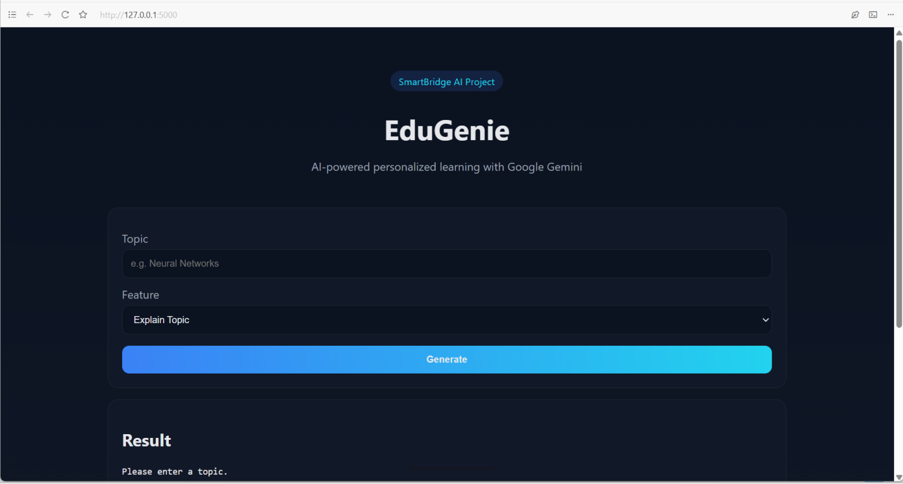
- Topic Explanation output example
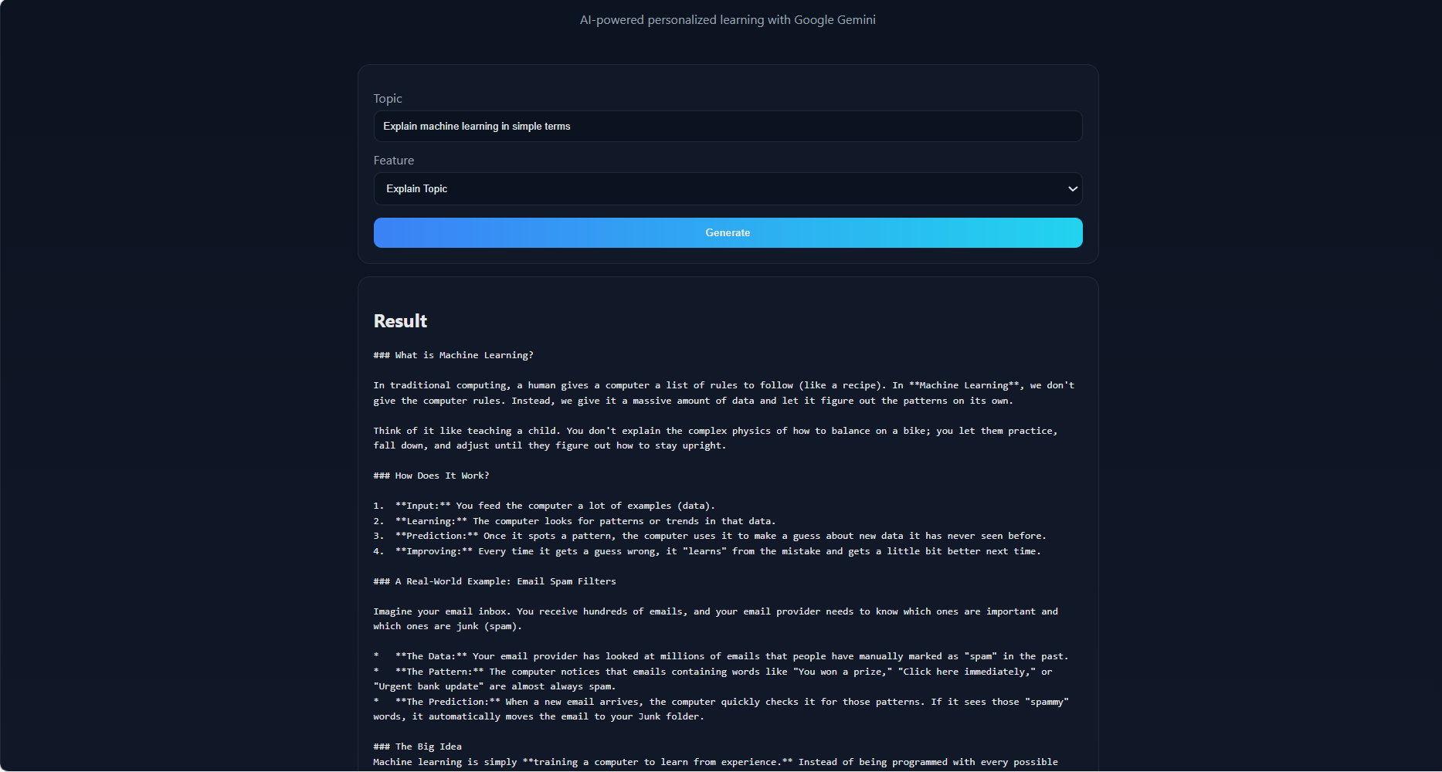

- Question & Answer output example

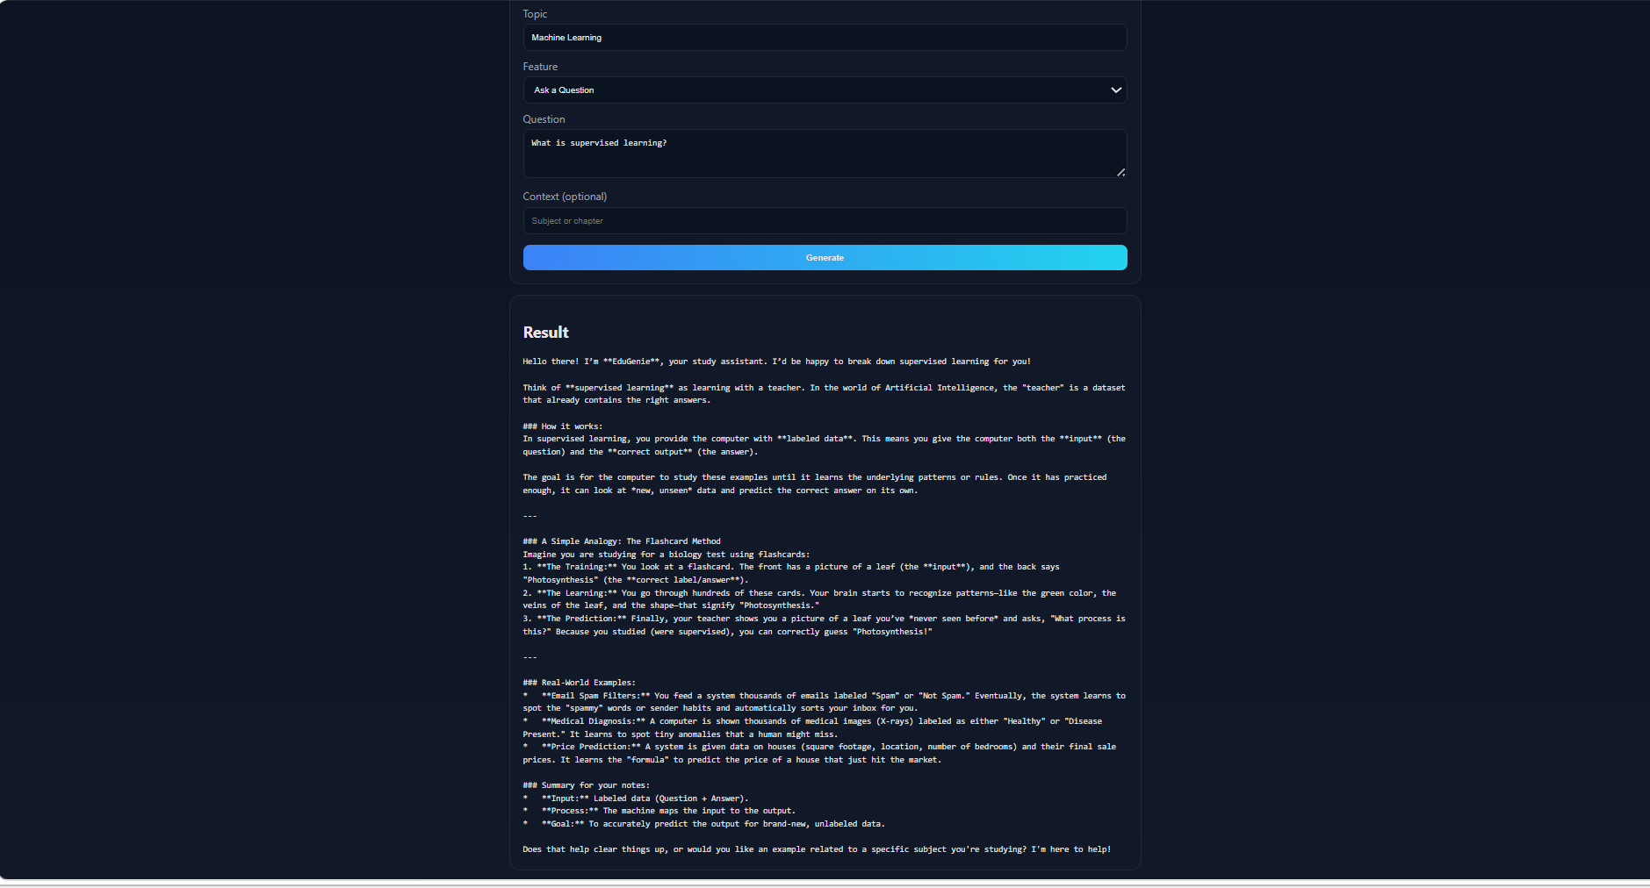
- Generated Quiz with options
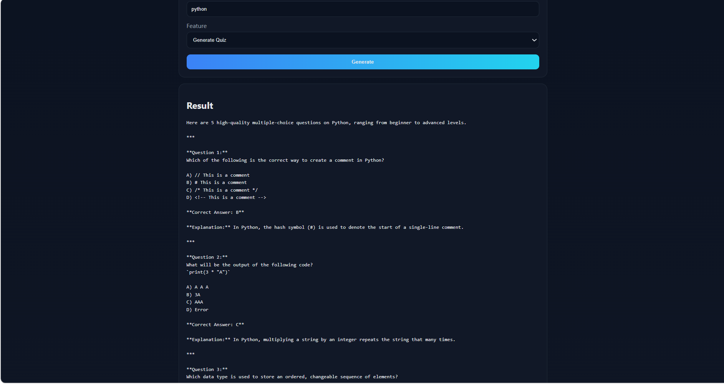

- Text Summarization result
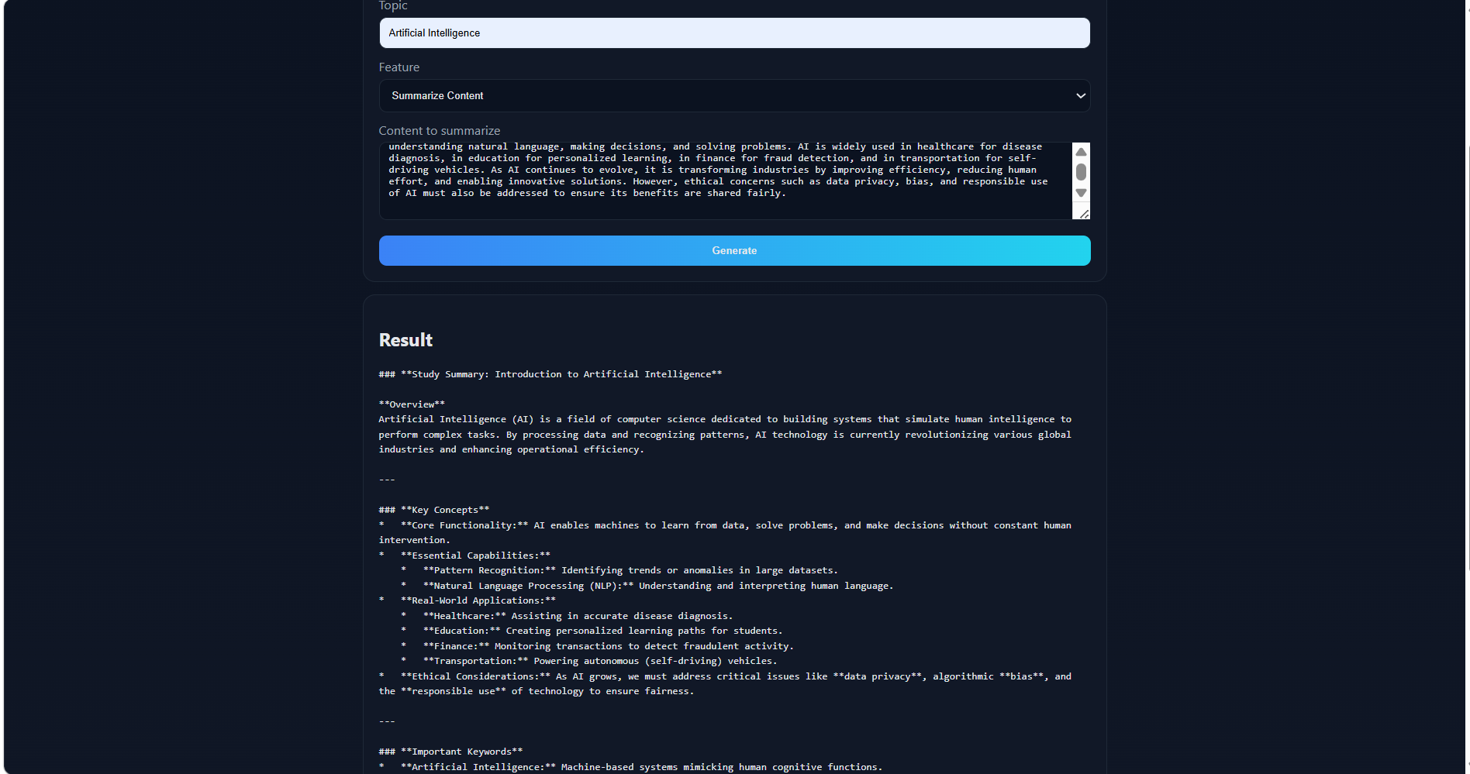
- Personalized Learning Path output
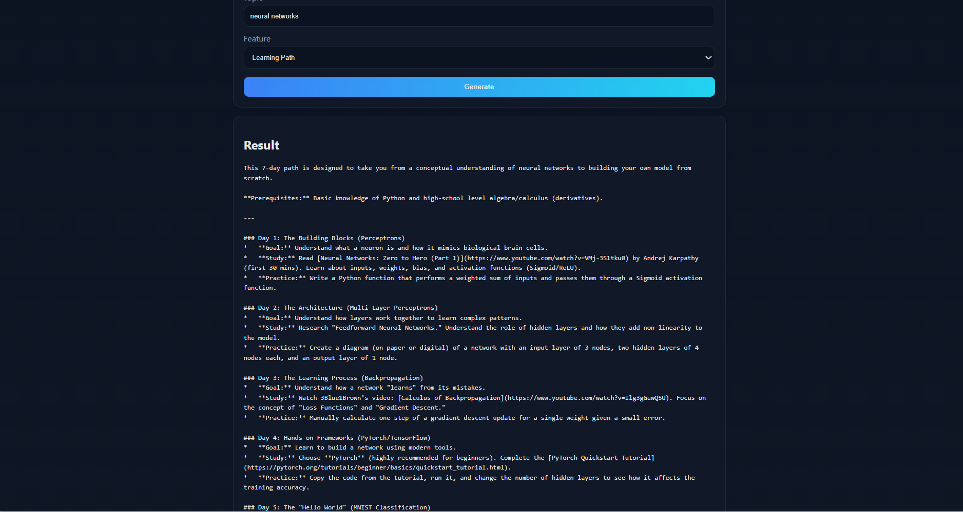

8. ADVANTAGES & DISADVANTAGES
Advantages
- Combines five learning-support features (explanation, QnA, quiz, summary, learning path) in a single platform
- Uses a hybrid AI approach — cloud-based Gemini for reasoning-heavy tasks, local model for summarization — balancing quality and cost
- Simple, lightweight interface requiring no installation for the end user
- Modular backend design makes it easy to add new features
- Reduces time students spend gathering resources across multiple websites

Disadvantages
- Requires an active internet connection for Gemini-powered features
- No user accounts or saved history — each session is independent
- Currently runs only on localhost; not yet deployed for public access
- Response quality depends on the underlying AI model and may occasionally be inaccurate
- No authentication, so it isn't currently suitable for multi-user production deployment

9. CONCLUSION
EduGenie successfully demonstrates how generative AI can be integrated into an educational platform to provide personalized, on-demand learning support. By combining Google's Gemini 2.5 Flash for reasoning-based tasks and a locally-run LaMini model for summarization, the project shows a practical hybrid AI architecture that balances response quality, cost, and performance.
The platform addresses a real problem — the fragmentation of online learning resources — by unifying explanation, question-answering, quiz generation, summarization, and learning-path creation into a single, easy-to-use interface. Testing confirmed that all core modules function reliably and return relevant, well-structured content within an acceptable response time.
Overall, EduGenie fulfills its intended objective of making self-paced learning more efficient, accessible, and personalized for students.

10. FUTURE SCOPE
- User Authentication & History: Allow students to create accounts and save past explanations, quizzes, and learning paths for later review.
- Deployment: Host the application on a cloud platform (e.g., Render, Railway, or Azure) with CORS configured, removing the localhost dependency.
- Progress Tracking & Analytics: Track quiz scores over time to identify weak topics and recommend focused revision.
- Multi-language Support: Generate explanations and quizzes in regional languages for wider accessibility.
- Voice Input/Output: Add speech-to-text input and text-to-speech playback for accessibility.
- Mobile App Version: Extend the platform to Android/iOS using the same Flask backend.
- Adaptive Difficulty: Adjust quiz difficulty and explanation depth based on student performance history.

11. APPENDIX

Source Code
Full source code is available in the project's GitHub repository (backend/ folder), including:
- app.py — Flask application and route definitions
- ai/gemini_model.py, ai/lamini_model.py — AI model integration
- modules/ — task-specific logic for explanation, QnA, quiz, summary, and learning path
- static/ — frontend (HTML, CSS, JS)
- tests/ — unit test scripts for each module

Dataset Link
Not applicable — EduGenie does not use a static training dataset. Content is generated dynamically at runtime via the Gemini API and the pre-trained LaMini-Flan-T5-248M model (sourced from Hugging Face Model Hub).

GitHub & Project Demo Link
- GitHub Repository: https://github.com/pranathiparimi3108/EduGenie
- Project Demo Video:https://1drv.ms/v/c/2ed7785f0f5cfe0c/IQCG2phtVi1_Q772-w6DZTlKAQO4MXrJDjR4WXLt4wo3WWs?e=9lxI5Q
- Watch the demo application in youtube : https://youtu.be/E1PSeyLu2P4?si=rV09Xy16WzxBeCiJ
- Live Demo: https://edugenie-production-46c5.up.railway.app

