PHASE 1. Docker Deployment

**Deliverables:**

1. Screenshot of the EC2 instance details (instance type, storage, ).

1. Screenshots of the services running (docker ps).

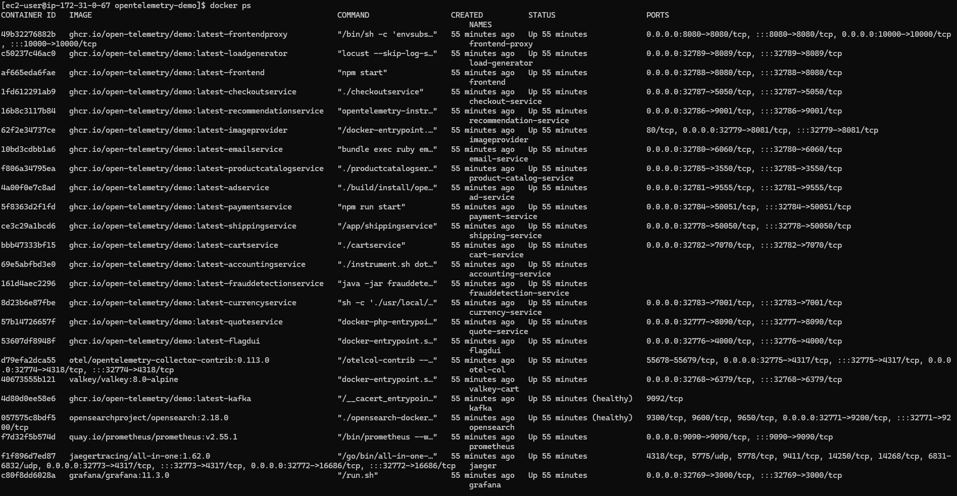

1. Screenshots of Docker logs showing the application's startup

1. Screenshot of accessible application

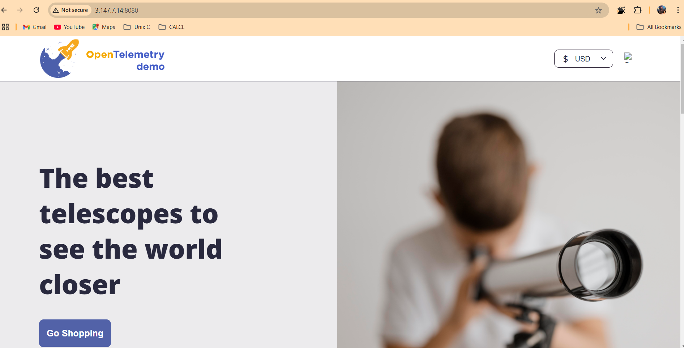

Task 2:

1. Screenshot of the EKS cluster configuration details (number of nodes, instance type, ).



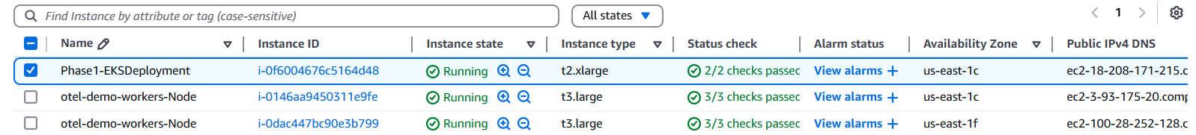

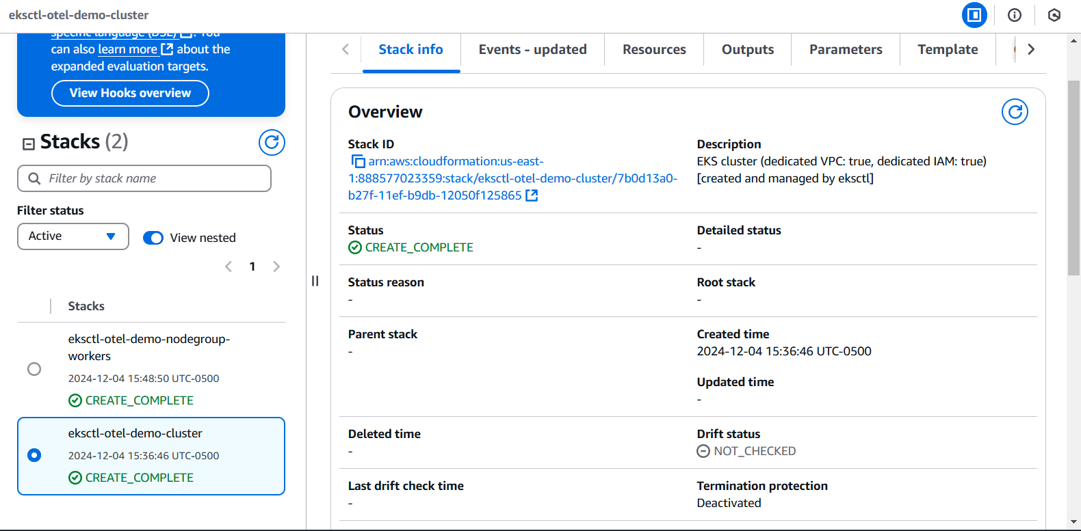

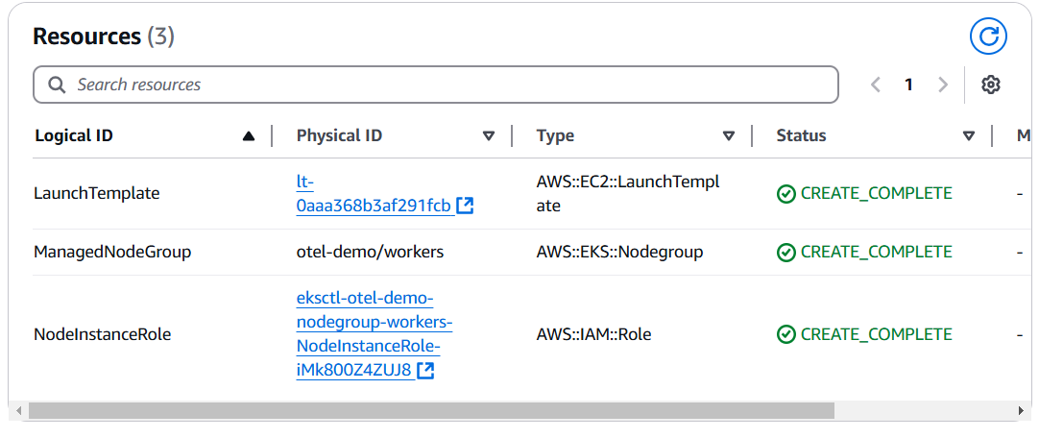

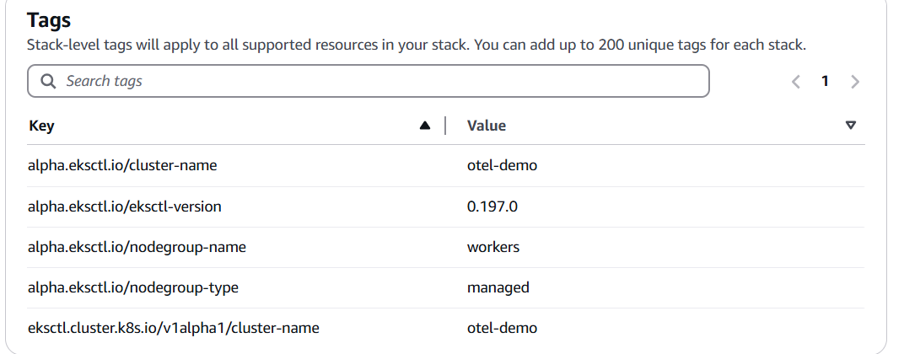

1. Screenshot of the EC2 instance used as the EKS client (instance type, storage, ).

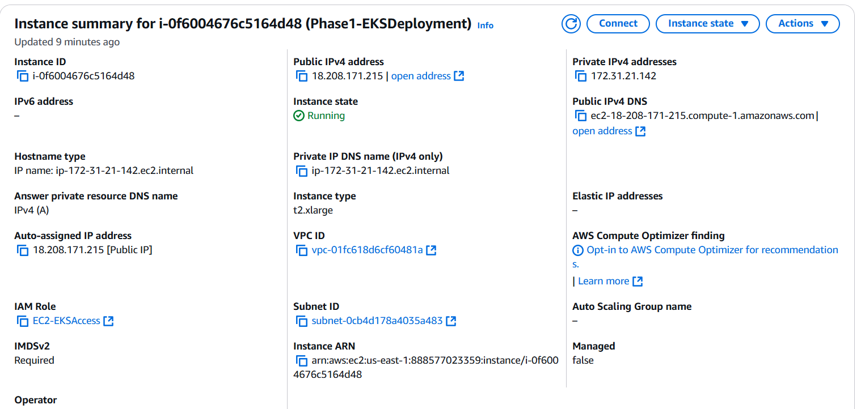

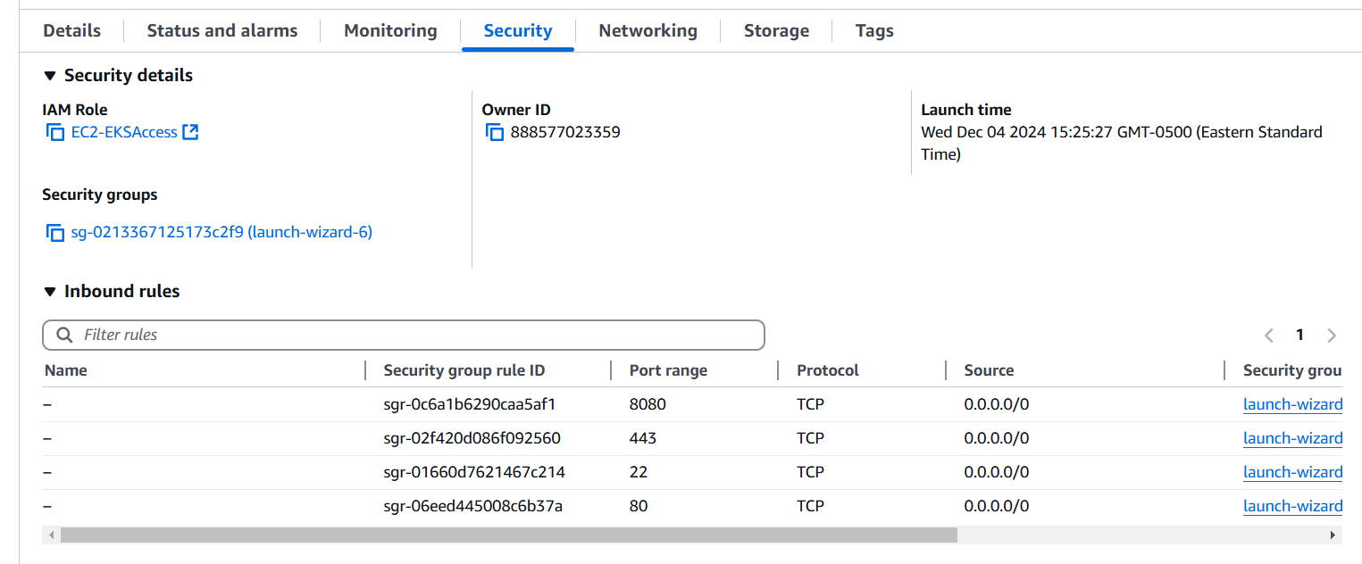

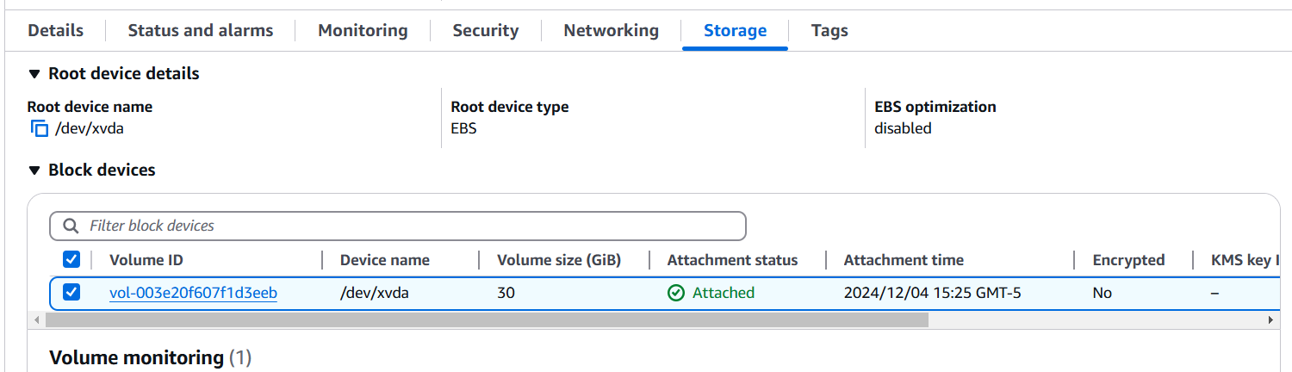

1. Screenshot of kubectl get all -n otel-demo showing the status of pods, services, and deployments

1. Screenshot of logs from key application pods to confirm successful

1. Exported Kubernetes manifest (opentelemetry-demo.yaml), if

1. Screenshot of accessible application follow the project documentation link

