1. Screenshots of the Helm repository being added and

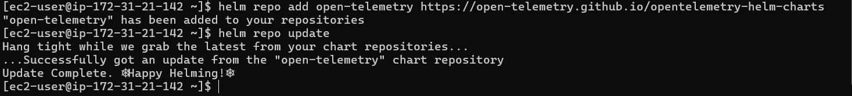

1. Screenshots of the application deployed successfully using

1. Screenshots or logs of the upgrade process showing changes being



1. Screenshots or logs demonstrating a successful rollback to a previous

