To run project double click on ‘run.bat’ file to get below screen

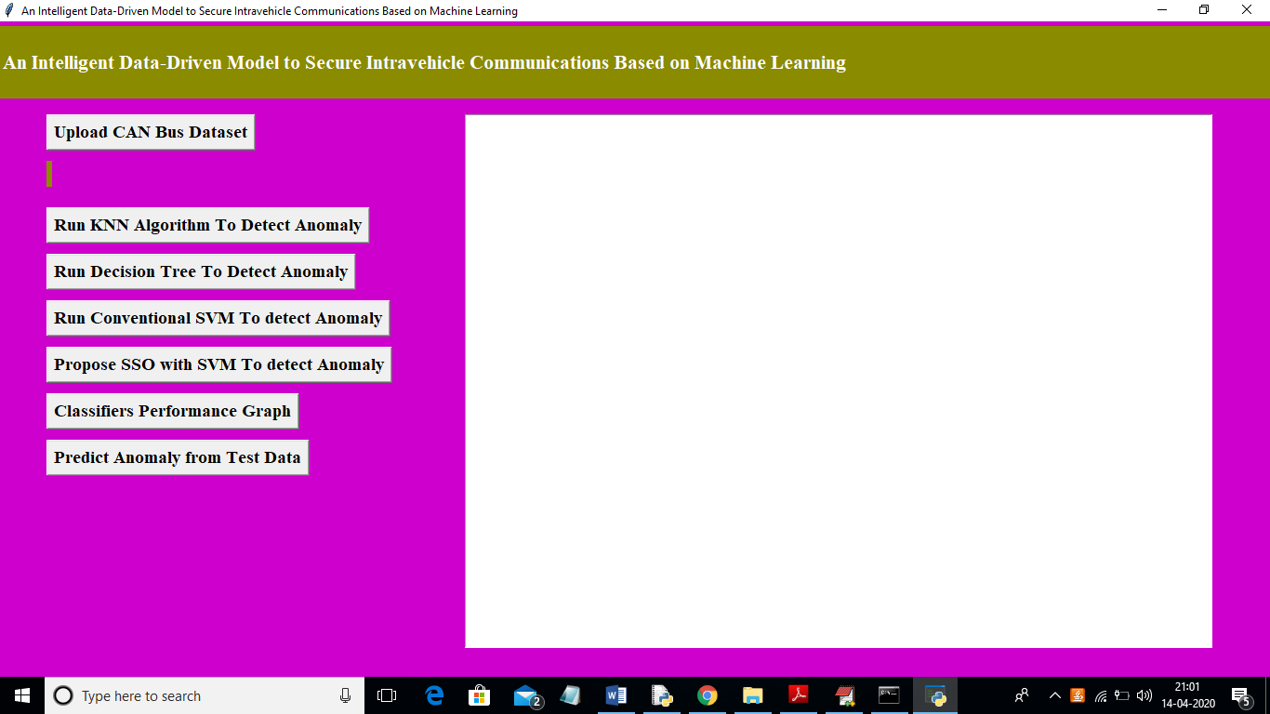

In above screen click on ‘Upload CAN Bus Dataset’ button and upload dataset

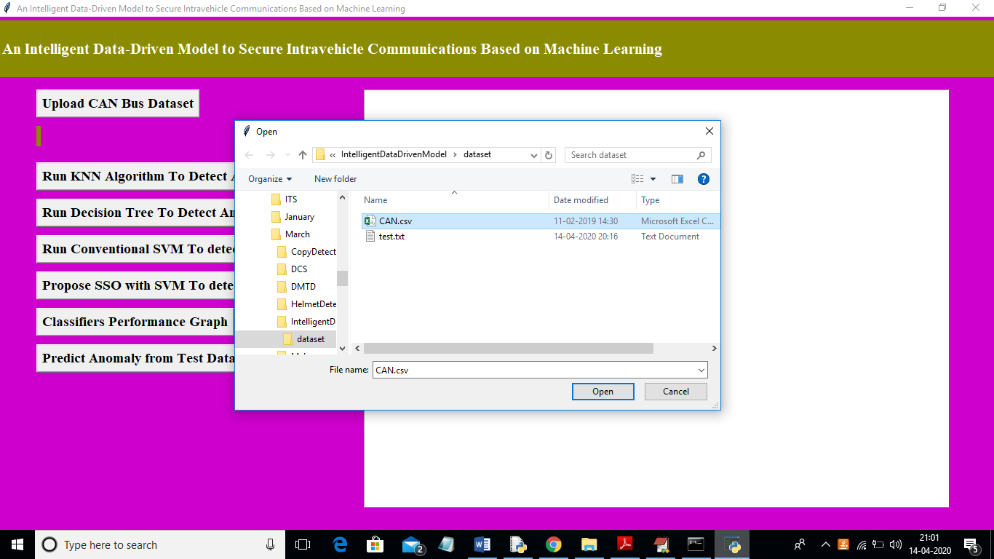

In above screen I am uploading ‘CAN.csv’ dataset and after uploading dataset will get below screen

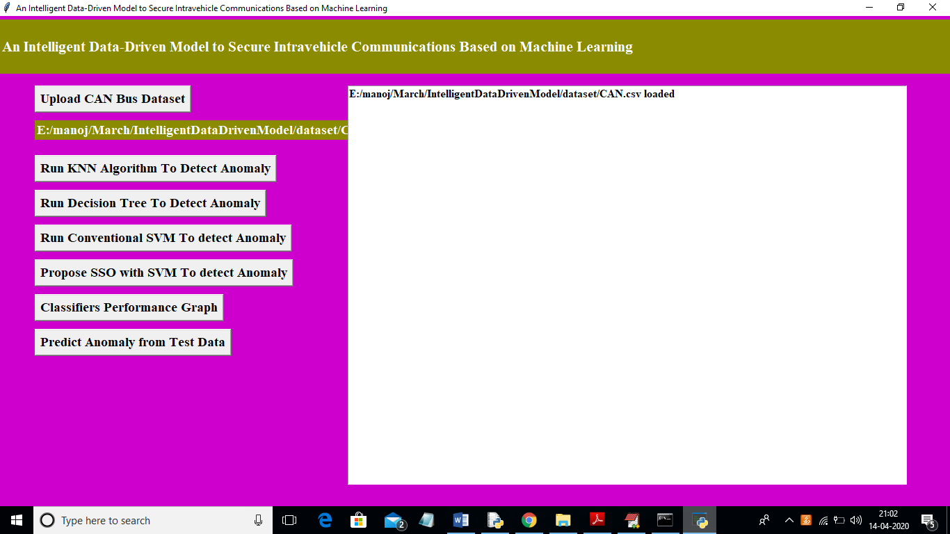

Now click on ‘Run KNN Algorithm To Detect Anomaly’ button to build KNN classifier train model to detect anomaly and evaluate its performance based on 4 indices

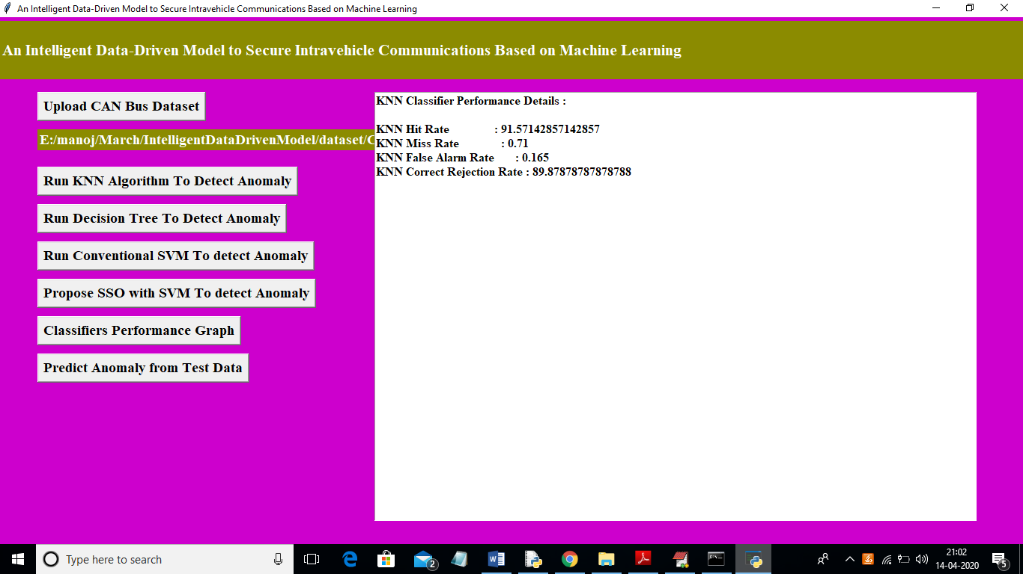

In above screen we got 4 indices values for KNN algorithm and now click on ‘Run Decision Tree To Detect Anomaly’ button to evaluate decision tree performance

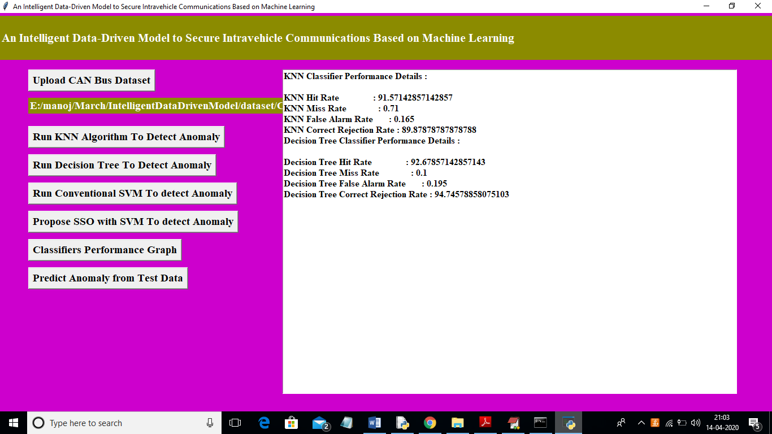

In above screen we got decision tree data and now click on ‘Run Conventional SVM To detect Anomaly’ button to evaluate conventional SVM performance.

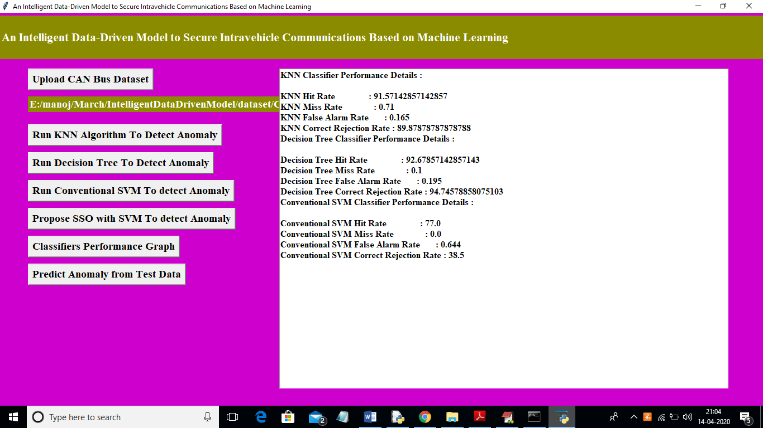

In above screen we got SVM performance data and now click on ‘Propose SSO with SVM To detect Anomaly’ button to run propose SSO with SVM classifier and evaluate its performance. (Note: when u run SSO then application will open 4 empty windows and you just close newly open empty window and keep working from first window only).

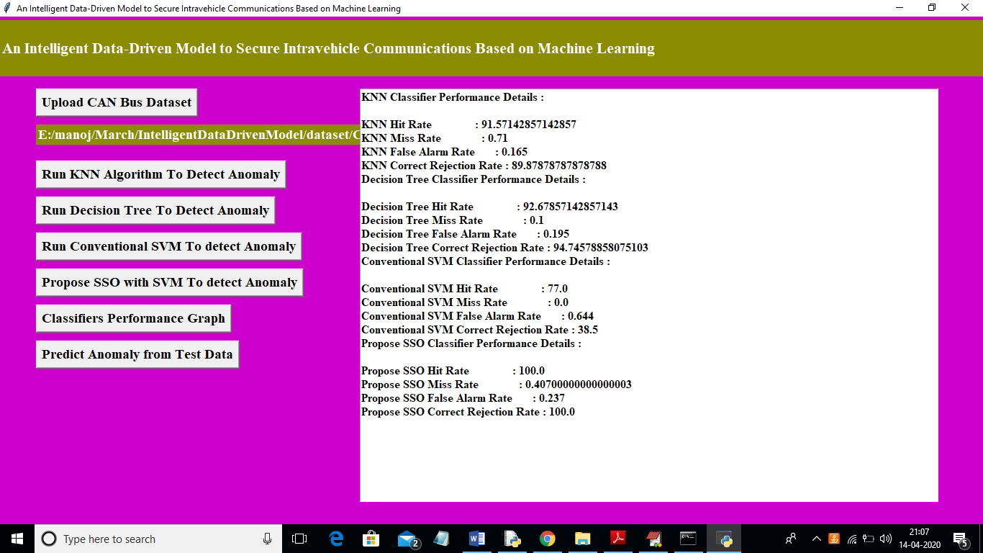

In above screen for SSO we got performance metric as 100% and MR and FR is not mandatory so we can ignore as said in paper. Now click on ‘Classifiers Performance Graph’ button to get performance graph between all classifiers

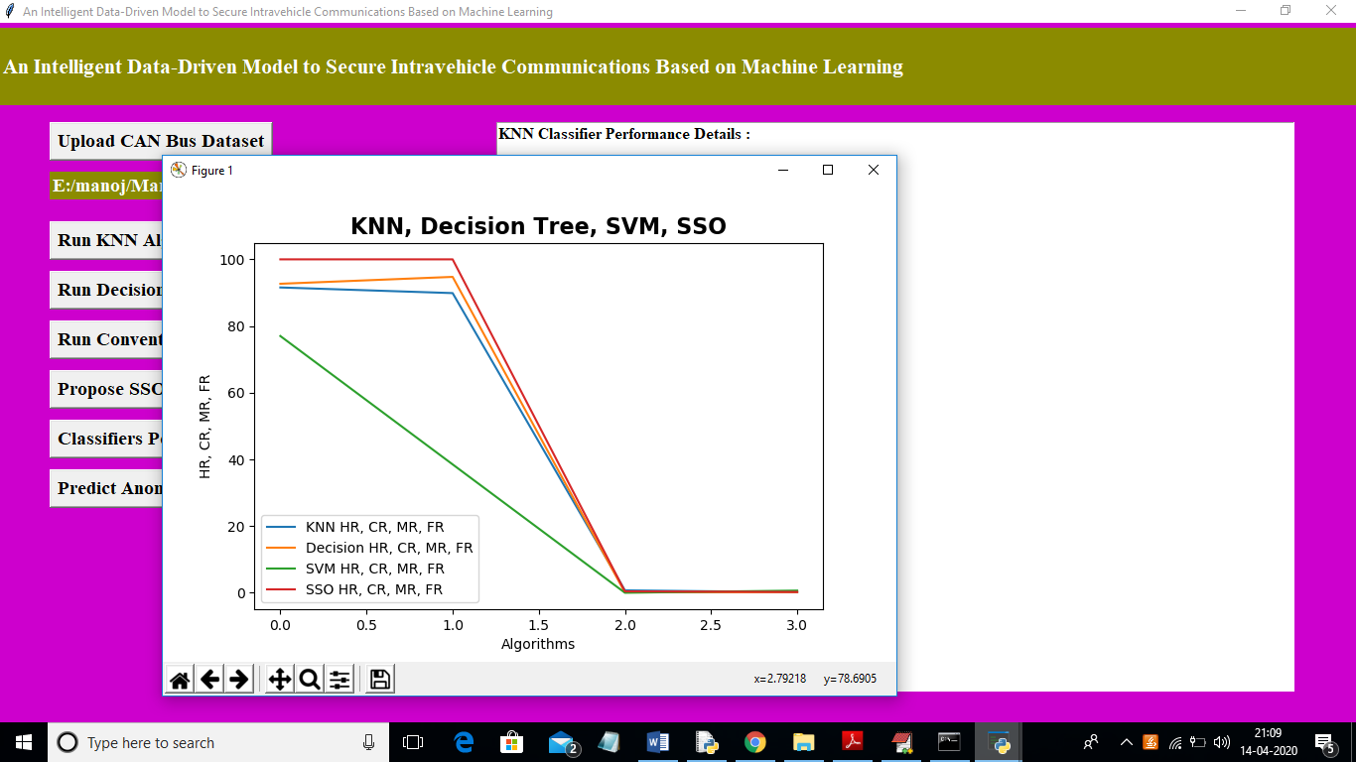

In above graph propose SSO has given high performance compare to other algorithms. In above graph y-axis represents HR, MR, FR and CR values. Now click on ‘Predict Anomaly from Test Data’ button to upload test data and predict it label

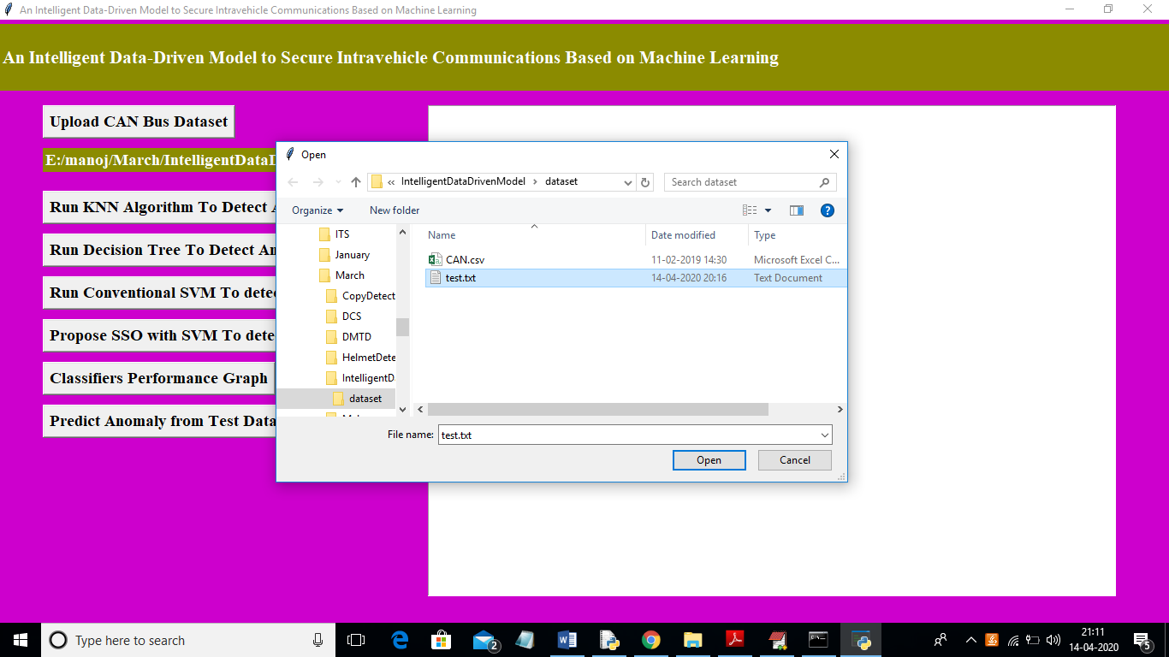

In above screen I am uploading ‘test.txt’ file and now click on ‘Open’ button to predict uploaded test file class label.

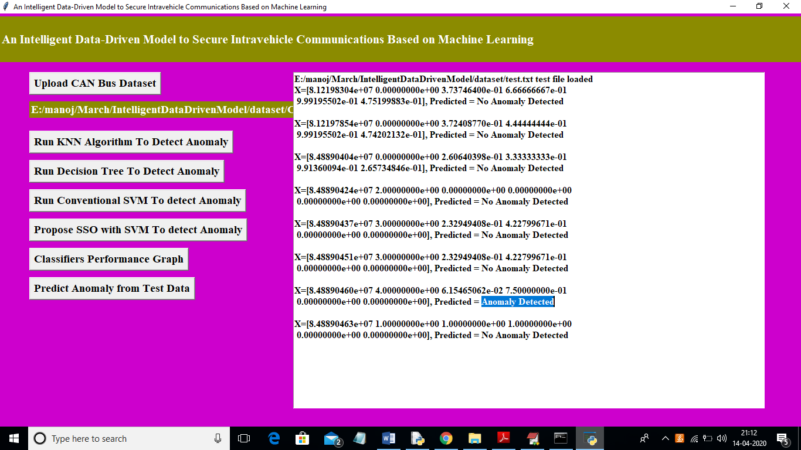

In above screen in text area we can see uploaded test data and its predicted class label. All records contains normal packet data accept one record. So by using machine learning algorithms we can analyse packets and if packet contains attack then we ignore processing such packets.