Name: Pranav Lamkhade
Roll No: 42
Batch: A3
PRN: 202401120062

Part 4: Clustering - Student Segmentation & Risk Analysis

Objective
Segment students into meaningful groups using GPA, Attendance Percentage, Credits Completed, and Study Load. Techniques used include K-Means Clustering (with Elbow Method) and Hierarchical (Agglomerative) Clustering (with Dendrogram).

1. Data Preparation, Feature Scaling, and K-Means Elbow Method
features = ['GPA', 'Attendance_Pct', 'Credits_Completed', 'Study_Load']
X = df[features].values
scaler = StandardScaler()
X_scaled = scaler.fit_transform(X)
inertias = []
silhouettes = []
k_range = range(2, 11)
for k in k_range:
km = KMeans(n_clusters=k, random_state=42, n_init=10)
km.fit(X_scaled)
inertias.append(km.inertia_)
silhouettes.append(silhouette_score(X_scaled, km.labels_))
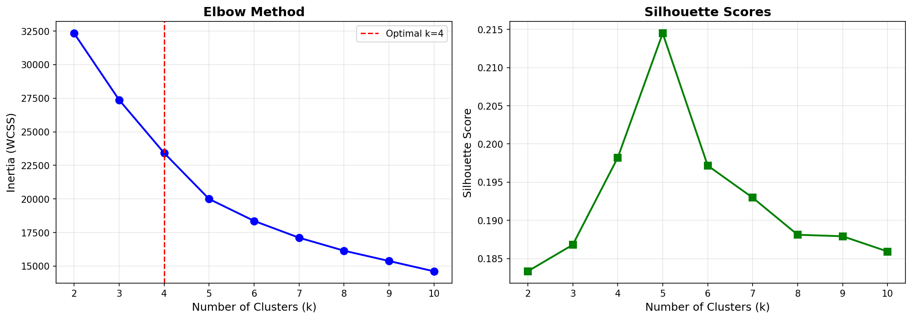

2. K-Means Clustering (k=4)
K = 4
kmeans = KMeans(n_clusters=K, random_state=42, n_init=10)
df['KMeans_Cluster'] = kmeans.fit_predict(X_scaled)
pca = PCA(n_components=2)
X_pca = pca.fit_transform(X_scaled)
df['PCA1'] = X_pca[:,0]
df['PCA2'] = X_pca[:,1]
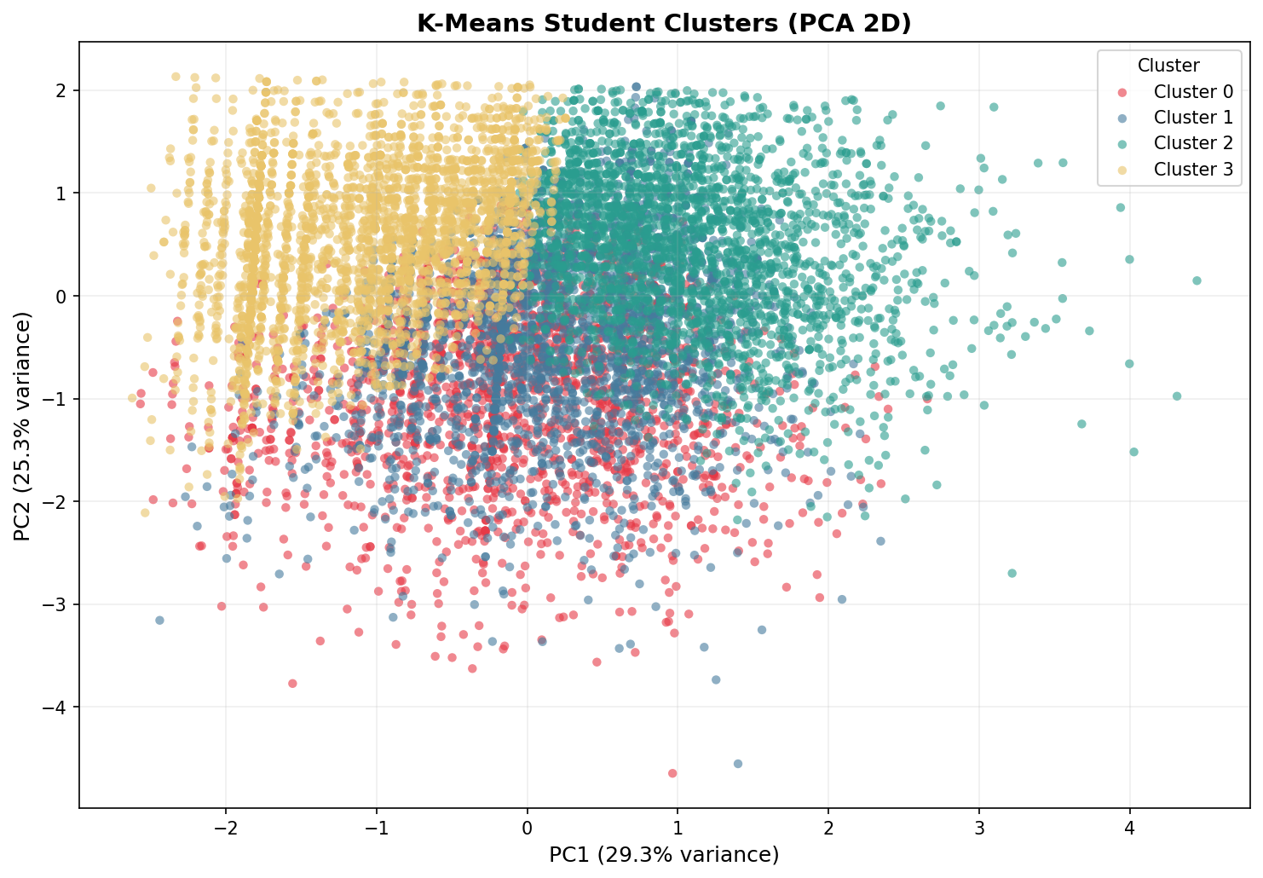

3. Cluster Profile Analysis
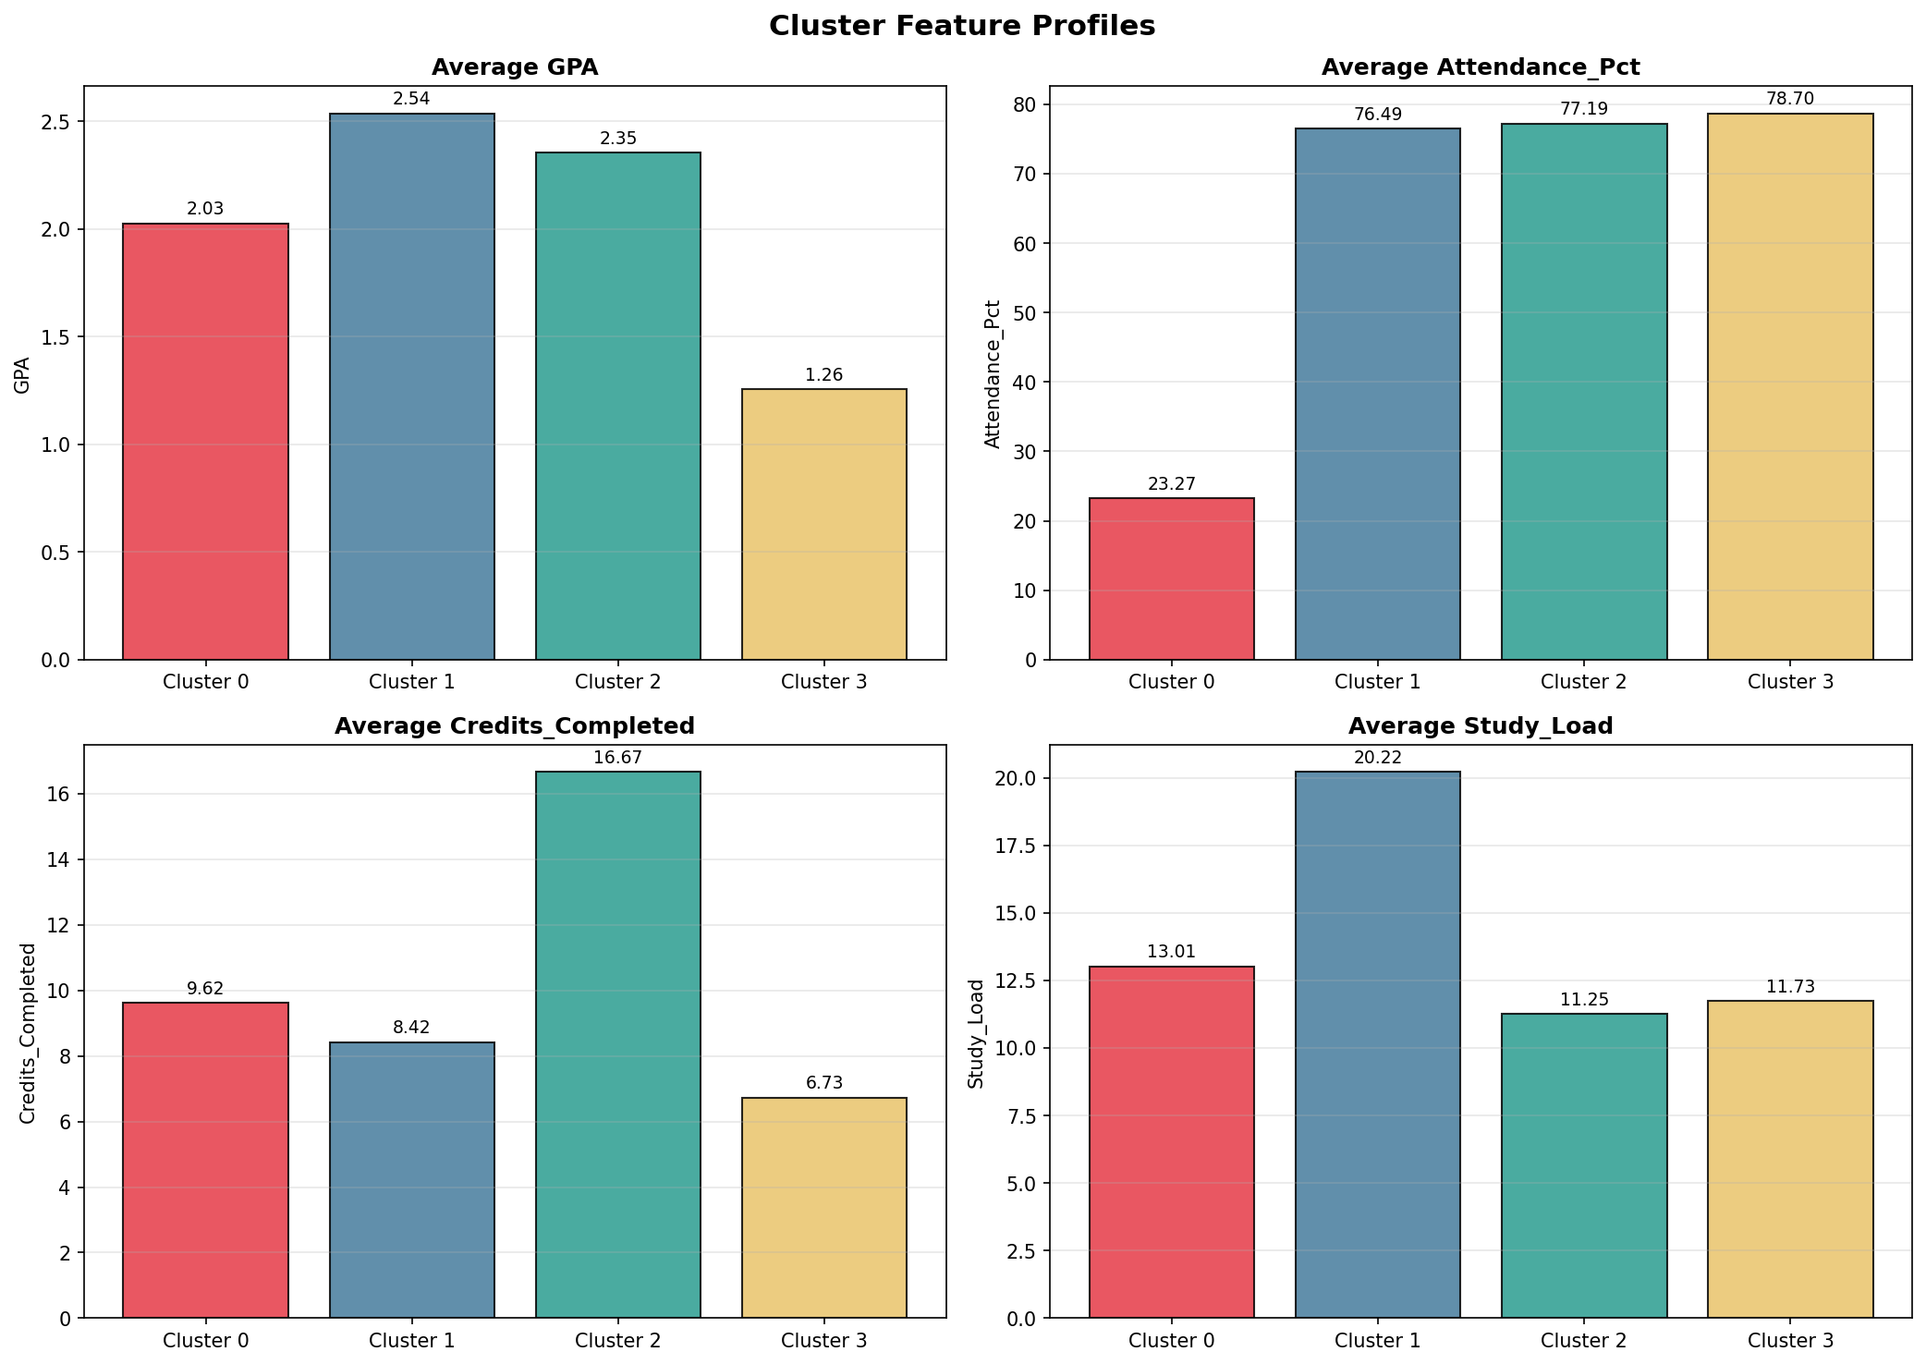

4. Risk Analysis - Segment Labels
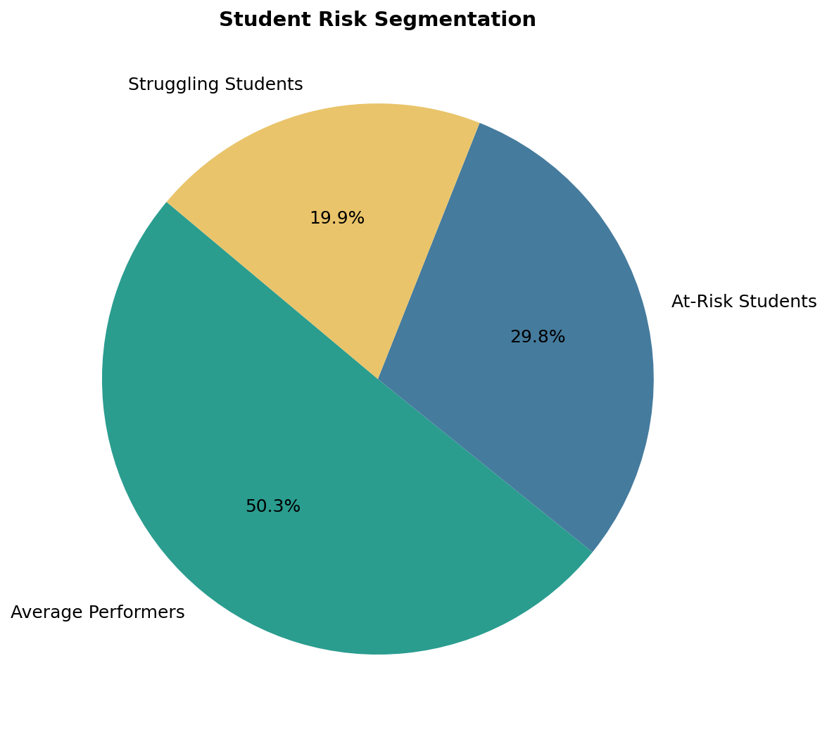

5. Hierarchical Clustering (Dendrogram)
sample_idx = np.random.choice(len(X_scaled), size=300, replace=False)
X_sample = X_scaled[sample_idx]
linked = linkage(X_sample, method='ward')
dendrogram(linked, truncate_mode='lastp', p=30)
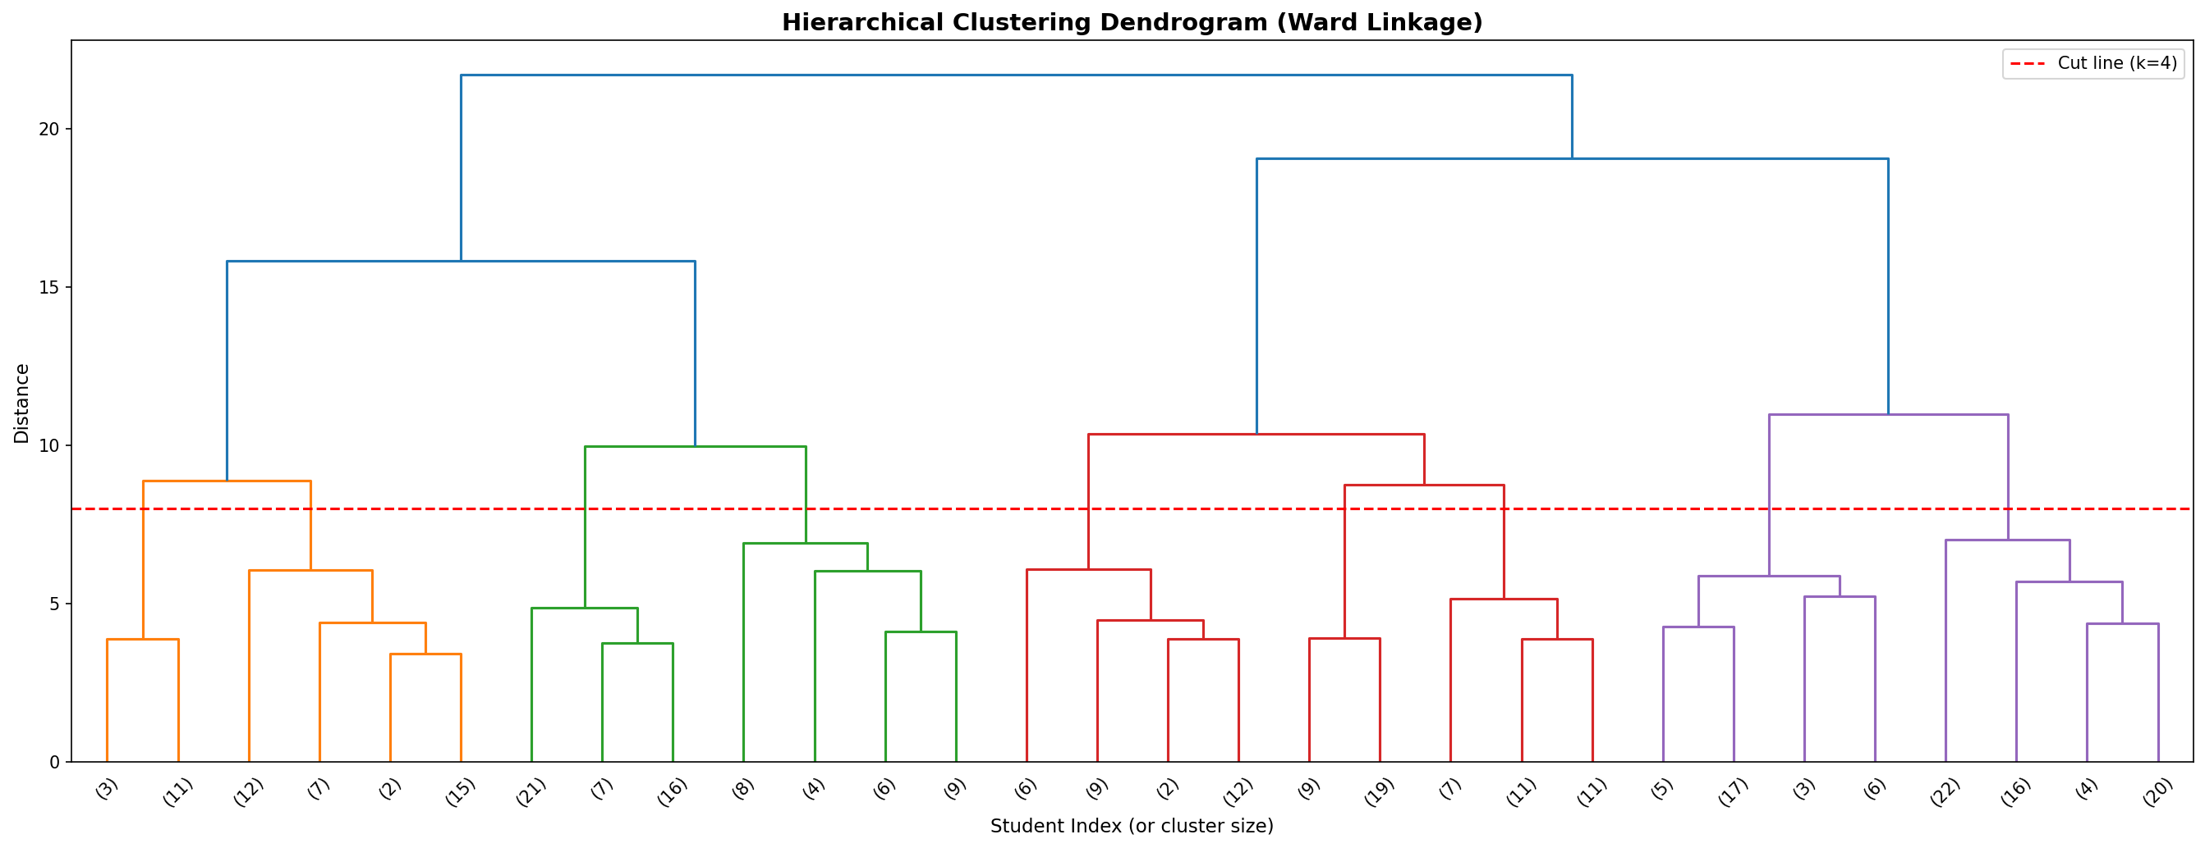

6. Agglomerative Clustering
agg = AgglomerativeClustering(n_clusters=4, linkage='ward')
df['Agg_Cluster'] = agg.fit_predict(X_scaled)
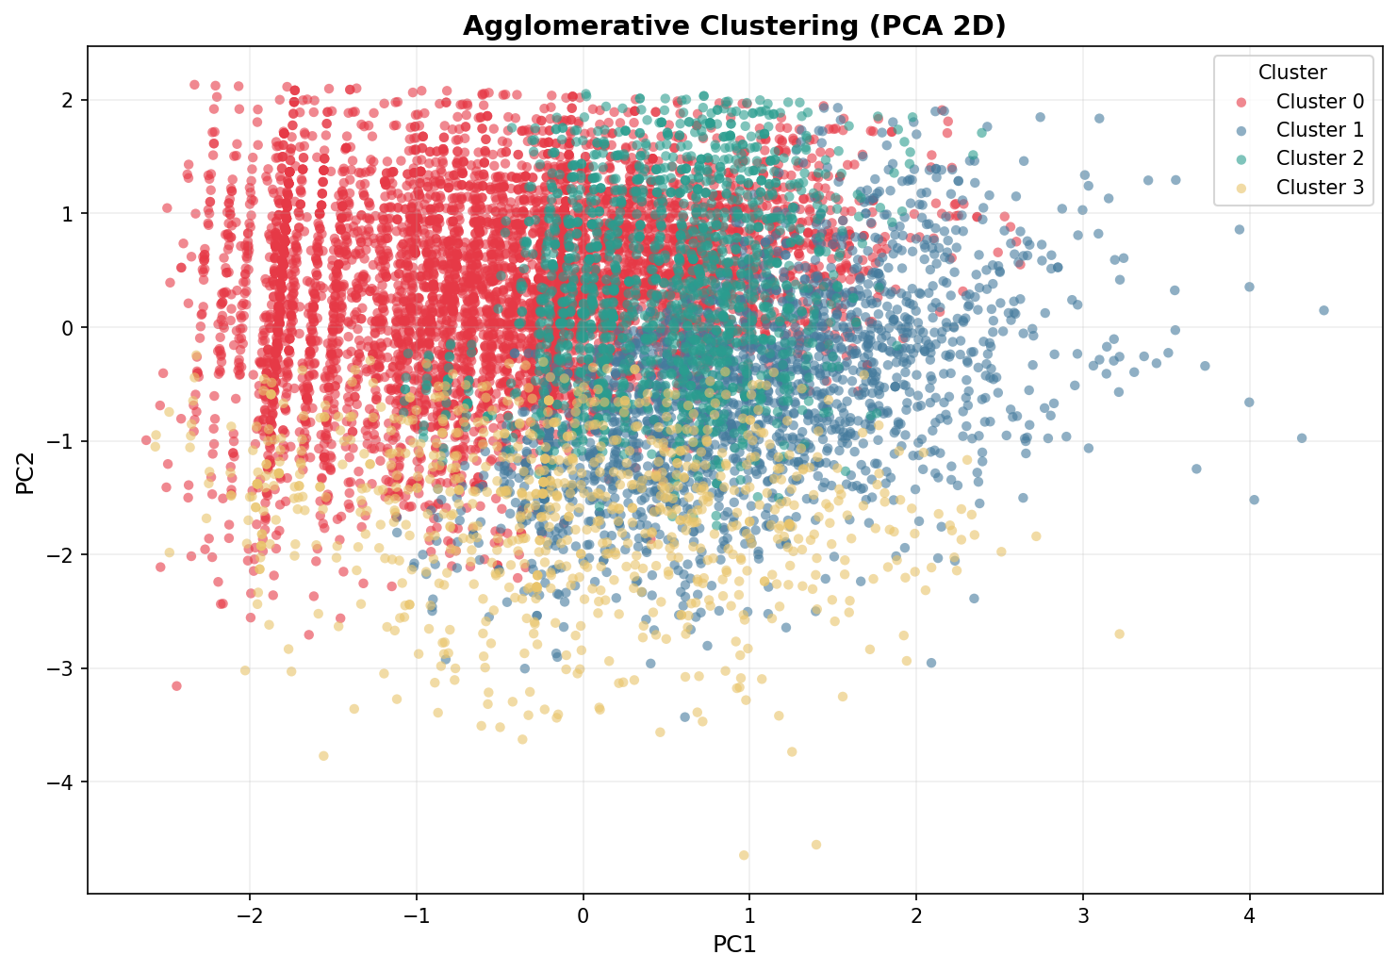

Conclusion
Both K-Means and Agglomerative Clustering identified 4 optimal segments: High Achievers, Average Performers, Struggling Students, and At-Risk Students. This segmentation enables targeted interventions for students based on their behavioral and academic profiles.

