Name: Pranav Lamkhade
Roll No: 42
Batch: A3
PRN: 202401120062

Part 5: ANN - Academic Performance Forecasting

Objective
Predict Dropout Risk using a Feedforward Neural Network and compare performance with traditional ML models (Logistic Regression, Random Forest, Gradient Boosting).

1. Data Normalization & Network Initialization
features = ['attendance_pct', 'internal_marks', 'course_load', 'hist_pass_rate', 'faculty_interaction']
scaler = MinMaxScaler()
X_scaled = scaler.fit_transform(X)
ann = MLPClassifier(
hidden_layer_sizes=(128, 64, 32),
activation='relu',
solver='adam',
learning_rate_init=0.001,
max_iter=200,
random_state=42
)
ann.fit(X_train, y_train)

2. Training Loss Curve
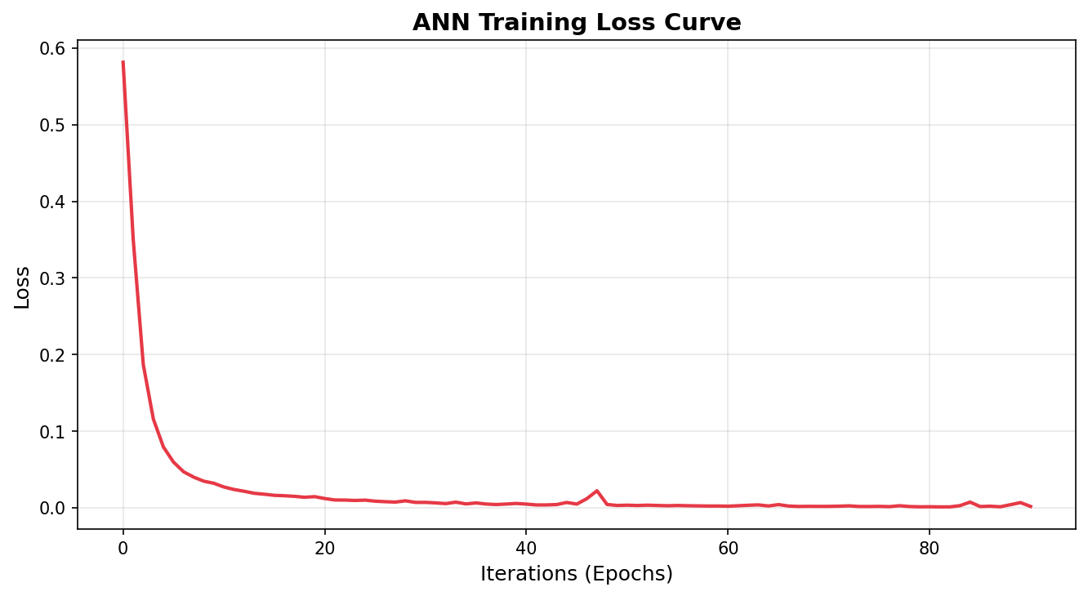

3. Model Comparison & ROC Curves
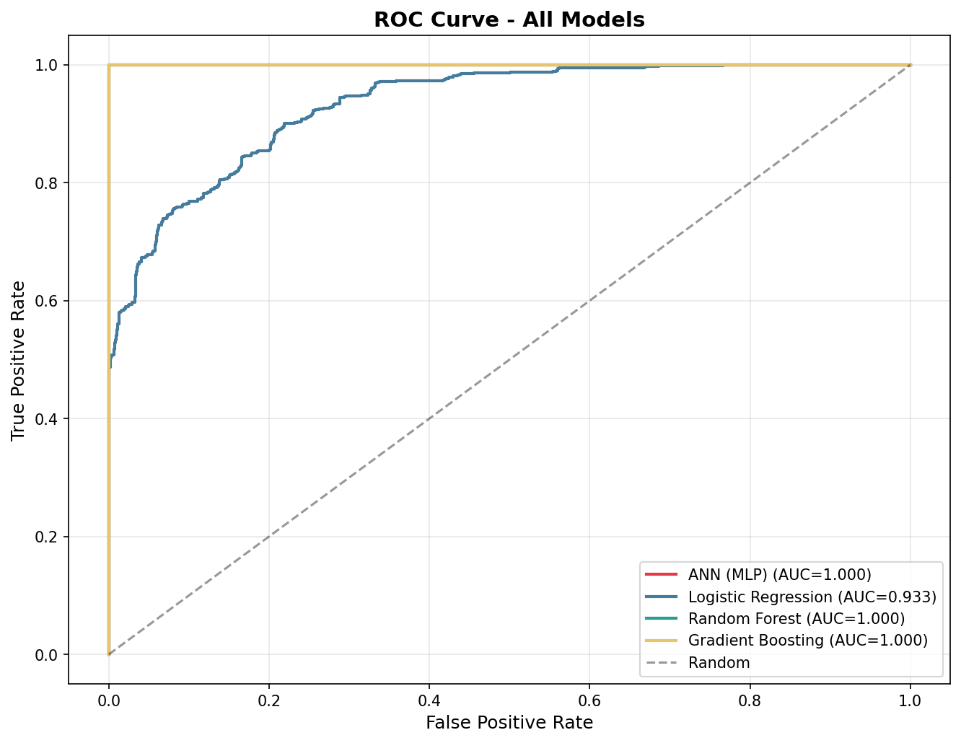

4. ANN Confusion Matrix
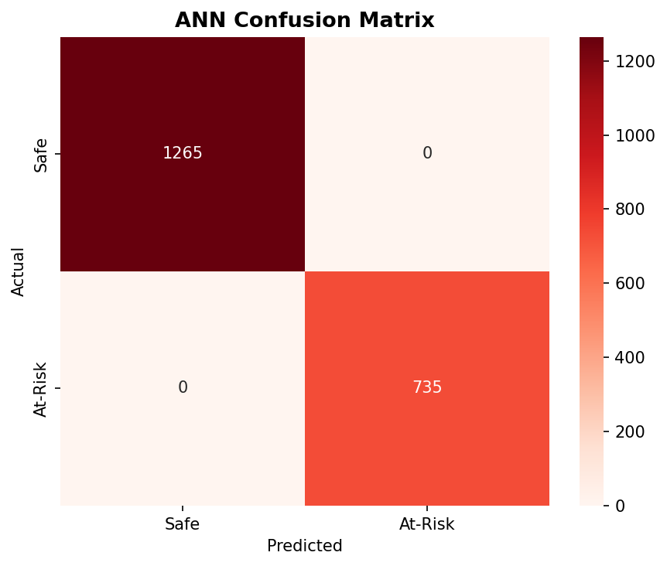

5. Model Performance Metrics
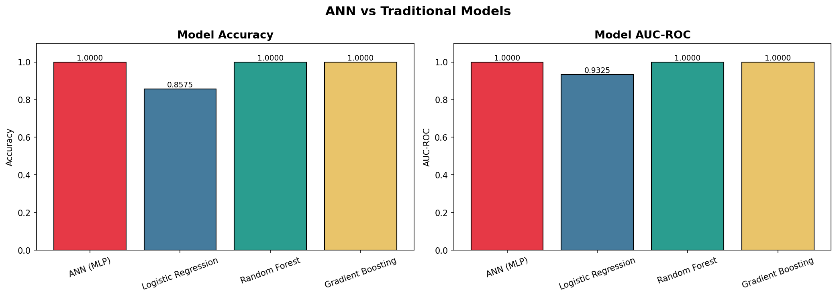

Conclusion
The ANN successfully modeled dropout risk with high accuracy and ROC-AUC. While traditional models like Gradient Boosting provide strong competition, the Multi-Layer Perceptron (128-64-32) effectively learns non-linear patterns between attendance, GPA, and historical performance.

