SMART AIRSPACE CONFLICT ANALYSIS
AND FLIGHT INTELLIGENCE SYSTEM
DDL QUERY EXECUTION
DBMS Level 3 Mini Project

Student 1 | Pranav Shashikiran Atreya  SRN: PES2UG24CS912
Student 2 | Yash Raghavendra A  SRN: PES2UG24CS913
Class | 5D
Database Platform | PostgreSQL with pgvector
Evidence of SQL DDL execution and verification in pgAdmin 4

1. Tables Created
Execution evidence
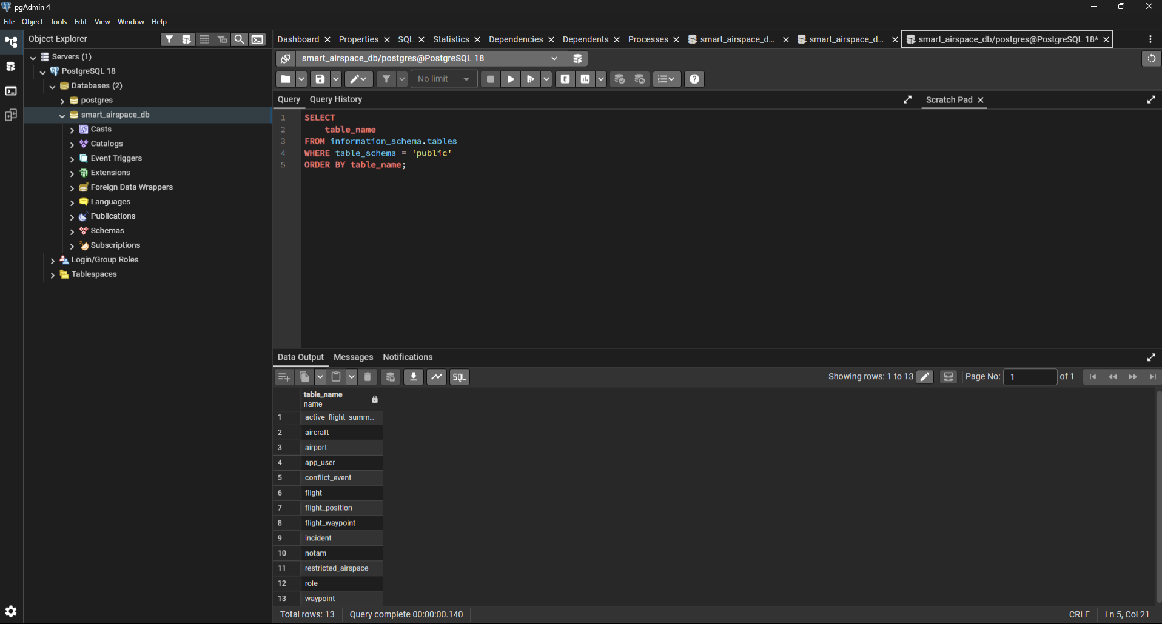
PostgreSQL query output confirming the project tables/view are present in the public schema.

2. Constraints, Primary Keys and Unique Constraints - Part 1
Execution evidence
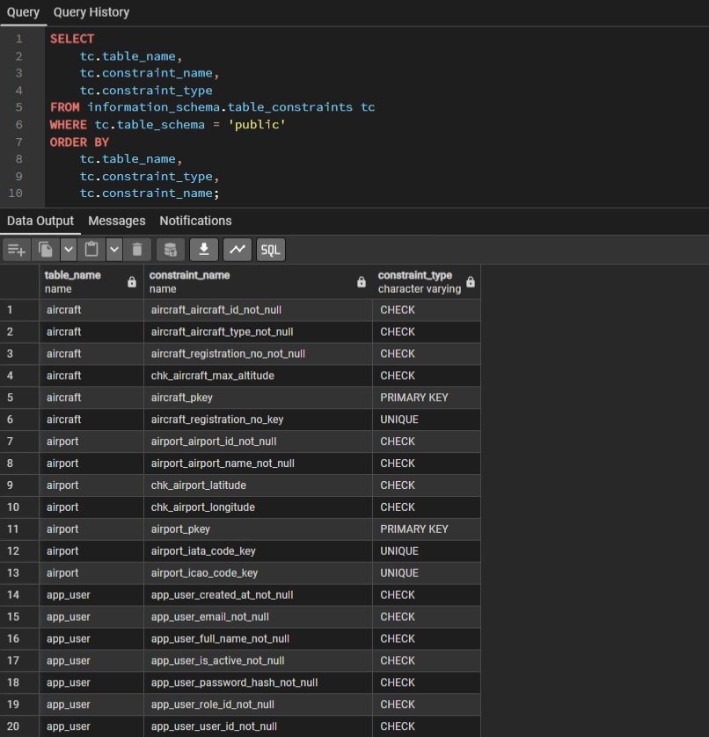
PostgreSQL information_schema output showing CHECK, PRIMARY KEY and UNIQUE constraints.

3. Constraints and Foreign Keys - Part 2
Execution evidence
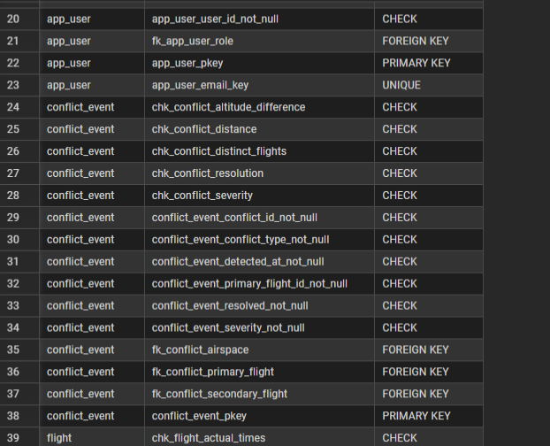
Continuation of the PostgreSQL constraint listing, including additional foreign-key and check constraints.

4. Schema Columns and Data Types
Execution evidence
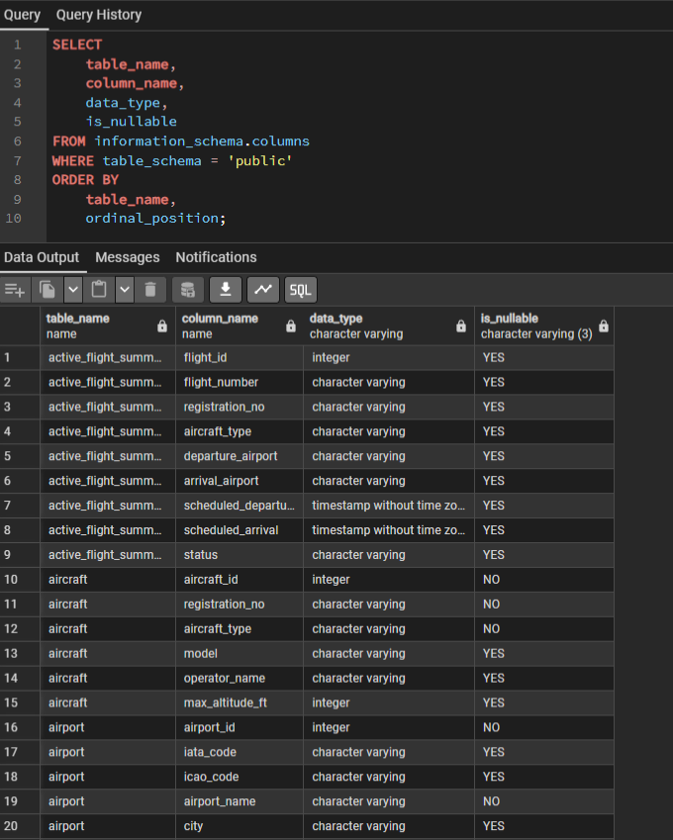
PostgreSQL information_schema.columns query showing table columns, data types and nullability.

5. Indexes - Part 1
Execution evidence
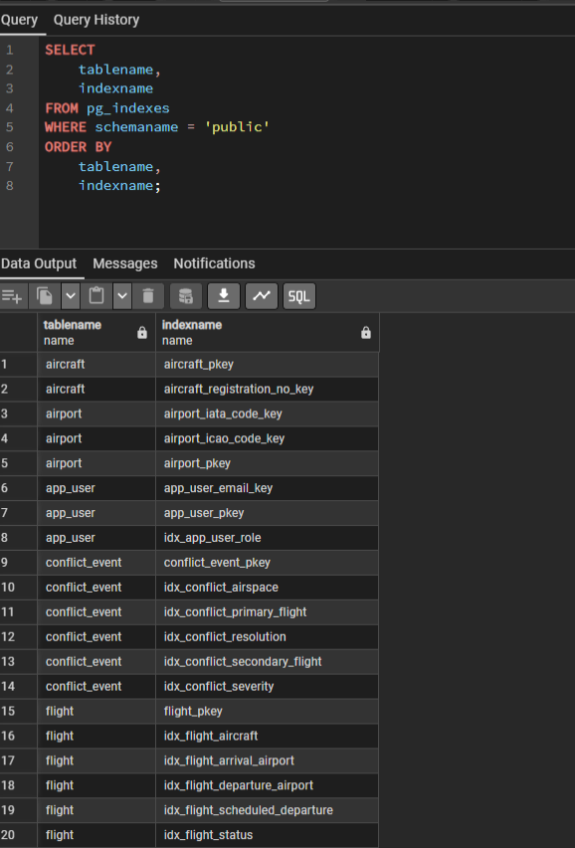
PostgreSQL pg_indexes query showing created indexes on the project tables.

6. Indexes - Part 2
Execution evidence
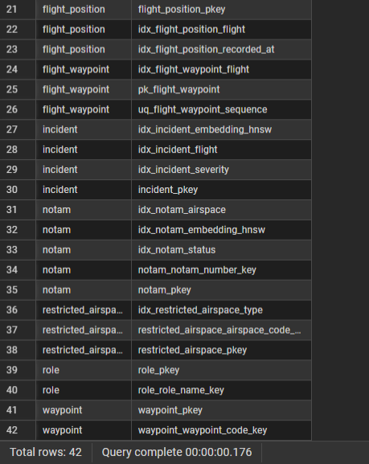
Continuation of the PostgreSQL index listing.

7. Vector Columns
Execution evidence
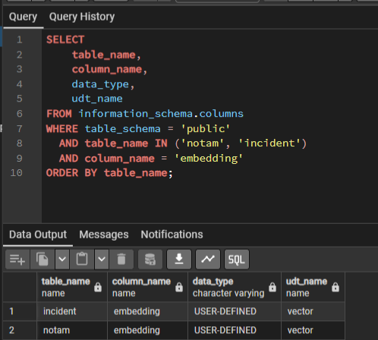
PostgreSQL output confirming VECTOR columns on incident and notam.

8. pgvector Extension
Execution evidence
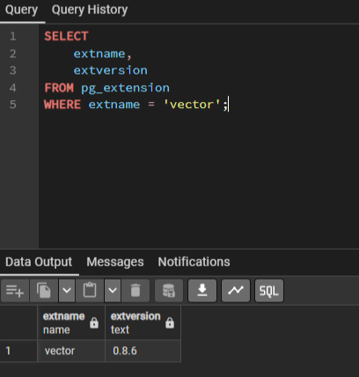
PostgreSQL extension query confirming the vector extension and installed version.

9. View Creation and Verification
Execution evidence
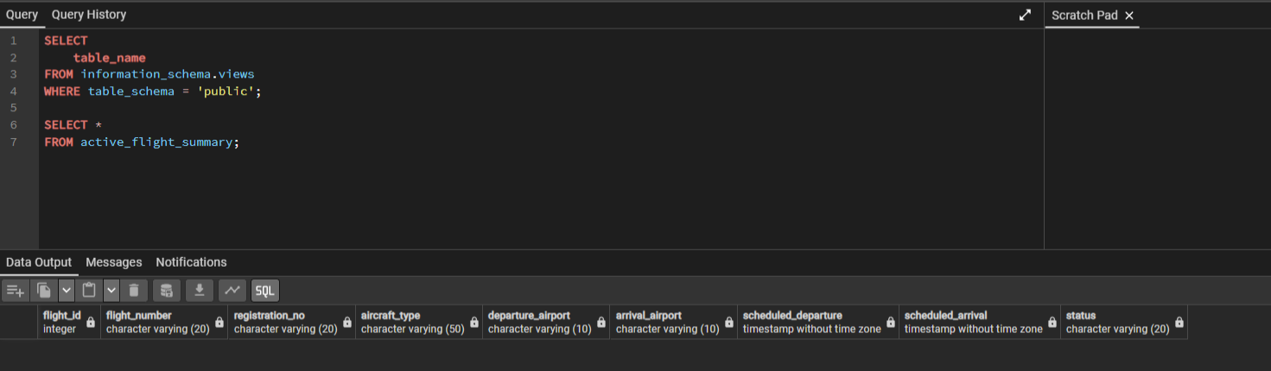
PostgreSQL query listing the view and selecting from active_flight_summary.

10. DROP TABLE Verification
Execution evidence
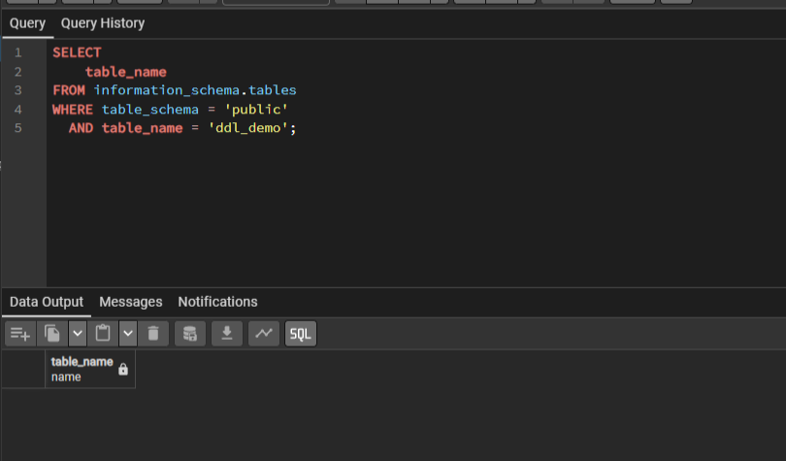
PostgreSQL query confirming that the temporary ddl_demo table was removed.

