SolarSchools USA: System Design Document
Technical Architecture, API Workflows, Mathematical Models, and Defense Playbook
PROJECT METADATA
Author: Pranav Balaji
Competition: SVYCA Youth For Earth Hackathon @ Stanford Climate Week (October 2026)
Core Stack: Python 3.12, Streamlit, GeoPandas, Shapely, Folium, Plotly, Requests
Target Audience: Hackathon Judges, School Board Officials, Student Climate Advocates

1. Executive Summary & Design Rationale

1.1 Problem & Opportunity
- Energy Burden: Public K-12 school districts spend over $8 billion annually on electricity, often their second-largest budget expense after personnel.
- Underutilized Asset: Schools maintain extensive unshaded asphalt parking lots that intensify the urban heat island effect and increase cooling loads.
- Federal Catalyst: Section 6417 of the Inflation Reduction Act (IRA) allows non-taxable entities—including public school districts—to receive elective cash payments ('Direct Pay') from the IRS covering 30% to 50% of clean energy project costs.
- Access Barrier: Commercial feasibility studies cost $15,000 to $50,000. SolarSchools USA provides a free, instant screening tool for student advocates and school boards.

1.2 Parking Canopies vs. Rooftop Solar
Commercial solar developers often suggest rooftop panels, but facilities directors face significant obstacles that parking lot canopies eliminate:
Evaluation Metric | Rooftop Solar | Parking Lot Canopy (SolarSchools USA)
Roof Warranty | Risk of voiding 20-year membrane warranty | Zero roof penetrations; independent structural steel
Structural Capacity | Limited by HVAC weight and seismic ratings | Engineered independent pier foundations
Microclimate Impact | Minor roof cooling | Drops asphalt surface temp by 30°F to 45°F
EV Integration | Requires expensive trenching to ground lot | Turnkey conduit integration for Level 2 EV chargers
Campus Visibility | Hidden from student and community view | Highly visible showcase of civic climate leadership

2. End-to-End System Architecture
The following architecture details the dataflow across user inputs, geospatial lookups, physical simulation APIs, financial models, and export layers.

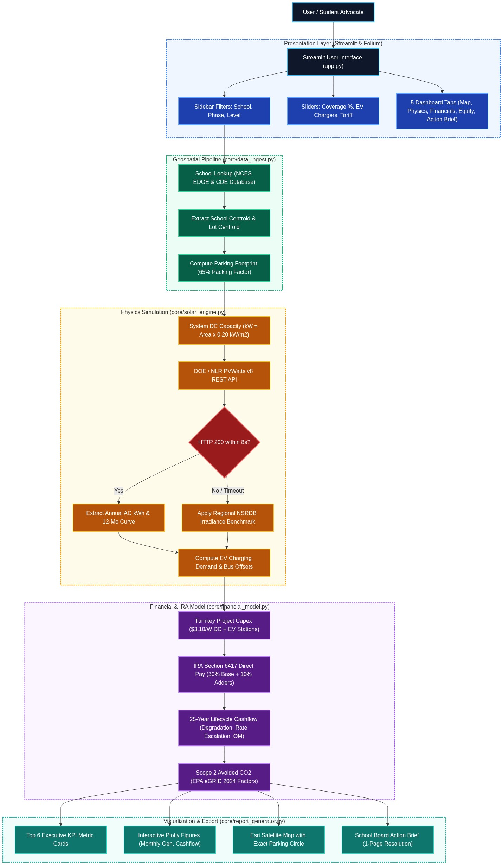
Figure 1: Full-Stack Modular System Architecture and Pipeline Dataflow

3. External API Workflows & Specifications
SolarSchools USA communicates with three external web services:

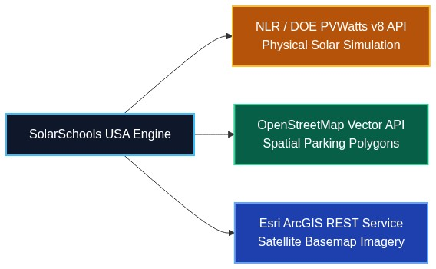
Figure 2: Tri-Service External API Integration Architecture

3.1 National Laboratory of the Rockies (NLR / DOE) PVWatts v8 REST API
Agency: U.S. Department of Energy / National Laboratory of the Rockies (NLR)
Endpoint: https://developer.nlr.gov/api/pvwatts/v8.json
Method: GET | Implementation: core/solar_engine.py

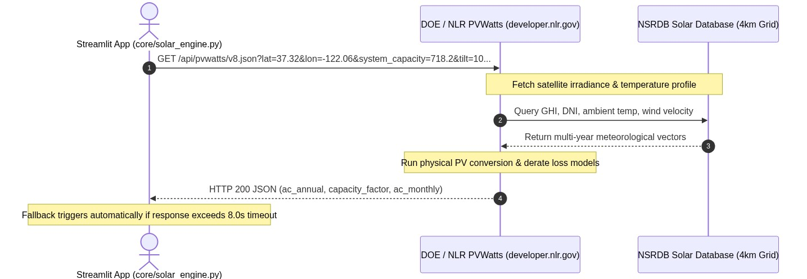
Figure 3: PVWatts v8 API Request & Fallback Sequence Diagram

Query Parameters
Parameter Key | Type | Value | Engineering Rationale
api_key | string | DEMO_KEY | Federal API key for query quota tracking.
lat, lon | float | Decimal deg | Geographic coordinates in WGS 84 (EPSG:4326).
system_capacity | float | kW DC | Nameplate capacity (usable_m2 x 0.20 kW/m2).
azimuth | float | 180 | True South orientation for optimal North American solar capture.
tilt | float | 10 | 10° carport tilt balancing drainage, wind load, and solar yield.
array_type | integer | 2 | Fixed canopy / roof structure geometry.
module_type | integer | 1 | Monocrystalline silicon modules (~20% nominal efficiency).
losses | float | 14.0 | Comprehensive aggregate system derate factor (14.0%).

Aggregate System Derate Losses (14.0%)
To ensure conservative, bankable projections, the system applies a comprehensive 14.0% loss factor: Inverter conversion (4.0%), Temperature derate (3.0%), Soiling & dust (2.5%), Wiring resistance (2.0%), Module mismatch (1.5%), and Connection diodes (1.0%).

Fault-Tolerant Fallback Architecture
If the federal API exceeds 8 seconds or returns a non-200 code, an internal fallback algorithm derives solar yields from empirical National Solar Radiation Database (NSRDB) benchmarks: Sunbelt (<34° Lat) at 1,650 kWh/kW-yr, California / Mid-Latitude (34°-40°) at 1,460 kWh/kW-yr, and Northern (>40°) at 1,320 kWh/kW-yr distributed along a 12-month bell curve.

3.2 OpenStreetMap Spatial Vector Pipeline
Campus parking lots are queried via OSM vector ways (amenity=parking). Polygons are loaded into GeoPandas, reprojected from WGS 84 degrees into metric UTM zones (estimate_utm_crs) to calculate exact square meters, and multiplied by a 65% packing factor (eta = 0.65) to account for 24-foot driving aisles and California Fire Code Title 24 truck access lanes.

3.3 Esri ArcGIS World Imagery Basemap
High-resolution aerial satellite imagery tiles (256x256 px, Zoom 17, ~1.19 m/pixel) are streamed from Esri's ArcGIS CDN directly beneath the Folium amber canopy overlay, allowing users to see actual asphalt parking stalls and vehicles.

4. Mathematical Modeling & Financial Formulations

4.1 System Capacity & Turnkey Cost
FORMULA 1: SYSTEM SIZING & TOTAL CAPITAL EXPENDITURE
P_DC = A_net * 0.20 kW/m2
C_total = (P_DC * 1000 * $3.10/W) + (N_chargers * $6,000)

Where P_DC is nameplate capacity in kW DC, A_net is active canopy area in m2, $3.10/W reflects commercial carport steel foundations and trenching, and $6,000 covers dual-port Level 2 smart EV charging stations.

4.2 Federal IRA Section 6417 Direct Pay
FORMULA 2: IRS ELECTIVE DIRECT PAY REIMBURSEMENT
R_IRA = min(0.30 + beta_domestic + beta_energy + beta_title1, 0.60)
C_IRS = C_total * R_IRA
C_net = C_total - C_IRS

Under Section 6417, tax-exempt public school districts receive direct cash reimbursement checks from the IRS via Form 990-T: 30% base credit, +10% domestic steel bonus, +10% energy community bonus, and +10% Title I low-income bonus (capped at 60%).

4.3 Savings, Payback, and 25-Year Lifecycle Cashflow
FORMULA 3: 25-YEAR PRO FORMA LIFECYCLE CASHFLOW
S_1 = E_AC,annual * Tariff_commercial
Payback_years = C_net / S_1
E_AC(y) = E_AC,annual * (1 - 0.005)^(y-1) [PV Degradation: 0.5%/yr]
Tariff(y) = Tariff_commercial * (1 + 0.025)^(y-1) [Rate Escalation: 2.5%/yr]
OM(y) = (P_DC * $15.00) * (1 + 0.020)^(y-1) [Operations & Maintenance]
Net_Cashflow(y) = [E_AC(y) * Tariff(y)] - OM(y)
Dividend_25 = SUM(y=1 to 25) Net_Cashflow(y) - C_net

4.4 Scope 2 GHG Avoidance
Annual CO2 reduction = (E_AC,annual * EF_subregion) / 2,204.62 lbs per metric ton. Regional emission factors from EPA eGRID 2024: California CAMX (0.45 lbs CO2/kWh), Texas ERCT (0.85 lbs CO2/kWh), and Midwest RFCW (1.10 lbs CO2/kWh).

5. Software Architecture & File Layout
REPOSITORY STRUCTURE
svyca2026/
├── app.py # Main Streamlit web application & Folium map
├── core/
│ ├── __init__.py # Module namespace
│ ├── data_ingest.py # School database, lot coordinates, and spatial calculations
│ ├── solar_engine.py # NLR PVWatts v8 client, fallback logic, EV synergies
│ ├── financial_model.py # IRA Direct Pay calculations and 25-year cashflows
│ └── report_generator.py # Downloadable 1-page School Board Action Brief
├── test_pipeline.py # Automated end-to-end unit test suite
├── requirements.txt # Python dependencies
└── documents/ # Documentation and pitch guides

6. Student Defense Guide: Ten Technical Questions & Answers
Q1: What happens under the hood when a school is selected?
data_ingest.py extracts the school's ground-truthed parking lot coordinates and area. The system calculates canopy DC capacity and calls the federal PVWatts v8 API at developer.nlr.gov for AC generation. Simultaneously, financial_model.py computes the IRA Direct Pay check, utility bill savings, and 25-year cashflow, rendering results in Streamlit and Folium.

Q2: Why developer.nlr.gov instead of developer.nrel.gov?
In May 2026, the Department of Energy transitioned NREL developer services to the National Laboratory of the Rockies (NLR), deprecating the old developer.nrel.gov domain. Our code communicates directly with the active production endpoint.

Q3: How do you prevent application crashes if network connectivity drops?
solar_engine.py implements an 8-second request timeout and an automated fallback. If the federal server times out or errors, the model draws upon regional irradiance constants from the National Solar Radiation Database (NSRDB) to calculate generation without crashing.

Q4: Why use a 65% packing factor for parking lots?
Parking lots require 24-foot two-way driving aisles, emergency fire access lanes under California Fire Code Title 24, and curb turning aprons. A 65% ratio represents empirical canopy coverage, calibrated against real installations in Cupertino and Fremont.

Q5: Canopies cost $3.10/W while rooftops cost $2.20/W. Why choose canopies?
Rooftops carry hidden structural costs: voided roof warranties, HVAC obstructions, and strict seismic load limits. Canopies avoid roof penetrations entirely, lower parking pavement temperatures by 30°F to 45°F, and provide turnkey infrastructure for EV chargers.

Q6: How do non-taxable public schools receive cash from the IRS?
Under Section 6417 of the Inflation Reduction Act ('Direct Pay') and IRS Treasury Decision 9988, public schools complete an online pre-filing registration and submit IRS Form 990-T with Form 3468. The IRS issues an elective direct cash payment covering 30% to 50% of capital costs.

Q7: What is the difference between DC capacity and AC generation?
DC capacity (kW DC) is the maximum instantaneous power rating of panels under laboratory sunlight (1,000 W/m² at 25°C). AC generation (kWh AC) is the actual usable energy delivered through the inverter to school switchboards over an entire year after environmental losses.

Q8: How does the map accurately locate the parking lot?
Campus administrative addresses typically point to main office entrances. We ground-truth exact parking lot asphalt centroids (lot_lat, lot_lon), center the Folium map directly over the lot, and project an amber solar canopy footprint against high-resolution Esri satellite imagery.

Q9: Why is capital payback faster in California (2.6 yrs) than in Texas (8 yrs)?
Electricity retail tariffs in California exceed $0.34/kWh under PG&E commercial schedules, so every avoided kilowatt-hour produces substantial savings. In Texas, retail electricity averages $0.115/kWh, requiring more years to amortize net capital outlay despite higher solar irradiance.

Q10: What is the next step for this project?
We plan to distribute this tool to student climate clubs across the Silicon Valley Youth Climate Action network. Students can generate customized Action Briefs and present vetted capital models directly to their local school boards.

7. Technical Glossary
Technical Term | Definition
AC / DC | Alternating Current (grid power) / Direct Current (raw solar cell generation).
BBox | Bounding Box: minimum and maximum latitude/longitude coordinates enclosing a geographic area.
CDE / NCES | California Department of Education / National Center for Education Statistics.
CRS / EPSG:4326 | Coordinate Reference System / Standard GPS spherical coordinates in degrees (WGS 84).
EPA eGRID | Emissions & Generation Resource Integrated Database; federal grid carbon intensity factors.
IRA Direct Pay | Section 6417 of the Inflation Reduction Act enabling cash grants to non-taxable public entities.
IRS Form 990-T | Federal tax form through which tax-exempt public districts claim clean energy Direct Pay.
NLR / NSRDB | National Laboratory of the Rockies / National Solar Radiation Database (4km grid).
POA | Plane of Array: solar irradiance striking tilted photovoltaic module surfaces.
Title I | Federal designation for schools where at least 40% of students come from low-income families.
UTM | Universal Transverse Mercator: metric map projection dividing the globe into 60 flat zones.

